- D - R - A - F - T -
A Proposal to Create a Test Platform for Evaluation of
Wireless Sensor Network Performance
by
David P. Daugherty

Submitted in partial fulfillment
of the requirements for
ITEC 650- Computer Networks
Radford University
Spring 2006

Introduction
Since wireless sensor networks (WSN) are severely constrained by the size of battery that can be deployed with the sensor nodes (SN), their lifetime performance depends on how data collected at SN are delivered to base stations (BS). Specifically, desirable strategies minimize individual SN energy requirements while maximizing coverage and lifetime for the overall WSN. Energy consumed by a SN is proportional to the product of its total bit traffic and a distance-sensitive transmission power. This transmission power is proportional to at least the second power of the nearest-node distance and sets a bound on SN spacing.

As time passes, SN far from their closest adjacent node, or nodes that have high bit traffic due to forwarding, deplete their batteries and effectively disappear from the WSN. At this point the routing topology must be reconfigured to extend the coverage and lifetime.

It is important to have a tool to evaluate the effectiveness of the many different routing strategies that can be devised. The tool must include realistic assumptions and give a total lifetime picture of the major performance metrics. Herein summarized is a proposal to create such a tool based on algorithms that minimizing non-Euclidean graph distances during a dynamic simulation.

Background
WSNs can be categorized by a number of features (Al-Karaki & Kamal 2005). In general their design is driven by the need to maximize network lifetime and coverage while transmitting the desired information with minimum energy consumption. Since transmission power is strongly influenced by distance, graph algorithms such as minimum spanning tree (MST) and all-pairs shortest path (APSP) can be used to choose the forwarding destination for each SN, and this can minimize energy if the SN transmitter is made adjustable so that only the minimum energy is expended. Many methods have been proposed to determine the best routing (Many, Many & Many More 200X). Herein is proposed a general tool to aid in devising and experimenting with alternative routing strategies. Performance over the full routing lifetime is simulated.

Proposed Idea
A Java-based tool will be created to evaluate key performance measures over the lifetime of two-tier, randomly-placed WSN. All of the lower-tier sensors are treated as identical with highly restricted energy storage and the same average bit generation rate. They are taken to have omni-directional transmitters with the ability to vary transmission power as needed to contact an adjacent node (with a resultant change in battery lifetime). A second tier of nodes acting as base stations (BS) with effectively-unlimited energy storage can be introduced into the network to serve as end collection points for SN bit traffic. The tool will permit the user to experiment with key WSN parameters:
- Average sensor density
- Sensor deployment dispersion
- Sensor range
- Base station to sensor node ratio
- Internal battery capacity
- Transmission energy vs. inter-node distance and bit traffic.

For each set of input parameters, performance simulations will be run for entire lifetime of the network with performance curves collected during the simulations for:
- Nodes connected to some BS : total node count
- Actual area coverage vs. theoretical maximum area
- Bit traffic received
- Energy consumption

Utility of the tool will be demonstrated by computing lifetime performance for routing topologies based on both minimum spanning tree (MST) and star connections to the base stations. In all cases, as sensor node batteries are depleted, that node (and its coverage area) will be removed from the network and a new topology calculated.

The key idea in this work is to show that graph minimization algorithms based on Euclidean (physical) distance minimization can be used to minimize highly non-linear penalties like those associated with transmission distance by using non-Euclidean distance inter-node distances.

Literature
(TO BE COMPLETED LATER)

Approach
Key tool modules to be developed, in approximate order, include:
- User Interface
- Random placement generator for sensor locations
- Star connection algorithm
- Simulation driver
- Performance statistics collector
- Full results storage
- Inter-node distance generators for both physical and transmission energy distances
- All-pairs shortest path algorithm
- MST algorithm

All implementation work will be done in Java and deployed JAR file for standalone execution. Code will be self-documenting via Sun Javadoc conventions so that it may be transferred to others. The initial user interface will permit modification of input parameters and display of summary simulation results through text fields. Emphasis will be on algorithm development not sophisticated user interface graphics. Export of full simulation data will be saved to files; but no relational database connection will be included.

Timeline
A proposed schedule for the project follows:
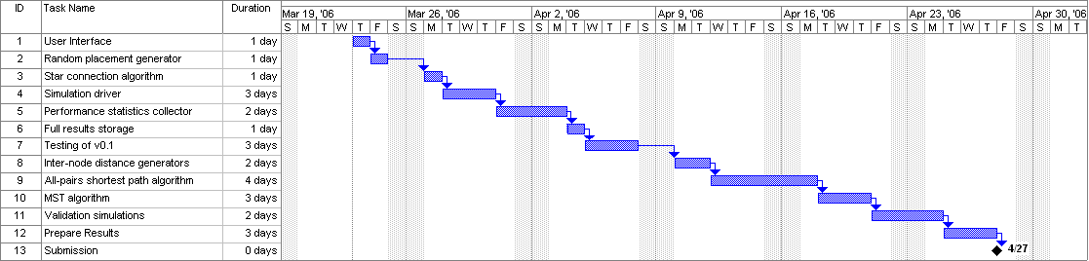

References
(TO BE COMPLETED LATER)

