Fuad, A Talal

wireless Network

[1]

**Abstract**— I am going to write about wireless Network and introduction about networking. I choses this topic because there is a lot of information on it that can I get an advantages on it. This subject is really interesting to me for example, how the the internet begins how to the internet become It has become very sophisticated with wireless and how people cannot live now without it. Also, how the the wireless network it became so easy to use like in your mobile, laptop and even in smart watch. I’m interesting to know the process for wireless Network from start until now.

INTRODUCTION

T

his paper is general about networking wireless. Also, about networking wireless types. A computer network is the best way to take advantage of resources over a computer by sharing such resources as storage space and data, and also sharing other devices such as printers and, of course, sharing Internet access

LAN LANA AREA NETWORK is a network located in a small area (or rather containing a small number of computers and devices) such as those in the office or home

WAN: Wide Are Network is a network located in a large area.

We have many example on networking wireless for example, smartphone, smart watch, smart car, video games etc. most of those in our day now need internet wireless

# WLANs

Smartphone become in this days really important to us we can’t live without our smartphone. The first generation of phone is just able to make a call but with smartphone you can do many things and you need internet wireless to do many things. The Cellular networks in phones starts with (1G) and (2G) but for more security mutual authentication became

required in the 3G along with improved security algorithms for both data confidentiality and integrity.

Cellular networks now are the important things that we use in our devices. But in WLAN give us small amount of communication range as what I understand WLANs is simple with LAN with wireless Access Point its called (AP). More security need in WLANs for downloading big amount of audio or high Definition (HD) video. Security is very important to work easily and without any problems. Reference [1]

# WMANs

WMANs is Wireless Metropolitan Area Networks. Wireless Metropolitan Area Networks is providing wireless communications so, Wireless Metropolitan Area Networks use Worldwide Interoperability for Microwave Access to make or give Mobile Stations (MS) communications with Base Stations connected to backbone networks and the Internet. The good things in Worldwide Interoperability for Microwave providing us a huge amount of communication that’s fit a big place or area. It fit almost 5 miles. Also, the good things in Wireless Metropolitan Area the security on it really high it supports all application that use by internet. Worldwide Interoperability for Microwave Access is now major competitor among the prevailing wireless communication technologies. Finally, now we know that wireless local area network gives us small amount communications and Worldwide Interoperability for Microwave Access gives us a huge or big amount of communications that could fit a big area. Reference [1]

# WSNs

WSNs is Wireless Sensor Networks. Wireless Sensor Networks used to track the enemies, also, for detect the fires and floods to save environmental pollutions and people. Or measuring the traffic. Security is really important in Wireless Sensor Networks. Wireless Sensor Networks are usually deployed in hostile or remote environments and work in an unattended manner. Reference [3]

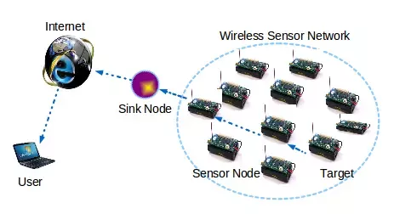

This image from reference [4]

# WMNs

WMNs is Wireless mesh network. Wireless mesh network one of wireless topology but not only each node is connected to every other in a wireless manner. Wireless mesh network we can call one of WLAN so, Wireless mesh network support same applications that use in internet. Also, same security that used in WLAN. Wireless mesh network (WMNs) and WLAN have security concerns such as secure routing and utilize additional protocols, For example, Simultaneous Authentication of Equals (SAE).

Wireless mesh networks typically consist of mesh clients, mesh routers, and gateways. The mesh clients can be like phone. reference [1]

# Cooperative Mesh network

A cooperative mesh network is about a new architecture developed on the ideas borrowed from wireless mesh network and cooperative communication networks. Wireless mesh backbone formed by mesh router and getaway. Also, the wireless Mesh user network is formed by users. Users have to access the wireless Mesh backbone to get service. Users close to the Mesh routers are connected directly to the wireless Mesh backbone. The advantage is users can cooperate with each other to obtain higher performance. Reference [2]

# RFID NETWORK

RFID is Radio Frequency Identification. RFID is Radio Frequency Identification kind of internet structure

RFID technology consists of small, inexpensive, computational devices. In Radio Frequency Identification the security is so important because might be Causing damage and deceiving people like in wars. The difficulty in securing RFID lies in the resource constraints of the RFID tags. So security in Radio Frequency Identification is really important. Reference [2]

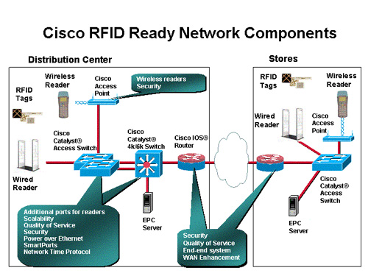

This image from reference [5]

# First generition of cellular

The First generation of cellular was using analogue signal. It was so weak signal even couldn’t get security service. That not mean the security was not required but it was so slow or weak. In an analogue wireless communication system could hacked or attack easily by communication of a cellular phone because in that time small number was using cellphone and it was new technology.

# second generation of cellular

The second generation of cellular communication give us most service that we need but not all. Also, the quality of the service. Major geographical regions adopted different 2G systems. The difference that happen between the second

generation and the third generation is the security. Security was improved a lot in the third generation of cellular communication. Also, and different radio frequency ranges providing larger communication bandwidth. reference[1]

# THIRD GENERATION OF CELLULAR

In third generation of cellular the future arrives. it is faster and more good quality. The security in the third generation of cellular was improve so, you can open any application. Also, more safe than the second generation. You can use map location service, weather, pictures massages, more easy to connect the internet. In this days we use our phone like we use our laptop because is easy to use it and not big like laptop. Also, you can use in smartphone like what we use in laptop.

# gsm networks

GSM is Global System for Mobile Communications, originally Group Special Mobile, s a digital mobile telephony system that is widely. GSM user is really large number more than who using the other communication networks. Each devices user has authenticated themselves to the

network before the network can provide services. In the GSM networks, a mobile user denoted as user equipment which includes a compatible mobile device for example, cell phone and a SIM card, get their unique ID from a mobile network authentication center. When mobile user want connect to the internet first, it send IMSI serving as its identity that’s collect the information than transfer to the VLR. This is little bit about GSM proses. Reference [1]

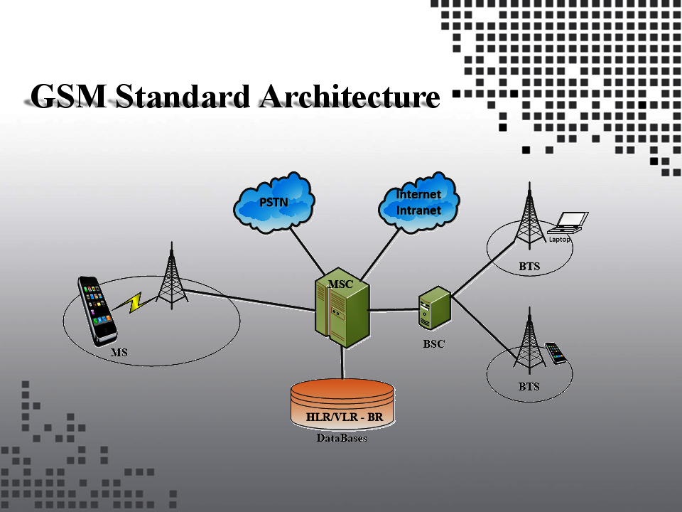

This image from reference [7]

XI. VANETs

VANETs is Vehicular ad-hoc network provides communication between vehicles and between vehicles and road-side base to providing efficient and safe transportation.

All applications that require security over the Internet are expected to be supported by VANETs. So, most important things on this application the security. There is advantage for VANTs for example, is really safety, comfortable, and new era of technology. VANETS also, has disadvantages for example, it cost a lot of money. Reference [1]

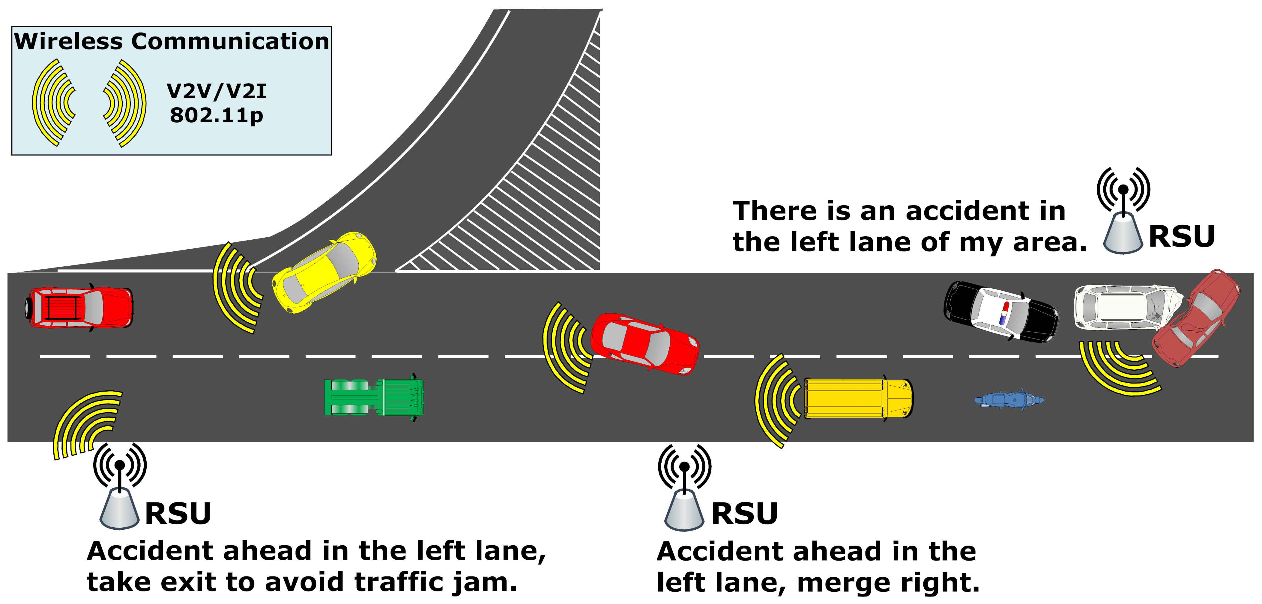

This image from reference [6]

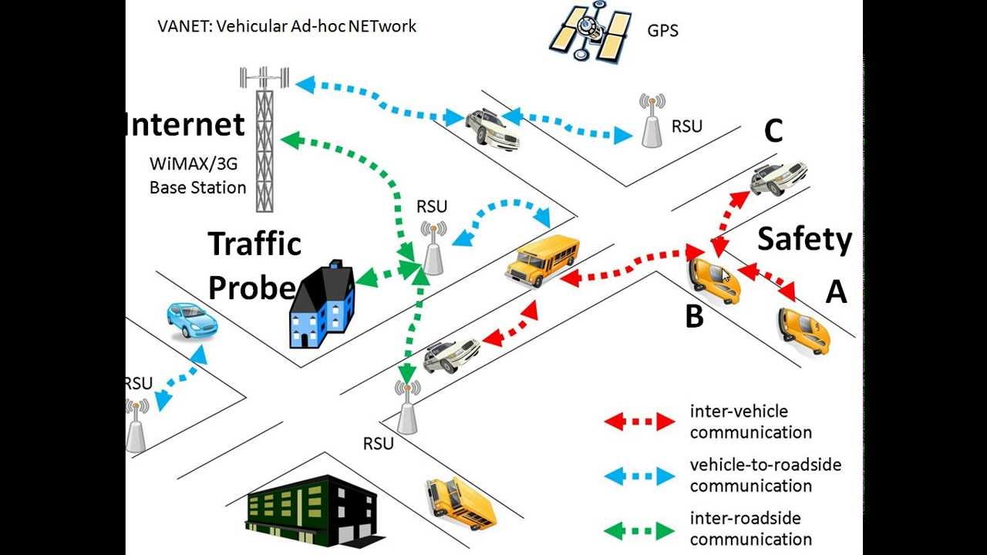

This image from reference [8]

XII. CONCLUSION

I talked about the general in networking wireless. After that I wrote about internet wireless types. I went through the explanation and the process. also, I mentioned the examples. I also, wrote about the size each one and what better for us now and some advantage of some types.

XIII. REFERNCE

[1] Chen, Lei, Jiahuang Ji, and Zihong Zhang. *Wireless network security* : *theories and applications. n.p*.: Beijing : Higher Education Press ; Heidelberg : Springer, ©2013., 2013. Radford WMS, EBSCOhost (accessed December 6, 2017).

[2] Chilamkurti, Naveen, Sherali Zeadally, and Hakima Chaouchi. 2013. Next-generation wireless technologies : 4G and beyond. n.p.: London : Springer, [2013], 2013. Radford WMS, EBSCOhost (accessed December 6, 2017)

[3] Chen, Cailian, Shanying Zhu, Xinping Guan, and X. Shen. 2014. Wireless sensor networks : distributed consensus estimation. n.p.: Cham : Springer, 2014., 2014. Radford WMS, EBSCOhost (accessed December 6, 2017)

[4] “What is wireless sensor network (WSN) technology?” (2015)

https://www.quora.com/What-is-wireless-sensor-network-WSN-technology

[5] “Radio Frequency Identification (RFID) Solutions” (2006)

http://people.sunyit.edu/~deciccm/RFID%20Stuff/RFID%20Scrapbook/data/20061019143918/

[6] “Authentication and Trust for Vehicular Ad Hoc Networks”

<http://www2.cs.siu.edu/~adwise/project-vanet.html>

[7] digital brains, “Global System for Mobile (GSM)” https://www.digibrains.com/cell-phone-networks/gsm-network/

[8] A Sharma ,S Preetsingh. “Node Selection Algorithm for Routing Protocols in VANET”.(2016)

http://www.sersc.org/journals/IJAST/vol96/5.pdf

1.