Underwater Acoustic Sensor Networks and Capabilities with Unmanned Underwater Vehicles (December 2017)

Dontey Branch, IEEE

**Abstract—with the internet of things growing rapidly, so does the advancement of ways that we can use internet connectivity to help us with communication in ways that were before seen as impossible or close to impossible. Underwater Acoustic Networks are allowing communication underneath the ocean in ways that are different than the basic radar and sonar. These networks can be used to remotely connect, communicate, and coordinate multiple unmanned underwater vehicles from an on shore location. Using acoustics these Underwater Acoustic Networks (UANs) are able to communicate. This method of underwater communication relies on a quicker more reliable connection so there is need for sensors with different functions to be placed in the ocean beforehand. The military and research groups benefit from this underwater communication for exploration and detection under the ocean surface.**

1. INTRODUCTION

Ocean exploration is something that mankind has been working at for a very long time. While many scientific discoveries have happened throughout exploration, there are still parts of the ocean that human are unable to go or stay in for an extended period of time. Underwater Acoustic Sensor Networks (UANs) allow people to further explore and communicate in ocean or other aquatic environments. UANs are valuable to use in all types of water bodies such as rivers, lakes, seas, and oceans. In the future there could be possibilities that UANs can be used for years and years to come similar to cell phone or internet towers on land. Remote control subs or Unmanned Underwater Vehicles (UUVs) can be used at further depths and ranges while also being able to coordinate with other unmanned subs nearby to complete an assignment or mission.

These underwater networks also require routing protocols just like networks on land, but the protocols used for the UANs have to conform to different restraints than the ones on land. Issues with energy, weather in the ocean, and salt or other chemical in the water need to be taken into account when developing a new UAN routing protocol. When working in a UAN with multiple Unmanned Underwater Vehicles (UUVs), failure of a UUV in a mission could be critical and protocols that are developed need to be able to dynamically change the network to when a failure like this occurs.

UANs can give real time data and communication as opposed to older sensor devices that needed to picked up manually after being set in the ocean for a certain period of time. With this real time data scientists are able to detect earthquakes, volcanoes eruptions, tsunamis, and other tectonic plate movement that can cause natural disasters from underneath the ocean surface. This data can also be used to detect pollution in the water around the sensor networks. Certain sensor can be initially set up to be able to detect chemicals or temperature changes in the water near by the nodes in the network. Detecting changes in water composition could the most useful in river, lakes and reservoirs due to the small amount of water to test. These smaller water sources are typically the water bodies that provide drinking water to the communities around them so toxins and chemicals in the water could be detrimental to the health of the people drinking it. Military personnel can use UANs to have a more secure underwater defense or attack strategy with the real time data provided. Defense with UANs allows for a more strict and tight for of security and detection. Patrolling and surveying areas for enemy activity can now be done remotely UANs could eventually be utilized to make underwater networks similar to the networks that are on land nowadays.

1. UNDERWWATER ACUSTIC NETWORKS

Underwater acoustic network research is a growing research subject that is allowing people to communicate underneath bodies of water with more ease than seemed possible only a few years ago. To make these networks operational, nodes and sinks are used to communicate. Nodes in UANs are the nodes in the network that remain underwater and the sinks are surface floating nodes that are able to communicate above and below water to the nodes below. These networks reduce the reliance on land communication to operate multiple Unmanned Underwater Vehicles (UUVs) or also known as Autonomous Underwater Vehicles (AUVs) [1]. To reduce this reliance, underwater sensor nodes used to create to the system that communicates with the vehicles seamlessly in theory.

Sensors and nodes used in a network underwater can be made to detect and send real-time details of an event or situation near a given sensor. For example sensors could be used to locate and keep track of objects and open spaces or underwater caverns that could be harmful to a research vessel. Military personnel are able to detect object as small as explosive mines to save lives. Keeping actual people on land and allowing UUVs to do surveillance could be compared to the military’s drones surveying an area from the air. The usage of a sensor could also be beneficial for exploration when caverns or trenches are found. Changes in pressure and water level can be detected to aid scientists when ocean earthquakes occur. Chemicals changes in the water can also be detected with sensors. This detection could be used to help offshore oil rigs and toxic chemical leaks in big bodies of water. Some UUVs can be equipped with instruments to help fix and clean up environmental disasters.

Unmanned Underwater Vehicles are getting the capability to go deeper in unsafe conditions to explore and collect data or as weapons against an enemy. Unlike original models of remote vehicles, these new UUVs and Autonomous Underwater Vehicles (AUVs) are able to be controlled without any physical tether wire or connections to the vehicle. Examples of some UUVs and AUVs can be seen in Fig. 2 for further understanding. These vehicles can operate at high or low tide and typical models are able to go up to 6,000 meters down into the ocean [7]. More advanced models are smaller but can go all the way to the bottom of the ocean in some areas up to 11,000 meters [7]. With a UAN installed in an area the AUVs and UUVs are able to send and receive data to other vehicles or the on-land controller through the underwater nodes. This is helpful in traversal through tight places or situations where a mistake could jeopardize the job that needs to be one by the vehicle. As sensors in a network detect events in the water, the AUVs are able to safely investigate the situation further. Using these UANs and AUVs are becoming more popular to detect pollutants and temperature changes that could be harmful to marine life or be the sign of a natural disaster occurring. Being able to react faster to an event such as a tsunami would saves hundreds to thousands of lives around the ring of fire in the pacific ocean. As the wave moves towards land it could also be tracked along the way if networks were set in place.

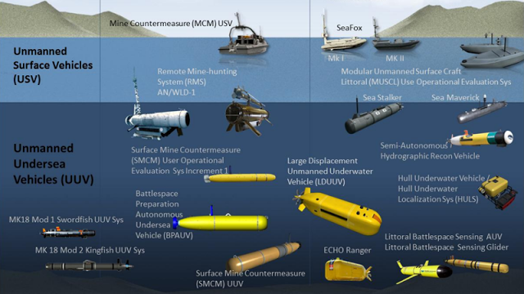

Fig 1. Figure of the different types of UUVs and AUVs [9].

Routing protocols of UANs have to be created with restrains in mind that protocols for sensor networks on land do not. Signal waves that sensor networks use on land cannot be used directly underwater as easy as on land due to water distorting the signal. Issues with energy storage and node movement with among the ocean currents [5]. Scientists have started to create some routing protocols that have been somewhat successful. A mobicast routing protocol has been made to help AUVs communicate even when nodes are displaced by the current. To do this the AUV acts as the center node in the network. All the other nodes in the network do not stay active to send and receive data until the AUV has come into a certain radius around each node [5]. This allows the network to dynamically change as the ocean currents and locations of the nodes change. A protocol called GEDAR can also dynamically conform to changes in location of nodes. This protocol uses depth adjustment apparatuses to manually change the location of node to better fit the physical network topology needed [5]. When moving a node the decision on where to move it is made based on the information received from nearby nodes. H2_DAB is a protocol that assigns address to each node in the network along with a hop count. As nodes are added the links between nodes are all connected by acoustics links based on hop count from the surface sinks. Addresses and hop counts are updated often to deal with changes in node location. Dealing with node location changes also creates more traffic on the network to update the networks address and hop counts. In Fig. 3 the basic method for topology set up and hop count assignment for UANs can be seen. A protocol to conserve energy and time is E-PULRP. E-PULRP uses only on sink node in the center of the network and layers of nodes around the sink are put into place. Each node is assigned a hop count number the same as the number of layer it is in. When sending information between nodes the nodes sending the information has to communicate with the nodes of the layer below it. This layered network strategy can be seen in Fig. 2. To choose which exact node to send the information through, the node measures the energy available and the energy needed to send the information and then picks the best option as the next place to send the information [5]. E-PULRP although good for conserving over all energy consumption, it can be messed up by movement of nodes into layers that they are not a part of. This could lead to hop counts taking longer than expected due to distance that has not been taken into account.

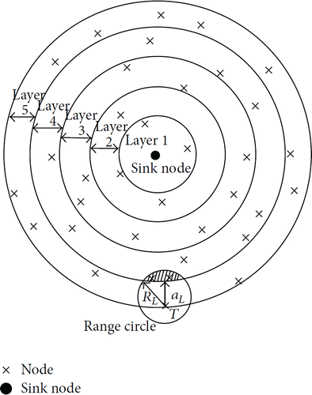

Fig 2. Model of a layered E-PULRP network topology [5].

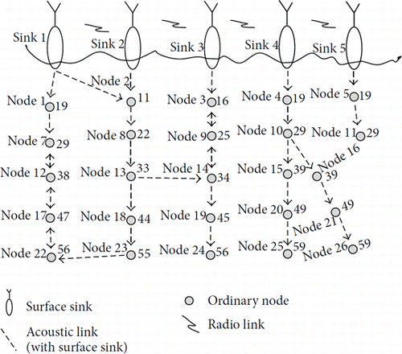

Fig 3. Model of a standard network that H2-DAB could be used for [5].

1. Existing Research

Although working toward further automation in ocean exploration and involvement is not a new subject or field, it is still a very thriving and growing topic in the science field. Research studies that have been done are typically testing of UANs functions in scenarios where the task to be done is critical.

1. *Reliable Mission Execution Using Unreliable UUVs [10]*

Gary Giger, Mahmut Kandemir, and John Dzielski have presented and algorithm to allow UANs and multiple UUVs to dynamically adapt when a vehicle failure happen in the middle of a critical mission [10]. The IEEE paper explains the approach to creating the algorithm needed to solve the problem of UUV failure in a multiple UUV network. This problem came about from the military needed more UUVs and UANs for underwater defense and detection. When a using a UUV when they were first made there was typically only one operator and one vehicle [10]. Now there are networks that allow a single operator to control multiple UUVs at the same time. Issues the military had with this feature was that if UUVs are patrolling an wide area and vehicle gets damaged by currents, waves, an enemy, or has a loss of power it became detrimental to the entire mission at hand. The algorithm that the paper explains uses certain nodes in sections of a wide area for each UUVs to patrol around. The UUV goes node to node in a specific cycle patrolling the section it travels around detecting what is needed. Now if a vehicle were to get damaged while patrolling, the Network would detect the downed UUV, alert the rest of the network, and then change the rest of the UUVs patrol sections to cover the section that is now unpatrolled. This algorithm works to calculate the best section for each UUV to take but it could not calculate the best path to in a section correctly when more than twelve nodes where given to travel around. Testing the algorithm with varying types of UUVs could be done to further test if the algorithm could take the energy capacity of each UUV into account when determining the best paths and sections.

1. *Lessons from the Field – Two Year of Developing Operational Wireless Sensor Networks on the Great Barrier Reef [12]*

Scott Bainbridge, Damien Eggeling, and Geoff Page have done a study on the bleaching and damage of the Great Barrier Reef by using UANs to detect different factors. This project was done to test the capability of sensor networks in seven different locations of the coast of Australia. The goal was to possibly find out why coral reef bleaching is happening and what the highest contributing factor is. Set up consisted of seven sites with hundreds of ‘cheap’ sensors placed in the area to set up networks. The networks initially had issues with the decision for cheap sensors and thousands of dollars were spent to fix the problems. Researchers had to deal with real-time data being unreliable. When trying to communicate through one of the networks, the given network could not guarantee successful communication if the communication period was a small amount of time. The system works now and is had made over nineteen million detections by the end of the study and found a tsunami and cyclones [12]. Using better sensors from the initial setup could solve the problem of extra cost in the middle of the operation.

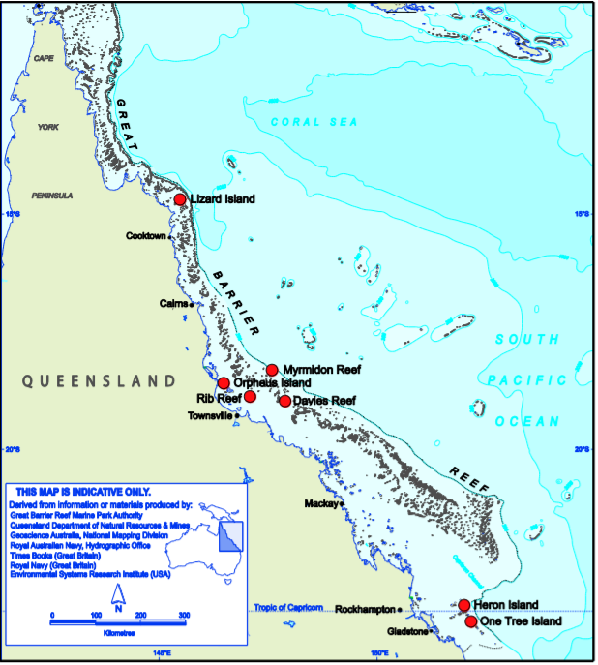

Fig 4. Figure of the seven sites where sensors where placed [12].

1. *Underwater acoustic sensor network for early warning generation,‖*

Prashant Kumar et al. did research on the detection of natural disasters with UANs. Nodes setup in in a networks were intended to detect certain actions underneath the ocean’s surface. The nodes were set to detect events such as temperature, sudden rises in water level, chemical changes, and earthquake activity. When a node detects something it send it to the surface sink and then is sent to the operations base on land and then to a satellite to further obverse the situation [13]. Energy of the nodes became a problem in the experiment. The amount of data being received was greater than initially predicted so the amount of energy being used by the nodes to send the data had increased as well. Problems with energy consumption and generation is a recurring issue with UAN nodes and UUVs in experiments and mission situations. More reliable energy sources are needed to make this system and other system with energy issues are fully functional for the times that they are active and sending data to on land operators and within themselves.

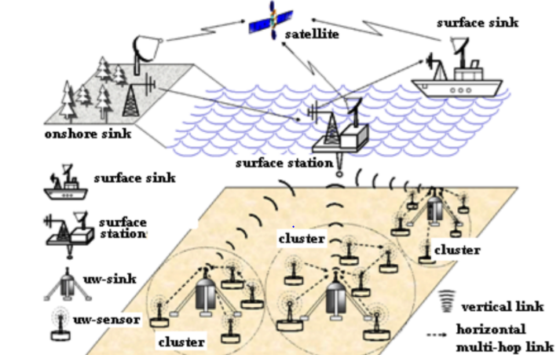

Fig 5. Figure of the way data was collected by the networks.

1. POSSIBLE RESEARCH IN UANS

The Navy has started to work on a system called POSYDON (Positioning System for Deep Ocean Navigation). This system is supposed control UUVs that can go far distances using maps to determine the correct route and current position in the route. This is currently possible but only though the use of GPS satellites. A UUV must come very close to the surface to be able to get a good signal to talk to the satellite and get the GPS information [14]. With the use of nodes and surface sinks the Navy hopes to be able to allow the surface sink to communicate with the satellite directly and the relay the information the nodes and UUVs below the ocean surface.

At the SENSORCOMM conference on sensor networks had many discussions about future possibilities for UANs and their capabilities. Research for lower power consuming networks to increase the longevity of networks. In addition to this research is also being done to create energy harvesters to supply a constant energy source to networks similar to on land. Overall quality of service in UANs needs to be improved. Current research has run into issues with node and UUV failure in test networks leaving an unrealizable way to communicate with systems underwater in certain situations.

Having the capability for any normal person to communicate through UANs could allow people to discover parts of the ocean floor just as if looking at google maps. The future of UANs could be as great as cell phone network span land. Possible research could result in longer range permanent networks throughout oceans changing continent to continent communication from satellite to ocean networks. This is unlikely in near future because of the immense costs that would come with setting up tower like theses in the ocean.

1. CONCLUSION

Underwater Acoustic Networks are a fascinating and an exciting topic the in the computer science and ocean exploration field. Advancements in technology with UANs are allowing scientists to make networks that could possibly change the way we travel the ocean and communicate over it. Satellites are used currently but if UANs grow to the potential that they have, they could take the place of satellites in certain ways of communication on earth. Military use is guaranteed with UANs due the possibility of defense with UUVs and AUVs. UUVs can allow surveillance and detection of an enemy or enemy placed objects. Lives could be saved with the capability to remove and disarm detected mines in the ocean. UANs can be beneficial in many facets of human’s lives. They can detect natural disasters, help out the military, and help us better understand the Earth’s oceans that have much too still be discovered. Much can still to be done with developing UANs and future development could lead to advancements in communication over oceans and other bodies of water.

REFERENCES

[1] Shen, J., Tan, H. W., Wang, J., Wang, J. W., & Lee, S. Y. (2015). A novel routing protocol providing good transmission reliability in underwater sensor networks. *網際網路技術學刊*, *16*(1), 171-178.

[2] Noh, Y., Lee, U., Lee, S., Wang, P., Vieira, L. F., Cui, J. H., ... & Kim, K. (2016). Hydrocast: pressure routing for underwater sensor networks. *IEEE Transactions on Vehicular Technology*, *65*(1), 333-347.

[3] Coutinho, R. W., Boukerche, A., Vieira, L. F., & Loureiro, A. A. (2016). Geographic and opportunistic routing for underwater sensor networks. *IEEE Transactions on Computers*, *65*(2), 548-561.

[4] Climent, S., Sanchez, A., Capella, J. V., Meratnia, N., & Serrano, J. J. (2014). Underwater acoustic wireless sensor networks: advances and future trends in physical, MAC and routing layers. *Sensors*, *14*(1), 795-833.

[5] Han, Guangjie, et al. “Routing Protocols in Underwater Acoustic Sensor Networks: A Quantitative Comparison.” *International Journal of Distributed Sensor Networks*, 11 Oct. 2015, journals.sagepub.com/doi/full/10.1155/2015/858593.

[6] Heidemann, J., Stojanovic, M., & Zorzi, M. (2011). Underwater sensor networks: applications, advances and challenges. Retrieved December 4, 2017, from <http://www.mit.edu/~millitsa/resources/pdfs/royal.pdf>

[7] Manley, J., & Crimmins, D. (2008). What Are AUVs, and Why Do We Use Them? Retrieved December 04, 2017, from <http://oceanexplorer.noaa.gov/explorations/08auvfest/background/auvs/auvs.html>

[8] Murad, M., Sheikh, A. A., Manzoor, M. A., Felemban, E., & Qaisar, S. (2015). A Survey on Current Underwater Acoustic Sensor Network Applications. *International Journal of Computer Theory and Engineering,* *7*(1), 1-6. Retrieved December 4, 2017, from <http://www.ijcte.org/vol7/929-AC0006.pdf>

[9] [Diagram of types of UUVs]. (2016, March 2). Retrieved December 5, 2017, from <http://gentleseas.blogspot.com/2016/02/us-diesel-remote-multi-mission-vehicle.html>

[10] Giger, Gary & Kandemir, Mahmut & Dzielski, J. (2008). Reliable Mission Execution Using Unreliable UUVs. AUVSI Unmanned Systems North America Conference 2008. 2

[11] L. Freitag, M. Grund, C. von Alt, R. Stokey, and T. Austin, “A shallow water acoustic network for mine countermeasures operations with autonomous underwater vehicles,” presented at the IEEE Oceans Conference, Washington DC, 2005.

[12] Bainbridge, S., Eggeling, D., & Page, G. (2011). Lessons from the Field—Two Years of Deploying Operational Wireless Sensor Networks on the Great Barrier Reef. *Sensors,* *11*(12), 6842-6855. doi:10.3390/s110706842

[13] Kumar, P., Kumar, P., Priyadarshini, P., & S. (2012). Underwater acoustic sensor network for early warning generation. *2012 Oceans*. doi:10.1109/oceans.2012.6405009

[14] Osborn, K., Holmes, J., DePetris, D. R., & Neumann, R. (2017, July 5). This Is How U.S. Navy Plans to Dominate the Wars of the Future. Retrieved December 06, 2017, from <http://nationalinterest.org/blog/the-buzz/how-us-navy-plans-dominate-the-wars-the-future-21417>

[15] Coutinho, R. W., Boukerche, A., Vieira, L. F., & Loureiro, A. A. (2014). GEDAR: Geographic and opportunistic routing protocol with Depth Adjustment for mobile underwater sensor networks. *2014 IEEE International Conference on Communications (ICC)*. doi:10.1109/icc.2014.6883327

**Dontey L. Branch**

My name is Dontey Branch and I am a computer science major with a concentration in networks. I am a senior here at Radford. I am looking forward to a career in networking and cyber security in the future when I graduate. My main interests are playing video games and binge watching good TV shows.