Abstract— Wireless technology is very popular in the world today, and is ever growing as the most popular form of getting connected to a network. Most modern devices don’t even have another form of connecting to a network but by wireless means. Smart phones, tablets, and most modern laptops do not have an RJ-45 port for connection via and Ethernet cable, and dongles and adapters are required, if available at all. All this wireless connectivity calls for some major security standards because security can’t be taken for granted in today’s day and age.
Survey on Security in Personal, Commercial, and Enterprise Wireless Networks
Andrew Nolen
Artis College of Science and Technology, Radford University - Radford, Virginia
With ever changing and more powerful computers, and more and more information being created and stored online or in private network, security has never been more important. There are way that wireless LAN networks have been, can be, and will be exploited in the future, and many of these ways will be outlined in this article.

Index Terms—Security, WEP, Wireless, WPA.

INTRODUCTION
These days wireless networks are all around us. The cell phone in your pocket is probably connected to at least one right now, possibly even two or three. With all this connectivity, security becomes a major factor in keeping you and your information safe from prying eyes. Security is constantly needing to be addressed as new standards are being implemented all the time and flaws in current standards are surfacing just as frequently.
Security can be implemented in both the hardware and in the software of wireless technology. In hardware, the security can be engineered to only allow certain hardware addresses to be connected or to prevent any wireless connection at all. Software can offer encryption and authentication as security to wireless enabled devices. Authentication, or the process of verifying the identity of a user that is trying to login or access a secure domain, can take many forms. Some examples of authentication processes include password authentication, biometric authentication, and public key authentication.
The problem is that each of these authentication methods have been breached, including the most recent standard method (WPA 2), which begs the question, how do we prevent this in the future? First, we must investigate how each of these standards were breached in order to understand what precautions need to be taken in the future.

Approach to Explain the Topic
Authentication, though not the sole means of securing a domain, is an important measure implemented into wireless networks in order to protect users. It seems, however, that each time the standards of authentication are revised, they are compromised once again.
So if hackers are relentless, what is the point in revising the standards? What are the repercussions if hackers continue to pursue the network? When these standards are penetrated, hackers can gain access private records through man-in-the-middle attacks which can lead to sensitive information being leaked to the public. This can cause companies to spend time and money implementing new standards, and it can even get businesses into legal trouble if the breach is extensive enough.
Because of these risks, security analysts are constantly reworking the system to promote better security.

Existing Research Issues on the Topics

Wired Equivalent Privacy (WEP)
WEP was initially designed to offer the same level of security that having a hard-wired connection into the network would provide. It uses a 64-bit key which is composed of a 40-bit long secret key (in WEP-40) with a 24-bit long Initialization Vector (IV) that acts as an encryption and decryption key [1], or a 128-bit encryption key that is composed of a 102 bit long secret key (in WEP-102) concatenated with a 24-bit long IV.
The encryption key is sent through an RC4 algorithm to further encrypt the data, but there have been several vulnerabilities with the RC4 algorithm because it is so simple and has been rendered insecure by the security community. The main reason it is donned as insecure is because the shared key is bound to be 5 (WEP-40) ASCII characters (0-9, a-z, A-Z) or 13 (WEP-102) ASCII characters and as such creates a very limited range of possible key values, in either case.

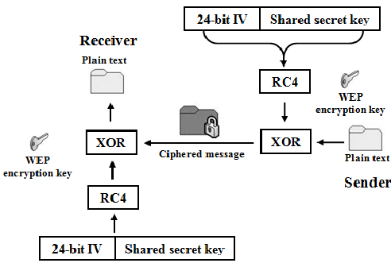
Figure 1: WEP encryption method
The figure above shoes just how simple the process of WEP verification is. The pre-shared key is appended to the end of the IV and goes through the RC4 encryption algorithm. It is then sent to the receiver, who then applies the RC4 algorithm to decrypt the message and is left with a plain-text of the sent message. Inside this plain text is the encryption key that was used.
There are many reasons that WEP was deprecated and replaced with a stronger authentication standard. Below are some of the findings of Lashkari in a 2009 conference [1][2].
WEP is vulnerable to replay attacks, where an attacker can send duplicates of packets that are legitimate only once, and they will be treated as legitimate every time they are sent. WEP also uses very weak keys with RC4 which causes the shared key to be very easily brute-forced on modern computer hardware very quickly and simply. Another issue is that WEP uses RC4, as RC4 is considered to be a very simple and weak encryption method. It has also been found that it is easy and simple to forge authentication messages when using WEP versions.
Due to how weak this method is, many home routers and access points that still have the functionality to use WEP will have a message that warns the administrator that it is not a strong method to use for the network and that other methods would be recommended, such as WPA or WPA-PSK, which is covered below.

Wi-Fi Protected Access (WPA)
There are two different versions of the WPA authentication method that are in use, WPA-PSK (WPA with a pre-shared key, also known as Personal WPA) and Enterprise (or Commercial) WPA. WPA is stronger than WEP in the fact that is uses a more complex encryption standard than just straight RC4. It uses the TKIP protocol (Temporal Key Integrity Protocol) [1] which also uses the RC4 technique, but makes a hash of the basic key and the IV before applying the RC4 algorithm, thus making it much less predictable.

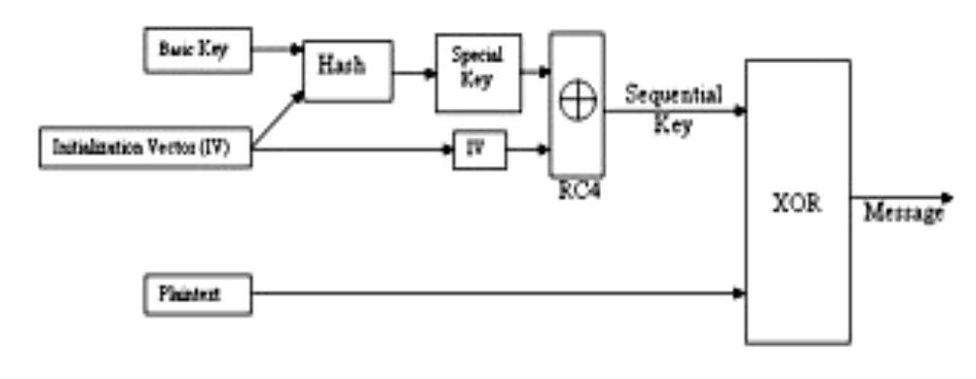
Figure 2: WPA Encryption Algorithm (TKIP) [1]

Personal WPA is used in home and small offices and uses a password shared with the device owners. The password, or pre-shared key, is stored on both the access point and the client device, so there is no need to transmit the key over the network with every packet like that of WEP. Also unlike WEP, the pre-shared key can be any alphanumeric string and is only used initially to connect a client.
Enterprise WPA is used in a business or large corporation setting. The authentication is made by a server. There is no pre-shared key, the replacement is a RADIUS (Remote Authentication Dial-In User Service) server. It uses the EAP (extensible authentication protocol) protocol to offer many different authentication methods. This also offers integration with Windows logon services [1] for Windows-based networks that use Active Directory as a logon method. It also supports PEAP (Protected Extensible Authentication Protocol) which encapsulates the traffic into a (possibly) encrypted TLS channel. WPA also implements MIC (Message Integrity Check) which protects against a bit-flipping attack, which WEP is susceptible to. A bit flipping attack is one where an attacker will intercept the message and change bits in the encrypted message that would yield predictable changes in the plain text, which could be noticed by the attacker and help to create a decryption tool.
In 2003 and in early 2004, development was made that would be the downfall of the WPA standard. Two Linux-based tools were created that could crack a network secured with the WPA encryption method. The tools would input a file of dictionary words to attempt the brute force attack, and also “a dump file that contains the WPA-PSK four-way handshake” [1].
This four-way handshake is what is used to initialize the connection and authenticate a user. By capturing this handshake, the attacker would have all the information he or she would need to perform a brute-force dictionary attack and figure out what the pre-shared key is, thus allowing them to connect to the network without having explicit access from the network owner. This handshake is captured by sending a de-authorization (de-auth) packet to the access point (AP). The AP then tries to reauthorize the user and the handshake packets are captured using software on the attacker’s computer. The brute-force attacks are not necessarily fast, as they are performing 4096 HMAC-SHA1 encryption on each passphrase. This can cause a lot of time waiting for longer passphrases.

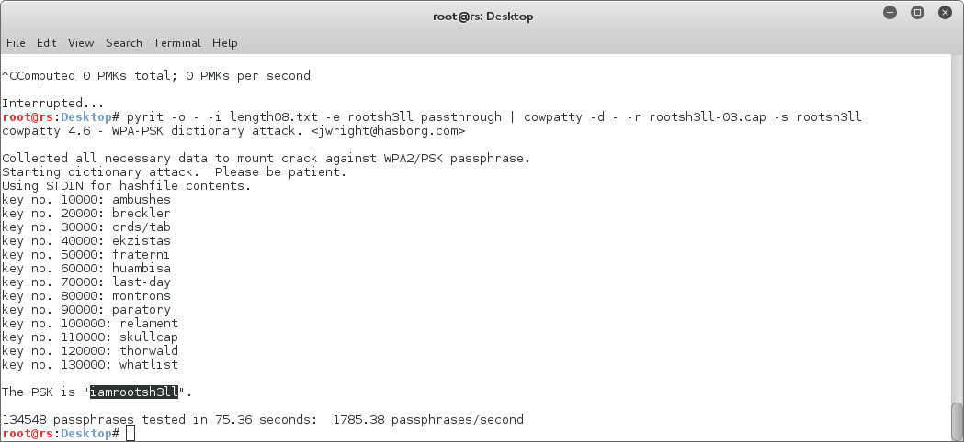
Figure 3: Running a WPA cracking tool and receiving the PSK for the network [4]

WPA2
WPA2 was designed to be a future-proof solution to the WPA standard. WPA was designed as a quick-and-dirty solution to fix WEP, but was not intended for a long-term solution. WPA2 was considered strong because of the choice of the encryption algorithm, AES (Advanced Encryption Standard). It was designed by the National Institute of Standards and Technology (NIST) and is a very well-documented encryption algorithm that is royalty free and accepted internationally [1].
WPA2 supports, like WPA, 2 modes of security, a home and corporate version. WPA2 for home use is almost identical to WPA, as it uses a pre-shared key of up to 64 ASCII characters.
One weakness that WPA2, like WPA faces is that the initial handshake for connection is not encrypted and can be intercepted by a third party. Due to this fact, this will be the downfall of the WPA2 standard, just as with WPA.
WPA2 was recently found to have a weakness that caused almost all Wi-Fi to be compromised, or able to be compromised. Since the vulnerability is due to an issue in the WPA2 method, it is not isolated to just certain implementations on certain platforms, such as Android, Linksys, or other isolated systems. The weakness has been called KRACK, or Key Reinstallation AttaCK. The way it works is that an attacker intercepts the initial authentication handshake, like in WPA. “For a successful KRACK attack, an attacker needs to trick a victim into re-installing an already-in-use key, which is achieved by manipulating and replaying cryptographic handshake messages” [5]. This attack then causes the encryption key to be used with parameter values that have been set back to 0, which is a key that had been used in the past. These attacks are especially serious for Linux and Android systems running Android 6.0 or higher [5].

Bluetooth
Bluetooth technology is unlike wireless LAN technology. It was created for short-range communication to connect many different devices. It is mainly used for peer-to-peer communication between a main device and the peripheral device to benefit the user in some way. It supports both data and voice services [3].
Bluetooth uses a different form of authentication than that of wireless LAN’s standards. The way a Bluetooth connection is authentication is made is by using 4 elements, “a Bluetooth device address, two separate key types (authentication and encryption), and a random number” [3]. During the authentication phase, the hardware of the Bluetooth device creates the encryption key to be used.
Recently, a suite of tools has been released that can exploit Bluetooth in many modern devices. Every device that the process was tested on was affected by the vulnerability.
The way the exploit works is that it scans for the device, identifies, connects to it and that then allows the remote user to control the device and even execute code remotely. The exploit is not completely covert in its actions though, as it “wakes” the device. It forces the device to give up information about itself and release passwords and keys, similar to the major vulnerability knows as “heartbleed” [6]. The big flaw in the Bluetooth implementation on the devices lies in Bluetooth Network Encapsulation Protocol (BNEP). This is what allows a smartphone to share its network connection via Bluetooth connection to another device. The flaw allows an attacking third party to remotely execute code after corrupting the memory of the device, which gives full access to it, similar to that of a buffer-overflow attack.

Exploitation tools
Many hackers and attackers use software and hardware tools specifically designed to cause harm or to be used for ill intent. Some tools they use are for security testing, but have the ability to be used for illegitimate purposes, such as exploits in operating systems that they use to take control of a device to use for their own purpose. Many tools in the popular penetration testing operating system Kali Linux are used for just that, penetration testing. But hackers and attackers can also use these tools for bad.
Other tools used for hacking and attacking can be hardware tools that add functionality to already powerful computer hardware. These devices can range from scanners, receivers, transmitters, or even be disguised as something else. One piece of hardware that is very relevant to the topic of this article is a tool called the Wifi-Pineapple. This tool is a piece of hardware that acts as a receiver/transmitter the intercept wireless network packets. It works by passively scanning the area for devices that are broadcasting packets looking for a remembered Wi-fi network. It will see, say, Jill’s iPhone is looking for a Wi-fi network called “Jill’s house.” The Pineapple will then create a network with the same specifications as Jill’s home Wi-fi and allow the iPhone to connect. After connecting, the iPhone will assume that it is connected to the Internet and start sending packets for updates. Theses could be for social media updates that would contain credentials for said social media sites, private messages, or even banking account credentials or account information, or other more sensitive data. While the iPhone is sending all this information directly to the Pineapple, the Pineapple is collecting this data and storing it for the owner to later review and use the information he or she has just collected.

Possible Future Research Issues on the Topic
For a possible research topic, it would be beneficial if there was a new standard that would prevent the stealing of initial authentication handshakes to prevent the issues that both WPA and WPA2 suffer from. If there was a way to prevent that, or use a completely different standard to protect the authentication, the wireless security could probably be safe for quite a long time. WPA2 went roughly a decade before it was eventually KRACKED which is quite a long time in the ever changing and evolving field of the Internet and networks.
Other research could be put into for use on preventing physical attacks like those of the Wi-fi Pineapple by implementing a way of checking to make sure that the device being connected to is the correct access point and not a phony access point like the Pineapple.

Concluding Remarks
Since security is such a large conversation in the technology industry today, it should not be taken lightly. Keeping data and information safe in this day and age is harder than ever and must be done with extreme care. Since there are so many vulnerabilities running around these days, it is definitely necessary to keep up to date with the most secure methods and the strongest passwords and encryption standards as possible.

Acknowledgment
I would like to express my most sincere thanks and gratitude to my professors and instructors at Radford University for giving me the education that I will cherish for the rest of my life and I know will help me to do nothing but succeed in my career and also in my personal life for the non-class-related lessons that I have learned. I also would like to thank my peers in the Cyber Defense Club that have taught me so much about cyber security and for giving me the chance to fellowship with fellow students that share the same passion as me. I have learned so much from them and with them, had lots of fun and really enjoyed my time at Radford University.

References
[1] A. H. Lashkari, M. M. S. Danesh, and B. Samadi, “2009 2nd IEEE International Conference on Computer Science & Information Technology,” pp. 48–52.

[2] A. H. Lashkari, F. Towhidi, R. S. Hoseini, “Wired Equivalent Privacy(WEP)”, ICFCC Kuala Lumpur Conference, 2009.

[3] P. Kitsos, N. Sklavos, K. Papadomanolakis, and O. Koufopavlou, “Hardware Implementation of Bluetooth Security,” IEEE Pervasive Computing, vol. 2, no. 1, p. 21.

[4] Harry, “RWSPS: Crack WPA2-PSK Using Pre generated PMKs [ch5pt1],” rootsh3ll, 05-Aug-2017. [Online]. Available: https://rootsh3ll.com/rwsps-speeding-wpa2-psk-cracking-using-pre-generated-pmks-ch5pt1/. [Accessed: 06-Dec-2017].

[5] S. Khandelwal, “KRACK Demo: Critical Key Reinstallation Attack Against Widely-Used WPA2 Wi-Fi Protocol,” The Hacker News, 16-Oct-2017. [Online]. Available: https://thehackernews.com/2017/10/wpa2-krack-wifi-hacking.html. [Accessed: 06-Dec-2017].

[6] J. Biggs, “New Bluetooth vulnerability can hack a phone in 10 seconds,” TechCrunch, 12-Sep-2017. [Online]. Available: https://techcrunch.com/2017/09/12/new-bluetooth-vulnerability-can-hack-a-phone-in-ten-seconds/. [Accessed: 06-Dec-2017].

 

