Amazon Web Services
Cloud Computing for small business
Christopher Pauley

Abstract— The use of cloud computing has expanded over this decade and is likely to increase. With the cost to run one own servers compared to that of using a cloud service like Amazon AWS companies and small business have turned to the cloud. With the increase in cloud usage the vulnerabilities of containing these huge clusters of data and constant requests to and from key cloud services have arose. How does Amazon authenticate who is trying to access on of their services? A single AWS console can contain various instance running for a company or group at once. An example would be my software engineering project running a EC2 instance used for our webserver and an S3 containing our MySQL database. With the use of multiple interfaces for a user to create applications AWS can be beneficial to up and coming businesses. With the ability to host a website created with ruby on rails and implement PHP to communicate with your database AWS provides a powerhouse in a small package. Having the ability to put your data in the hands of a capable company like Amazon allows a small business owner to have the peace of mind that they won’t lose data on a customer or even an order. AWS charges based on usage so the less you use your cost can stay under the pay range and allow your business to operate in the black in terms of outsourcing your IT.
Index Terms—Amazon AWS, small business, cloud

Introduction
Most people would here Amazon and think of only the online retail store, without realizing Amazon hosts a variety of Web services for little to no cost depending on usage. I had never heard of AWS before this semester when I was tasked with researching ways to host a database for free. The group I was representing did not have the capital to be paying a huge fee to host a commercial group organizer so we needed to create one from scratch. Our system was relatively simple, a few web pages that would take information from a user store that information inside the database, then allow the leader of the group to access the data to keep track of the group and its events.
Transitioning this to a business could be seamless. Have your customers create an account and sign in to your webpage each time. Allow them to select products or request services. Save the jobs or orders in your database and then pass that information along to your business. One of the ways Amazon beat much of their competition was understanding the way their customers think. Using a database and data about each user they can determine many things about each individual customer. What they may want to buy, what a customer may be looking for in a gift, and even what a customer may need without realizing it. If more business could determine how to better reach customers many small business could become much more efficient.
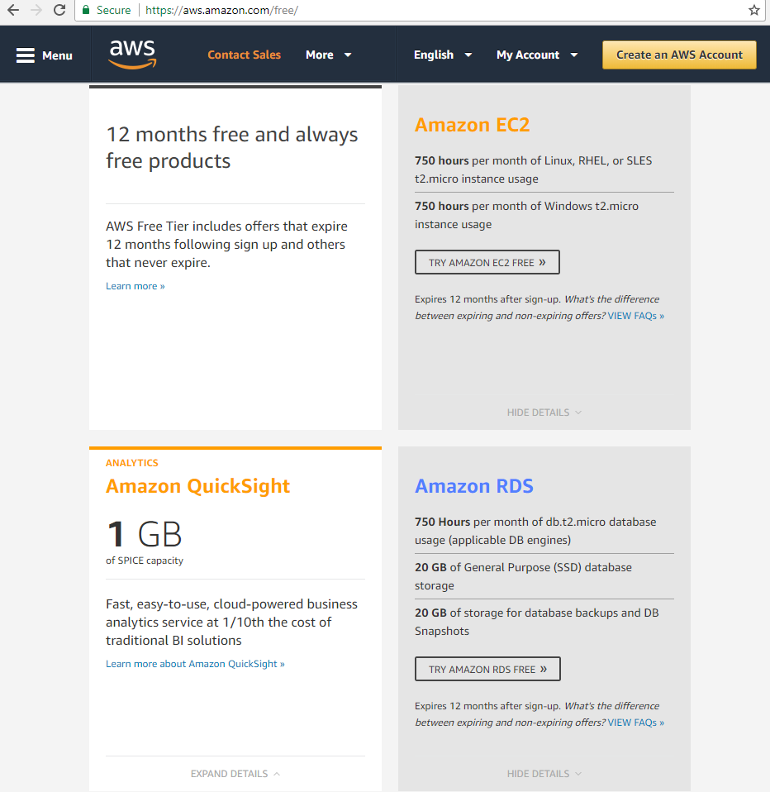[1]
If a business was to invest time in developing their own web pages and AWS database they would need developers. Although AWS is pretty intuitive there are quirks and certain knowledge of how to develop backend code to make a database and a webserver run together seamlessly.
AWS allows the customer to pick where there cloud server is hosted. With locations ranging from Ohio (cost effective and allows more requests to a database for free) to Northern Virginia (more expensive but has functions that Ohio does not). When considering what server to implement your companies cloud service I would take a look at the Northern Virginia cluster. Within AWS only the Northern Virginia cluster and Ireland allow SMTP giving a customer the ability to send emails.
One of the main ways to get AWS out too more people who could use it would be developing college courses that could tackle some of the dynamics of the developing a system using AWS. After working with creating a system it seems that this could be service could be used for clubs here at Radford all the way down to someone selling custom t-shirts from their dorm room. One of the ways to push the acceptance and knowledge of a product is teaching students how to use it and let it spread from the classroom out into the business world.

Approach
In order to host begin hosting and using any service within AWS you must first sign up through https://aws.amazon.com/. Doing so will require a working email address and a valid credit card. This is after your free 12 month trial if your system is using over what is considered in the free tier this credit card will be charged. Looking back to the first image if your business or organization will be using more data than 1million queries to your database you may want to see if a paid version of AWS would be beneficial to you.
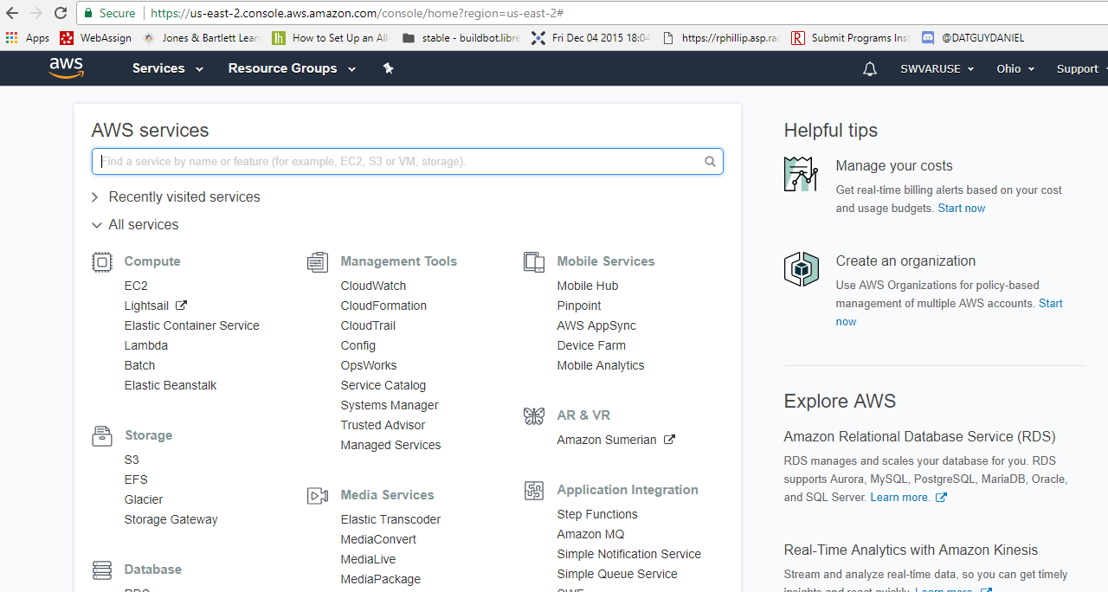[2]
This is the list of available resources to use for a developer. The ability to use server such as EC2, relation databases, Media services, and even game development; allows a wide variety of applications. For a small business I would recommend using EC2 running Linux to host your webpages and any other scripts you may need to collect information from customers.
With most businesses or organizations we need ways to store data and also ways to interpret and organize data so that it is manageable. Using a relation database or RDS in this console screen is what I would suggest people to try out. You can implement any sort of database. Since we are looking at cost saving MySQL is open sourced and was free to use and download and easy to learn. Other databases such as Oracle may provide more functionally but also are much more expensive.
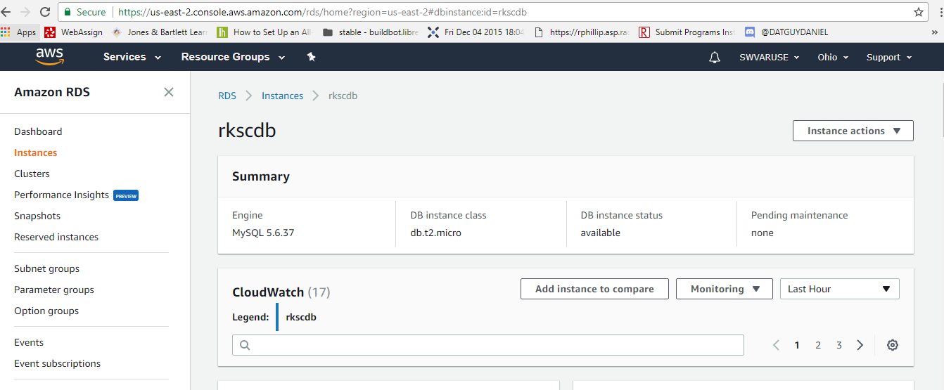
Creating a database can be easily made following an AWS white page tutorial. Just by creating this instance holding your database won’t allow you to create tables and update your database. Downloading some sort of workbench in order to access your database. Amazon provides great info and ways to get the correct information to connect to your database. Providing a hostname, username and a key that you will use as your password to verify who is trying to connect. MySQL Workbench for our project was seamless developing our tables and overall database. Throughout development using this application can help debug and verify other components of your application are working correctly.
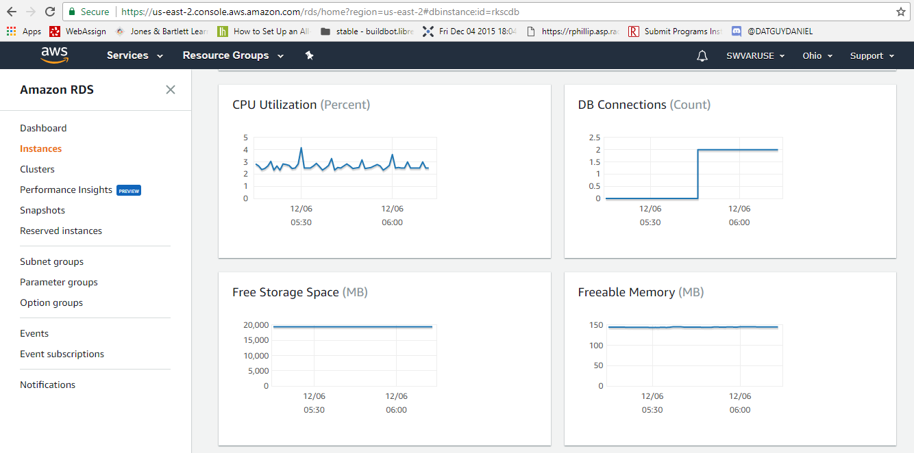
You will also have graphs showing how much your database is in use and overtime how much writing and editing is occurring. One aspect for a business that we weren’t able to replicate in our project was the delete of data deemed to irrelevant from the database over time. This would need to be determined on an each individual situation.
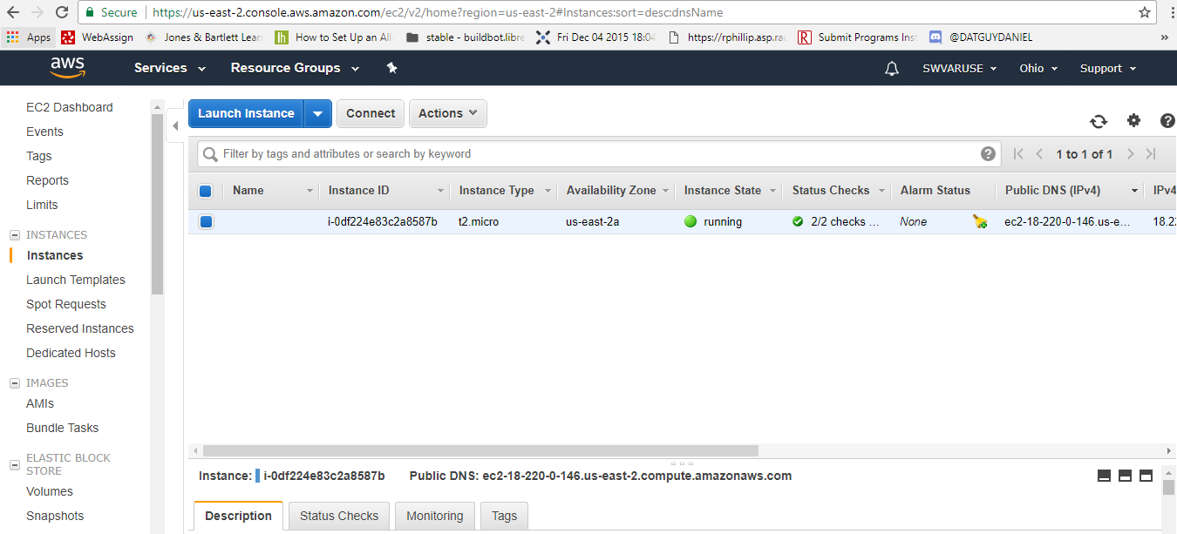
I recommend studying and deciding what kind of server will cover your needs. I only recommend EC2 because that is what my project required and using a Linux based server was great when implementing code. Pyhton scripts may be necessary if you need to pull information from another website or when you are trying to send out emails. You can use this EC2 instance to host any of your webpages when they are connected to the database with php you can host data from you database. This can be useful to display products images, prices, descriptions, and pretty much anything that can be displayed to the user. The limits to what you can develop are basically how much time and effort do you want to put into creating your website?
Some may question why not just sell your items through Amazon retail or eBay? The purpose of this representation is to save as much money as possible for a business and save profit. With both of those services you must pay to either sell items on their application or pay a percentage of the profit from a sell. Another question as to why to create your own application instead of using one already proven? The answer would be to cut out the middle man and have control over your content and what you can sell. This comes with more responsibility, but can be justified by the flexibility you have to display products on your own pages.
On Amazon retail or other pages your product would be competing against tons of other products. Realistically people are more inclined to go for the cheaper item available. When a company can control the content they are able to set the price instead of being dictated the price of their product or service based on others.
While AWS and Amazon retail likely have a lot of the same security you can rest easy that your application has a level of security on par with big business.
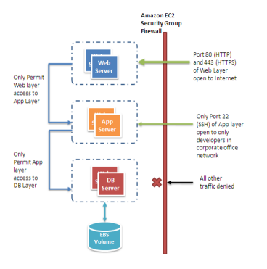[3]
AWS allows the use of security groups so you can block access the EC2 instance from outside sources and only allow IP ranges you deem safe. As the image shows people can still hit your webpages and webserver from the internet and you can set who has access to the application level. Security groups can also be set from AWS Database.
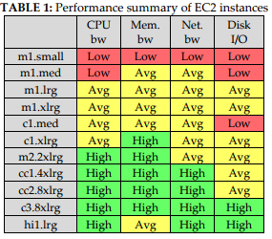[4]
The previous table was created after a study on how Amazon Web Services could be used for scientific applications. The Institute of Technology in Illinois was trying to determine how cost effective using AWS could be for huge scientific problems and studies.
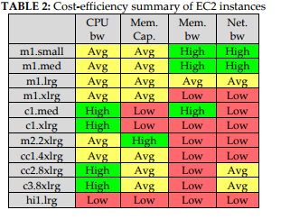[4]
This table shows the cost efficiency summary. Comparing the two tables together you get great value for the smaller level instances. The instance used for the free tier the micro would be all green because it’s totally free.
The great thing about EC2 is that you can host really professional websites if you have the developers to create them. EC2 works with Ruby on Rails which is used by various companies now for their own websites. For my personal project we had to work with an API to get data from another website that would populate that data into our database. Since you can run Linux on your EC2 instance CRON jobs can be used to execute scripts at certain business hours throughout the day. If you were a small stock broker your website could pull information from the stock ticker and host that on your website running a script like this. You might be surprised to learn that website such as Netflix, Reddit, ETSY, and even LinkedIn.[5] So lots of large multinational companies employ the services of AWS and that same service can be available to new small businesses. Personally that blows my mind, why would anyone want to pay to have their business websites hosted when you can create your own and essentially do it for free? With Amazon taking care of maintaining the cloud services stay running there is a lot of stress and responsibility taken off the small business.

Existing Research issues
The Institute of Technology in Illinois conducted a research project on the potential cloud computing for scientific applications. They set were set up with the same EC2 instance as my project and would test each tier including those that are priced to use. In their paper they have detailed specs on how each instance from the smallest a t1.micro runs compared to the largest and most expensive the c3.8xlarge. For scientific use varies greatly from my proposed use of AWS for small business. It is inevitable when running a business that at a certain time your website or database won’t be getting hit for information or requests. In this study they want to test the benchmarks for these instances and how they handle constant use. The tests show the wide ability of theses cloud platforms and how clusters together while costing a good chunk of money can help with data processing.
The study also focused on a cost analysis of how products are used. I think one way to improve on their study is to specifically focus on the smaller clusters and test them more thoroughly. How does a t1.micro handle constant requests for data? If 100 people are on your website at once can it handle multiple requests for the same webpage? This test is one I didn’t manage to study if our system for our project could handle multiple users on the same webpage updating information at once.
Another study completed by Ruhr University in Germany focused on the security aspects of AWS. The study showed that in 2011 Amazon had deployed security for SOAP message passing that had conceptual flaws and was vulnerable.[5] It was discovered that some arguments in SOAP authentication were not covered. This was discovered in 2011 and I am unable to find any documentation that suggests this issue was ever patched.
[5]
As shown in the diagram the body of SOAP message could be manipulated and then sent on its way to AWS with the malicious code intact. Another security flaw in SOAP authentication was that a timestamp could be faked and inserted into a message.

Future Research issues
More in depth research about how small businesses operate and value owning their own infrastructure would be vital to determine if this concept would work. A study or poll done on whether businesses would be open to the idea of hosting their own webpages and being able to update content on demand rather than using an expensive service would be determined. As stated in section three the idea of testing a large number of users trying to access your web server at once never occurred to me. The research could be done with an existing web server hosted by Amazon Web Services and could use actual Amazon EC2 instances requesting data from a single source. This would either show vulnerability to lend credence to the fact that EC2’s can handle large numbers of requests at once.
Another research topic could be on the cost effectiveness of hosting your own physical servers on site at a business. Lots of businesses currently follow this model. They can house their own servers on site and manage their database onsite as well. One benefit of this is knowing when an outage may occur with your site. With AWS if an outage occurs it would affect a multitude of users but really you have no control if a cluster goes down. With housing the physical servers you could implement safety measures such as generators to ensure your server won’t go down. This idea would work for those with very critical products and can’t afford to be offline. The business does assume more responsibility in this case they most buy servers and also manage them if they crash. With this setup in order to back up your data and move it to an offset storage facility which itself would cost money to use. Lots of companies follow this system and it works for them. From my prospective in our changing world we want someone else to manage the data and make sure that the system is running properly. Most of the time business people don’t want to know the inner workings and cost involved with maintaining their own servers and database. In my opinion this is why AWS would be beneficial to many business that don’t want the stress of having backup generators or calling in a technician if a disk fails on a Saturday.
Research and studies performed by business focused students may be necessary to determine what kind of business this solution could help. Well established business may not want to rely on a third party to watch after their data. This may be only viable for very small businesses or upstarts that are looking to push their idea into the market place. One reason why I believe this could be beneficial is the ease of use and long list of documentation provided. In one semester, someone who is not a gifted programmer, can develop a backend system for a local group that manages group member information, group events, members who register for events, and has login capabilities for admins. Now imagine a team of three or four skilled programmers developing websites with very efficient backend to process orders for someone who takes professional photographs. The idea is their but knocking out the concrete cost benefit analysis for each individual company would need to be completed.

Conclusion
This paper research topic was originally going to be about the security of Amazon Web Services. After completing my project in my other class I realized the application for this AWS idea was everywhere. The ease of use struck me as one of the most important aspects of helping a small business grow. We see in the news daily that sales have risen with online shopping and how consumers now want the ease of access of going to a website and getting all of their Christmas shopping done in one sitting. With Amazon Web Services if you have a small profitable local business, you have the ability to reach a large number of consumers that were previously only accessible by spending a good amount of money for someone to host your website.

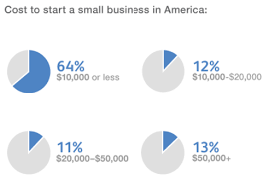[6]
FitSmallBusiness.com graph shows the kind of capital many small businesses are working with. 64% of these upstarts are beginning with $10,000 or less of capital. When attempting to generate profitability it is likely that spending money on tangible product to sell would be the first major cost to a business. Using AWS to have a website available day 1 could be mean the difference in survival. In business being first to market sometimes means that your company must act quickly to change products or meet consumer concerns. Having Amazon managing your data and hosting your websites you can dynamically make changes when issues arise.

References

- Amazon AWS Free, Amazon Web Services, [online] 2017, https://aws.amazon.com/free/ (Accesed: 2 December 2017)
- Amazon EC2 Instance Types, Amazon Web Services, [online] 2017, “Could not enter Url due to project security” (Accesed: 2 December 2017)
- Amazon Web Services, “Web Application Hosting in the AWS Cloud”, AWS [online] 2017, https://d0.awsstatic.com/whitepapers/aws-web-hosting-best-practices.pdf( Accesed: 2 December 2017)
- Iman Sadooghi, Jesús Hernández Martin, Tonglin Li, Kevin Brandstatter, Ketan Maheshwari, Tiago Pais Pitta de Lacerda Ruivo, Gabriele Garzoglio, Steven Timm,Yong Zhao, Ioan Raicu, “Understanding the Performance and Potential of Cloud Computing for Scientific Applications” DataSys Lab Illinios Intsitute of Technologoy, IEEE, 2015.
- David Gewirtz, 15 sites you know, that you may not know are based on Amazon Web Services, [online] 2014, http://www.zdnet.com/article/15-sites-you-know-that-you-may-not-know-are-based-on-amazon-web-services/ (Accesed: 2 December 2017)
- Thorsten Schreiber “Amazon Web Services Security” Ruhr Universty at Bochum, 2011
- Fit Small Business, 30 Insightful Small Business Statistics, [online] 2017, (Accesed: 2 December 2017)

