**Cloud Competing**

AKLILU KAHASY*, IEEE*

***Abstract* – This paper start by introducing Cloud Competing to the reader. In the introduction, the paper indicate what Cloud Competing means and the purpose they serve. After the introduction, the paper will give the reader information about the different types of Cloud Competing and security. The paper goes to explain in more details about Cloud Competing including the purposes and the background of Cloud Competing.**

***Index Terms*—** **cloud computing, *Hesitation to adopt cloud*, *Cloud competing benefits,******Cloud Computing Models, Common Cloud Service Models, Security and privacy issues, Possible solutions.***

1. INTRODUCTION

T

his topic is highly advanced and very helpful for anyone who would like to be educate him or herself with networking technology. First let’s start by defining what Cloud competing networking? The best definition I found, according to webopedia.com author Vangie Beal wrote, “Cloud computing is a type of computing that relies on sharing computing resources rather than having local servers or personal devices to handle applications.” Cloud competing networking enables us to share different files from one computer to another without the physical data transfer disk (flash drive, CDs, hard drives). The file will be stored online in the internet and the person can be able to share or download in any different computer. According to webopedia.com author Vangie Beal wrote, “In cloud computing, the word cloud (also phrased as "the cloud") is used as a metaphor for "the Internet," so the phrase cloud computing means "a type of Internet-based computing," where different services — such as servers, storage and applications — are delivered to an organization's computers and devices through the Internet. The cloud infrastructure is maintained by the cloud provider, not the individual cloud customer.”

The IT foundation for cloud services consists of a growing list of technologies. Infrastructure systems (e.g., servers, storage, networks) enables cloud services. It can economically scale to very high volumes, and preferably do so in a granular fashion. This application software provides web-based UIs, web services APIs, multi-tenant architecture and riches variety of configuration options. Application development and deployment software that supports the developments integration or runtime execution of cloud application. Cloud computing has several deployment models, which are Private, Public Community, Hybrid and Partner. Software System and application management software that supports rapid self-service provisioning and configuration, usage monitoring, etc. For all of the above, pricing agreements for cloud services providers that scale technology costs with their cloud services volumes/revenues. Of course, in addition to supporting the unique IT requirements of cloud services, cloud computing offerings must also support the perennial “must haves” of enterprise IT environments, including: manageability, reliability, availability, security and price-competitiveness. “Reference [1]”

Provides a precise definition of cloud computing, more accurate and unambiguous. In its "The NIST Definition of Cloud Computing" document

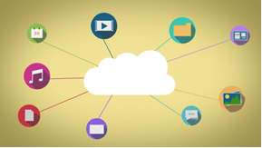

The image above showed how devices and how each device connected with each other.

1. CLOUD COMPUTING

Cloud computing is a model for enabling ubiquitous, convenient, on-demand network access to a shared pool of configurable computing resources (e.g., networks, servers, storage, applications, and services) that can be rapidly provisioned and released with minimal management effort or service provider Interaction. This cloud model is composed of five essential characteristics, three service models, and four deployment models.

1. *Hesitation to adopt cloud*

A consumer can singularly arrange computing capabilities, like server time and network storage, as needed automatically without requiring human interaction with each service provider. Capabilities are available over the network and accessed through standard mechanisms that promote use by heterogeneous thin or thick client platforms (e.g., mobile phones, tablets, laptops, and workstations). The provider’s computing resources are pooled to serve multiple consumers using a multi-tenant model, with different physical and virtual resources dynamically assigned and reassigned according to consumer demand. There is a sense of location independence in that the customer generally has no control or knowledge over the exact location of the provided resources but may be able to specify location at a higher level of abstraction (e.g., country, state, or datacenter). Examples of resources include storage, processing, memory, and network bandwidth.

Capabilities can be elastically provisioned and released, in some cases automatically, to scale rapidly outward and inward commensurate with demand. To the consumer, the capabilities available for provisioning often appear to be unlimited and can be appropriated in any quantity at any time. Cloud systems automatically control and optimize resource by leveraging a metering capability at some level of abstraction appropriate to the type of service (e.g., storage, processing, bandwidth, and active user accounts). Resource usage can be monitored, controlled, and reported, providing transparency for both the provider and consumer of the utilized service.

Cloud computing is the delivery of on-demand computing resources “There are at least three distinct deployment models for computing clouds Public, Private and Hybrid (NIST defines 4 because it establishes Community Cloud as another service but that distinction is not usually made) as well as three different service models usually offered by providers: Infrastructure as a Service (IaaS), Platform as a Service (PaaS) and Software as a Service (SaaS). Cloud Computing Models:

1. *Cloud Computing Models*

Figure 1 and Figure 2

### *Public clouds*

Public clouds are owned and operated by companies that use them to offer rapid access to affordable computing resources to other organizations or individuals. With public cloud services, users don’t need to purchase hardware, software or supporting infrastructure, which is owned and managed by providers.

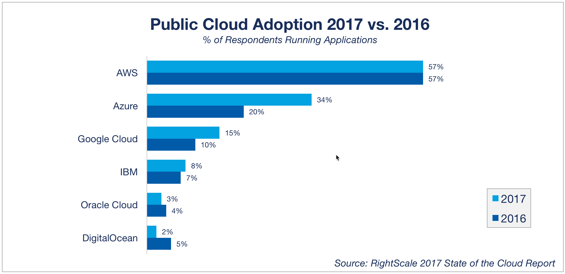

### *Private clouds*

A private cloud is owned and operated by a single company that controls the way virtualized resources and automated services are customized and used by various lines of business and constituent groups. Private clouds exist to take advantage of many of cloud’s efficiencies, while providing more control of resources and steering clear of multi-tenancy.

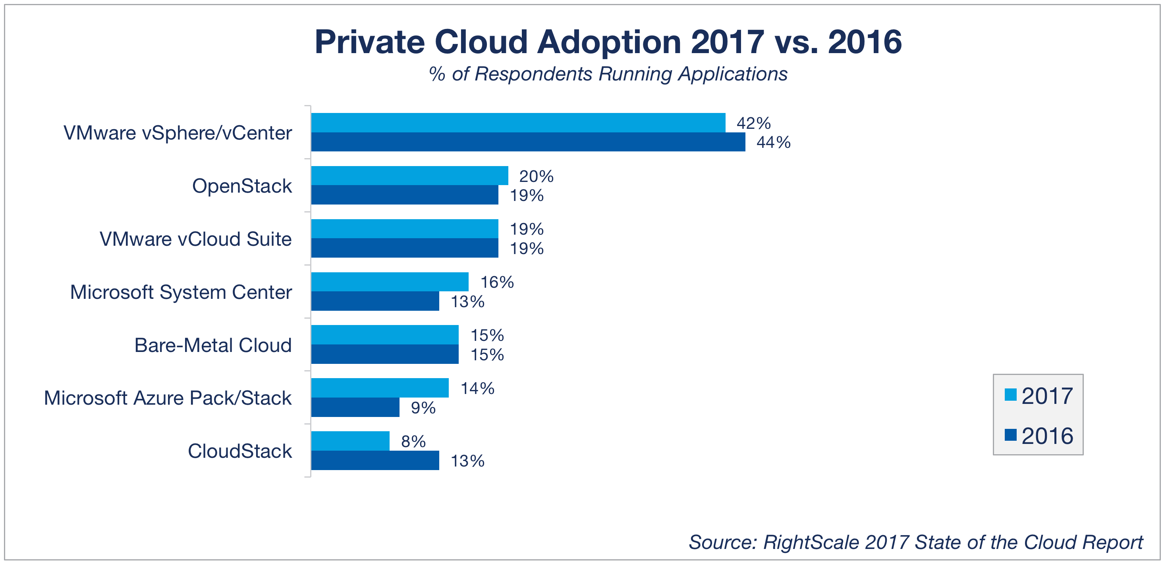

### *Hybrid cloud*

A hybrid cloud uses a private cloud foundation combined with the strategic use of public cloud services. The reality is a private cloud can’t exist in isolation from the rest of a company’s IT resources and the public cloud. Most companies with private clouds will evolve to manage workloads across data centers, private clouds and public clouds—thereby creating hybrid clouds.

## Common Cloud Service Models

Cloud services are typically deployed based on the end-user (business) requirements. The primary services include the following:

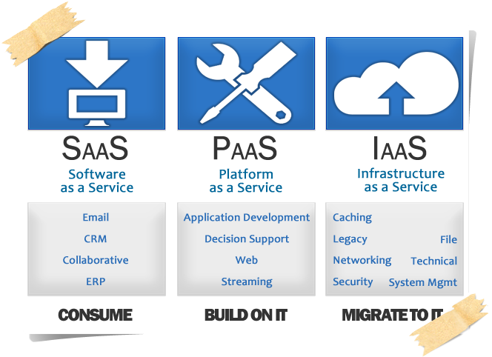

### Software as a Service (SaaS)

A software delivery method that provides access to software and its functions remotely as a Web-based service. Software as a Service allows organizations to access business functionality at a cost typically less than paying for licensed applications since SaaS pricing is based on a monthly fee.

### Platform as a Service (PaaS)

A computing platform being delivered as a service. Here the platform is outsourced in place of a company or data center purchasing and managing their own hardware and software layers.

### Infrastructure as a Service (IaaS)

A computer infrastructure, such as virtualization, being delivered as a service. IaaS is popular in the data center where software and servers are purchased as a fully outsourced service and usually billed on usage and how much of the resource is used

## *What are Cloud competing benefits?*

What are Cloud competing benefits: According to ieeexplore.ieee.org “Cloud computing materializes the vision of utility computing? Tenants can benefit from on-demand provisioning of compute, storage, and networking resources according to a pay-per-use business model.”

Another benefit of cloud competing is through this technology it’s easier and faster to transfer different files. For example, if someone is using hard drives like flash drives, or CDs to transfer files from computer A to computer B, he or she risk of getting different unwanted viruses. If computer A is infected by different viruses and transferred file from it to different computer, the virus will be included in the file and could damage our personal data as well as the computer system. Another benefit of cloud competing is the time; it takes few seconds to share our files in cloud of the internet. This makes us highly productive and get things done fast compared to the old way of sharing files with hard drives. It will take longer time to share files using different drives and sometimes the files we share won’t be able to work due to the software availabilities in the other computer. According to webopedia.com author Vangie Beal wrote, “Cloud computing uses networks of large groups of servers typically running low-cost consumer PC technology with specialized connections to

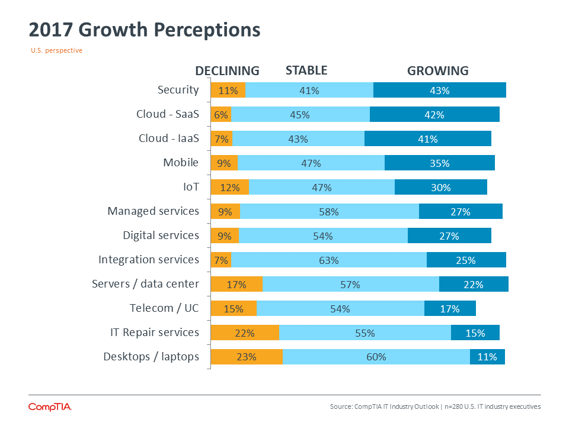

According [comptia.org](https://www.comptia.org/resources/it-industry-trends-analysis-2017) this graph how fast growth.

Another example is through cloud computing networking many big and small companies are benefiting largely. They share their product online using cloud computing technology and everyone who is interested to make purchase he or she will be required to make some amount of payment. This gives company owners new way to make some extra money as well as saving them time and energy. Furthermore, also the consumer market is benefit because of this technology they can make any kinds of purchasing while they are home. In the past it requires to move to different shopping places to make any kinds of purchase and require to be physically presented. However, that is changed now because the cloud computing technology. According to <http://ieeexplore.ieee.org>, “Cloud computing materializes the vision of utility computing. Tenants can benefit from on-demand provisioning of compute, storage, and networking resources according to a pay-per-use business model.”

1. SECURITY AND PRIVACY ISSUES

When using any computer system, security and privacy issues are always a concern, especially when the data belongs to a business entity and may have critical business information involved, such as customer’s info, financial info, etc. On cloud computing people can have several categories for these issues. In this paper I will focus only on the following: Infrastructure Security, Data Security and Storage, Identity Management Systems and finally Privacy.

1. *Infrastructure Security*

Infrastructure as a service provides companies with computing resources including servers, networking, storage, and data center space on a pay-per-use basis. Platform as a service provides a cloud-based environment with everything required to support the complete lifecycle of building and delivering web-based (cloud) applications—without the cost and complexity of buying and managing the underlying hardware, software, provisioning and hosting. Cloud-based applications—or software as a service (SaaS) run on distant computers “in the cloud” that are owned and operated by others and that connect to users’ computers via the Internet and, usually, a web browser. Reference [2]

1. *Hesitate to use cloud*

There are many reasons why anyone would hesitate before basing their infrastructure or core business on cloud computing. Some of them belong to the technical field, others are business oriented reasons and some concern both fields. Some of the reasons may be There is a risk of lock-in. Since much of the technology available is proprietary and cloud implementation depends on the provider, there's always the risk of developing infrastructure using a provider and then find yourself looking into its technology. People become dependent on the cloud computing provider for the IT resources, then could be exposed to outages and other service interruptions and can do nothing to fix them. Since it uses the Internet, Cloud Computing may not be suitable for applications that require low latency. You find yourself not in control of costs if subscription prices go up in the future. This is especially worrying when you have a technological lucking because migrating to another provider may not be simple or possible at all. Data privacy issues could arise, if your cloud provider seeks to monetize the data in their system. Reference [4]

Security is largely immature, and currently requires specialized expertise. Especially since the lack of knowledge in cloud computing technologies may pose great security risks. Public clouds are, by definition, shared resources, and this slows down changes. If there is a service issue or structural limitation, you could have to wait a long time before your vendor can solve the problem. Reference [3].

# *POSSIBLE SOLUTIONS*

## *Minimize lack of Trust:*

Trust is a complex concept for which it will don’t have the exact accepted definition. There are two kind of trust security solutions which are hard security- oriented and soft trust (non- security oriented trust). Hard trust is including like technology based the people who has a knowledge in technologies. It involves authenticity, encryption, and security in transactions. The soft trust is different from hard trust it more focusing on human psychology, brand name (the loyalty of the brand how much is popular), and the user friendless.

Most people have difficult trusting issues on online services than off-line services. Because in our century everything is change to digital instead of physical services so they will not have full trust on this digital world. But there are many possible solutions ways to trust on-line cloud computing the first thing is build our mind by saying online cloud computing is very testing by many software developers. Increasing security trust to increase trust comes from people being more willing to engage in e-commerce if they are assured that their credit card numbers and personal data are cryptographically protected. Since we are on the transition of cloud computing we must have a trust on off-line technologies in our mind.

## *Avoid Lack of Training and Expertise:*

Especiallyon this generation companies hire employees without giving enough tanning. On the transition of hiring employees if the person doesn’t have much knowledge and experience on cloud computing it can occur an attack on the cloud data. In addition, people, may have lack of understanding about privacy impacts of decision they make. Hence, unless proper management procedures are in place, there is a danger that employees could switch to using cloud computing services without adequately considering the consequences and risks for that particular situation.

The New York college student teaming up with Security Company and trying to test the security of cloud environment professionalism with curriculums, depend on the college information they ben working on black ridge for a while.

This institution gears Black Ridge’s First Packet Authentication technology, security gateways that, according to the company, conceal network applications from port scans, network "reconnaissance” and imposition while still allowing authorized and authenticated users to access network applications.

Bill Thirsk, Marist's CIO and vice president of IT, in a prepared statement Say “"Until now, we have spent most of our time protecting the castle from anyone who would approach and try to kick down the door and access secured data,"

"With the Black Ridge solution set, the intruder is not able to see the castle beside stop them from using secure network segment, no approach and no breach. The way the school tested the security software is starting from internal network and after that jump to across the college academic community cloud. That computing platform is built on multiple IBM z systems and runs about a thousand virtual machines at a time to support research, production and educational services for itself and other schools, both higher education and K-12.

Marist College and black ridge technology work partnership to develop an advanced cybersecurity, this can help a lots of industry’s like financial sectors and private clod providers etc.

# CONCLUSION

The benefit of the cloud computing technology is highly beneficial for everyone. Thanks to the technology our life has been involving and changing for the better. From sharing computer files in fastest and safest way to making shopping and sharing different information with our seller in couple of seconds. However, through the years the technology is still changing, and many new features are being added to it. For example, according to ieeexplore.ieee.org, “Cloud computing technology is still evolving. Various companies, standards bodies, and alliances are addressing several remaining gaps and concerns. Some of these concerns are: What are the challenges behind the virtual networking in IaaS deployment? What are the potential solutions using the existing technologies for the implementation of virtual networks inside the IaaS vision? Is there any room to utilize innovative paradigms like software-defined networking (SDN) [2] to address virtual networking challenges? When cloud federation (or even cloud bursting) is involved, should the servers in the cloud be on the same layer 2 network as the servers in the enterprise, or should a layer 3 topology be involved because the cloud servers are on a network outside the enterprise? In addition, how would this approach work across multiple cloud data centers?”

# REFERENCES

1. B. Han, V. Gopalakrishnan, L. Ji and S. Lee, "Network function virtualization: Challenges and opportunities for innovations," in *IEEE Communications Magazine*, vol. 53, no. 2, pp. 90-97, Feb. 2015.
2. Beal, Vangie. “Cloud Computing.” *What Is Cloud Computing?* Webopedia Definition, 2017, www.webopedia.com/TERM/C/cloud_computing.html.
3. “Cloud Computing : SPI model (SaaS, PaaS, IaaS) – Part 17.” Just a random "*Microsoft Server / Client Tech*" info.., 11 Oct. 2013,
4. M. Drozdova, S. Rusnak, P. Segec, J. Uramova and M. Moravcik, "Contribution to cloud computing security architecture," 2017 15th *International Conference on Emerging eLearning Technologies and Applications (ICETA)*, Stary Smokovec, 2017, pp. 1-6.
5. CEPIS Electronic Publication: Cloud Computing Security and Privacy Issues:
6. Frank Gens, “Defining “Cloud Services” and “Cloud Computing” September 23rd, 2008. *(references)*
7. IBM Electronic Publication: What is cloud computing:
8. Sara Angeles,“8 Reasons to Fear Cloud Computing” October 01, 2013. *(references)*
9. S. Azodolmolky, P. Wieder and R. Yahyapour, "Cloud computing networking: challenges and opportunities for innovations," in *IEEE Communications Magazine,* vol. 51, no. 7, pp. 54-62, July 2013.