http://www.ufv.ca/Assets/Computer+Information+Systems/Icons/Cisco+Networking+Academy+at+UFV+-+Mind+Wide+Open.gif

**Academy Support Center (ASC)**

***NEWS LETTER***

***July 2014***

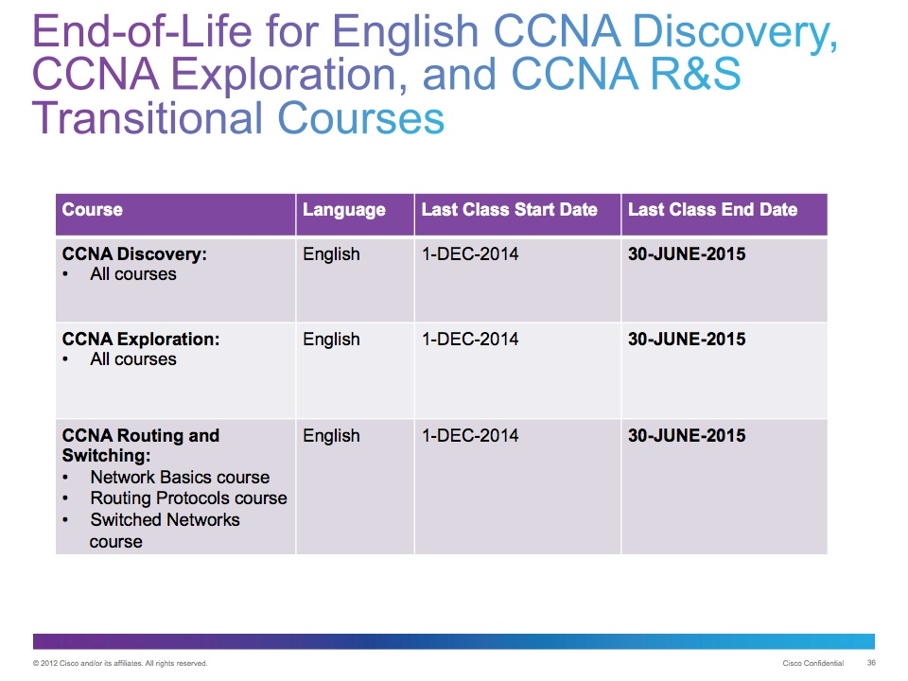

***As back to school and the 2014 Fall Semester comes this announcement should support your transition from Exploration to the new CCNA Routing & Switching course. Please note that the first two courses of CCNA Routing & Switching have more content and will extend your in class duration. Adjust your schedules as required.***