With 2018 heading off to a great start, the company would like to make hardware upgrades throughout the business. Three new servers, a new firewall, switch, router, network service, emergency power supply unit, and desktop accessories are all needed. The two budgets we will be working with is one for $10,000 and the other for $20,000.

The $10,000 included many powerful components. The server chosen for this project was the PowerEdge R230 Rack Server. The reasoning behind this decision is due to the fact its processor is the Intel Xeon E3-1240 v5 Quad-core 3.50 GHz and comes with 8GB of DDR4 RAM. The switch used in this build is the Netgear 24-port Gigabit Smart managed Pro Switch purely due to the number of ports. The router chosen for this build is the Cisco RV345 Dual Wan Gigabit VPN router due to it having 16 ports, 2 WAN ports, and 900 Mbps TCP throughput for improved productivity. The firewall used in this build is the Cisco ASA 5505 Security Plus due to the fact is supports up to 25 IPsec VPN peers and two premium VPN peers. The business also requires internet service, so we decided to go with Google Fiber to get one Gigabit per second. The setup needs to be online for at least 22 hours a day, so an emergency power supply system, The APC Smart-UPS C 1500VA RM 2U 120V, was purchased. Finally, the setup is complete with the purchase of three Dell 20|p2018H monitors with a 5ms response time. The final build totaled at $9,942.62 and coming under budget by a margin of $57.38.

The $20,000 server build had power in mind. The server chosen, Cisco B200 M5 Blade, has a heavy upgrade on the previous build. The server can support up to 80 Gbps of I/O throughput. The server also includes up to 24GB DDR4 of RAM as well as 2 GPUs. The switch component did not change for this server. The router used was the Cisco 1941 Wireless Router, allowing for 16 encrypted wireless VLANs. The firewall device used is the Cisco ASA5510 Model. This device is amazing allowing up to 150Mbps of throughput and up to 25 SSL VPN Peer licenses. Network services remain the same with Google Fiber as our number one choice. The emergency supply system, APC Smart UPS C 1500VA RM 2U, will allow us to maintain our goal of 22 hours a day online time. Finally, with the purchase of three Dell U2417H monitors, our setup is complete. Having three monitors will increase productivity drastically. The final build totaled at $21,553.96 and coming over budget by a margin of $1,553.96.

The $10,000 setup successfully meets the budget goal with a little money to spare. The $20,000 build unfortunately did not meet the budget. I would personally recommend the $10,000 setup because it has fantastic specs for the price you are paying, and successfully meet our budget goal.

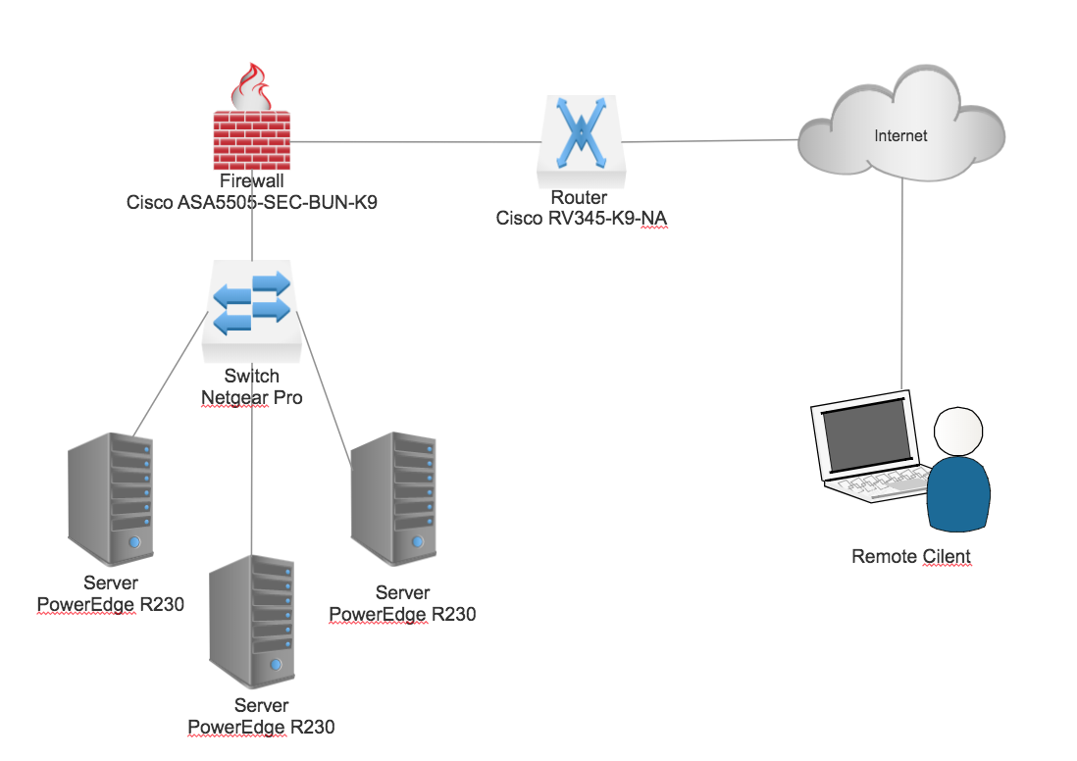**$10K**

**$20K**