****Packet Tracer - Testing Connectivity with Traceroute**** (Answer)

1. Topology
2. 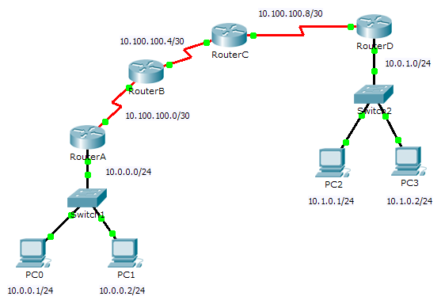
3. Objectives

Part 1: Test End-to-End Connectivity with the tracert Command

Part 2: Compare to the traceroute Command on a Router

1. Background

This activity is designed to help you troubleshoot network connectivity issues using commands to trace the route from source to destination. You are required to examine the output of **tracert** (the Windows command) and **traceroute** (the IOS command) as packets traverse the network and determine the cause of a network issue. After the issue is corrected, use the **tracert** and **traceroute** commands to verify the completion.

1. Test End-to-End Connectivity with the tracert Command
   1. Send a ping from one end of the network to the other end.

Click **PC1** and open the **Command Prompt**. Ping **PC3** at **10.1.0.2**. What message is displayed as a result of the ping? Destination host unreachable

* 1. Trace the route from PC1 to determine where in the path connectivity fails.
     1. From the **Command Prompt** of **PC1**, enter the **tracert 10.1.0.2** command.
     2. When you receive the **Request timed out** message, press **Ctrl**+**C**. What was the first IP address listed in the **tracert** output? 10.0.0.254—the gateway address of the PC
     3. Observe the results of the **tracert** command. What is the last address reached with the **tracert** command? 10.100.100.6
  2. Correct the network problem.
     1. Compare the last address reached with the **tracert** command with the network addresses listed on the topology. The furthest device from the host 10.0.0.2 with an address in the network range found is the point of failure. What devices have addresses configured for the network where the failure occurred? RouterC and RouterD
     2. Click **RouterC** and then the **CLI** tab.
     3. What is the status of the interfaces? They appear to be up and active.
     4. Compare the IP addresses on the interfaces with the network addresses on the topology. Does there appear to be anything extraordinary? The Serial 0/0/0 interface has an incorrect IP address based on the topology.
     5. Make the necessary changes to restore connectivity; however, do not change the subnets. What is solution? Change the IP address on S0/0/0 to 10.100.100.9/30
  3. Verify that end-to-end connectivity is established.
     1. From the **PC1 Command Prompt**, enter the **tracert 10.1.0.2** command.
     2. Observe the output from the **tracert** command. Was the command successful? Yes

1. Compare to the traceroute Command on a Router
   * 1. Click **RouterA** and then the **CLI** tab.
     2. Enter the **traceroute 10.1.0.2** command. Did the command complete successfully? Yes
     3. Compare the output from the router **traceroute** command with the PC **tracert** command. What is noticeably different about the list of addresses returned? The router has one less IP address because it will be using RouterB as the next device along the path.

Suggested Scoring Rubric

|  |  |  |  |
| --- | --- | --- | --- |
| Activity Section | Question Location | Possible Points | Earned Points |
| Part 1: Test End-to-End Connectivity with the **tracert** Command | Step 1 | 10 |  |
| Step 2b | 10 |  |
| Step 2c | 10 |  |
| Step 3a | 10 |  |
| Step 3c | 10 |  |
| Step 3d | 10 |  |
| Step 3e | 10 |  |
| Step 4b | 10 |  |
| **Part 1 Total** | | **80** |  |
| Part 2: Compare to the **traceroute** Command on a Router | a | 10 |  |
| b | 10 |  |
| **Part 2 Total** | | **20** |  |
| **Total Score** | | **100** |  |