OR CHAPTER 8.5 SOLUTIONS

1. min z = 4x₁₂ + 3x₂₄ + 2x₄₆ +3x₁₃ + 3x₃₅ + 2x₂₅ + 2x₅₆
st x₁₂ + x₁₃ = 1 (node 1 constraint)
x₁₂ = x₂₄ + x₂₅ (node 2 constraint)
x₁₃ = x₃₅ (node 3 constraint)
x₂₄ = x₄₆ (node 4 constraint)
x₂₅ = x₅₆ (node 5 constraint)
x₄₆ + x₅₆ = 1 (node 6 constraint)
all x_{ij}≥0
If x_{ij} = 1 the shortest path from node 1 to node 6 will contain arc (i, j) while if x_{ij} = 0 the shortest path from node 1 to node 6 does not contain arc (i, j).

2. Let y_{ij} be the dual variable corresponding to the arc (i, j) constraint. Then the dual to the CPM LP is
max w = 6y₁₃ + 9y₁₂ + 8y₃₅ + 7y₃₄ + 10y₄₅ + 12y₅₆
st -y₁₃ -y₁₂ = -1
y₁₂ - y₂₃ = 0
y₁₃ + y₂₃ - y₃₅ - y₃₄ = 0
y₃₄ - y₄₅ = 0
y₃₅ + y₄₅ - y₅₆ = 0
y₅₆ = 1
all y_{ij}≥0
This LP represents the problem of sending one unit of flow from node 1 to node 6 through a path of maximum length in the project diagram. It is a MCNFP because each variable has a +1 coefficient in a single constraint and a -1 coefficient in a single constraint. By the Dual Theorem, the optimal z-value for the above LP = Length of the critical path. Thus the length of the critical path in a project network is equal to the length of the longest path in the network.

3. Node Net Outflow
Detroit 6500
Dallas 6000
City 1 -5000
City 2 -4000
City 3 -3000
Dummy -500
All arcs from Detroit or Dallas to City 1, 2, or 3 have a capacity of 2200. Other arcs have infinite capacity
Arc Shipping Cost
Detroit-City 1 $2800
Detroit-City 2 $2600
Detroit-City 3 $2300
Detroit-Dummy $0
Dallas-City 1 $2300
Dallas-City 2 $2000
Dallas-City 3 $2000
Dallas-Dummy $0

4a. All arcs have infinite capacity
Arc Shipping Cost
Bos-Chic 800 + 80 = $880
Bos-Austin 800 + 220 = $1,020
Bos-LA 800 + 280 = $1,080
Ral-Chic 900 + 100 = $1,000
Ral-Aus 900 + 140 = $1,040
Ral-LA 900 + 170 = $1,070
Chic-Aus $40
Chic-LA $50
Problem is balanced so no Dummy Point is needed
City Net Outflow
Boston 400
Raleigh 300
Chicago 0
LA -400
Austin -300

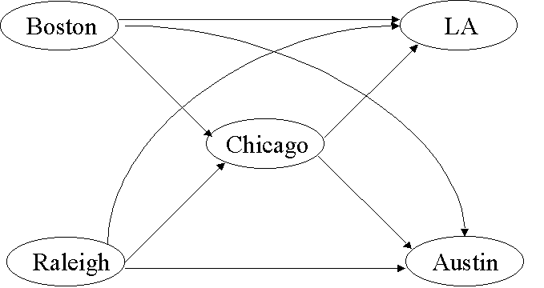

4b. If at most 200 units can be shipped through Chicago, we must add a node Chicago'. Delete the Raleigh-Chicago and Boston- Chicago arcs and insert the following arcs

Arc Shipping Cost Arc Capacity
Boston-Chicago' $880 ∞
Raleigh-Chicago' $1000 ∞
Chicago-Chicago' 0 200

5a. Net Outflow (in Hundred Thousand Barrels/Day)
SD LA Dallas Houston Chic NY Dummy
5 4 0 0 -4 -3 -2
Unit Cost For Each Arc
SD-Dallas:$420
SD-Houston:$100
LA-Dallas:$300
LA-Houston:$110
SD-Dummy:$0
LA-Dummy:$0
Dallas - Chic.: 700 + 550 = $1,250
Dall-NY:700 + 450 = $1,150
Houston - Chic.: 900 + 530 = $1,430
Hous. - N.Y.:900 + 470 = $1,370

5b. Delete arcs leading into Dallas and Houston. Add nodes Dallas' and Houston' to the network. Also add the following arcs:

Arc Shipping Cost Arc Capacity
LA-Dallas' $300 ∞
SD-Dallas' $420 ∞
LA-Houston' $110 ∞
SD-Houston' $100 ∞
Dallas'-Dallas 0 500
Houston'-Houston 0 500

6. The objective function represents firing costs + hiring costs + salary costs. (1) Ensures that at least 20 workers are working during month 1. (2) Ensures that at least 16 workers are working during month 2. (3) Ensures that at least 25 workers are working during month 3.
An LP with constraints (i)-(iv) has the same feasible region as the LP with constraints (1)-(3). To see this observe that any point in the feasible region for (1)-(3) clearly satisfies (i)- (iv). If a point satisfies (i)-(iv), then the point satisfies (1), satisfies, (i) + (ii) = (2), and -(iv) = 3. Thus the two LP's have the same feasible region. The LP with constraints (i)- (iv) has the following constraint matrix.

x₁₂ x₁₃ x₁₄ x₂₃ x₂₄ x₃₄ e₁ e₂ e₃ RHS
---------------------------------------------------
Node 1' 1 1 1 0 0 0 -1 0 0 20
Node 2' -1 0 0 1 1 0 1 -1 0 -4
Node 3' 0 -1 0 -1 0 1 0 1 -1 9
Node 4' 0 0 -1 0 -1 -1 0 0 1 -25
----------------------------------------------------
Each variable has a +1 coefficient in a single constraint and a -1 coefficient in a single constraint, so these constraints are the flow balance equations for the network in the figure. The variable e₁ represents "flow" from node 2' to node 1', the variable e₂ represents flow from node 3' to node 2' and the variable e₃ represents flow from node 4' to node 3'. All arcs have infinite capacity. Shipping costs are as follows:
Arc Shipping Cost Arc Shipping Cost
1'-2' 50 + 100 + 140 4'-3' 0
1'-3' 50 + 100 + 280 3'-2' 0
1'-4' 100 + 420 2'-1' 0
2'-3' 50 + 100 + 140
2'-4' 100 + 280
3'-4' 100 + 140

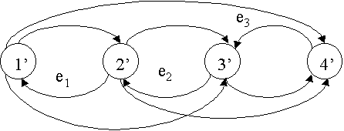

7. See Figure

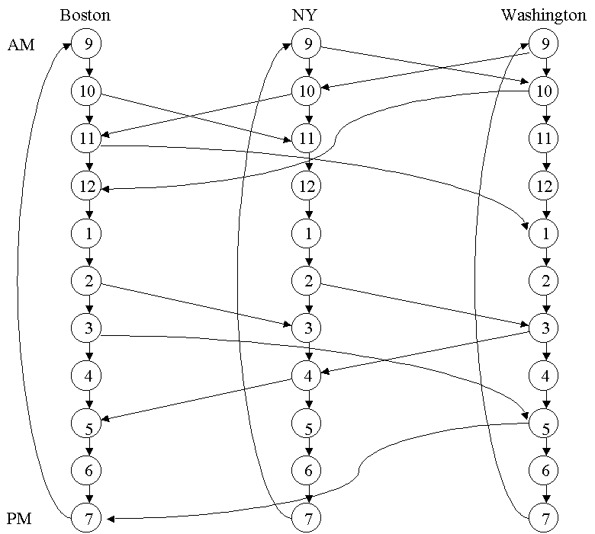

8. The network requires the following nodes:
Monday Tuesday Wednesday Thursday Friday
Phil Phil Phil Phil Phil
NY NY NY NY NY
Wash Wash Wash Wash Wash

Six arcs emanate from each node, indicating whether the truck is loaded or empty and where the truck will be tomorrow. For example, from the Monday Philadelphia node we have the following six arcs: P = Philadelphia N = New York W = Washington M = Monday, T = Tuesday, etc.
Cost of Arc
MP-TP(loaded) $700
MP-TP(empty) $400
MP-TW(loaded) $1000
MP-TW(empty) $800
MP-TN(loaded) $1000
MP-TN(empty) $800
Arcs which correspond to fulfilling a shipping requirement are handled by making the arc have lower bound = upper bound = requirement. Thus MP-TN(loaded) has upper bound = lower bound = 2. All other arcs have a lower bound of 0 and upper bound of ∞. Arcs are needed from Friday nodes to Monday nodes(six arcs leave each Friday node). Each node has a net outflow of 0.

