OR CHAPTER 8.3 SOLUTIONS

1. max z = x₀
s.t. x_{so,1}≤6, x_{so,2}≤2 x₁₂≤1, x₃₂≤3, x₁₃≤3, x_{3,si}≤2, x₂₄≤7, x_{4,si}≤7
x₀ = x_{so,1} + x_{so,2} (Node so)
x_{so,1} = x₁₃ + x₁₂ (Node 1)
x₁₂ + x₃₂ + x_{s0,2} = x₂₄ (Node 2)
x₁₃ = x₃₂ + x_{3,si} (Node 3)
x₂₄ = x_{4,si} (Node 4)
x_{3,si} + x_{4,si} = x₀ (Node si)
All variables ≥0
Initial flow of 0 in each arc. Begin by labeling sink via path of forward arcs (so, 1) - (1, 3) - (3, 2) - (2, 4) - (4, si). Increase flow in each of these feasible arcs by 3, yielding the following feasible flow:

Arc Flow
so-1 3
so-2 0
1-3 3
1-2 0
2-4 3
3-si 0
3-2 3
4-si 3
Flow to sink 3

Now label sink by (so-2) - (2-4), (4, si). Each arc is a forward arc and we can increase flow in each arc by 2. This yields the following feasible flow:
Arc Flow
so-1 3
so-2 2
1-3 3
1-2 0
2-4 5
3-si 0
3-2 3
4-si 5
Flow to sink 5
Now label sink by (so-1) - (1, 2) - (3, 2) - (3, si). All arcs on this path are forward arcs except for (3, 2), which is a backwards arc. We can increase the flow on each forward arc by 1 and decrease the flow on each backward arc by 1. This yields the following feasible flow:
Arc Flow
so-1 4
so-2 2
1-3 3
1-2 1
2-4 5
3-si 1
3-2 2
4-si 5
Flow to sink 6

The sink cannot be labeled, so we found the maximum flow of 6 units. The minimum cut is obtained from V' = {3, 2, 4, si}. This cut consists of arcs (1, 3), (1, 2), (so, 2) and has capacity of 3 + 1 + 2 = 6 = maximum flow.

2. max z = x₀
s. t. x_{so,1}≤2, x₁₂≤4, x_{1,si}≤3,x_{2,si}≤2, x₂₃≤1,x_{3,si}≤2,x_{so,3}≤1
x₀ = x_{so,1} + x_{so,3} (Node so)
x_{so,1} = x_{1,si} + x₁₂ (Node 1)
x₁₂ = x₂₃ + x_{2,si} (Node 2)
x₂₃ + x_{so,3} = x_{3,si} (Node 3)
x_{1,si} + x_{2,si} + x_{3,si} = x₀ (Node si)
All variables ≥0

We begin with a flow of 0 through each arc. Label the sink by (so, 1)-(1, 2)-(2, 3)-(3, si). We can increase the flow on each of these arcs by one unit, obtaining the following feasible flow:

 |  | Arc | Flow
 |  | (so,1) | 1
 |  | (so,3) | 0
 |  | (1,2) | 1
 |  | (1,si) | 0
 |  | (2,3) | 1
 |  | (2,si) | 0
 |  | (3,si) | 1
 |  | Flow to Sink | 1

We next label the sink by (so, 1)-(1, 2)-(2, si) and increase the flow in each of these arcs by 1 unit. We obtain the following feasible flow:

 |  | Arc | Flow
 |  | (so,1) | 2
 |  | (so,3) | 0
 |  | (1,2) | 2
 |  | (1,si) | 0
 |  | (2,3) | 1
 |  | (2,si) | 1
 |  | (3,si) | 1
 |  | Flow to Sink | 2

Now we label the sink by (so, 3)-(3, si), and increase the flow in each of these arcs by 1 unit. We obtain the following feasible flow:

 |  | Arc | Flow
 |  | (so,1) | 2
 |  | (so,3) | 1
 |  | (1,2) | 2
 |  | (1,si) | 0
 |  | (2,3) | 1
 |  | (2,si) | 1
 |  | (3,si) | 2
 |  | Flow to sink | 3
Now the sink cannot be labeled, so we have obtained a maximal flow. V' = {1, 2, 3, si} yields the minimal cut (arcs (so, 1) and (so, 3)) with a capacity of 2+1=3 = maximal flow.

3. max z = x₀
s.t. x_{so,1}≤1, x_{so,2}≤3, x₁₃≤4, x₁₂≤3, x_{3, si} ≤1, x_{2,si} ≤2
x₀ = x_{so,1} + x_{so,2} (Node so)
x_{so,1} = x₁₃ + x₁₂ (Node 1)
x₁₂ + x_{so,2} = x_{2,si} (Node 2)
x₁₃ = x_{3,si} (Node 3)
x_{3,si} + x_{2,si} = x₀ (Node si)
All variables ≥0

We begin with a flow of 0 through each arc and label the sink by (so-2)-(2-si). We increase the flow in each of these arcs by 2 units. This yields the following feasible flow.
 |  | so-1 | 0
 |  | so-2 | 2
 |  | 1-2 | 0
 |  | 1-3 | 0
 |  | 2-si | 2
 |  | 3-si | 0
 |  | Flow to Sink | 2

Now label the sink by the chain (so, 1)-(1, 3)-(3, si) and increase the flow in each of these arcs by 1 unit. This yields the following feasible flow:

 |  | so-1 | 1
 |  | so-2 | 2
 |  | 1-2 | 0
 |  | 1-3 | 1
 |  | 2-si | 2
 |  | 3-si | 1
 |  | Flow to Sink | 3

The sink cannot be labeled, so we have obtained a maximal flow. V' = {si} yields the minimal cut (3, si), (2, si) with a capacity of 1+2 = 3 = maximum flow.

4. Maximum flow is 45. Min Cut Set = {1, 3, and si}. Capacity of Cut Set = 20 + 15 + 10 = 45. See Figure.
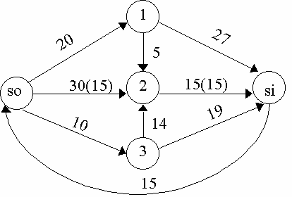

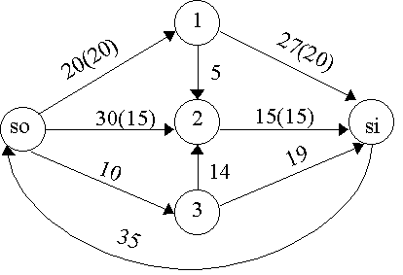

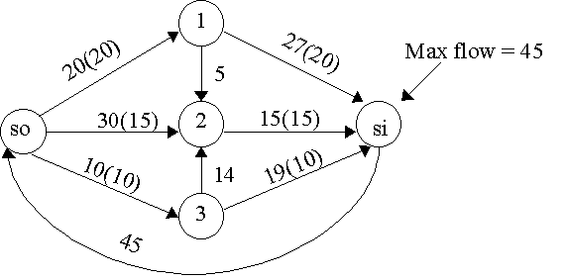

5. Maximum flow = 9. Min Cut Set = {2, 4, si}. Capacity of Cut = 3 + 1 + 3 + 2 = 9. See Figure.
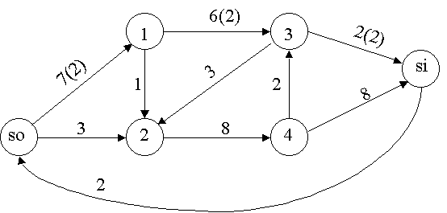

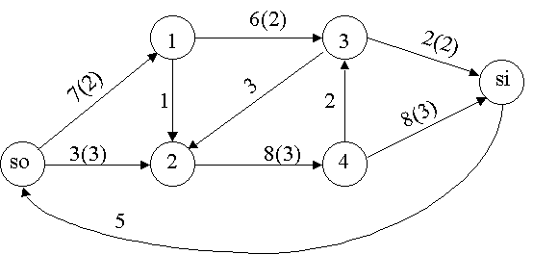
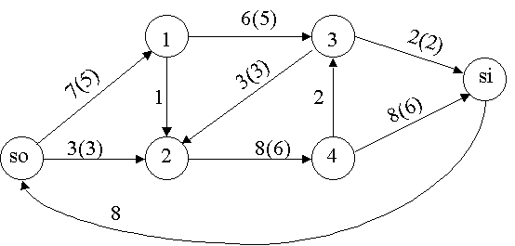
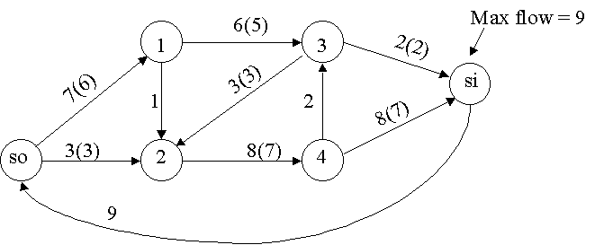

6. See figure. If the maximum flow = 21, then all packages can be loaded.
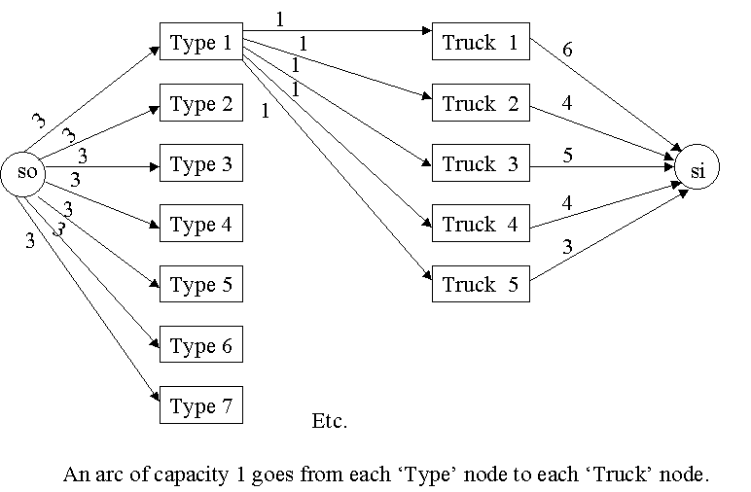

7. See figure.

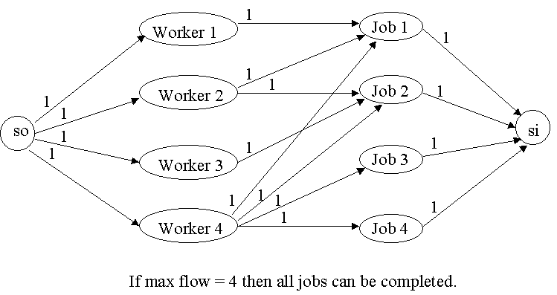

8. See figure.
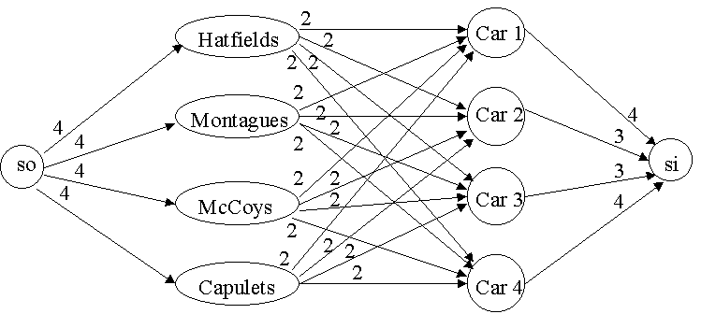

9. Step 1-Add 4 units of flow along so-1-3-si
Step 2-Add 2 units of flow along so-2-4-si
Step 3-Add 1 unit of flow along so-2-4-3-si
Step 4-Add 1 unit along so-2-1-3-si
Cannot label si. Maximum flow = 8 Arcs in cut are 3-si and 4-si with capacity of 8. Flow along each arc is as follows:
Arc Flow
so,1 4
so,2 4
2,1 1
1,3 5
1,4 0
2,4 3
3,si 6
4,3 1
4,si 2

10. Step 1-Add 7 units along so-2-si
Step 2-Add 6 units along so-1-3-si
Step 3 Add 6 units along so-4-si
Cannot label si. Maximal flow = 19. Cut set is derived from V' = {si} and consists of arcs (3, si), (2, si), (4, si) with capacity 6+7+6=19

Arc Flow
so,1 6
so,2 7
so,4 6
1,3 6
2,si 7
3,si 6
4,si 6

11. Suppose maximum flow = k. At each step the flow to the sink increases by an integer amount of at least one unit. Thus at most k iterations of the Ford-Fulkerson method will yield the maximum flow. Also, after each iteration the flow to the sink is an integer, so the optimal flow will be an integer.

12. Construct a "supersource" that has arcs of infinite capacity leading to each real source. Also construct a "supersink' that has infinite capacity arcs leading from each real sink to the supersink.

13. Suppose we know the flow into node i cannot exceed 10 units. Add a new node, node i', to the network. Replace each arc of the form (j,i) in the original network with an arc (j,i') and add an arc (with capacity 10 units) (i',i). This will ensure that at most 10 units flow into node i!

- See figure.

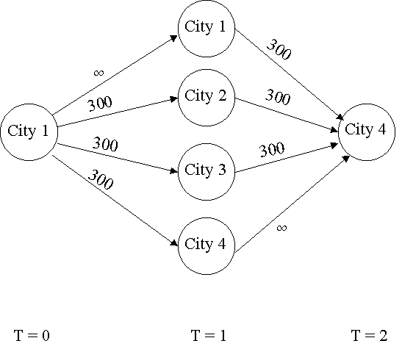

- Let F = a set of flights and CUTF = cut corresponding to the sink, nodes associated with flights not in F, and nodes associated with airports not used by F. Then CUTF consist of arcs from so to nodes for flights not in F and arcs from nodes for airports used by F to si.
Then
Capacity of Cut F = (revenue from flights not in F) + (costs associated with airports used by F).
Therefore
(Profit from F) = (total revenue from all flights) - (capacity of CUTF).
Thus set of flights F' corresponding to CUTF' of minimum capacity will maximize profit. Note that the network contains cuts other than those CUTF cuts corresponding to a set of flights, but all these other cuts have an infinite capacity. Thus the minimal cut must be CUTF' for some set of flights F'. Once the minimal cut is found, the airline knows what set of flights will maximize profit.

- All arcs from month i workers to Project j have a capacity of 6. All projects can be completed if and only if the maximum flow from source to sink equals 30.
