OR CHAPTER 8 SOLUTIONS

SECTION 8.2

1. First label node 1 with a permanent label: [0* 7 12 21 31 44]
Now node 2 receives a permanent label [0* 7* 12 21 31 44].

Node Temporary Label (* denotes next assigned permanent label)
3 min{12,7+7} = 12*
4 min{21,7+12} = 19
5 min{31,7+21} = 28
6 min{44,7+31} = 38
Now labels are [0* 7* 12* 19 28 38]

Node Temporary Label (* denotes next assigned permanent label)
4 min{19,12+7} = 19*
5 min{28,12+12} = 24
6 min{38,12+21} = 33
Now labels are [0* 7* 12* 19* 24 33]

Node Temporary Label (* denotes next assigned permanent label)
5 min{24,19+7} = 24*
6 min{33, 19+12} = 31
Now labels are [0* 7* 12* 19* 24* 31]
Node Temporary Label (* denotes next assigned permanent label)
6 min{31,24+7} = 31
Now labels are [0* 7* 12* 19* 24* 31*]
31 -24 = c₅₆, 24 - 12 = c₃₅, 12 - 0 = c₁₃. Thus 1-3-6 is the shortest path (of length 31) from node 1 to node 6.

2. We begin by permanently labeling node 1 and assigning temporary labels to other nodes: [0* 2 8 ∞ ∞]. Then we give node 2 a permanent label: [0* 2* 8 ∞ ∞]

Node Temporary Label (* denotes next assigned permanent label)
3 min{8,2+5} = 7
4 min{∞, 2+4} = 6*
5 min{∞,2+12} = 14
Now labels are [0* 2* 7 6* 14]

Node Temporary Label (* denotes next assigned permanent label)
3 min{7} = 7*
5 min{14,6+10} = 14
Now labels are [0* 2* 7* 6* 14]. Since there is no node joining the newest permanently labelled node (node 3) to node 5, we may give make node 5 a permanent label. We obtain [0* 2* 7* 6* 14*]. Since c₂₅ = 14 - 2 and c₁₂ = 2 - 0 we find the shortest path from node 1 to 5 to be 1-2-5(length 14).

3.
Node 2 Node 3 Node 4 Node 5 Supply
Node 1
2 | 8 | M | M | 1
0 | 5 | 4 | 12 | 1
M | 0 | 5 | M | 1
M | M | 0 | 10 | 1
1 | 1 | 1 | 1

Node 2

Node 3

Node 4

Demand

4. We begin by giving node 1 a permanent label [0* 2 1 ∞]. Next node 3 obtains a permanent label: [0* 2 1*∞]. Node 4 now obtains a new temporary label of min{∞,1+1} = 2, and node 2 obtains a permanent label yielding [0* 2* 1* 2]. Finally node 4's temporary label becomes permanent and we obtain [0* 2* 1* 2*] which yields the shortest" path 1-3-4. Of course, 1-2-3-4 with length 1 is a shorter path, but we fail to find this because Dijkstra's method assumes that because node 3 is not connected to node 1 by an arc, node 3 cannot be the closest node to node 1.

5. Node 1 = beginning of year 1, Node 7 = end of year 6 or beginning of year 7
c₁₂ = 3300, c₁₃ = 4800, c₁₄ = 7600, c₁₅ = 9800, c₁₆ = 12,400, c₁₇ = 15,600, c₂₃ = 3300, c₂₄ = 4800, c₂₅ = 7600, c₂₆ = 9800, c₂₇ = 12,400, c₃₄ = 3300, c₃₅ = 4800, c₃₆ = 7600, c₃₇ = 9800, c₄₅ = 3300, c₄₆ = 4800, c₄₇ = 7600, c₅₆ = 3300, c₅₇ = 4800, c₆₇ = 3300

We begin by giving node 1 a permanent label [0* 3300 4800 7600 9800 12,400 15,600]. Next we give node 2 a permanent label: [0* 3300* 4800 7600 9800 12,400 15,600]

Node Temporary Label (* denotes next assigned permanent label)
3 min{4800,3300+3300} = 4800*
4 min{7600,4800+3300} = 7600
5 min{9800,7600+3300} = 9800
6 min{12,400,9800+3300} = 12,400
7 min{15,600,12,400+3300} = 15,600
We now make node 3's label permanent and obtain
[0* 3300* 4800* 7600 9800 12,400 15,600].

Node Temporary Label (* denotes next assigned permanent label)
4 min{7600,4800+3300} = 7600*
5 min{9800,4800+4800} = 9600
6 min{12,400,4800+7600} = 12,400
7 min{15,600,4800+ 9800} = 14,600
We now make node 4's label permanent and obtain [0* 3300* 4800* 7600* 9600 12,400 14,600].
Node Temporary Label (* denotes next assigned permanent label)
5 min{9600,7600+3300} = 9600*
6 min{12,400,7600+4800} = 12,400
7 min{14,600,7600+7600} = 14,600

We next give node 5 a permanent label and obtain [0* 3300* 4800* 7600* 9600* 12,400 14,600].
Node Temporary Label (* denotes next assigned permanent label)
6 min{12,400,9600+3300} = 12,400*
7 min{14,600,9600+4800} = 14,400
We now give node 6 a permanent label and obtain [0* 3300* 4800* 7600* 9600* 12,400* 14,400]

Node Temporary Label (* denotes next assigned permanent label)
7 min{14,400,12,400+3300} =14,400
We now make node 7's label permanent obtaining [0* 3300* 4800* 7600* 9600* 12,400* 14,400*]. Since 14,400 - 9600 = c₅₇, 9600 - 4800 = c₃₅, and 4800 - 0 = c₁₃, we find the shortest path from node 1 to node 7 to be 1-3-5-7. Thus car should be kept for a two year period and then sold.

6. Node 1 = beginning of year 1, Node 7 = end of year 6 or beginning of year 7
c₁₂ = 60, c₁₃ = 90, c₁₄ = 130, c₁₅ = 190, c₁₆ = 260 c₂₃ = 60, c₂₄ = 90, c₂₅ = 130, c₂₆ = 190, c₂₇ = 260, c₃₄ = 60, c₃₅ = 90, c₃₆ = 130, c₃₇ = 190, c₄₅ = 60, c₄₆ = 90, c₄₇ = 130, c₅₆ = 60, c₅₇ = 90, c₆₇ = 60

We begin by giving node 1 a permanent label [0* 60 90 130 190 260 ∞]. Next we give node 2 a permanent label: [0* 60* 90 130 190 260 ∞] .

Node Temporary Label (* denotes next assigned permanent label)
3 min{90,60+60} = 90
4 min{130,60+90} = 130
5 min{190,60+130}=190
6 min{260,60+190} = 250
7 min{∞,60+260} = 320
We now make node 3's label permanent and obtain
[0* 60* 90* 130 190 250 320].

Node Temporary Label (* denotes next assigned permanent label)
4 min{130,90+60} = 130*
5 min{190,90+90} = 180
6 min{250,90+130} = 220
7 min{320,90+190} = 280
We now make node 4's label permanent and obtain [0* 60* 90* 130* 180 220 280]

Node Temporary Label (* denotes next assigned permanent label)
5 min{180,130+60} = 180*
6 min{220,130+90} = 220
7 min{280,130+130} = 260
We next give node 5 a permanent label and obtain [0* 60* 90* 130* 180* 220 260]

Node Temporary Label (* denotes next assigned permanent label)
6 min{220,180+60} = 220*
7 min{260,180+90} = 260
We now give node 6 a permanent label and obtain [0* 60* 90* 130* 180* 220* 260]

Node Temporary Label (* denotes next assigned permanent label)
7 min{260,220+60} =260
We now make node 7's label permanent obtaining [0* 60* 90* 130* 180* 220* 260*]. Since 260 - 130 = c₄₇ and 130 - 0 = c₁₄ we find that 1-4-7 yields the shortest path. Thus the phone should always be kept for three years.

7. Let c_{ij} = cost incurred if a machine is purchased at beginning of year i and is kept until beginning of year j. Then we may formulate the problem of minimizing total cost incurred over 5 years as the following transshipment problem:

2 3 4 5 6

1

2 4 5 6
208 | 258  1 | 355 | 537 | 841 | 1
0  1 | 258 | 278 | 375 | 557 | 1
M | 0 | 248 | 298 | 395  1 | 1
M | M | 0  1 | 288 | 388 | 1
M | M | M | 0  1 | 388 | 1

3

4

5

1 1 1 1 1

The optimal tableau above indicates that we should first keep the machine for two years and then trade it in. Then we should keep the new machine for three more years (until problem is over).

8. Let c_{ij} = cost of storing books >i inches and ≤j inches on a single shelf.c₀₄ = 2300 + 200(.5)(4)(5) = $4300
c₀₈ = 2300 + 300(.5)(8)(5) = $8300
c_{0,12} = 2300 + 380(.5)(12)(5) = $13,700
c_{4,8} = 2300 + 100(.5)(5)(8) = $4300
c_{4,12} = 2300 + .5(180)(5)(12) = $7700
c_{8,12} = 2300 + .5(5)(12)(80) = $4700
It is easily found that the shortest path from 0 to 12 is 0- 4-12 (cost of $12,000). Thus a 4" shelf should be built for 4" books, and a 12" shelf is built for 8" and 12" books.

9. For j>i let x_{ij} = 1 if a type i box is used to meet demand for boxes of types i, i+1, ..., j-1 . Then we have a transshipment problem which may be formulated as the following balanced transportation problem (optimal solution is also given); all supplies and demands=1: Note: x_{ii} = 1 means that a type i box is not used.

2 3 4 5 6 7 8
 | 24,100  1 | 40,600 | 63,700 | 70,300 | 83,500 | 90,100
 | 10,000 | 25,000 | 46,000 | 52,000 | 64,000 | 70,000
14,200 | 0 | 14,000  1 | 32,200 | 37,400 | 47,800 | 53,000
0  1 | M | 0 | 17,800  1 | 22,600 | 32,200 | 37,000
M | M | M | 0 | 4800 | 12,400 | 16,200  1
M | M | M | M | 0  1 | 8200 | 11,800
M | M | M | M | M | 0  1 | 4400
1

2

3

4

5

6
7

For example,c₃₆ = 1000 + 26(500+700+200) = $37,400
We find minimum total cost of $72,100 is attained by using a size 33 box for size 33 and 30 demand, a size 26 box for size 26 demand, a size 24 box for size 24 demand, and a size 19 box for the remaining demand.

10. To illustrate we consider Example 2 and set up a transshipment problem whose solution will yield the shortest path from node 1 to all other nodes. We create a node 0 with a net supply of 6 - 1 = 5 units and create an arc (0, 1). We give node 1 a net supply of 0 and nodes 2, 3, 4, 5, 6 a net demand of 1. The optimal solution to this problem will ship a single unit from node 1 to each of nodes 1-6. The single unit shipped from node 1 to node i will be shipped along the shortest path from node 1 to node i; if the single unit shipped from node 1 to node i in the "optimal solution" was not shipped along the shortest path from node 1 to node i, then by transferring this unit to the shortest path from node 1 to node i we would find a better solution to the transshipment problem, thereby contradicting the assumed optimality of our current solution.

SECTION 8.3 SOLUTIONS

1. max z = x₀
s.t. x_{so,1}≤6, x_{so,2}≤2 x₁₂≤1, x₃₂≤3, x₁₃≤3, x_{3,si}≤2, x₂₄≤7, x_{4,si}≤7
x₀ = x_{so,1} + x_{so,2} (Node so)
x_{so,1} = x₁₃ + x₁₂ (Node 1)
x₁₂ + x₃₂ + x_{s0,2} = x₂₄ (Node 2)
x₁₃ = x₃₂ + x_{3,si} (Node 3)
x₂₄ = x_{4,si} (Node 4)
x_{3,si} + x_{4,si} = x₀ (Node si)
All variables ≥0
Initial flow of 0 in each arc. Begin by labeling sink via path of forward arcs (so, 1) - (1, 3) - (3, 2) - (2, 4) - (4, si). Increase flow in each of these feasible arcs by 3, yielding the following feasible flow:

Arc Flow
so-1 3
so-2 0
1-3 3
1-2 0
2-4 3
3-si 0
3-2 3
4-si 3
Flow to sink 3

Now label sink by (so-2) - (2-4), (4, si). Each arc is a forward arc and we can increase flow in each arc by 2. This yields the following feasible flow:
Arc Flow
so-1 3
so-2 2
1-3 3
1-2 0
2-4 5
3-si 0
3-2 3
4-si 5
Flow to sink 5
Now label sink by (so-1) - (1, 2) - (3, 2) - (3, si). All arcs on this path are forward arcs except for (3, 2), which is a backwards arc. We can increase the flow on each forward arc by 1 and decrease the flow on each backward arc by 1. This yields the following feasible flow:
Arc Flow
so-1 4
so-2 2
1-3 3
1-2 1
2-4 5
3-si 1
3-2 2
4-si 5
Flow to sink 6

The sink cannot be labeled, so we found the maximum flow of 6 units. The minimum cut is obtained from V' = {3, 2, 4, si}. This cut consists of arcs (1, 3), (1, 2), (so, 2) and has capacity of 3 + 1 + 2 = 6 = maximum flow.

2. max z = x₀
s. t. x_{so,1}≤2, x₁₂≤4, x_{1,si}≤3,x_{2,si}≤2, x₂₃≤1,x_{3,si}≤2,x_{so,3}≤1
x₀ = x_{so,1} + x_{so,3} (Node so)
x_{so,1} = x_{1,si} + x₁₂ (Node 1)
x₁₂ = x₂₃ + x_{2,si} (Node 2)
x₂₃ + x_{so,3} = x_{3,si} (Node 3)
x_{1,si} + x_{2,si} + x_{3,si} = x₀ (Node si)
All variables ≥0

We begin with a flow of 0 through each arc. Label the sink by (so, 1)-(1, 2)-(2, 3)-(3, si). We can increase the flow on each of these arcs by one unit, obtaining the following feasible flow:

 |  | Arc | Flow
 |  | (so,1) | 1
 |  | (so,3) | 0
 |  | (1,2) | 1
 |  | (1,si) | 0
 |  | (2,3) | 1
 |  | (2,si) | 0
 |  | (3,si) | 1
 |  | Flow to Sink | 1

We next label the sink by (so, 1)-(1, 2)-(2, si) and increase the flow in each of these arcs by 1 unit. We obtain the following feasible flow:

 |  | Arc | Flow
 |  | (so,1) | 2
 |  | (so,3) | 0
 |  | (1,2) | 2
 |  | (1,si) | 0
 |  | (2,3) | 1
 |  | (2,si) | 1
 |  | (3,si) | 1
 |  | Flow to Sink | 2

Now we label the sink by (so, 3)-(3, si), and increase the flow in each of these arcs by 1 unit. We obtain the following feasible flow:

 |  | Arc | Flow
 |  | (so,1) | 2
 |  | (so,3) | 1
 |  | (1,2) | 2
 |  | (1,si) | 0
 |  | (2,3) | 1
 |  | (2,si) | 1
 |  | (3,si) | 2
 |  | Flow to sink | 3
Now the sink cannot be labeled, so we have obtained a maximal flow. V' = {1, 2, 3, si} yields the minimal cut (arcs (so, 1) and (so, 3)) with a capacity of 2+1=3 = maximal flow.

3. max z = x₀
s.t. x_{so,1}≤1, x_{so,2}≤3, x₁₃≤4, x₁₂≤3, x_{3, si} ≤1, x_{2,si} ≤2
x₀ = x_{so,1} + x_{so,2} (Node so)
x_{so,1} = x₁₃ + x₁₂ (Node 1)
x₁₂ + x_{so,2} = x_{2,si} (Node 2)
x₁₃ = x_{3,si} (Node 3)
x_{3,si} + x_{2,si} = x₀ (Node si)
All variables ≥0

We begin with a flow of 0 through each arc and label the sink by (so-2)-(2-si). We increase the flow in each of these arcs by 2 units. This yields the following feasible flow.
 |  | so-1 | 0
 |  | so-2 | 2
 |  | 1-2 | 0
 |  | 1-3 | 0
 |  | 2-si | 2
 |  | 3-si | 0
 |  | Flow to Sink | 2

Now label the sink by the chain (so, 1)-(1, 3)-(3, si) and increase the flow in each of these arcs by 1 unit. This yields the following feasible flow:

 |  | so-1 | 1
 |  | so-2 | 2
 |  | 1-2 | 0
 |  | 1-3 | 1
 |  | 2-si | 2
 |  | 3-si | 1
 |  | Flow to Sink | 3

The sink cannot be labeled, so we have obtained a maximal flow. V' = {si} yields the minimal cut (3, si), (2, si) with a capacity of 1+2 = 3 = maximum flow.

4. Maximum flow is 45. Min Cut Set = {1, 3, and si}. Capacity of Cut Set = 20 + 15 + 10 = 45. See Figure.
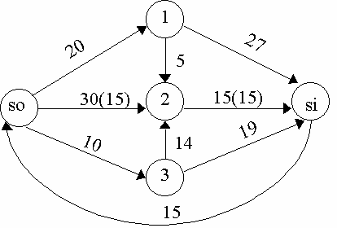

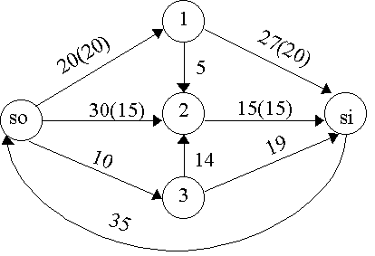

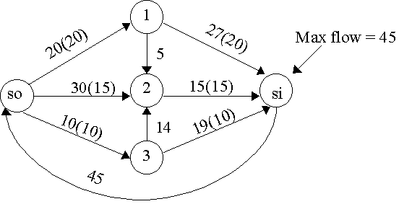

5. Maximum flow = 9. Min Cut Set = {2, 4, si}. Capacity of Cut = 3 + 1 + 3 + 2 = 9. See Figure.
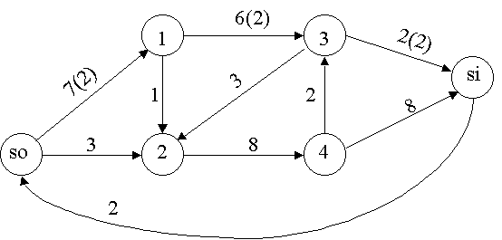

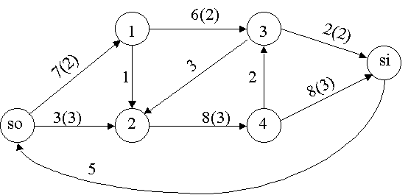
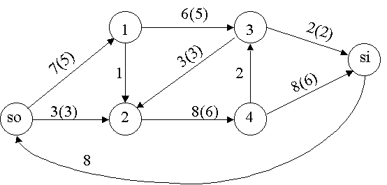
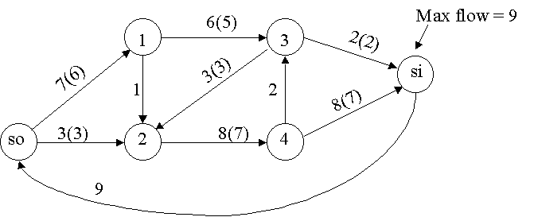

6. See figure. If the maximum flow = 21, then all packages can be loaded.
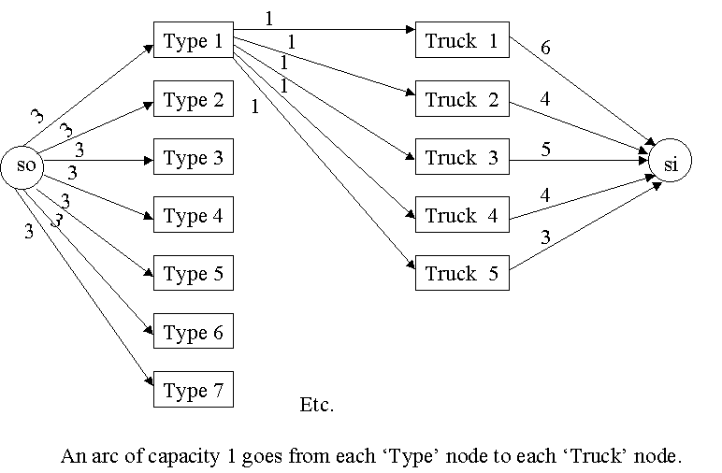

7. See figure.

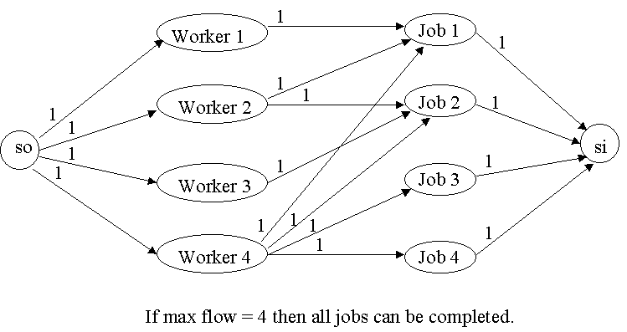

8. See figure.
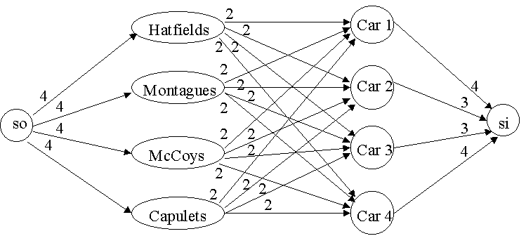

9. Step 1-Add 4 units of flow along so-1-3-si
Step 2-Add 2 units of flow along so-2-4-si
Step 3-Add 1 unit of flow along so-2-4-3-si
Step 4-Add 1 unit along so-2-1-3-si
Cannot label si. Maximum flow = 8 Arcs in cut are 3-si and 4-si with capacity of 8. Flow along each arc is as follows:
Arc Flow
so,1 4
so,2 4
2,1 1
1,3 5
1,4 0
2,4 3
3,si 6
4,3 1
4,si 2

10. Step 1-Add 7 units along so-2-si
Step 2-Add 6 units along so-1-3-si
Step 3 Add 6 units along so-4-si
Cannot label si. Maximal flow = 19. Cut set is derived from V' = {si} and consists of arcs (3, si), (2, si), (4, si) with capacity 6+7+6=19

Arc Flow
so,1 6
so,2 7
so,4 6
1,3 6
2,si 7
3,si 6
4,si 6

11. Suppose maximum flow = k. At each step the flow to the sink increases by an integer amount of at least one unit. Thus at most k iterations of the Ford-Fulkerson method will yield the maximum flow. Also, after each iteration the flow to the sink is an integer, so the optimal flow will be an integer.

12. Construct a "supersource" that has arcs of infinite capacity leading to each real source. Also construct a "supersink' that has infinite capacity arcs leading from each real sink to the supersink.

13. Suppose we know the flow into node i cannot exceed 10 units. Add a new node, node i', to the network. Replace each arc of the form (j,i) in the original network with an arc (j,i') and add an arc (with capacity 10 units) (i',i). This will ensure that at most 10 units flow into node i!

- See figure.

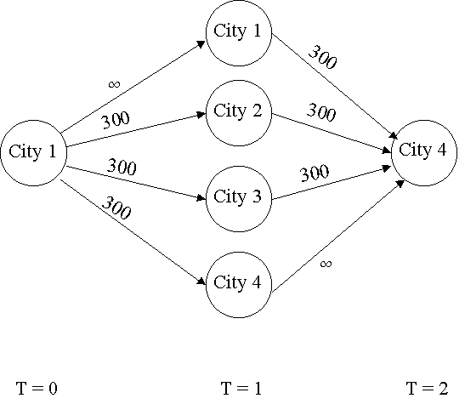
- Let F = a set of flights and CUTF = cut corresponding to the sink, nodes associated with flights not in F, and nodes associated with airports not used by F. Then CUTF consist of arcs from so to nodes for flights not in F and arcs from nodes for airports used by F to si.
Then
Capacity of Cut F = (revenue from flights not in F) + (costs associated with airports used by F).
Therefore
(Profit from F) = (total revenue from all flights) - (capacity of CUTF).
Thus set of flights F' corresponding to CUTF' of minimum capacity will maximize profit. Note that the network contains cuts other than those CUTF cuts corresponding to a set of flights, but all these other cuts have an infinite capacity. Thus the minimal cut must be CUTF' for some set of flights F'. Once the minimal cut is found, the airline knows what set of flights will maximize profit.

- All arcs from month i workers to Project j have a capacity of 6. All projects can be completed if and only if the maximum flow from source to sink equals 30.
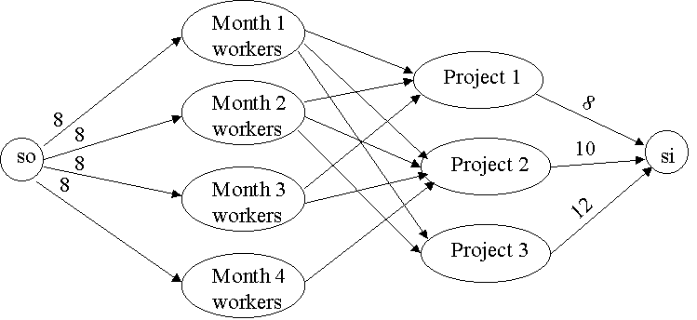

SECTION 8.4

1. We could not determine ET(2) without knowing ET(4). Similarly, we could not determine ET(4) without knowing ET(3). To find ET(3), however, we need to know ET(2). Thus we are in trouble! The reason for this is the arc from a higher numbered node (4) to a lower numbered node (2).

2. | Activity | Predecessors | Duration (wks.)
 | A = Design | - | 5
 | B = Make Part A | A | 4
 | C = Make Part B | A | 5
 | D = Make Part C | A | 3
 | E = Test Part A | B | 2
 | F = Assemble A and B | C,E | 2
 | G = Attach C | D,F | 1
 | H = Test Final Product | G | 1

From the project diagram we find that

ET(1) = 0 | LT(1) = 0 | TF(1,2) = 0 | FF(1,2) = 0
ET(2) = 5 | LT(2) = 5 | TF(2,3) = 0 | FF(2,3) = 0
ET(3) = 9 | LT(3) = 9 | TF(3,4) = 0 | FF(3,4) = 0
ET(4) = 11 | LT(4) = 11 | TF(2,4) = 1 | FF(2,4) = 1
ET(5) = 13 | LT(5) = 13 | TF(4,5) = 0 | FF(4,5) = 0
ET(6) = 14 | LT(6) = 14 | TF(2,5) = 5 | FF(2,5) = 5
ET(7) = 15 | LT(7) = 15 | TF(5,6) = 0 | FF(5,6) = 0
 |  | TF(6,7) = 0 | FF(6,7) = 0
Looking at the activities with TF of 0, we find that the critical path is 1-2-3-4-5-6-7 (length 15 days).
The appropriate LP is
min z = x₇ - x₁
s.t. x₂≥x₁ + 5
x₃≥x₂ + 4
x₄≥x₃ + 2
x₄≥x₂ + 5
x₅≥x₂ + 3
x₅≥x₄ + 2
x₆≥x₅ + 1
x₇≥x₆ + 1
all variables urs
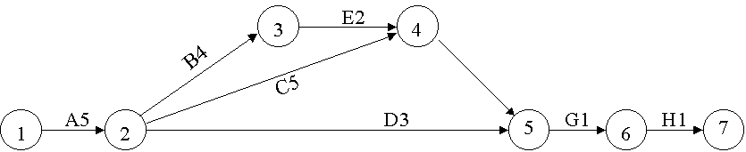

3.In the project diagram we use the mean time for each activity. For each activity's duration we find

 |  | Activity | Mean | Variance
 |  | (1,2) | 6 | 0.44
 |  | (1,3) | 4.33 | 1
 |  | (2,4) | 3.33 | 1
 |  | (3,4) | 9 | 1
 |  | (3,5) | 10 | 2.78
 |  | (3,6) | 12.17 | 3.36
 |  | (4,7) | 8.83 | 1.36
 |  | (5,7) | 2 | 0.11
 |  | (6,8) | 3.33 | 0.44
 |  | (7,9) | 15 | 2.78
 |  | (8,9) | 8.83 | 0.69

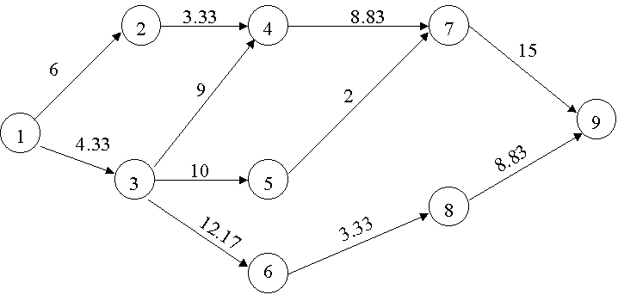

From the project diagram we find that

ET(1) = 0 | LT(1) = 0 | TF(1,2) = 4 | FF(1,2) = 0
ET(2) = 6 | LT(2) = 10 | TF(1,3) = 0 | FF(1,3) = 0
ET(3) = 4.33 | LT(3) = 4.33 | TF(2,4) = 4 | FF(2,4) = 4
ET(4) = 13.33 | LT(4) = 13.33 | TF(3,4) = 0 | FF(3,4) = 0
ET(5) = 14.33 | LT(5) = 20.16 | TF(3,5) = 5.83 | FF(3,5) = 0
ET(6) = 16.5 | LT(6) = 25 | TF(3,6) = 8.5 | FF(3,6) = 0
ET(7) = 22.16 | LT(7) = 22.16 | TF(4,7) = 0 | FF(4,7) = 0
ET(8) = 19.83 | LT(8) = 28.33 | TF(5,7) = 5.83 | FF(5,7) = 5.83
ET(9) = 37.16 | LT(9) = 37.16 | TF(6,8) = 8.5 | FF(6,8) = 0
 |  | TF(7,9) = 0 | FF(7,9) = 0
 |  | TF(8,9) = 8.5 | FF(8,9) = 8.5

We find the critical path to be 1-3-4-7-9 with expected length of the project being 4.33 + 9 + 8.83 + 15 = 37.16 and the variance of the project length being given by 1 + 1 + 1.36 + 2.78 = 6.14.
Since the standard deviation of the length of the critical path is given by 6.14^{1/2} = 2.48 we find that
CP - 37.16 40 - 37.16
P(CP≤40) = P( ≤ ) =
2.48 2.48
= P(Z≤1.15)
= .875 . Alternatively we could find answer in EXCEL with the formula =NORMDIST(40,37.16,2.48,1)= .875.
We can find the critical path from the following LP:
min z = x₉ - x₁
s.t. x₂≥x₁ + 6
x₃≥x₁ + 4.33
x₄≥x₂ + 3.33
x₄≥x₃ + 9
x₅≥x₃ + 10
x₆≥x₃ + 12.17
x₇≥x₄ + 8.83
x₇≥x₅ + 2
x₈≥x₆ + 3.33
x₉≥x₇ + 15
x₉≥x₈ + 8.83
all variables urs

4a. See figure

4b. For the duration of each activity we find that

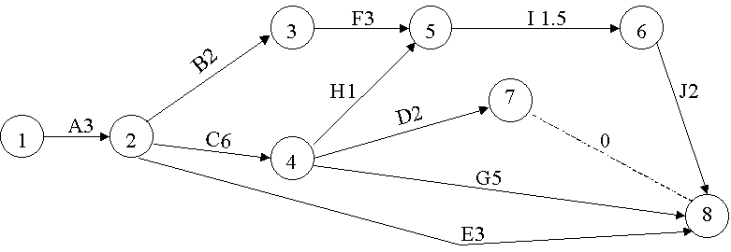

Activity | Mean | Variance
(1,2) | 3 | 0.11
(2,3) | 2 | 0.11
(2,4) | 6 | 1.78
(4,7) | 2 | 0.11
(2,8) | 3 | 0.44
(3,5) | 3 | 0.11
(4,8) | 5 | 0.44
(4,5) | 1 | 0.03
(5,6) | 1.5 | 0.03
(6,8) | 2 | 0.11
(7,8) | 0 | 0.00
()

From the project diagram we find that

ET(1) = 0 | LT(1) = 0 | TF(1,2) = 0 | FF(1,2) = 0
ET(2) = 3 | LT(2) = 3 | TF(2,3) = 2.5 | FF(2,4) = 0
ET(3) = 5 | LT(3) = 7.5 | TF(2,4) = 0 | FF(2,4) = 0
ET(4) = 9 | LT(4) = 9 | TF(4,7) = 3 | FF(4,7) = 0
ET(5) = 10 | LT(5) = 10.5 | TF(2,8) = 8 | FF(4,8) = 0
ET(6) = 11.5 | LT(6) = 12 | TF(3,5) = 2.5 | FF(3,5) = 2.33
ET(7) = 11 | LT(7) = 14 | TF(4,8) = 0 | FF(4,8) = 0
ET(8) = 14 | LT(8) = 14 | TF(4,5) = 0.5 | FF(4,5) = 0
 |  | TF(5,6) = 0.5 | FF(5,6) = 0
 |  | TF(6,8) = 0.5 | FF(6,8) = 0
 |  | TF(7,8) = 2.5 | FF(7,8) = 2.5

The critical path is 1-2-4-8 with expected length 3 + 6 + 5 = 14.

4c. The variance of the critical path is 0.11 + 1.78 + 0.44 = 2.33. Then the standard deviation of the critical path is 2.33^{1/2} = 1.53. Let D = random variable representing duration of the project and d = number such that 99% of the time the project duration is at most d days. Then
P(D≤d) = .99 or

D-14 d-14
P( ≤ ) = .99.
1.53 1.53

We find that F(2.33) = .99. Also we may use NORMINV(.99,14,1.53)= 17.56
d-14
Thus = 2.33 or d = 17.56
1.53

Now if we begin project on June 13 we have 18 days to complete the project. Thus if we begin the project on June 13, there is a 99% chance of completing the project by the end of June 30.

4d.
min z = x₈ - x₁
s.t. x₂≥x₁ + 3
x₃≥x₂ + 2
x₄≥x₂ + 6 x₈≥x₇
x₅≥x₄ + 1
x₅≥x₃ + 3
x₆≥x₅ + 1.5
x₇≥x₄ + 2
x₈≥x₂ + 3
x₈≥x₄ +5
x₈≥x₆ +2
all variables urs

5a.From the project diagram we find that
ET(1) = 0 | LT(1) = 0 | TF(1,2) = 0 | FF(1,2) = 0
ET(2) = 5 | LT(2) = 5 | TF(2,3) = 0 | FF(2,3) = 0
ET(3) = 13 | LT(3) = 13 | TF(3,5) = 0 | FF(3,5) = 0
ET(4) = 17 | LT(4) = 17 | TF(3,6) = 8 | FF(3,6) = 8
ET(5) = 23 | LT(5) = 23 | TF(3,4) = 0 | FF(3,4) = 0
ET(6) = 26 | LT(6) = 26 | TF(4,5) = 0 | FF()4,5 = 0
Both are 1-2-3-5-6 and 1-2-3-4-5-6 are critical paths having length 26 days.

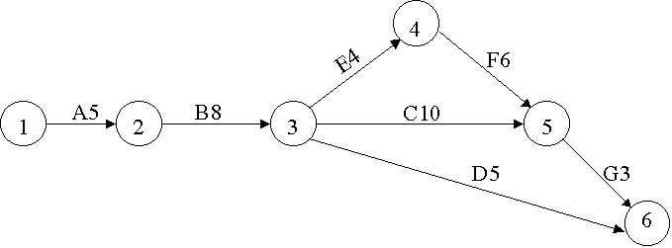

5b. Let A = number of days by which we reduce duration of activity A, etc. and x_{j} = time that event at node j occurs
min z = 30A + 15B + 20C + 40D + 20E + 30F + 40G
A≤2, B≤3, C≤1, D≤2, E≤2, F≤3, G≤1
x₂≥x₁ + 5 - A
x₃≥x₂ + 8 - B
x₄≥x₃ + 4 - E
x₅≥x₃ + 10 - C
x₅≥x₄ + 6 - F
x₆≥x₅ + 3 - G
x₆≥x₃ + 5 - D
x₆ - x₁≤20
A,B,C,D,E,F,G≥0, x_{j} urs

6a. From the project network we find that
ET(1) = 0 LT(1) = 0 TF(1,2) = 0 FF(1,2) = 0
ET(2) = 2 LT(2) = 2 TF(2,3) = 0 FF(2,3) = 0
ET(3) = 6 LT(3) = 6 TF(3,5) = 0 FF(3,5) = 0
ET(4) = 8 LT(4) = 9 TF(3,4) = 1 FF(3,4) = 0
ET(5) = 9 LT(5) = 9 TF(3,6) = 9 FF(3,6) = 9
ET(6) = 19 LT(6) = 19 TF(5,6) = 0 FF(5,6) = 0
TF(4,5) = 1 FF(4,5) = 1

The critical path is 1-2-3-5-6. The length of the critical path is 19 days.

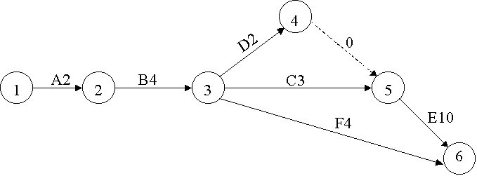

6b. min z = x₆ - x₁
st x₂≥x₁ + 2
x₃≥x₂ + 4
x₄≥x₃ + 2
x₅≥x₃ + 3
x₅≥x₄
x₆≥x₅ + 10
x₆≥x₃ + 4
x_{j} urs

7a. From the project network we find
ET(1) = 0 LT(1) = 0 TF(1,2) = 0 FF(1,2) = 0
ET(2) = 3 LT(2) = 3 TF(2,3) = 0 FF(2,3) = 0
ET(3) = 17 LT(3) = 17 TF(3,4) = 0 FF(3,4) = 0
ET(4) = 25 LT(4) = 25 TF(4,5) = 0 FF(4,5) = 0
ET(5) = 29 LT(5) = 29 TF(2,5) = 20 FF(2,5) = 20
ET(6) = 37 LT(6) = 37 TF(5,6) = 0 FF(5,6) = 0
ET(7) = 46 LT(7) = 46 TF(6,7) = 0 FF(6,7) = 0

The critical path is 1-2-3-4-5-6-7 with a duration of 46 days. The critical path may also be found from the following LP:

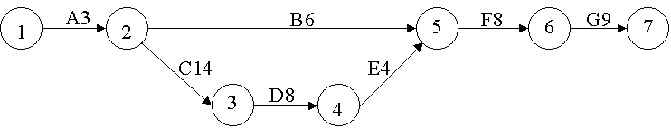

min z = x₇ - x₁
st x₂≥x₁ + 3
x₃≥x₂ + 14
x₄≥x₃ + 8
x₅≥x₄ + 4
x₅≥x₂ + 6
x₆≥x₅ + 8
x₇≥x₆ +9
x_{j} urs

7b. min z = 100A + 80B + 60C + 70D + 30E + 20F + 50G
st A≤3, B≤4, C≤5, D≤2, E≤4, F≤4, G≤4
x₂≥x₁ + 3 - A
x₃≥x₂ + 14 - C
x₄≥x₃ + 8 - D
x₅≥x₄ + 4 - E
x₅≥x₂ + 6 - B
x₆≥x₅ + 8 - F
x₇≥x₆ + 9 - G
x₇ - x₁≤30
A, B, C, D, E, F, G, ≥_0, x_{j} urs

8a. Using the fact that each constraint in the LP represents an arc and the rhs of any constraint is the duration of the activity associated with that arc, we obtain the project network given in the answer to problem 5.

8b. Looking at the rows with dual prices of -1 we find that 1-2- 3-4-5-6 is a critical path, the length of the project is 26 days, and the activities corresponding to arcs (1,2), (2,3), (3,4), (4,5) and (5,6) are critical activities.

9. Since ET(j)≤LT(j) we find that FF(i, j)≤TF(i, j) will hold for any activity.

10. See Figure. Note that without the dummy arc Rule 4 would have been violated.

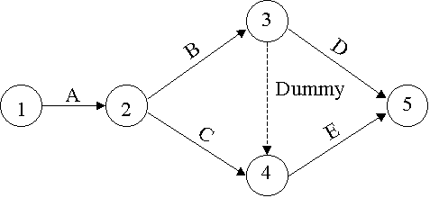

11. Let CD = Duration of path 1-3-4 AB = Duration of path 1-2-4.
For CD there are 9 equally likely outcomes; C may last a time units and D a time units, etc Each of these outcomes has a probability of 1/9.. Thus
P(CD = 12) = 1/9, P(CD = 14) = 3/9, P(CD = 13) = 2/9 P(CD = 15) = 2/9, P(CD = 16) = 1/9.
Similarly, P(AB = 7) = 1/9, P(AB = 11) = 2/9, P(AB = 15) = 3/9, P(AB = 19) = 2/9, P(AB = 23) = 1/9
Now Probability that only 1-2-4 is critical path is given by
P(CD = 12)P(AB>12) + P(CD = 14)P(AB>14) + P(CD = 13)P(AB>13)
+P(CD = 15)P(AB>15) +P(CD = 16)P(AB>16) = (1/9)(6/9) + (3/9)(6/9)
+(2/9)(6/9) + (2/9)(3/9) +(1/9)(3/9) = 15/27.
Probability that both 1-2-4 and 1-3-4 are critical paths is
P(AB = 15)P(CD = 15) = 2/27.
Then the probability that 1-3-4 is the only critical path is
1 - 2/27 - 15/27 = 10/27

12a. See Figure

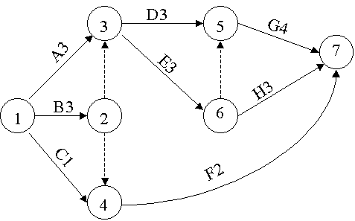

12b. Critical paths are A-D-G, A-E-G, B-D-G, and B-E-G, all having length 10.

13. See figure.
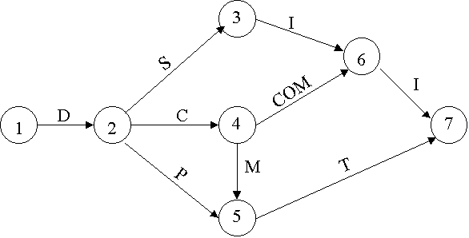

14. MODEL:
1]SETS:
2]NODES/1..6/:TIME;
3]ARCS(NODES,NODES)/
4]1,2 1,3 2,3 3,4 3,5 4,5 5,6/:DUR,CR,LIM,COST;
5]ENDSETS
6]MIN=@SUM(ARCS(I,J):COST(I,J)*CR(I,J));
7]@FOR(ARCS(I,J):TIME(J)>TIME(I)+DUR(I,J)-CR(I,J););
8]TIME(6)-TIME(1)<25;
9]@FOR(ARCS(I,J):CR(I,J)<LIM(I,J););
10]DATA:
11]LIM=5,5,0,5,5,5,5;
12]COST=20,10,0,30,3,40,50;
13]DUR=9,6,0,7,8,10,12;
14]END DATA
END

15. min z = 300A+200B+350C+260D+320E
st A≤5, B≤5, C≤5, D≤5, E≤5,
x₃-x₁≤90,
x₂≥x₁ + 20 - A
x₃≥x₁ + 25 - B
x₄≥x₂ + 50 - C
x₄≥x₃ + 40 - D
x₅≥x₄ + 30 - E
All variables ≥0

16. ET(1) = 0, ET(2) = 2, ET(3) = 8, ET(4) = 6,
ET(5) = Max{ET(3)+4, ET(4)+2} = 12
ET(6) = Max{ET(3)+1, ET(5)+2, ET(4)+1} = 14
LT(6)=14, LT(5) = 12,
LT(4) = Min{LT(5)-2,LT(6)-1} = 10
LT(3) = Min{LT(5)-4,LT(6)-1} = 8
LT(2) = Min{LT(3)-6,LT(4)-4} = 2
LT(1) = LT(2) - 2 = 0
1-2-3-5-6 is critical path(length 14)
Arc TF FF
1,2 2-0-2=0 2-0-2=0
2,3 8-2-6=0 8-2-6=0
2,4 10-2-4=4 6-2-4=0 TF not equal to FF!
3,5 12-8-4=0 12-8-4=0
3,6 14-8-1=5 14-8-1=5
4,5 12-6-2=4 12-6-2=4
4,6 14-6-1=7 14-6-1=7
5,6 14-12-2=0 14-12-2=0

17. ET(1) = 0, ET(2) = 3, ET(3) = 3+3=6, ET(4) = 3+3=6
ET(5) = Max{ET(3)+4 ,ET(2)+4, ET(4)+3} = 10
ET(6) = Max{ET(3)+5 , ET(5)+5} = 15
ET(7) = Max{ET(6)+6, ET(5)+4, ET(4) + 2} = 21
ET(8) = ET(7) + 6 = 27
LT(8) = 27, LT(7) = 27 - 6 = 21, LT(6) = 21 - 6 = 15
LT(5) = Min{LT(7)-4, LT(6)-5} = 10
LT(4) = 10 - 3 = 7
LT(3) = Min{LT(6)-5,LT(5)-4} = 6
LT(2) = Min{LT(5)-4, LT(4)-3, LT(3)-3} = 3
LT(1) = 3 - 3 = 0

Arc TF FF
1,2 3-0-3=0 3-0-3=0
2,3 6-3-3=0 6-3-3=0
2,4 7-3-3=1 6-3-3=0 TF not equal to FF!
2,5 10-3-4=3 10-3-4=3
3,5 10-6-4=0 10-6-4=0
3,6 15-6-5=4 15-6-5=4
4,5 10-6-3=1 10-6-3=1
4,7 21-6-2=13 21-6-2=13
5,6 15-10-5=0 15-10-5=0
5,7 21-10-4=7 21-10-4=7
6,7 21-15-6=0 21-15-6=0
7,8 27-21-6=0 27-21-6=0

Critical Path is 1-2-3-5-6-7-8; length 27.

SECTION 8.5

1. min z = 4x₁₂ + 3x₂₄ + 2x₄₆ +3x₁₃ + 3x₃₅ + 2x₂₅ + 2x₅₆
st x₁₂ + x₁₃ = 1 (node 1 constraint)
x₁₂ = x₂₄ + x₂₅ (node 2 constraint)
x₁₃ = x₃₅ (node 3 constraint)
x₂₄ = x₄₆ (node 4 constraint)
x₂₅ = x₅₆ (node 5 constraint)
x₄₆ + x₅₆ = 1 (node 6 constraint)
all x_{ij}≥0
If x_{ij} = 1 the shortest path from node 1 to node 6 will contain arc (i, j) while if x_{ij} = 0 the shortest path from node 1 to node 6 does not contain arc (i, j).

2. Let y_{ij} be the dual variable corresponding to the arc (i, j) constraint. Then the dual to the CPM LP is
max w = 6y₁₃ + 9y₁₂ + 8y₃₅ + 7y₃₄ + 10y₄₅ + 12y₅₆
st -y₁₃ -y₁₂ = -1
y₁₂ - y₂₃ = 0
y₁₃ + y₂₃ - y₃₅ - y₃₄ = 0
y₃₄ - y₄₅ = 0
y₃₅ + y₄₅ - y₅₆ = 0
y₅₆ = 1
all y_{ij}≥0
This LP represents the problem of sending one unit of flow from node 1 to node 6 through a path of maximum length in the project diagram. It is a MCNFP because each variable has a +1 coefficient in a single constraint and a -1 coefficient in a single constraint. By the Dual Theorem, the optimal z-value for the above LP = Length of the critical path. Thus the length of the critical path in a project network is equal to the length of the longest path in the network.

3. Node Net Outflow
Detroit 6500
Dallas 6000
City 1 -5000
City 2 -4000
City 3 -3000
Dummy -500
All arcs from Detroit or Dallas to City 1, 2, or 3 have a capacity of 2200. Other arcs have infinite capacity
Arc Shipping Cost
Detroit-City 1 $2800
Detroit-City 2 $2600
Detroit-City 3 $2300
Detroit-Dummy $0
Dallas-City 1 $2300
Dallas-City 2 $2000
Dallas-City 3 $2000
Dallas-Dummy $0

4a. All arcs have infinite capacity
Arc Shipping Cost
Bos-Chic 800 + 80 = $880
Bos-Austin 800 + 220 = $1,020
Bos-LA 800 + 280 = $1,080
Ral-Chic 900 + 100 = $1,000
Ral-Aus 900 + 140 = $1,040
Ral-LA 900 + 170 = $1,070
Chic-Aus $40
Chic-LA $50
Problem is balanced so no Dummy Point is needed
City Net Outflow
Boston 400
Raleigh 300
Chicago 0
LA -400
Austin -300
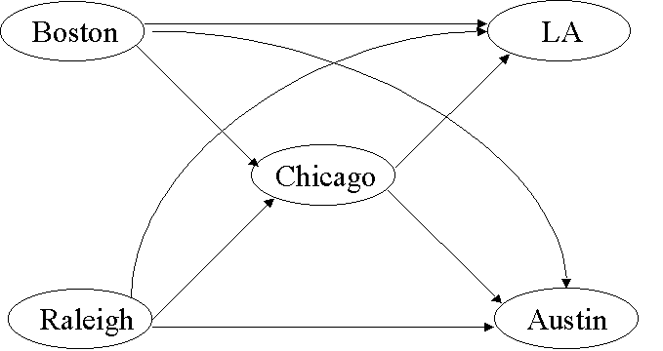

4b. If at most 200 units can be shipped through Chicago, we must add a node Chicago'. Delete the Raleigh-Chicago and Boston- Chicago arcs and insert the following arcs

Arc Shipping Cost Arc Capacity
Boston-Chicago' $880 ∞
Raleigh-Chicago' $1000 ∞
Chicago-Chicago' 0 200

5a. Net Outflow (in Hundred Thousand Barrels/Day)
SD LA Dallas Houston Chic NY Dummy
5 4 0 0 -4 -3 -2
Unit Cost For Each Arc
SD-Dallas:$420
SD-Houston:$100
LA-Dallas:$300
LA-Houston:$110
SD-Dummy:$0
LA-Dummy:$0
Dallas - Chic.: 700 + 550 = $1,250
Dall-NY:700 + 450 = $1,150
Houston - Chic.: 900 + 530 = $1,430
Hous. - N.Y.:900 + 470 = $1,370

5b. Delete arcs leading into Dallas and Houston. Add nodes Dallas' and Houston' to the network. Also add the following arcs:

Arc Shipping Cost Arc Capacity
LA-Dallas' $300 ∞
SD-Dallas' $420 ∞
LA-Houston' $110 ∞
SD-Houston' $100 ∞
Dallas'-Dallas 0 500
Houston'-Houston 0 500

6. The objective function represents firing costs + hiring costs + salary costs. (1) Ensures that at least 20 workers are working during month 1. (2) Ensures that at least 16 workers are working during month 2. (3) Ensures that at least 25 workers are working during month 3.
An LP with constraints (i)-(iv) has the same feasible region as the LP with constraints (1)-(3). To see this observe that any point in the feasible region for (1)-(3) clearly satisfies (i)- (iv). If a point satisfies (i)-(iv), then the point satisfies (1), satisfies, (i) + (ii) = (2), and -(iv) = 3. Thus the two LP's have the same feasible region. The LP with constraints (i)- (iv) has the following constraint matrix.

x₁₂ x₁₃ x₁₄ x₂₃ x₂₄ x₃₄ e₁ e₂ e₃ RHS
---------------------------------------------------
Node 1' 1 1 1 0 0 0 -1 0 0 20
Node 2' -1 0 0 1 1 0 1 -1 0 -4
Node 3' 0 -1 0 -1 0 1 0 1 -1 9
Node 4' 0 0 -1 0 -1 -1 0 0 1 -25
----------------------------------------------------
Each variable has a +1 coefficient in a single constraint and a -1 coefficient in a single constraint, so these constraints are the flow balance equations for the network in the figure. The variable e₁ represents "flow" from node 2' to node 1', the variable e₂ represents flow from node 3' to node 2' and the variable e₃ represents flow from node 4' to node 3'. All arcs have infinite capacity. Shipping costs are as follows:
Arc Shipping Cost Arc Shipping Cost
1'-2' 50 + 100 + 140 4'-3' 0
1'-3' 50 + 100 + 280 3'-2' 0
1'-4' 100 + 420 2'-1' 0
2'-3' 50 + 100 + 140
2'-4' 100 + 280
3'-4' 100 + 140

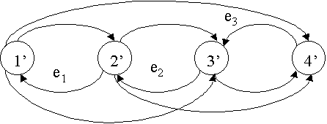

7. See Figure

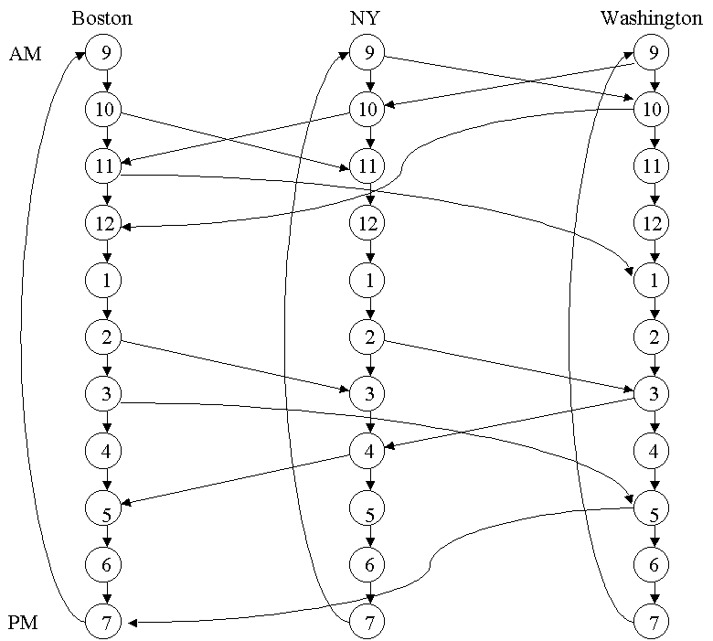

8. The network requires the following nodes:
Monday Tuesday Wednesday Thursday Friday
Phil Phil Phil Phil Phil
NY NY NY NY NY
Wash Wash Wash Wash Wash

Six arcs emanate from each node, indicating whether the truck is loaded or empty and where the truck will be tomorrow. For example, from the Monday Philadelphia node we have the following six arcs: P = Philadelphia N = New York W = Washington M = Monday, T = Tuesday, etc.
Cost of Arc
MP-TP(loaded) $700
MP-TP(empty) $400
MP-TW(loaded) $1000
MP-TW(empty) $800
MP-TN(loaded) $1000
MP-TN(empty) $800
Arcs which correspond to fulfilling a shipping requirement are handled by making the arc have lower bound = upper bound = requirement. Thus MP-TN(loaded) has upper bound = lower bound = 2. All other arcs have a lower bound of 0 and upper bound of ∞. Arcs are needed from Friday nodes to Monday nodes(six arcs leave each Friday node). Each node has a net outflow of 0.

SECTION 8.6

1. We begin at Gary and include the Gary-South Bend arc. Then we add the South Bend-Fort Wayne arc. Next we add the Gary-Terre Haute arc. Finally we add the Terre Haute-Evansville arc. This minimum spanning tree has a total length of 58 + 79 + 164 + 113 = 414 miles.

2. We begin at node 1 with arc (1,3). Then we add (in turn) arcs (3,5), arc (3,4), and arc (3,2). Total length of the tree is 15.

3. If you replace a_{t}' with a_{t} you still have a spanning tree
(this follows because a_{t} connects C_{t-1} to C_{t-1}' so all nodes are
still connected). The spanning tree with a_{t} has a shorter total
length than the spanning tree with a_{t}'. Thus the tree with a_{t}' is
not a minimum spanning tree. This contradiction proves that the algorithm yields a minimum spanning tree.

4a. Clearly MST has length 1+1 = 2.

4b. See Figure. Length of MST is AD+DC+DB=3DC. CDE is a 30-60 right triangle with angle DCE = 30 degrees and angle CDE = 60 degrees. Length CE = .5. Let length DE = x. Then length DC = (.25+x²)^{1/2}. Since sine 30 degrees = .5, x/(.25+x²)^{1/2} = .5 which yields x = .5*(3)^{-1/2}. Then length DC = 1/3^{1/2} and length of MST = 3DC = 3^{1/2}, which is 13% smaller than 2!

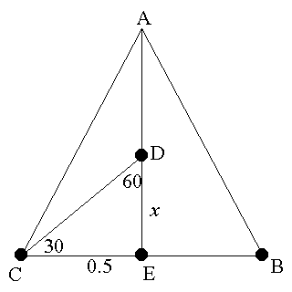

Section 8.7
Problems

1a. 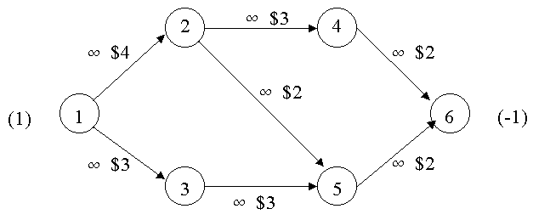

1b. One possible bfs is

1
2
4
1
1
6
(-1)
1
(1)

0 0
3
5

1c) Find the Y values.
Y₁=0, Y₁-Y₂=4, Y₁-Y₃=3, Y₂-Y₄=3, Y₅-Y₆=2, Y₄-Y₆=2

This yields
Y₁=0, Y₂=-4, Y₃=-3, Y₄=-7, Y₅=-7, Y₆=-9

Find the row 0 coefficients for each non-basic variable.
_
C₂₅=-4-(-7)-2=1 (violates optimality condition)
_
C₃₅=-3-(-7)-3=1 (violates optimality condition)

Ties are broken arbitrarily, so choose to enter X₂₅ into the basis.

1-
2
4
1-
1
6
(1) (-1)
1

0 0+
3
5

=1

Either X₂₄ or X₄₆ leaves the basis. Arbitrarily choose X₄₆.

0
4
2

1
6
1
(1) 1 (-1)

0 1
3
5

Find the Y values.
Y₁=0, Y₁-Y₂=4, Y₁-Y₃=3, Y₂-Y₄=3, Y₂-Y₅=2, Y₅-Y₆=2

This yields
Y₁=0, Y₂=-4, Y₃=-3, Y₄=-7, Y₅=-6, Y₆=-8

Find the row 0 coefficients for each non-basic variable
__
C₃₅ = -3 – (-6) -3 = 0 (satisfies optimality condition)
__
C₄₆ = -7 – (-8) -2 = -1 (satisfies optimality condition)

Thus, an optimal solution to this MCNFD is

(Basic Variables) X₁₂ = 1, X₂₅ = 1, X₅₆ = 1
(Basic Variables at lower bound) X₁₃ = 0, X₂₄ = 0
(Non-basic Variables at lower bound) X₃₅ = 0, X₄₆ = 0

The optimal z-value is

Z = 1(4) + 1(2) + 1(2) = $8

(Note that there are alternate optimal solutions.)

2.) Many answers may be correct as long as the arcs corresponding to
the basic variables form a spanning tree. A bfs which happens to be optimal is shown.
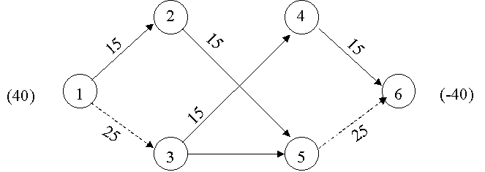

- Find the Y values.
Y₁ = 0, Y₁ – Y₂ = 15, Y₂ – Y₄ = 5, Y₂ – Y₅ = 10, Y₃ – Y₄ = 4

This yields

Y₁ = 0, Y₂ = -15, Y₃ = -16, Y₄ = -20, Y₅ = -25

Find the row 0 coefficients for each non-basic variable.
_
C₁₃ = 0-(-16)-11 = 5 (satisfies optimality condition)
_
C₂₃ = -15-(-16)-5 = -4 (satisfies optimality condition)
_
C₃₅ = -16-(-25)-5 = 4 (violates optimality condition)
_
C₄₅ = -20-(-25)-14 = -9 (satisfies optimality condition)

Enter X₃₅ into the basis.

4
10+ (-22)
2

20
10-
1
(32)

12-
12
3
5
(-10)

= 10, X₂₅ leaves the basis

20
2
4
(-22)

20
(32)
1

2

12
3
5
(-10)

10
Find the Y values.

Y₁ = 0, Y₁ – Y₂ = 15, Y₂ – Y₄ = 5, Y₃ – Y₄ = 4, Y₃ – Y₅ = 5

This yields

Y₁ = 0, Y₂ = -15, Y₃ = -16, Y₄ = -20, Y₅ = -21

Find the row 0 coefficients for each non-basic variable.
_
C₁₃ = 0-(-16)-11 = 5 (satisfies optimality condition)
_
C₂₃ = -15-(-16)-5 = -4 (satisfies optimality condition)
_
C₂₅ = -15-(-21)-10 = -4 (satisfies optimality condition)
_
C₄₅ = -20-(-21)-14 = -13 (satisfies optimality condition)

Thus, an optimal solution to this MCNFP is
(Basic Variables) X₁₂ = 20, X₂₄ = 20, X₃₄ = 2, X₃₅ = 10
(Non-basic Variables at upper bound) X₁₃ = 12
(Non-basic Variables at lower bound) X₂₃ = 0, X₂₅ = 0, X₄₅ = 0

The optimal z-value is
Z = 20(15) + 12(11) + 20(5) + 2(4) + 10(5) = $590
4.) Many answers may be correct as long as the arcs corresponding to the basic variables form a spanning tree. A bfs which happens to be optimal is shown.

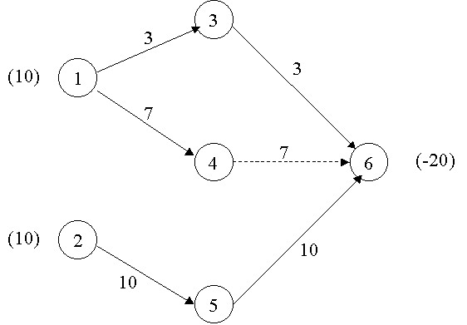

- Find the Y values.

Y₁ = 0, Y₁-Y₂ = 15, Y₂-Y₄ =10, Y₂-Y₆ = 5, Y₃-Y₆ = 8, Y₄-Y₅ = 30, Y₅-Y₇ = 10, Y₆-Y₈ = 15

This yields

Y₁ = 0, Y₂ = -15, Y₃ = -12, Y₄ = -25, Y₅ = -55, Y₆ = -20, Y₇ = -65, Y₈ = -35

Find the row 0 coefficients for each non-basic variable.
_
C₁₃ = 0-(-12) -10 = 2 (satisfies optimality condition)
_
C₂₃ = -15-(-12)-5 = -8 (satisfies optimality condition)
_
C₂₅ = -15-(-55) -10 = 30 (violates optimality condition)
_
C₃₅ = -12-(-55)-25 = 18 (violates optimality condition)
_
C₄₇ = -25-(-65)-45 = -15 (satisfies optimality condition)
_
C₅₈ = -35-(-35)-10 = -10 (satisfies optimality condition)
_
C₆₇ = -20-(-65)-30 = 15 (violates optimality condition)
_
C₇₈ = -65-(-35)-45 = -75 (satisfies optimality condition)

Enter X₂₅ into the basis
4

25-
25-
2
7
(-25)
50 25
5
(100)
1

50 25

3
8
(-75)
6
50 75

= 25, Choose X₄₅ to leave the basis

0
4
2
(-25)
7
50 25
25
1
(100)
5

50 25

3
8
50 (-75)
6
75

Find the Y values.
Y₁=0, Y₁-Y₂=15, Y₂-Y₄=10, Y₂-Y₅=10, Y₂-Y₆=5, Y₃-Y₆=8, Y₅-Y₇=10, Y₆-Y₈=15

This yields
Y₁=0, Y₂=15, Y₃=-12, Y₄=-25, Y₅=-25, Y₆=-20, Y₇=-35, Y₈=-35

Find the row 0 coefficient for each non-basic variable
_
C₁₃ = 0-(-12)-10 = 2 (satisfies optimality condition)
_
C₂₃ = -15-(-12)-5 = -8 (satisfies optimality condition)
_
C₃₅ = -12-(-25)-25 = -12 (satisfies optimality condition)
_
C₄₅ = -25-(-25)-30 = -30 (satisfies optimality condition)
_
C₄₇ = -25-(-35)-45 = -35 (satisfies optimality condition)
_
C₅₈ = -25-(-35)-10 = 0 (satisfies optimality condition)
_
C₆₇ = -20-(-35)-30 = -15 (satisfies optimality condition)
_
C₇₈ = -35-(-35)-45 = -45 (satisfies optimality condition)

Thus, an optimal solution to this MCNFP is
(Basic variables) X₁₂ = 50, X₂₅ = 25, X₂₆ = 25, X₃₆ = 50, X₅₇ = 25, X₆₈ = 75
(Basic variables at lower bound) X₂₄ = 0
(Non-basic variables at upper bound) X₁₃ = 50
(Non-basic variables at lower bound) X₂₃ = 0, X₃₅ = 0, X₄₅ = 0, X₄₇ = 0, X₅₈ = 0, X₆₇ = 0, X₇₈ = 0

The optimal z-value is
50(15)+50(10)+0(10)+25(10)+25(5)+50(8)+25(10)+75(15) = $3400

SOLUTION TO CHAPTER 8 REVIEW PROBLEMS

1a. The closest node to New York is Cleveland (via NY-Clev path of length 400 miles.)
Second closest node to New York is Nashville (via NY-Nash path of length 800 miles).
Third closest node to New York is St. Louis (via NY-St. Louis path of length 950 miles).
Fourth closest node to New York is Dallas (via NY-Clev- Dallas path of length 1300 miles)
Fifth closest node to New York is Salt Lake City (via NY- Nash-SLC path of length 2000 miles)
Sixth closest node to New York is Phoenix (via NY-St. Louis- Phoenix path of length 2050 miles).
Seventh closest node to New York is LA (via NY-St. Louis- Phoenix-LA) path of length 2450 miles.)

1b. CLEV STL NASH PHO DALL SLC LA
400 | 950 | 800 | M | M | M | M
0 | M | M | 1800 | 900 | M | M
M | 0 | M | 1100 | 600 | M | M
M | M | 0 | M | 600 | 1200 | M
M | M | M | 0 | M | M | 400
M | M | M | M | 0 | M | 1300
M | M | M | M | M | 600 | M
NY 1

CLEV 1

STL 1

NASH 1

PHO 1

DALL 1

SLC 1

0+1 0+1 0+1 0+1 0+1 0+1 1+1

1c. NY has a net outflow of +1 and LA a net outflow of -1. All other nodes have a net outflow of 0. Each arc has a shipping cost equal to its length, and each arc has an infinite arc capacity.

2a. City 1 = NY,... City 6 = LA (see figure)

max z = x₀
s.t. x₁₂ + x₁₃ = x₀ (Node 1)
x₁₂ = x₂₄ + x₂₅ (Node 2)
x₁₃ = x₃₄ + x₃₅ (Node 3)
x₂₄ + x₃₄ = x₄₆ (Node 4)
x₂₅ + x₃₅ = x₅₆ (Node 5)
x₄₆ + x₅₆ = x₀ (Node 6)
x₁₂≤500, x₁₃≤400, x₂₄≤300, x₂₅≤250, x₃₄≤200, x₃₅≤150,
x₄₆≤400, x₅₆≤350,All variables ≥0

2b. Begin by labeling sink via chain (1,2)-(2,4)-(4,6) and add a flow of 300 to each of these arcs. Then label sink by path (1,3)- (3,5)-(5,6) and add a flow of 150 to each of these arcs. Then label sink by chain (1,2)-(2,5)-(5,6) and add a flow of 200 to each arc on this path. Finally label the sink by (1,3)-(3,4)- (4,6) adding a flow of 100 to each arc on this path. This yields the following (maximum) flow

Arc Flow
NY-CHIC 500
NY-MEMP 250
CHIC-DENV 300
CHIC-DALL 200
MEMP-DENV 100
MEMP-DALL 150
DENV-LA 400
DALL-LA 350
INTO SINK 750
We can tell this is a maximum flow because the cut defined by node 6 (LA) with arcs (4, 6) and (5, 6) has capacity 400 + 350 = 750 = flow.

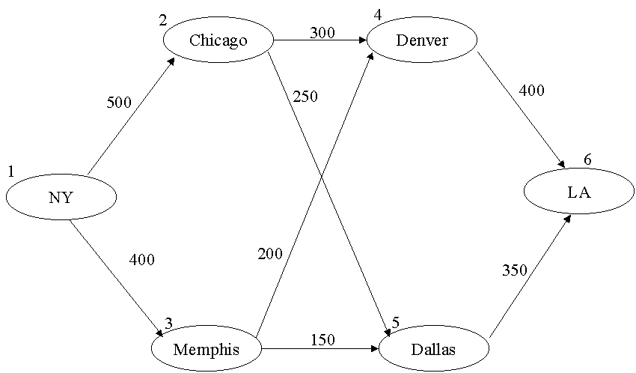
3a. See figure (we use expected duration of each activity in figure).

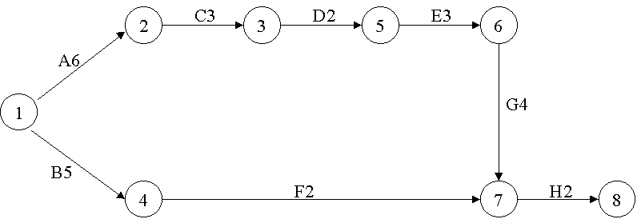

3b. and 3c. ET(1) = 0 LT(1) = 0 TF(1,2) = 0 FF(1,2) = 0
ET(2) = 6 LT(2) = 6 TF(2,3) = 0 FF(2,3) = 0
ET(3) = 9 LT(3) = 9 TF(3,5) = 0 FF(5,6) = 0
ET(4) = 5 LT(4) = 16 TF(5,6) = 0 FF(5,6) = 0
ET(5) = 11 LT(5) = 11 TF(6,7) = 0 FF(6,7) = 0
ET(6) = 14 LT(6) = 14 TF(7,8) = 0 FF(7,8) = 0
ET(7) = 18 LT(7) = 18 TF(1,4) = 11 FF(1,4) = 0 ET(8) = 20 LT(8) = 20 TF(4,7) = 11 FF(4,7) = 11
The critical path is 1-2-3-5-6-7-8 with a duration of 20 days.

3d. min z = x₈ - x₁
st x₂≥x₁ + 6
x₃≥x₂ + 3
x₅≥x₃ + 2
x₆≥x₅ + 3
x₇≥x₆ + 4
x₈≥x₇ + 2
x₄≥x₁ + 5
x₇≥x₄ + 2
x_{j} urs

3e. Node 1 has an outflow of +1, node 8 has an outflow of -1, and all other nodes have an outflow of 0. For each arc the shipping cost equals the arc length, and the goal is to maximize total cost. Each arc has infinite capacity. If the flow through an arc equals one, then the arc is on a critical path.

3f. Mean length of Critical Path = 6 + 3 + 2 + 3 + 4 + 2 = 20

Variance of length of Critical path =
64 + 4 + 4 + 16 + 16 + 16
--------------------------
36

= 3.33

Standard deviation of length of critical path = 3.33^{1/2} = 1.82.
12 - 20
We must determine P(CP≤12) = P(Z≤ ---------- ) = 0! Or
1.82
from EXCEL =NORMDIST(12,20,1.82,1) = 0.

3g. min z = 80A + 60B + 30C + 60D + 40E + 30F + 20G
st x₂≥x₁ + 6 - A
x₃≥x₂ + 3 - C
x₅≥x₃ + 2 - D
x₆≥x₅ + 3 - E
x₇≥x₆ + 4 - G
x₈≥x₇ + 2 - H
x₄≥x₁ + 5 - B
x₇≥x₄ + 2 - F
x₈ - x₁≤12
A,B,C,D,E,F,G≤2
x_{j} urs A...G≥0

4. Dummy (which receives Total Supply-Total Demand) must be added so we know how much will be `shipped' out of each production point. Node Rt represents month t regular-time production and Node Ot represents month t overtime production,

Node Net Outflow
R1 1,000
O1 400
R2 1,200
O2 400
R3 1,200
O3 400
Dummy Inflow of (3400+1200)-4300=300 so b_{Dummy}= -300
Demand 1 -1000
Demand 2 -1500
Demand 3 has b_{i} of -1800. All arcs have infinite capacity.
Arc Shipping Cost
R1-Dem 1 $4
R1-Dem 2 $5.50
R1-Dem 3 $7.00
O1-Dem 1 $6
O1-Dem 2 $7.50
O1-Dem 3 $9
R2-Dem 2 $4
R2-Dem 3 $5.50
O2-Dem 2 $6
O2-Dem 3 $7.50
Arc Shipping Cost
R3-Dem 3 $4
O3-Dem 3 $6
All arcs to dummy have 0 shipping cost.

5. Begin at NY and include NY-Cleveland arc (length 400). Next include NY-Nashville arc (length 800). Next include Nashville-Dallas(length 600). Next include Dallas-St. Louis(length 600). Next include Dallas-Phoenix(length 900). Next include Phoenix-LA (length 400. Finally include Salt Lake City-Los Angeles (length 600). Total length of minimum spanning tree is 4300 miles.

6. ARC SHIPPING COST ARC CAPACITY
P11-C1 33 + 51 -
P11-I' 33 + 51 -
P21-C1 30 + 42 -
P21-I' 30 + 42 -
P12-C2 43 + 60 -
P22-C2 41 + 71 -
I'-I 0 6
I-C2 13 -
P11-D 0 -
P21-D 0 -
P12-D 0 -
P22-D 0 -
Pij = Plant i production during period t
I = Inventory at end of period 1
C1 = Period 1 demand
C2 = Period 2 demand
D = Dummy demand point
NODE NET OUTFLOW
P11 7
P12 4
P21 9
P22 9
C1 -9
C2 -11
I' 0
I 0
D -(29 - 20)

7a. See Figure

7b. B-E-F is a critical path of length 15 (follow DUAL PRICES of -1).

8. See Figure. Each "Professor" node has a net outflow of 4. Each "Course" node has a net outflow of -4. All other nodes have a net outflow of 0. Arcs from, say, Fall Finance to Finance have a lower bound of 1 to ensure that the minimum number of courses are taught each semester. The cost for each arc from a "professor" to a "season-course" node is -(reward associated with that teaching assignment). Thus Professor 1 to Fall Marketing has a cost of -(3+6) = -9.

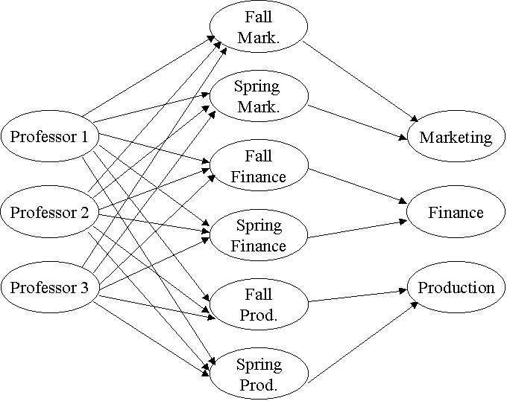

9. The key is to think of demands in terms of minutes needed on a machine! Let node Dij represent month i demand for product j(in terms of minutes of machine time required). Let node Mij represent available minutes during month i on machine j.

Node Net Outflow Arc Shipping Cost/Minute
M11 2400 M11-D11 40/30
M12 2400 M11-D12 45/20
M21 2400 M11-D21 (40 + 15)/30
M22 2400 M11-D22 (45 + 10)/20
D11 -30(50) M12-D12 60/20
D12 -20(70) M12-D13 55/15
D13 -15(80) M12-D22 (60 + 10)/20
D21 -30(60) M12-D23 (55 + 5)/15
D22 -20(90) M21-D21 40/30
D23 -15(120) M21-D22 45/20
DUMMY -100 M22-D22 60/20
M22-D23 55/15
M11-DUMMY 0
M12-DUMMY 0
M21-DUMMY 0
M22-DUMMY 0
All arcs have an infinite capacity.

