ITEC451
Solutions of Homework 2

Homework 2
- Page 55 (Section 3.1): Problems 1, 2, and 3
- Page 63 (Section 3.2): Problems 3, 4, 5, and 6
- Page 71 (Section 3.4): Problem 1
- Pages 117~123 (Review Problems): Problems 23, 30, 31, 39, 51, and 59

Page 55 (SECTION 3.1)

1. max z = 30x₁ + 100x₂
s.t. x₁ + x₂≤7 (Land Constraint)
4x₁ + 10x₂≤40(Labor Constraint)
10x₁ ≥30(Govt. Constraint)
x₁≥0, x₂≥0

2a. No, government constraint is violated.

2b. No; Labor constraint is not satisfied.

2c. No, x₂≥0 is not satisfied.

2d. Yes, all constraints and sign restrictions are satisfied.

3. 1 bushel of corn uses 1/10 acre of land and 4/10 hours of labor while 1 bushel of wheat uses 1/25 acre of land and 10/25 hours of labor. This yields the following formulation:

max z = 3x₁ + 4x₂
s.t. x₁/10 + x₂/25≤7 (Land Constraint)
4x₁/10 + 10x₂/25 ≤ 40 (Labor Const.)
x₁ ≥30 (Govt. Const.)
x₁≥0, x₂≥0

Page 63 (Section 3.2)

3. x₁ = Number of hours of Process 1 and x₂ = Number of hours of Process 2. Then the appropriate LP is
min z = 4x₁ + x₂
s.t. 3x₁ + x₂≥10 (A constraint)
x₁ + x₂≥5 (B constraint)
x₁ ≥3 (C constraint)
x₁ x₂≥0
AB is 3x₁ + x₂ = 10. CD is x₁ + x₂ = 5. EF is x₁ = 3. The feasible region is shaded. Dotted line is isocost line 4x₁ + x₂ = 24. Moving isocost line down to left we see that H (where B and C constraints intersect) is optimal. Thus optimal solution to LP is x₁ = 3, x₂ = 2, z = 4(3) + 2 = $14.

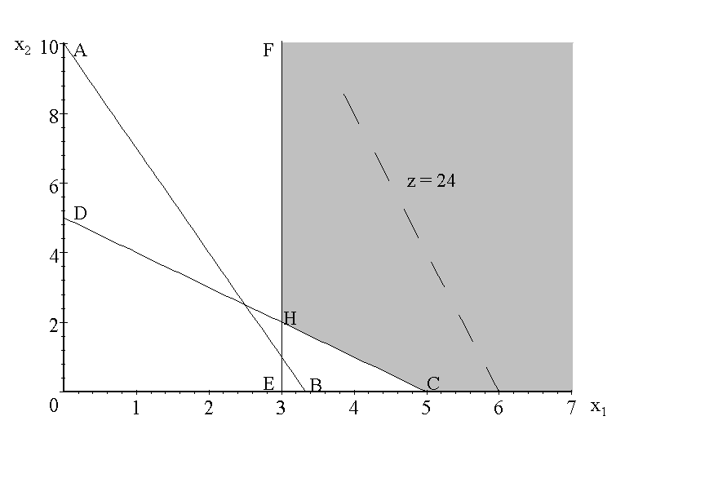

4a. We want to make x₁ larger and x₂ smaller so we move down and to the right.

4b. We want to make x₁ smaller and x₂ larger so we move up and to left.

4c. We want to make both x₁ and x₂ smaller so we move down and to left.

5. Let x₁ = desks produced, x₂ = chairs produced. LP formulation is
max z = 40x₁ + 25x₂
s.t. -2x₁ + x₂≥0
4x₁ + 3x₂≤20
x₁, x₂ ≥0
Graphically we find the optimal solution to be x₁ = 2, x₂ = 4 and z = 180.
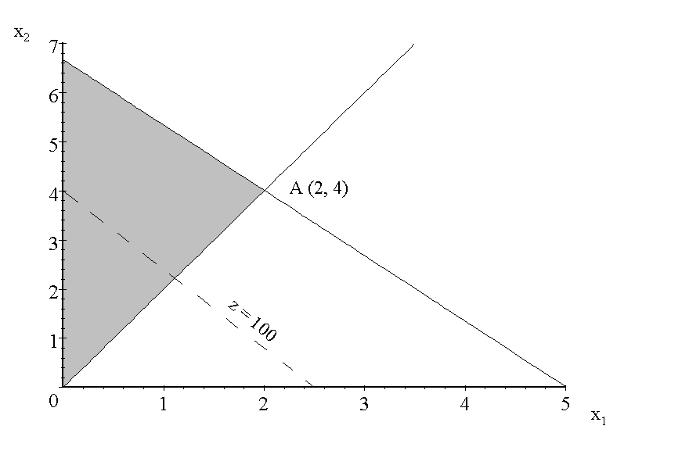

6. Let W = acres of wheat planted and C = acres of corn planted. Then the appropriate LP is
max = 200W + 300C
st W + C≤45 (Land)
3W + 2C≤100 (Workers)
2W + 4C≤120 (Fertilizer)
W, C≥0
Graphically solving this LP we find the optimal solution to be z = $10,000, W = C = 20 acres.

Page 71 (Section 3.4)

1. For i = 1, 2, 3 let x_{i} = Tons of processed Factory i waste.
Then appropriate LP is

min z = 15x₁ + 10x₂ + 20x₃
s.t. .10x₁ + .20x₂ + .40x₃≥30(Pollutant 1)
.45x₁ + .25x₂ + .30x₃≥40(Pollutant 2)
x₁≥0,x₂≥0,x₃≥0
It is doubtful that the processing cost is proportional to the amount of waste processed. For example, processing 10 tons of waste is probably not ten times as costly as processing 1 ton of waste. The divisibility and certainty assumptions seem reasonable.

Pages 117~123 (Review Problems)
23. Let xi = number of hours workers spend each week on machine i and pi = units of product i produced each week
max z = 6p1 + 8p2 + 10p3
st 2p1 + 3p2 + 4p3≤x1
2p1 + 3p2 + 4p3≤200
3p1 + 5p2 + 6p3≤x2
3p1 + 5p2 + 6p3≤120
4p1 + 7p2 + 9p3≤x3
4p1 + 7p2 + 9p3≤160
x1 + x2 + x3≤350
All variables nonnegative

30. The LP is unbounded.

31. The LP is unbounded.

39. Pi = product I made, RMi=raw material I bought

MAX Z=30P1+35P2-4RM1-5RM2
ST
.6P1+.4P2<=200 (MACHINE 1 TIME CONSTRAINT)
.4P1+.3P2<=300 (MACHINE 2 TIME CONSTRAINT)
P1<=400, P2<=300 (DEMAND CONSTRAINTS)
RM1 = 2P1+P2, RM2=P1+2P2 (RAW MATERIAL BOUGHT=RAW MATERIAL USED)
ALL VARIABLES>=0.

51. Let X1 = number of transistors melted by method 1
X2 = number of transistors melted by method 2
D = number of defectives not refired
RD = number of refired defectives
R1 = number of refired grade 1 transistors
R2 = number of refired grade 2 transistors
R3 = number of refired grade 3 transistors
Y1 = number of grade 1 transistors not refired
Y2 = number of grade 2 transistors not refired
Y3 = number of grade 3 transistors not refired
Then the appropriate LP is
min z = 50X1 + 70X2 + 25RD + 25R1 + 25R2 + 25R3
s.t. .3X1 + .2X2 - RD -D = 0
.3X1 + .2X2 - R1 - Y1 = 0
.2X1 + .25X2 - R2 - Y2 = 0
.15X1 + .20X2 - R3 - Y3 = 0
.25RD + .30R1 + Y1 ≥ 3000
.15RD + .30R1 + .40R2 + Y2 ≥ 3000
.20RD + .20R1 + .30R2 + .50R3 + Y3≥ 2000
.05X1 + .15X2 + .10RD + .20R1 + .30R2 + .50R3 ≥1000
X1 + X2 + RD + R1 + R2 + R3≤20000
All variables ≥ 0

59a. Let Rt = resistance of resistor t
min z = 16R1 + 36R2 + 64R3 + 324R4
st 4R1 = 6R2, 6R2 = 8R3
2≤4R1≤10
2≤6R2≤10
2≤8R3≤10
All variables ≥0

59b.Let Ri' = reciprocal of the resistance of
resistor i
min z = 36R1' + 36R2' + 36R3' + 16R4'
st 2≤6R1'≤6
2≤6R2'≤6
2≤6R3'≤6
2≤4R4'≤6
6R1' + 6R2' + 6R3' = 4R4'
All variables Nonnegative

