**Private Cloud or Dedicated Hosts**

Mason Mabardy

&

Matt Maples

**Abstract – Virtual machines Vs. Physical machines both are have their pros and cons that depending on a user’s needs will be a better fit. This experiment will determine for three different services in certain situations which machine configuration would be best suited to for those services. Using Openstack, a private cloud platform, to manage the virtual machines and see what kind of computing power can be achieved.**

I. Justification on your topic

IT specialists are often presented with a dilemma, use virtual machines to solve this issue or should the issue be solved by using a physical machine. This has been a problem that can cost business a lot of money, time, and resources if not carefully planned and tested. This topic would be of great interest to any business that has a large number of servers. The experiment will be to test the performance of three services tested both as a virtual machine and as physical machines. Two of the servers will be mainstream business oriented, the file server and web server will demonstrate how business could network work stations to gain more computing power because majority of workers rarely use above 50 percent of their processing power. Similar to distributed computing, cloud computing would work great in this scenario by using multiple machines to work a VM and work on many tasks at once while saving money and time. This type of computing will greatly benefit the smaller business that can’t afford a large number of servers and machines. “The cloud does for IT what companies like UPS and Federal Express did for the shipping industry, Stephen Braat, senior director and general manager of cloud and managed solutions for CDW, said.“ When it comes to getting product to customers, their technology enables them to do it on a larger scale at a lower cost,” he said. “The cloud is the great technology equalizer.” Technology is a huge driver of competitive advantage, and historically, technology that larger companies used was not available to smaller companies, who typically have 50 employees or less [3].” This technology really is a game changer, small businesses can finally have a competitive edge against the larger companies that can afford a large server farm. “ Today, companies can have the cloud and get world-class infrastructure maintained by some of the best companies on the planet, and get it for $50 a month or less, Levin added. If a company does it right, cloud services will enable them to get enterprise-level information technology at a cost that is aligned with their own business model, Parallels' Zanni said. Because cloud is pay-as-you-go, owners may pay between $5 and $10 per user versus several thousands of dollars for servers and specialists to run them [3]. ” This research that we are performing will show how having the cloud can be of great benefit to small businesses.

Large businesses could deploy could private cloud computing if they have an abundance of machines that are not be utilized. Private cloud would allow large companies to perform huge computations and accomplish a vast work load. Private cloud would greatly benefit researchers that need to do large number crunching and just a few machines won’t do it because that would need a more then they could afford; private cloud would allow them to perform research securely and privately while saving money and time. Recently a poll was taken on companies that are using the private cloud and the results are greatly in favor of it. “The results of our InformationWeek 2014 Private Cloud Survey are eye-opening. All 242 respondents hail from ­organizations with 50 or more employees and screened into the survey by indicating involvement with managing, ­purchasing, advising on, or implementing datacenter technologies, and we were able to trend from our April 2012 poll [4].” The current survey was taken in 2014 “The percentage reporting that they have functional private clouds more than doubled, from 21% to 47%. And we saw very little falloff of those who told us in 2012 that they were on the private cloud path. Other stats: 36% of private cloud users rate their projects as somewhat successful versus 64% saying they’ve achieved complete ­(17%) or very good (47%) success. There were zero failures in the bunch [4].” The results taken from this servay are proving that businesses are not only liking the idea of the private cloud but more and more are already adopting the technology. The companies that have projects using the private cloud are reporting great success with private cloud computing.

II. Background knowledge

Virtual machines as of late have been a life saver for many companies that are struggling to expand or suffering from lack of resources. Virtual Machines or VMs have allowed companies to consolidate hardware and allow almost any OS or platform to run on more than one piece of hardware. “A virtual machine (VM) is a software program or operating system that not only exhibits the behavior of a separate computer, but is also capable of performing tasks such as running applications and programs like a separate computer [1].” Virtual machine technology has allowed one piece of hardware to not only just serve just one purpose. Many IT professionals need multiple operating systems to get the job done, software like VMWare has allowed people to take advantage of having multiple operating systems. Having Linux and Windows on the same piece of hardware is a great advantage because of the ability to now interact with almost every other machine without having to worry about how one operating system will interact with the other. “A virtual machine can support individual processes or a complete system depending on the abstraction level where virtualization occurs. Some VMs support flexible hardware usage and software isolation, while others translate from one instruction set to another. Virtualizing a system or component -such as a processor, memory, or an I/O device - at a given abstraction level maps its interface and visible resources onto the interface and resources of an underlying, possibly different, real system. Consequently, the real system appears as a different virtual system or even as multiple virtual systems. Interjecting virtualizing software between abstraction layers near the HW/SW interface forms a virtual machine that allows otherwise incompatible subsystems to work together. Further, replication by virtualization enables more flexible and efficient and efficient use of hardware resources [5].” It has been proven over time that Virtual machines can have great benefits, in the past virtual machines were thought of as more of a academia thing. Now virtual machines are everywhere, with great success in many fields the idea of virtualizing a machine has created many possibilities.

The idea of cloud computing is very popular today and has just started to really take off in the business world. For smaller businesses the cloud is a life line, especially to those with 50 or less employees. The cloud has allowed those small businesses to compete with larger businesses or utilize their services by using the cloud services they offer. Amazon, for a long time now, has offered cloud storage and cloud computing opportunities for a single user to full businesses. Microsoft offers many cloud package software now with Office 365 many companies don’t need much local storage all documents can accessed and managed from any location. Google has a free online cloud service called google docs that offers services very similar to the Microsoft Office package. Cloud computing has revolutionized the world and will continue to do so. Those business that have the money and resources can invest in the private cloud that is a cloud just for that business. Private cloud has allowed for researchers or business with a need for a large amount of computing power or private cloud for security reasons are able to utilize this idea. Researchers with a big data or number crunching machines can save a large amount of time by implementing or buying a private cloud.

III. Literature Survey

Research on the area on Virtual machines has been conducted and studied; physical or virtual, each has its own pros and cons that could sway a user to one or the other depending on the needs of the user. The cost is always one of the big issues to consider when picking sides “The cost of buying individual servers is much higher than virtualization. Even though you may save costs on hardware, the costs of the virtualization software and licensing may be high. You may have to treat each virtual server as a physical instance like before, so normal licensing costs for each virtual server stays as same [2] .” Performance is also a big issue to consider, virtualization technology at this time is still not as good as physical in some areas. “Performance is not as good if you increase the work load for a single machine must handle. While the virtualization hardware is getting faster and faster each year, you still have more resources being used with virtualization. Performance needs for an application should to be addressed on a case by case basis [2].” There are more issues to consider when picking virtual or physical such as time management, Disaster recovery, Security, and Migration. These issues are just some of the many things that need to be considered before picking a side.

The idea of using the cloud to create a massive cluster of machines to perform large task is now being implemented, it is a hot topic of the IT world. In the past grid computing was the only real was to get a large amount of processing power. Now with a private cloud anyone can create a massive cluster of machines and perform huge processes that would normally take a large amount of time in a much shorter time. “Cloud computing refers to both the applications delivered as services over the Internet and the hardware and systems software in the data centers that provide those services. The services themselves have long been referred to as Software as a Service (SaaS).a Some vendors use terms such as IaaS (Infrastructure as a Service) and PaaS (Platform as a Service) to describe their products, but we eschew these because accepted definitions for them still vary widely. The line between "low-level" infrastructure and a higher-level "platform" is not crisp. We believe the two are more alike than different, and we consider them together. Similarly, the related term "grid computing," from the high-performance computing community, suggests protocols to offer shared computation and storage over long distances, but those protocols did not lead to a software environment that grew beyond its community [6].” The paper “A View of Cloud Computing” offers a great perspective on all cloud based services whether it be cloud storage of cloud computing. The author made three great points as the why the cloud should be used vs any other service “From a hardware provisioning and pricing point of view, three aspects are new in cloud computing. 1st The appearance of infinite computing resources available on demand, quickly enough to follow load surges, thereby eliminating the need for cloud computing users to plan far ahead for provisioning. 2nd The elimination of an up-front commitment by cloud users, thereby allowing companies to start small and increase hardware resources only when there is an increase in their needs. 3rd The ability to pay for use of computing resources on a short-term basis as needed (for example, processors by the hour and storage by the day) and release them as needed, thereby rewarding conservation by letting machines and storage go when they are no longer useful [6].” Private cloud computing is the way to go if you need a secure and powerful machine to conduct business or research.

IV. Problem Statement

The idea is to test 3 types of servers, a game server, a web server, and a file server using Openstack to launch servers as a VM vs using separate hardware for each server. This experiment will allow for a great comparison of the advantages and disadvantages of using VMs. Using a private cloud, which Openstack will allow us to create could give us an edge over using 3 physical standalone units to host our services.

V. Approach to Solve the Problem

The experiment will be to set up an array of virtual machines to host a game server, a web server and a file server and measure the performance difference when using physical machines. Openstack will be used to manage the virtual machines that will in theory allow for much better optimization and use of resources than setting up separate VMs. The combination of Openstack and large number of machines should allow for a good comparison of virtual machine use vs physical machine use.

The plan is to set up physical machine one machine for each service and perform stress test. The test will consist of three sets of stress testing, and data will be collected at three time’s low stress, medium stress and high stress. Once data is collected the machines will then be repurposed to conduct the same test using virtual machines and Openstack to manage the machines and perform stress testing on the services, collect data then compare data and perform cost analysis to determine if it would be worth it in this scenario to use VMs over physical machines.

The game server will run on Ubuntu and will be hosting a Minecraft server the experiment will be to test how much TNT detonation the server will be able to handle. The test will start at one block of TNT and will be monitored to see how much the server can handle to certain levels. The amount of TNT will be incremented until the server crashes the maximum number will give us a great number to compare. TNT will be used to determine the amount of stress the server can handle because of the huge of amount of processing power it consumes to perform all tasks that TNT requires. Most Items in minecraft move at a slow rate and TNT is one of the few items that requires a large number of physics calculations rapidly. Not only does TNT explode with force but it also destroys blocks of land, approximately a 3x3x3 area will be destroyed from one block of TNT. Once we stack a large number of these blocks in the square pattern the processing power of the server should be tested to its limits.

The file server will be setup to receive requests from clients wanting to download a 10GB file from the server. The server will then try to accommodate with a growing number of client requests until the server crashes. This will be tested from both private cloud and physical server.

The web server will be set up using apache to create a web page. Web traffic will be flowing regularly to the site. The Test will be performed as a DDoS attack and the time it takes to crash the server will be the data compared from both private cloud and physical server setup. The DDoS attack will be performed from a ping generator that will be set a constant level of pings per second to maintain a constant.

VI. Results

During the course of testing the various services, we discovered that they are incredibly resilient to attacks. The minecraft server software can withstand thousands of blocks of TNT without crashing in both virtual and physical implementations.

1. Minecraft after TNT processor usage

This graph shows the amount of TNT to processor percent usage by server. We think that from 50 to 100 TNT blocks the game uses a different method of displaying and creating destruction of block units.



1. Minecraft after TNT

After the detonation of several hundred blocks of TNT we determined that the server was handling Minecraft with easy and in fact our local machines were taking more stress.

We found it to be impossible to crash a Minecraft server within the game environment on default settings. That being said, it is possible to crash a server outside of the game using an application to flood the server with requests. Using the application “Low Orbit Ion Cannon”,

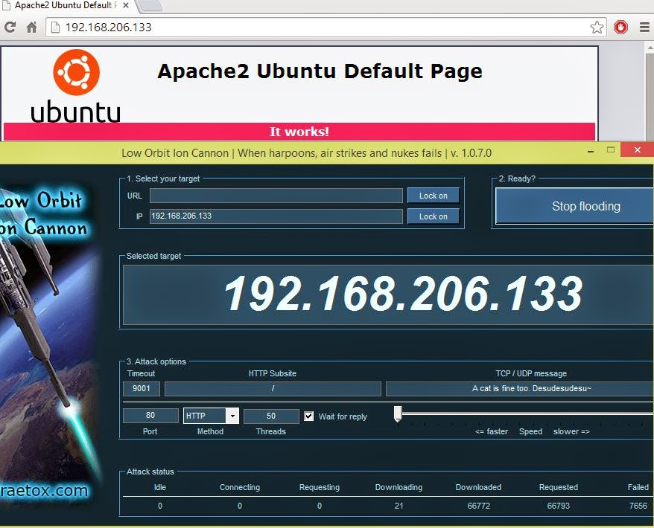

2. DoS attack

In the picture it is showing the web page still up and running during the DoS attack with no issues.

we attempted to crash the apache default page and we discovered that again, we could not cause the service to crash either as a virtual machine or a dedicated machine. The only service we were able to impact was the file server. While simulating 10 users all trying to download a 10GB file we were able to see drastic connection slowdowns for the clients. Again, we weren’t able to actually crash the service, but we were able to slow it down.

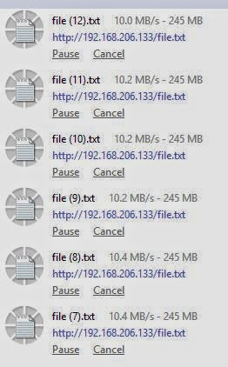

3. File server demand

Here the speeds for client downloads are starting to slow with the requests piling up. Even with just six requests the server is starting to struggle. After the demand increased the file server just came to a standstill.

VII. Concluding RemarkS

Virtual machines when hosted on good hardware can be very cost effective when deciding on whether to host services physically or virtually. It seems that the key to reliability with virtual machines is the power of the hardware they are hosted on. With the trend of falling prices in computing components, it is becoming cheaper to virtualize services and consolidate servers. We were looking for performance differences between virtual and physical machines, but what we found was that they are fairly similar in performance. Virtual machines are also much easier to backup and migrate than physical servers and can prove to reduce costs in the event of a server failure. All of this testing has shown us that if a small business needs to save money using virtual machines is a great option as it will save a large deal of money while also utilizing unused resources. There are still some costs associated with licensing and so on but overall the cost will out way the cost of buying an actual server. For small bossiness there is no real reason not to use virtual machines they are easy to use and very cost effective. Large businesses are another deal, they need to consider the kind of hardware that they have at their disposal and the kind of human resources they have to manage the virtual machines. Depending on the amount of demand on the server the ideal solution would be for them to gather a number of potential users, then determine if a virtual machine is right for them. If the user base was low and the task that need to be accomplished would only use a low to medium amount of resources then that would be ideal for that task. If the business had a larger need task that need to be accomplished the virtual machines might be able to handle it depending on user demand. The choke point of using virtual machines seems not to be with the hardware resources it’s self but handling a large deal of outside requests from users. As shown by the file server test is was impacted the most by user demand and the game server was also effected more by user request more than it was the TNT. In summery a task that requires consumption of resources and not a large deal of outside user requests would be an ideal situation for using virtual machines, however if the user demand for outside clients is going to be high then it would be ideal to user physical machines. The question that the business needs to ask is

1. Will the service that is be required have a large user base?

2. What kind of hardware will host the virtual machines?

3. What kind of service will the machine be providing?

4. What is your budget?

If the first question is a large user base then the business should lean more towards physical machines. For questions two and three no matter the answer you can always use virtual machines that will just depend on if the hardware could support multiple virtual machines or you will need to use the privatized cloud computing to use multiple pieces of hardware as your machine. The forth question is also a big factor cost is one of the biggest differences between buying a physical machine and using existing hardware to run virtual machines. If the business can answer these four questions then they will have the answer to if they should use virtual machines or user physical machines.

VIII. REFERNCES

[1] J. Cory “Vitual Machines (VM)” Internet: http://www.techopedia.com/definition/4805/virtual-machine-vm [April 16, 2014].

[2] S. Sebastian “Physical Vs Virtual server : Which one should you choose?” Internet: http://bobcares.com/blog/virtualization-or-physical-server/ [April 16, 2014].

[3] C. Hall “What Is The Cloud? (And Why Small Businesses Need To Care)” Internet: http://www.huffingtonpost.com/2013/11/06/amex-what-is-the-cloud-and-why_n_3964066.html [April 16, 2014].

[4] A. Wittmann “Research: 2014 Private Cloud Survey” Internet: http://reports.informationweek.com/abstract/6/11795/Data-Center/Research:-2014-Private-Cloud-Survey.html [April 16, 2014].

[5] J. Smith “The architecture of virtual machines” Paper: http://ieeexplore.ieee.org/xpl/articleDetails.jsp?tp=&arnumber=1430629&url=http%3A%2F%2Fieeexplore.ieee.org%2Fxpls%2Fabs_all.jsp%3Farnumber%3D1430629 [April 16, 2014].

[6] M. Armbrust, A. Fox, R. Griffith “A View of Cloud Computing” Paper: http://cacm.acm.org/magazines/2010/4/81493-a-view-of-cloud-computing/fulltext [April 16, 2014].