**CS 452**

**Homework 3: Socket Programming**

**What to do:** Please write socket programs which run the following client-server task.

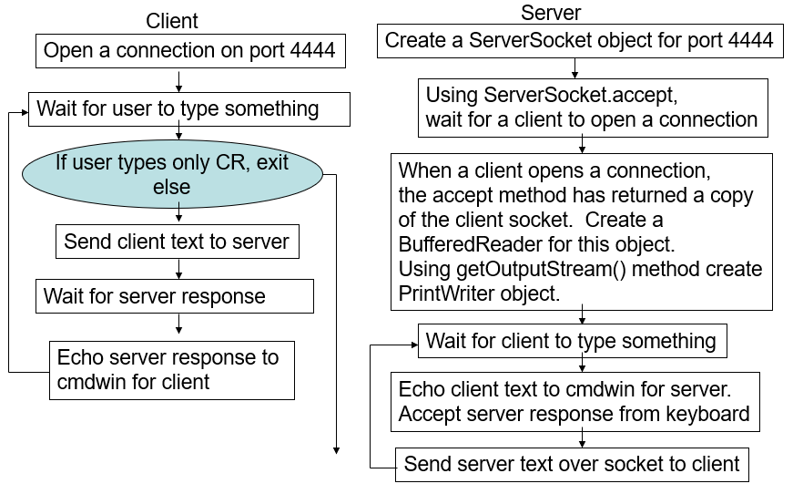

**What to Submit**: to the Assignment submission folder in D2L.

1. Your source codes
2. ReadMe.doc file
   * The ReadMe.doc file must include:
     + Your name
     + File names of your source codes and descriptions of each files.
     + Executing Instruction
     + Length: Less than 3 pages