ITEC 324 - Sample
Midterm Exam 1

Name:

- Point values are shown in parentheses. 100 points total.

- (9) What relationship is appropriate between the following classes: aggregation, inheritance, or neither? And explain why?

  - Student – Freshman

  - Car – Door

  - Traffic – TrafficSign

- (10) Consider the following use case for “Change the passcode” case and give one possible variation of it and a step-by-step use case for the variation.

Step 1. Mailbox owner carries out Log in
Step 2. Mailbox owner selects "change passcode" menu option
Step 3. Mailbox owner dials new passcode
Step 4. Mailbox owner presses #
Step 5. System sets new passcode

- (4) What is the name of the class relationship, depicted in the following class diagram?

  - .

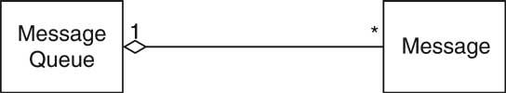

  - .

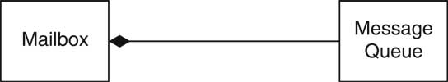

- (5) Complete the following sequence diagram to represent the case that the MailSystem class constructs an object of the Mailbox class.

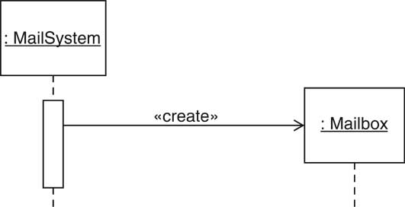

- (5) Define the term Class Invariant.

- (10) When sorting a collection of objects that implements the Comparable type, the sorting method compares and rearranges the objects. Explain the role of polymorphism in this situation.

- (4) State who/what is responsible for fulfilling each of the following:

  - Precondition:
  - Postcondition:

- (10) List the “Five Cs” which are the five concepts used to analyze the quality of an interface.

- (15) For three of the five Cs, give an example that illustrates that one. Make sure that you make it clear which of the C’s each of your examples illustrates.

- (10) Java requires that a local variable must be declared as final if it is accessed by method in anonymous class. Explain why this restriction is necessary.

- (18) Complete the following code whose purpose is to create a user interface that contains two buttons and a textField. The buttons should be labeled “Open” and “Close” and the text in the textField should change to “Open” and “Close” as the corresponding buttons are pressed. The initial text in the textField should be “None”.

import … // You do not need to code any import statement

public class ActionTester
{
public static void main(String[] args)
{
JFrame frame = new JFrame();
//PUT YOUR CODE BELOW

frame.setDefaultCloseOperation(JFrame.EXIT_ON_CLOSE);
frame.pack();
frame.setVisible(true);
}
}

