ITEC 324
Programming Assignment 2

Problem Specification

- Enhance the ShapeIcon class so that it can display multiple moving shapes. Hint: in the class, include an array list of shapes and methods to add and remove shapes to the set of objects that are displayed.

- Main Window with 4 buttons (Show, Exit, Add, Remove) and a checkbox group (BLUE, YELLOW, and RED)

- Show button - When clicked, a new subwindow should be displayed. If the window does not already exist, it should be created.
- Add button - When clicked, a new BLUE, YELLOW, or RED shape (depending on which checkbox is selected) is added to the subwindow, at a random location. When added, the BLUE, YELLOW, or RED is automatically in motion across the screen. If the subwindow is not currently showing, it is displayed (first being created, if necessary).
Note: If multiple shapes are clicked, all of the selected shapes must be added.
- Remove button - When clicked, the most recently added shape is removed. If the subwindow is not currently showing, the button has no effect.
- Exit button – When clicked, all the windows should close and the application should terminate.
- Checkbox group - Checkboxes for BLUE, YELLOW, and RED that specify whether an BLUE, a YELLOW, or a RED is added when the Add button is pressed. The initial state of the checkbox group should have the BLUE box checked. Multiple checkbox can be checked.
- Note: BLUE, YELLOW, and RED must have more than two colors. Following are samples.

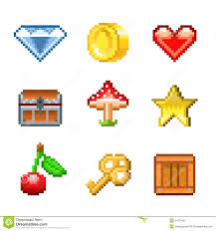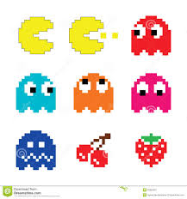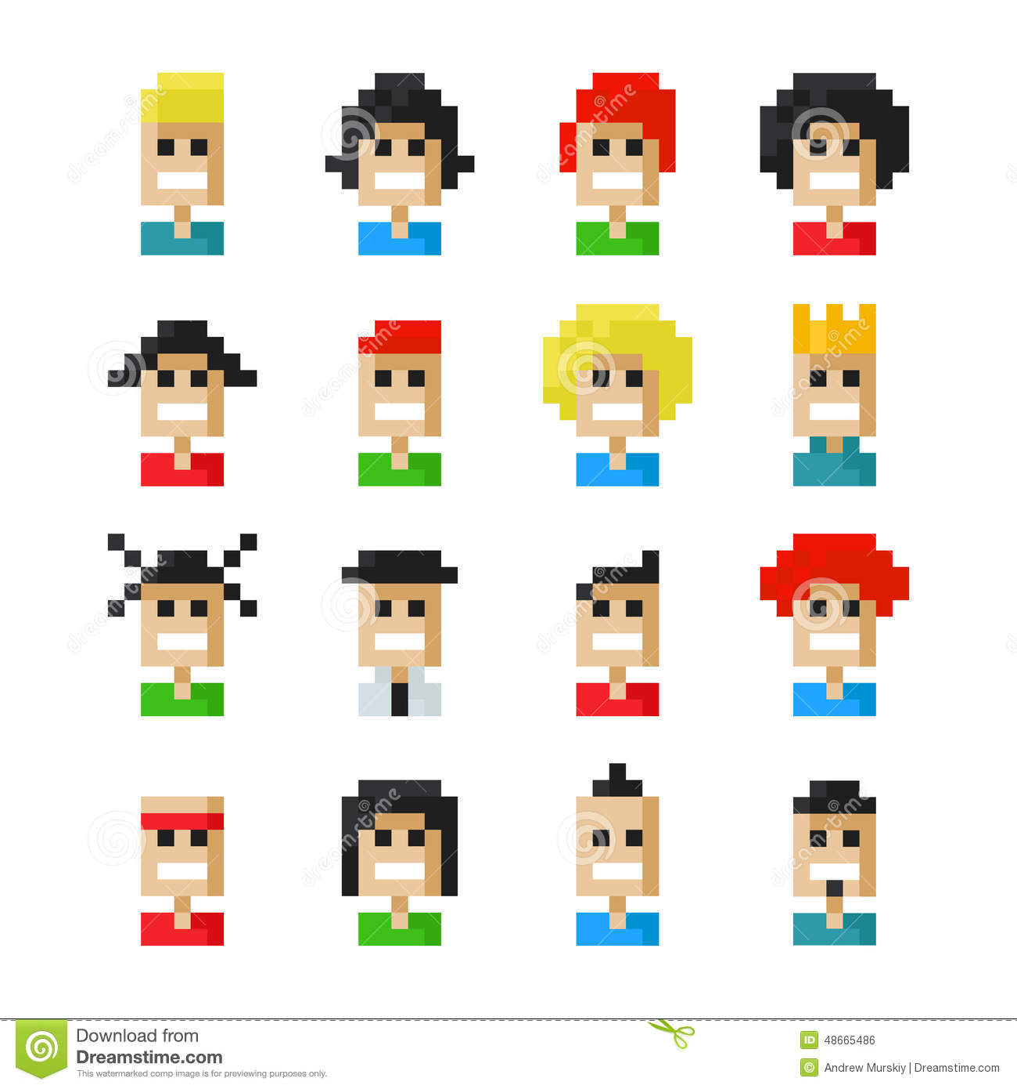

[Image Source] dreamtimes.com

3. Subwindow which has one JLabel and two buttons (Hide and Exit)

- JLabel – Displays the BLUEs, YELLOWs, and REDs that are added to
- Hide button – When clicked, the subwindow disappears but continues to exist. The animation should halt when the subwindow is hidden.
- Exit button in the subwindow – When clicked, the subwindow should be closed and destroyed. The main window should NOT be closed.

4. UML Documentation:
- Class diagram of your system
- Sequence diagram showing the scenario of displaying the subwindow, adding an BLUE, a YELLOW, and a RED to it, hiding the subwindow, showing the subwindow again, and then exiting the system.

Notes:
- All the icons should wrap. That is, once an icon disappears at the edge of the window, it should appear at the opposite side of the window.
- You are to include java documentation for all of your non-private classes and methods. Since I will run the javadoc command on your program, you do NOT need to submit the output from the javadoc command.
- Your UML documentation should not be hand written.
- your UML diagrams should be submitted as an image file such as .jpg, .png, and .gif.
- Your program must include a class called MultiShapeTest that contains the main routine that runs your user interface.
- Please check the grading criteria in the class syllabus.

