Sample

Computer Science III

Homework 1 – Part 2

**Class-Responsibility-Collaboration Cards**

|  |  |
| --- | --- |
| **DisplayScreen** | |
| *display messages to user* |  |
| *get user input from touchpad* |  |
|  |  |
|  |  |
|  |  |
|  |  |
|  |  |

|  |  |
| --- | --- |
| **Product** | |
| *keep track of self information* |  |
|  |  |
|  |  |
|  |  |
|  |  |
|  |  |
|  |  |

|  |  |
| --- | --- |
| **VendingMachine** | |
| *manage products* | Product |
| *manage number of coins* | DisplayScreen |
| *manage operator passcode* |  |
|  |  |
|  |  |
|  |  |
|  |  |

**UML Diagrams**

**Class Diagram**

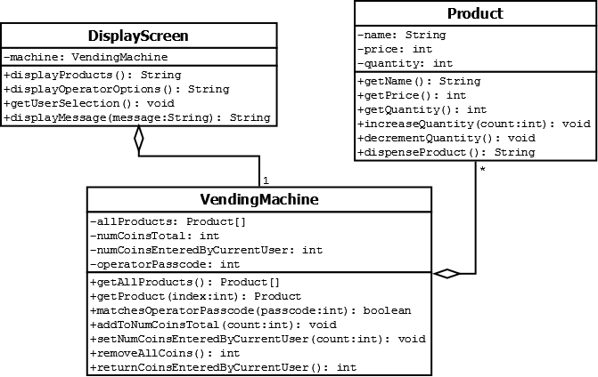

**Sequence Diagram**

User Purchases a Product:

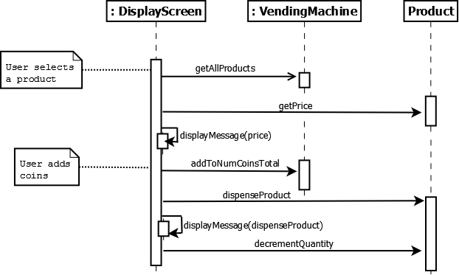

Operator Removes Coins:

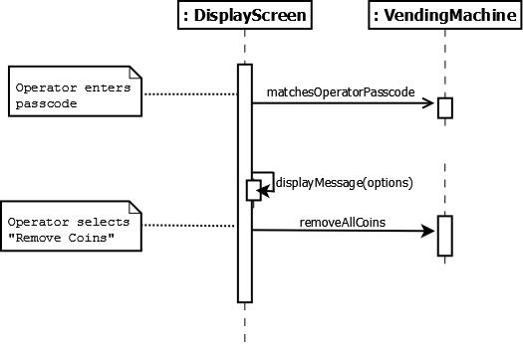

Operator Restocks a Product:

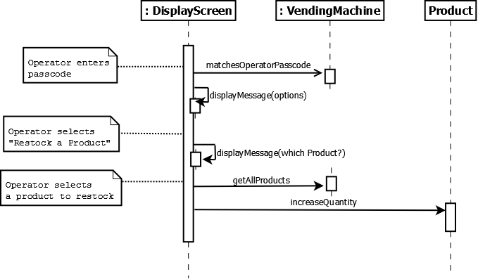

**State Diagram**

None.