ITEC 350
Sample Exam

Name:

- The following figure shows a classification of interconnected processors by scale. Fill in the blacks using one of the terms, BAN, LAN, MAN, PAN, WAN, and Internet.

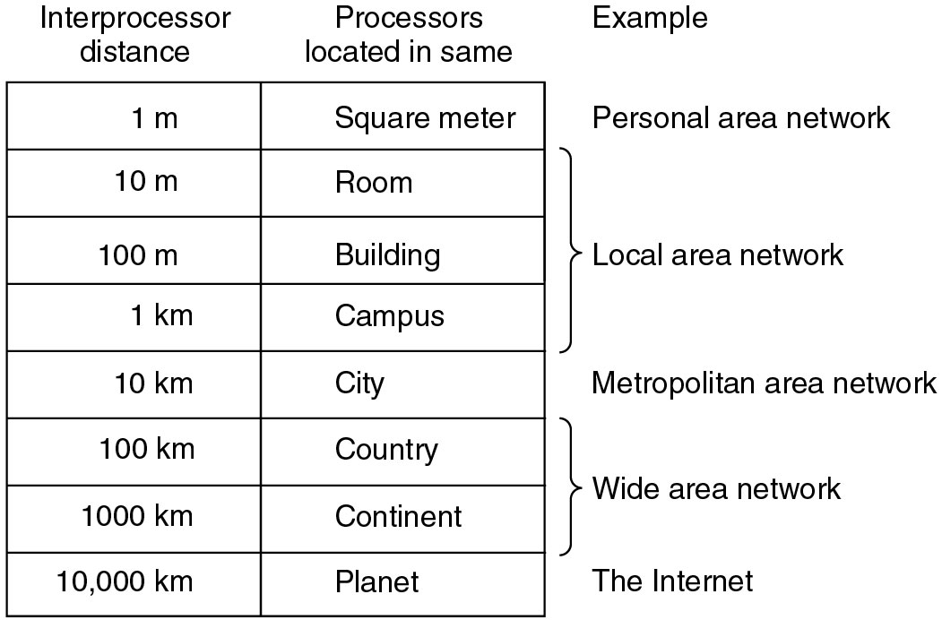
(1)
(2)
(3)
(4)
(5)

What do LAN, MAN, PAN, and WAN stand for, respectively?

(6) BAN

(7) LAN

(8) MAN

(9) PAN

(10) WAN

- What is the principal difference between connectionless communication and connection-oriented communication?

- What is the main difference between TCP and UDP?

- Fill in the blanks in the following figure.

OSI 7 layer
(7)
(6)
(5)
(4)
(3)
(2)
(1)

Which of the OSI layers handles each of the following:

(8) Handling a transmission between two nodes which are directly connected each other.

(9) Determining the best path between two nodes in a network topology.

- Pick five among the following acronyms and write what they stand for.

- FTP
- UDP
- TCP
- SMTP
- HTTP
- DNS
- ICMP

- What is the major difference between a packet and a frame?

- Subnet
(Each answer show the binary representation as well as the dotted decimal representation of IP address)

Radford Corporation has the following class C Internet License:

195.10.1.0

Radford Corp. would like to allow for at least 8 sub-networks using classful subnetting.

(1) How should Radford Corp. divide up the bits in their Class C license to allow for this?

(2) How many devices on each subnet would this allow?

(3) What would their subnet mask be?

(4) What would be the IP address (Subnet ID) of the second subnet?

(5) What would be the IP address of the first machine on the second subnet?

(6) What would be the IP address of the last machine on the second subnet?

(7) What is the broadcast address of the second subnet?

- What is promiscuous mode in LAN?

- What can be benefits by using the nonroutable address?

- What is the major role of DNS?

- What is the major role of the reverse lookup using .arpa?

- What is the difference between a Router and a Gateway?

- What is the major role of ARP?

