Layered Network Design Simulation (Instructor Version)

**Instructor Note**: Red font color or Gray highlights indicate text that appears in the instructor copy only.

1. Objective

Explain the need to design a hierarchical network that is scalable.

Instructor Note: This activity is can be completed by individual students or groups of two students. It can then be shared with another individual, group, class, or the instructor.

1. Scenario

As the network administrator for a very small network, you want to prepare a simulated-network presentation for your branch manager to explain how the network currently operates.

The small network includes the following equipment:

* One 2911 series router
* One 3560 switch
* One 2960 switch
* Four user workstations (PCs or laptops)
* One printer

For further instructions on how to complete this activity, open the accompanying PDF.

1. Resources

* Packet Tracer software

1. Directions
   1. Create a simple network topology using Packet Tracer software. Place the devices at the appropriate levels of the Cisco three-layer hierarchical model design. Include:
      1. One 2911 series router
      2. One 3560 switch
      3. One 2960 switch
      4. Four user workstations (PCs or laptops)
      5. One printer
   2. Using Packet Tracer’s drawing tool and indicate the hierarchical layers with different color coding and labels:
      1. Access Layer
      2. Distribution Layer
      3. Core Layer
   3. Configure the network and user devices. Check for end-to-end connectivity.
   4. Share your configuration and hierarchical network design Packet Tracer file with another student, group, the class, or the instructor.

**Suggested Activity Example Solution:**

Instructor Note: In the Packet Tracer simulation, a 2911 Series router is used in the Core Layer of the network. Normally, a higher-capacity router, such as the Cisco 3800 series routers, would be used at the Core Layer. **Please make students aware of this fact as they work through the activity**.

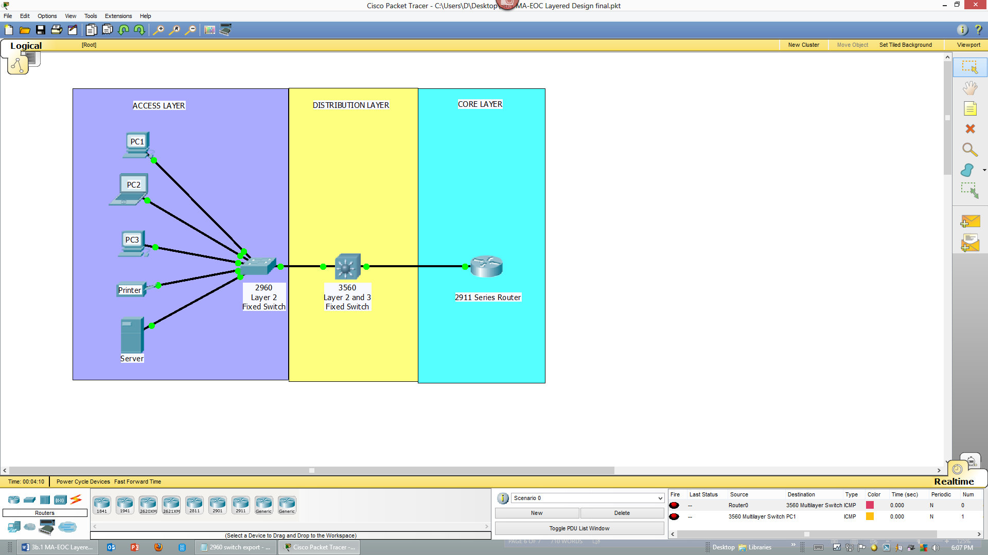

2960 Fixed Switch Configuration:

Cisco_2960_Switch# **show running-configuration**

version 12.2

no service timestamps log datetime msec

no service timestamps debug datetime msec

no service password-encryption

!

hostname "Cisco 2960 Switch"

!

spanning-tree mode pvst

!

interface FastEthernet0/1

!

(output omitted)

!

interface GigabitEthernet1/1

!

interface GigabitEthernet1/2

!

interface Vlan1

ip address 192.168.10.2 255.255.255.0

shutdown

!

ip default-gateway 192.168.10.1

!

!

line con 0

!

line vty 0 4

no login

line vty 5 15

no login

!

!

End

3560 Switch Configuration

Cisco_3560_Switch# **show running-configuration**

version 12.2

no service timestamps log datetime msec

no service timestamps debug datetime msec

no service password-encryption

!

hostname "Cisco 3560 Switch"

!

ip routing

!

spanning-tree mode pvst

!

interface FastEthernet0/1

no switchport

ip address 10.11.48.2 255.255.255.252

duplex auto

speed auto

!

interface FastEthernet0/2

!

<output omitted)

!

interface GigabitEthernet0/1

no switchport

ip address 192.168.10.1 255.255.255.0

duplex auto

speed auto

!

interface GigabitEthernet0/2

no switchport

ip address 192.168.11.1 255.255.255.0

duplex auto

speed auto

!

interface Vlan1

no ip address

shutdown

!

router rip

version 2

network 10.0.0.0

network 192.168.10.0

network 192.168.11.0

no auto-summary

!

ip classless

!

line con 0

!

line aux 0

!

line vty 0 4

login

line vty 5 15

no login

!

End

2911 Router Configuration

2911_Series_Router# **show running-configuration**

version 15.1

no service timestamps log datetime msec

no service timestamps debug datetime msec

no service password-encryption

!

hostname "2911 Series Router"

!

license udi pid CISCO2911/K9 sn FTX15248II7

!

spanning-tree mode pvst

!

interface Loopback0

ip address 1.1.1.1 255.255.255.252

!

interface GigabitEthernet0/0

ip address 10.11.48.1 255.255.255.252

duplex auto

speed auto

!

<output omitted>

!

router rip

version 2

network 10.0.0.0

network 1.0.0.0

no auto-summary

!

ip classless

!

line con 0

!

line aux 0

!

line vty 0 4

login

!

end

Identify elements of the model that map to IT-related content:

* Network Design
* Cisco Three-Layer Hierarchical Model
* Access Layer
* Distribution Layer
* Core Layer
* Network Configuration
* Network device show running-configuration command