Documentation Tree (Instructor Version)

**Instructor Note**: Red font color or Gray highlights indicate text that appears in the instructor copy only.

1. Objective

Identify common STP configuration issues.

Instructor Note: This activity may be completed individually or in small groups.

1. Scenario

The employees in your building are having difficulty accessing a web server on the network. You look for the network documentation that the previous network engineer used before he transitioned to a new job; however, you cannot find any network documentation whatsoever.

Therefore, you decide create your own network recordkeeping system. You decide to start at the access layer of your network hierarchy. This is where redundant switches are located, as well as the company servers, printers, and local hosts.

You create a matrix to record your documentation and include access layer switches on the list. You also decide to document switch names, ports in use, cabling connections, and root ports, designated ports, and alternate ports.

For more detailed instructions on how to design your model, use the student PDF that accompanies this activity.

1. Resources

* Packet Tracer software
* Word processing software

1. Directions
   1. Create the topology diagram with three redundant switches.
   2. Connect host devices to the switches.
   3. Create the switch documentation matrix.
      1. Name and switch location
      2. General switch description
      3. Model, IOS version, and image name
      4. Switch serial number
      5. MAC address
      6. Ports currently in use
      7. Cable connections
      8. Root ports
      9. Designated ports, status, and cost
      10. Alternate ports, status, and cost
   4. Use show commands to locate Layer 2 switch information.
      1. show version
      2. show cdp neighbors detail
      3. show spanning-tree
2. Instructor – Example Activity Answer

Topology Diagram Example

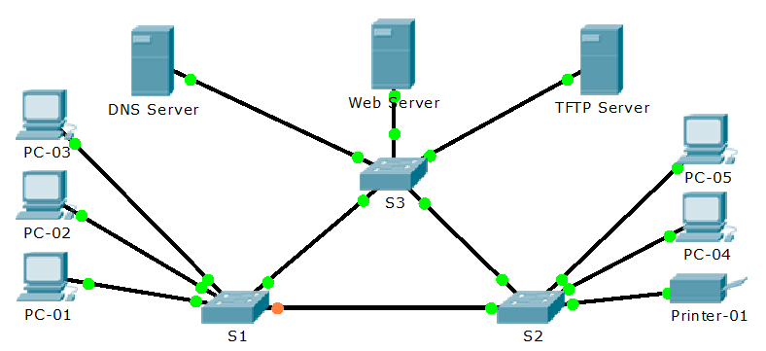

Documentation Form Example (S1 only)

|  |  |
| --- | --- |
| Switch Name and Location | S1 – Main Distribution Facility |
| General Switch Description | Access Layer Switch – grants network access for PCs 01-03 |
| Switch Model, IOS Version, and Image Name | WS-C2960-24TT  12.2  C2960-LANBASE-M |
| Switch Serial Number | FOC1033Z1EY |
| Switch MAC Address | 0050.0F5C.A2D1 |
| Ports in Use | Fa0/2  Fa0/3  Fa0/1  Gi1/1  Gi1/2 |
| Cable Connections | Fa0/2 connected to PC-02  Fa0/3 connected to PC-03  Fa0/1 connected to PC-01  Gi1/1 connected to S2 Gi1/1  Gi1/2 connected to S3 Gi1/2 |
| Root Port | Gi1/2 |
| Designated Port(s), Status, and Cost | Fa0/1, Forwarding, Cost 19  Fa0/3, Forwarding, Cost 19  Fa0/2, Forwarding, Cost 19 |
| Alternate Port(s), Status, and Cost | (non-designated port) Gi1/1, Blocking, Cost 4 |

S1# **show version**

Cisco IOS Software, C2960 Software (C2960-LANBASE-M), Version 12.2(25)FX, RELEASE SOFTWARE (fc1)

Copyright (c) 1986-2005 by Cisco Systems, Inc.

Compiled Wed 12-Oct-05 22:05 by pt_team

ROM: C2960 Boot Loader (C2960-HBOOT-M) Version 12.2(25r)FX, RELEASE SOFTWARE (fc4)

System returned to ROM by power-on

Cisco WS-C2960-24TT (RC32300) processor (revision C0) with 21039K bytes of memory.

24 FastEthernet/IEEE 802.3 interface(s)

2 Gigabit Ethernet/IEEE 802.3 interface(s)

63488K bytes of flash-simulated non-volatile configuration memory.

Base ethernet MAC Address : 0050.0F5C.A2D1

Motherboard assembly number : 73-9832-06

Power supply part number : 341-0097-02

Motherboard serial number : FOC103248MJ

Power supply serial number : DCA102133JA

Model revision number : B0

Motherboard revision number : C0

Model number : WS-C2960-24TT

System serial number : FOC1033Z1EY

Top Assembly Part Number : 800-26671-02

Top Assembly Revision Number : B0

Version ID : V02

CLEI Code Number : COM3K00BRA

Hardware Board Revision Number : 0x01

Switch Ports Model SW Version SW Image

------ ----- ----- ---------- ----------

* 1 26 WS-C2960-24TT 12.2 C2960-LANBASE-M

Configuration register is 0xF

S1#

S1# **show cdp neighbors detail**

Device ID: S2

Entry address(es):

Platform: cisco 2960, Capabilities: Switch

Interface: GigabitEthernet1/1, Port ID (outgoing port): GigabitEthernet1/1

Holdtime: 151

Version :

Cisco IOS Software, C2960 Software (C2960-LANBASE-M), Version 12.2(25)FX, RELEASE SOFTWARE (fc1)

Copyright (c) 1986-2005 by Cisco Systems, Inc.

Compiled Wed 12-Oct-05 22:05 by pt_team

advertisement version: 2

Duplex: full

---------------------------

Device ID: S3

Entry address(es):

Platform: cisco 2960, Capabilities: Switch

Interface: GigabitEthernet1/2, Port ID (outgoing port): GigabitEthernet1/2

Holdtime: 151

Version :

Cisco IOS Software, C2960 Software (C2960-LANBASE-M), Version 12.2(25)FX, RELEASE SOFTWARE (fc1)

Copyright (c) 1986-2005 by Cisco Systems, Inc.

Compiled Wed 12-Oct-05 22:05 by pt_team

advertisement version: 2

Duplex: full

S1#

S1# **show spanning-tree**

VLAN0001

Spanning tree enabled protocol ieee

Root ID Priority 32769

Address 0001.635E.CE64

Cost 4

Port 26(GigabitEthernet1/2)

Hello Time 2 sec Max Age 20 sec Forward Delay 15 sec

Bridge ID Priority 32769 (priority 32768 sys-id-ext 1)

Address 0050.0F5C.A2D1

Hello Time 2 sec Max Age 20 sec Forward Delay 15 sec

Aging Time 20

Interface Role Sts Cost Prio.Nbr Type

---------------- ---- --- --------- -------- --------------------------------

Fa0/1 Desg FWD 19 128.1 P2p

Fa0/3 Desg FWD 19 128.3 P2p

Fa0/2 Desg FWD 19 128.2 P2p

Gi1/1 Altn BLK 4 128.25 P2p

Gi1/2 Root FWD 4 128.26 P2p

S1#

1. Identify elements of the model that map to IT-related content:

* Designated ports
* Root ports
* Alternate ports
* STP switch commands output
* LAN, Access-Layer documentation