Packet Tracer – Skills Integration Challenge

1. Topology

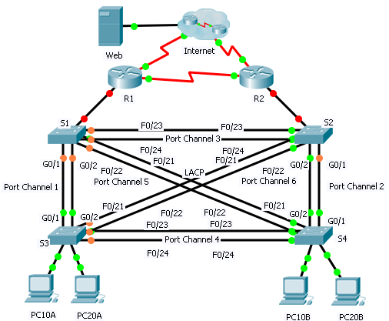

Addressing Table

|  |  |  |  |  |  |
| --- | --- | --- | --- | --- | --- |
| Device | Interface | IP Address | Subnet Mask | Default Gateway | VLAN Association |
| R1 | G0/0.1 | 192.168.99.1 | 255.255.255.0 | N/A | VLAN 99 |
| G0/0.10 | 192.168.10.1 | 255.255.255.0 | N/A | VLAN 10 |
| G0/0.20 | 192.168.20.1 | 255.255.255.0 | N/A | VLAN 20 |
| S0/0/0 | 209.165.200.238 | 255.255.255.224 | N/A | N/A |
| S0/0/1 | 192.168.1.1 | 255.255.255.0 | N/A | N/A |
| R2 | G0/0.1 | 192.168.99.2 | 255.255.255.0 | N/A | VLAN 99 |
| G0/0.10 | 192.168.10.2 | 255.255.255.0 | N/A | VLAN 10 |
| G0/0.20 | 192.168.20.2 | 255.255.255.0 | N/A | VLAN 20 |
| S0/0/0 | 192.168.1.2 | 255.255.255.0 | N/A | N/A |
| S0/0/1 | 209.165.202.158 | 255.255.255.224 | N/A | N/A |
| ISP | S0/0/0 | 209.165.200.225 | 255.255.255.224 | N/A | N/A |
| S0/0/1 | 209.165.202.129 | 255.255.255.224 | N/A | N/A |
| Web | NIC | 64.104.13.130 | 255.255.255.252 | 64.104.13.129 | N/A |
| PC10A | NIC | 192.168.10.101 | 255.255.255.0 | 192.168.10.1 | VLAN 10 |
| PC10B | NIC | 192.168.10.102 | 255.255.255.0 | 192.168.10.1 | VLAN 10 |
| PC20A | NIC | 192.168.20.101 | 255.255.255.0 | 192.168.20.1 | VLAN 20 |
| PC20B | NIC | 192.168.20.102 | 255.255.255.0 | 192.168.20.1 | VLAN 20 |

1. Scenario

In this activity, two routers are configured to communicate with each other. You are responsible for configuring subinterfaces to communicate with the switches. You will configure inter-VLAN routing with RIPv2, VLANs with VTP, trunking, and EtherChannel with Rapid PVST+. The PCs and Internet devices are all preconfigured.

1. Requirements

You are responsible for configuring routers **R1** and **R2** and switches **S1**, **S2**, **S3**, and **S4**.

**Note**: Packet Tracer does not allow assigning point values less than 1. Because this activity is checking over 150 items, not all configurations are assigned a point value. Click **Check Results** > **Assessment Items** to verify you have correctly configured all items.

Inter-VLAN Routing

On **R1** and **R2**, enable and configure the subinterfaces with the following requirement:

* Configure the appropriate dot1Q encapsulation.
* Configure VLAN 99 as the native VLAN.
* Configure the IP address for the subinterface according to the Addressing Table.

Routing

Configure RIPv2 using the following requirements:

* Do not advertise the network connected to the Internet.
* Disable autosummarization.
* Disable RIP updates for each subinterface.

VTP and VLANs

* Configure S1 as the VTP server. Configure all other switches as VTP clients. They are not allowed to create VLANs.
* VTP domain is **CCNA**.
* VTP password is **cisco123**.
* Create VLAN 10, 20, and 99 on **S1**.
* Configure the following static ports for **S1** and **S2**:
* F0/1 – 9 as access ports in VLAN 10.
* F0/10 – 19 as access ports in VLAN 20.
* F0/20 – F24 and G0/1 – 0/2 as the native trunk for VLAN 99.
* Configure the following static ports for **S3** and **S4**:
* F0/1 – 9 as access ports in VLAN 10.
* F0/10 – 20 as access ports in VLAN 20.
* F0/21 – F24 and G0/1 – 0/2 as the native trunk for VLAN 99.

EtherChannels

* All EtherChannels are configured as LACP.
* All EtherChannels are statically configured to trunk all VLANs including VLAN 99 as the native VLAN.
* Use the following table to configure the appropriate switch ports to form EtherChannels:

|  |  |  |
| --- | --- | --- |
| Port Channel | Device: Ports | Device: Ports |
| 1 | S1: G0/1 – 2 | S3: G0/1 – 2 |
| 2 | S2: G0/1 – 2 | S4: G0/1 – 2 |
| 3 | S1: F0/23 – 24 | S2: F0/23 – 24 |
| 4 | S3: F0/23 – 24 | S4: F0/23 – 24 |
| 5 | S1: F0/21 – 22 | S4: F0/21 – 22 |
| 6 | S2: F0/21 – 22 | S3: F0/21 - 22 |

Spanning Tree

* Configure per-VLAN rapid spanning tree mode for all switches.
* Configure spanning tree priorities according to the table below:

|  |  |  |
| --- | --- | --- |
| Device | VLAN 10 Priority | VLAN 20 Priority |
| S1 | 4096 | 8192 |
| S2 | 8192 | 4096 |
| S3 | 32768 | 32768 |
| S4 | 32768 | 32768 |

Connectivity

* All PCs should be able to ping the **Web** and other PCs.