Packet Tracer – Skills Integration Challenge

1. Topology

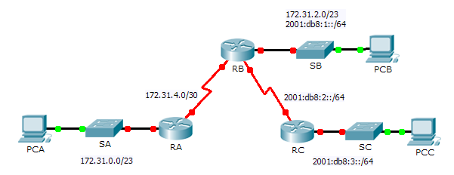

1. Addressing Table

|  |  |  |  |  |
| --- | --- | --- | --- | --- |
| Device | Interface | IPv4 Address | Subnet Mask | Default Gateway |
| IPv6 Address/Prefix | |
| RA | G0/0 | 172.31.0.1 | 255.255.254.0 | N/A |
| S0/0/0 | 172.31.4.1 | 255.255.255.252 | N/A |
| RB | G0/0 | 172.31.2.1 | 255.255.254.0 | N/A |
| 2001:DB8:1::1/64 | | N/A |
| S0/0/0 | 172.31.4.2 | 255.255.255.252 | N/A |
| S0/0/1 | 2001:DB8:2::1/64 | | N/A |
| RC | G0/0 | 2001:DB8:3::1/64 | | N/A |
| S0/0/0 | 2001:DB8:2::2/64 | | N/A |
| PC-A | NIC |  |  |  |
| PC-B | NIC |  |  |  |
|  | |  |
| PC-C | NIC |  | |  |

1. Background

In this Skills Integration Challenge, your focus is OSPFv2 and OSPFv3 configurations. You will configure IP addressing for all devices. Then you will configure OSPFv2 routing for the IPv4 portion of the network and OSPFv3 routing for the IPv6 portion of the network. One router will be configured with both IPv4 and IPv6 configurations. Finally, you will verify your configurations and test connectivity between end devices.

**Note:** This activity is graded using a combination of assessment items and connectivity tests. The instructions window will not show your score. To see your score, click **Check Results** > **Assessment Items**. To see the results of a specific connectivity test, click **Check Results** > **Connectivity Tests**.

1. Requirements

* Use the following requirements to configure **RA** addressing and OSPFv2 routing:
* IPv4 addressing according to the Addressing Table
* Process ID 1
* Router ID 1.1.1.1
* Network address for each interface
* LAN interface set to passive (do not use the **default** keyword)
* Use the following requirements to configure **RB** addressing, OSPFv2 routing and OSPFv3 routing:
* IPv4 and IPv6 addressing according to the Addressing Table

Set the Gigabit Ethernet 0/0 Link Local address to FE80::1

* OSPFv2 routing requirements:

Process ID 1

Router ID 2.2.2.2

Network address for each interface

LAN interface set to passive (do not use the **default** keyword)

* OSPFv3 routing requirements:

Enable IPv6 routing

Process ID 1

Router ID 2.2.2.2

Enable OSPFv3 on each interface

* Use the following requirements to configure **RC** addressing and OSPFv3 routing:
* IPv6 addressing according to the Addressing Table

Set the Gigabit Ethernet 0/0 Link Local address to FE80::3

* OSPFv3 routing requirements:

Enable IPv6 routing

Process ID 1

Router ID 3.3.3.3

Enable OSPFv3 on each interface

* Configure PCs with appropriate addressing.
* **PCA** and **PCB** IPv4 addressing must use the last assignable address in the IPv4 subnet.
* **PCB** and **PCC** IPv6 addressing must use the second assignable address in the IPv6 network and the link-local FE80 address as the default gateway.
* Finish the Addressing Table documentation
* Verify your configurations and test connectivity
* OSPF neighbors should be established and routing tables should be complete
* Pings between PCA and PCB should be successful
* Pings between PCB and PCC should be successful

**Note**: If OSPFv3 has not converged, check the status of interfaces using the **show ip ospf interface** command. Sometimes, the OSPFv3 process needs to deleted from the configuration and reapplied to force convergence.