Packet Tracer – Skills Integration Challenge

1. Topology

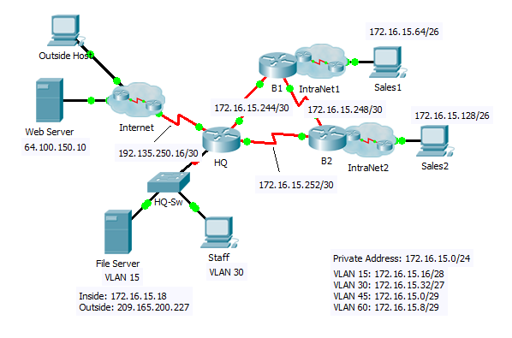

1. Addressing Table

|  |  |  |  |  |
| --- | --- | --- | --- | --- |
| Device | Interface | IP Address | Subnet Mask | Default Gateway |
| HQ | G0/0.15 | 172.16.15.17 | 255.255.255.240 | N/A |
| G0/0.30 | 172.16.15.33 | 255.255.255.224 | N/A |
| G0/0.45 | 172.16.15.1 | 255.255.255.248 | N/A |
| G0/0.60 | 172.16.15.9 | 255.255.255.248 | N/A |
| S0/0/0 | 172.16.15.245 | 255.255.255.252 | N/A |
| S0/0/1 | 172.16.15.254 | 255.255.255.252 | N/A |
| S0/1/0 | 192.135.250.18 | 255.255.255.252 | N/A |
| B1 | G0/0 | 172.16.15.65 | 255.255.255.192 | N/A |
| S0/0/0 | 172.16.15.249 | 255.255.255.252 | N/A |
| S0/0/1 | 172.16.15.246 | 255.255.255.252 | N/A |
| B2 | G0/0 | 172.16.15.129 | 255.255.255.192 | N/A |
| S0/0/0 | 172.16.15.253 | 255.255.255.252 | N/A |
| S0/0/1 | 172.16.15.250 | 255.255.255.252 | N/A |
| HQ-Sw | VLAN 60 | 172.16.15.10 |  |  |
| Staff | NIC | DHCP Assigned | DHCP Assigned | DHCP Assigned |

1. VLANs and Port Assignments Table

|  |  |  |
| --- | --- | --- |
| VLAN Number - Name | Port assignment | Network |
| 15 - Servers | F0/11 - F0/20 |  |
| 30 - PCs | F0/1 - F0/10 |  |
| 45 - Native | G0/1 |  |
| 60 - Management | VLAN 60 |  |

1. Scenario

This activity includes many of the skills that you have acquired during your CCNA studies. First, you will complete the documentation for the network. So make sure you have a printed version of the instructions. During implementation, you will configure VLANs, trunking, port security and SSH remote access on a switch. Then, you will implement inter-VLAN routing and NAT on a router. Finally, you will use your documentation to verify your implementation by testing end-to-end connectivity.

1. Documentation

You are required to fully document the network. You will need a print out of this instruction set, which will include an unlabeled topology diagram:

* 1. Label all the device names, network addresses and other important information that Packet Tracer generated.
  2. Complete the **Addressing Table** and **VLANs and Port Assignments Table**.
  3. Fill in any blanks in the **Implementation** and **Verification** steps. The information is supplied when you launch the Packet Tracer activity.

1. Implementation

Note: All devices in the topology except **HQ**, **HQ-Sw**, and **Staff** are fully configured. You do not have access to the other routers. You can access all the servers and PCs for testing purposes.

Implement to following requirements using your documentation:

**HQ-Sw**

•         Configure remote management access including IP addressing and SSH:

-       Domain is cisco.com

-       User **HQadmin** with password **ciscoclass**

-       Crypto key length of 1024

-       SSH version 2, limited to 2 authentication attempts and a 60 second timeout

-       Clear text passwords should be encrypted.

•         Configure, name and assign VLANs. Ports should be manually configured as access ports.

•         Configure trunking.

•         Implement port security:

-       On Fa0/1, allow 2 MAC addresses that are automatically added to the configuration file when detected. The port should not be disabled, but a syslog message should be captured if a violation occurs.

-       Disable all other unused ports.

**HQ**

•         Configure inter-VLAN routing.

•         Configure DHCP services for VLAN 30. Use **LAN**as the case-sensitive name for the pool.

•         Implement routing:

-       Use OSPF process ID 1 and router ID 1.1.1.1

-       Configure one network statement for the entire **172.16.15.0/24** address space

-       Disable interfaces that should not send OSPF messages.

-       Configure a default route to the Internet.

•         Implement NAT:

-       Configure a standard, one statement ACL number 1. All IP addresses belonging to the **172.16.15.0/24** address space are allowed.

-       Refer to your documentation and configure static NAT for the File Server.

-       Configure dynamic NAT with PAT using a pool name of your choice, a /30 mask, and these two public addresses:

**209.165.200.225 and 209.165.200.226**

**Staff**

Verify **Staff** has received full addressing information from **HQ**.

1. Verification

All devices should now be able to ping all other devices. If not, troubleshoot your configurations to isolate and solve problems. A few tests include:

•         Verify remote access to **HQ-Sw** by using SSH from a PC.

•         Verify VLANs are assigned to appropriate ports and port security is in force.

•         Verify OSPF neighbors and a complete routing table.

•         Verify NAT translations and statics.

-       **Outside Host**should be able to access **File Server** at the public address.

-       Inside PCs should be able to access **Web Server**.

•         Document any problems you encountered and the solutions in the **Troubleshooting Documentation**table below.

1. Troubleshooting Documentation

|  |  |
| --- | --- |
| Problem | Solution |
|  |  |
|  |  |
|  |  |
|  |  |

1. Suggested Scoring Rubric

Packet Tracer scores 70 points. Documentation is worth 30 points.