5G and *The Future of Wireless Communications*

Sean Grenfell

***Abstract—Modern society has grown fond of being connected to the world wide web, however access to the internet is no longer a simple luxury but a necessity of everyday life. Research into 5G strives to outline the necessary steps that must be taken to ensure that not only are our current wireless access needs being met, but that the capacity of these networks grows with our ever increasing data needs. To do this we will need to use our existing spectrum base more efficiently, deploy new types of mini broadcast towers, and incorporate new spectrum for use in our growing wireless networks.***

***Index Terms—Densification, LOS or Line of Sight, Spectral Efficiency, Spectrum***

1. INTRODUCTION

T

HE PAST few decades have seen remarkable advances in wireless communication technology, from the lowly voice only 1G network to the multimedia powerhouse of 4G. The next challenge involves interconnecting everything that is capable of wireless communication. Seamless wireless connectivity of all capable devices is the future and that list of capable devices is growing every day. It is because of this huge need for wireless communication that 4G will no longer be sufficient. A new paradigm in wireless technology must be established to take advantage of the power at our finger tips. Consumer demand will need 4g’s successor to be more than a simple upgrade; it needs to be able to handle extreme data consumption from billions of wireless interconnected devices all over the world [1].

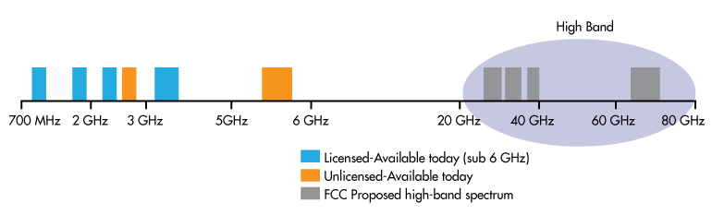 While 4G was about big data, 5G will be about bigger data and seamless delivery to exponentially more devices than ever before. It is expected that the data capacity that 5G will service will be on the order of 1000 times the capacity of current networks [5]. Extensive research will be needed to bring such a network to fruition. 5G is in the process of being standardized as an array of companies look to innovate in the challenging, but rewarding, wireless communication space. Three key things have emerged as the pillars to ensuring 5G’s success in the coming years [1].

The first is spectrum; this is needed to ensure that the proper amount of frequency space is available. Second is spectral efficiency, the use of those frequencies needs to be as efficient as possible due to the sheer amount of traffic volume. Lastly, densification, the process of adding cell sites to guarantee that the need never outstrips the capacity. It is through these initiatives that researchers hope to bring the next generation of wireless communication to the masses.

Spectrum refers to the actual frequencies that can be used for mobile traffic. At the moment, there simply are not enough of them to support something as ambitious as 5G. The procurement of additional spectrums is one of the main undertakings in making 5G viable. There are, however, large portions of frequencies that are used but only in limited capacities. Many of these usable frequencies will need to be repurposed for use in the new mobile network. These frequencies and the services that use them will need to be able to share with mobile traffic on an unprecedented scale.

1. SPECTRUM

Wireless communications have reached a tipping point; the demand for connectivity and data consumption necessitates that more frequencies become available. In order to facilitate its growth, existing frequency bands must be shared for use in mobile network traffic. This includes most if the sub 6GHz frequencies that have been cordoned off for other uses. Research into frequencies 10GHz and higher, as in Fig. 1, is also expected to show results. However, it is important to note that if these higher frequencies remain out of reach, the lower bands will be even more vital to 5G’s success. Technologies enabling the coexistence of current legacy systems and mobile traffic within these frequency bands will be absolutely essential to 5G’s deployment.

Fig. 1. Displays the Various frequency bands that are in use today as well as some higher band frequencies being proposed to the FCC for use in 5G’s deployment.

1. SPECTRAL EFFICIENCY

The second pillar essential to the successful rollout of 5G is spectral efficiency. While it is true that the network will have more of the spectrum to work with than ever before, it will be imperative that it is used as efficiently as possible. Currently 4G uses a protocol called LTE or Long Term Evolution and that in turn uses a couple of prominent modulation techniques that are used for efficiencies sake, OFDM and OFDMA [2]. However these will not be suitable going forward for a number of reasons. These two modulation protocols have issues synchronizing with multiple sources, and in the 5G world, synchronization with multiple access points will be paramount.

In addition the speeds that these networks operate with will not be sufficient for much longer. Network speeds are going to have to dramatically increase to keep pace with data consumptions rates of the users of tomorrow. 4k streaming and augmented reality are examples of data intensive activities that will be ubiquitous among our mobile users. We will need to use frequencies capable of handling very high speed transmissions.

One approach that has shown promise is the use of the terahertz band frequencies, shown in Fig. 2. This will enable data delivery at a rate not seen before from wireless delivery platforms; the jump could be to as high as 1012 bps. However a big drawback of using terahertz frequencies is the limited range. Range is limited due to the immense amount of power it takes to project it at further distances. This approach would have been completely impractical if it weren’t for the densification process that installs many much smaller cell-sites all over a coverage area. 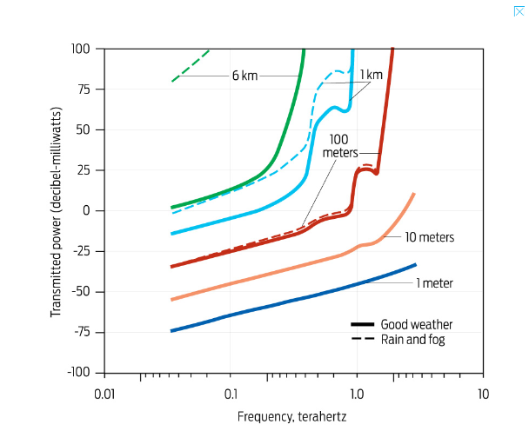

Fig. 2. Shows the relative power draw needed to send a signal various distances.

Covering a populated area with many smaller cell-sites has two benefits. The first being that it allows for much more coverage even in confined spaces. Secondly, it allows for technologies such as the use of terahertz frequencies to be used without drawing costly power [4]. However, there are disadvantages to consider when attempting to use the terahertz band.

Some of the largest hurdles that will need to be addressed is the noneline-of-sight connections (NLoS) [4]. Even with the increase in small cell sites there will still be many places these signals cannot reach. One proposed solution is the use of smart antennas, shown in Fig. 3. These can be used to retransmit or mirror the signal around so that no packets are dropped. This would also help reduce the impact of molecular absorption loss and the Doppler Effect. With this in mind, the limited range would no longer be an issue and terahertz band frequencies can be used to deliver much higher wireless speeds.

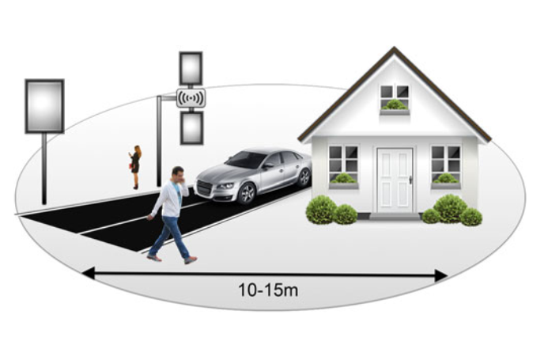

Fig. 3. Smart antennas for 5G small cells with terahertz-band communication. These antennas have a dielectric mirror coupled to each antenna and assist by reflecting signals from neighboring base stations.

1. DENSIFICATION

The last pillar vital to 5G’s deployment is a process known as densification, shown in Fig. 4. This process not only helps with efficiency of up to 24.5 times, but also ensures that there are always enough resources for the consumers to use. The use of many smaller cells as opposed to fewer larger ones gives rise to the increased possibility of cooperation between cells also known as cooperation opportunities [3]. This also allows for a hot spot effect, allowing for coverage where it may not have been before. In addition, a densified network spectrum efficiency is increased through the reuse of the available spectrum.

However, densification does have its share of complications. The first being interference from other nearby cells [5]. This can cause signals to degrade and become unreliable, especially for those at the edge of a coverage area. Another complication to consider is the substantial increase in cost with having more equipment to purchase and maintain as well as the increase in power consumption.

Interference can be addressed by limiting how high the antennas are situated in relation to each other, as well as being directed at the ground [5]. Reducing transmission power can keep signals from crisscrossing and thereby degrading each other’s signals. And finally setting up a thoroughly thought out network layout can also help reduce interference from other cells.

Another facet of Densification is the use of a type of technology that reflects signals. This would be useful for providing data streams to areas that are not in line of sight of an existing tower. Advanced algorithms would be needed to adjust the mirrors to reflect the signal in a way that reaches the most people at any given time.

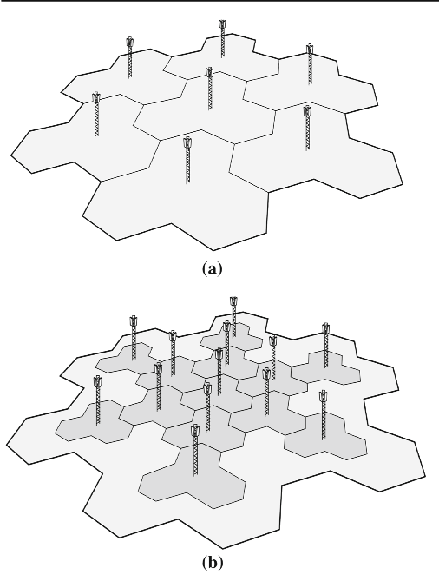

Fig. 4 a Macrocellular network topology, b densified macrocellular network topology

1. CONCLUSION

Wireless technology is on an unstoppable march forward. While 4G has met the needs of consumers these last few years admirably it cannot do so for much longer. Demand has grown at such a rate that research is already taking place on what will replace 5G, and it hasn’t even been fully defined yet. However, it is hoped that with the deployment of 5G in the near future, wireless communications can continue to grow at their unprecedented rate for decades to come. It is through the innovation of those areas mentioned above that wireless communication will effortlessly carry us into the future.

REFERENCES

[1] Badic, Biljana, Christian Drewes, Ingolf Karls, and Markus Mueck. “Introduction to Mobile Wireless Systems.”In Rolling Out 5G: Use Cases, Applications and Technology Solutions. Apress, 2016. http://proquest.safaribooksonline.com.lib-proxy.radford.edu/book/programming/mobile/9781484215067/firstchapter.

[2] Banelli, P, S Buzzi, G Colavolpe, A Modenini, F Rusek, and A Ugolini. “Modulation Formats and Waveforms for 5G Networks: Who will be the Heir of OFDM? [An Overview of Alternative Modulation Schemes for Imporved Spectral Efficiency].” IEEE SIGNAL PROCESSING MAGAZINE 31, no. 6(November 2014):80-93.

[3] Yang, C., J. Li, Q. Ni, A. Anpalagn and M. Guizani. “Interface-Aware Energy Efficiency Maximization in 5G Ultra-Dense Networks.” IEEE Transactions on Communcations 65, no. 2 (February 2017): 728-39. Doi:10.1109/TCOMM.2016.2638906.

[4] Michael Taynnan Barros, Robert Mullins, and Sasitharan Balasubramaniam. “Integrated Terahertz Communication With Reflectors for 5G Small-Cell Networks.” IEEE Transactions on Vehicular Technology, vol, 66, no. 7(July 2017).

[5] Sheikh Muhammad, Sae Joonas Lempiainen Jukka. “In preparation towards future cellular networks: the detailed analysis of macro and micro site densification and sector densification.” Telecommunication Systems. Vol. 65, Issue 4, p621-636 (August 2017).