Network by Design (Instructor Version)
Instructor Note: Red font color or Gray highlights indicate text that appears in the instructor copy only.
Objective
Explain the need to design a hierarchical network that is scalable.
Instructor Note: This activity can be completed by individuals or groups of two students. It can then be shared with another individual, group, class, or the instructor.
Scenario
Your employer is opening a new, branch office.
You have been reassigned to the site as the network administrator where your job will be to design and maintain the new branch network.
The network administrators at the other branches used the Cisco three-layer hierarchical model when designing their networks. You decide to use the same approach.
To get an idea of what using the hierarchical model can do to enhance the design process, you research the topic.
Resources
- World Wide Web access
- Word processing software
Directions
  - Use the Internet to find information and take notes about the Cisco three-layer hierarchical model. The site should include information about the:
    - Access layer
    - Distribution layer
    - Core layer
  - In your research, make sure to include:
    - A simple definition of each hierarchical layer
    - Three concise facts about each layer
    - Network device capabilities needed at each layer
    - A detailed graphic that shows a full, three-layer hierarchical model design
  - Create a simple table to organize and share your research with another student, group, the class, or instructor.

Suggested Activity Example Solution: (information based on The Cisco Three-Layered Hierarchical Model and LAN Design)
Access Layer
Definition | This hierarchical layer connects local clients to the network. It is sometimes called the desktop layer.
Facts | At this level:  - Network equipment works with the distribution and core layers to send and receive transmissions from clients and users.  - Collision domains are created using switches.  - Switches can be configured to filter MAC addresses and share bandwidth.
Network Device Features | - Port security  - VLANs functionality  - Fast Ethernet/Gigabit Ethernet transmissions  - Power over Ethernet (PoE)  - Link aggregation  - Quality of service (QoS)
Distribution Layer
Definition | This hierarchical layer provides policy-based, decision-making network connectivity to the access layer below it and the core layer above it.
Facts | At this level:  - Firewalls and access lists can be placed.  - Link aggregation can occur.  - Broadcast and multicast domain boundaries are created.
Network Device Features | - Layer 3 support  - High forwarding rate  - Gigabit Ethernet/10 Gigabit Ethernet  - Redundant components  - Security policies/access control lists  - Link aggregation  - Quality of service (QoS)
Core Layer
Definition | This hierarchical layer is the backbone of the network. It includes high-powered routers and switches that use high-speed cabling, such as fiber optics. The main function of this layer is reliable delivery of network packets.
Facts | At this level:  - All other layers of the hierarchical design model are supported.  - Load balancing is desired as an integral service.  - Efficient, fast, reliable data paths ensure fast network transmissions.
Network Device Features | - Layer 3 support  - Very high forwarding rate  - Gigabit Ethernet/10 Gigabit Ethernet  - Redundant components  - Link aggregation  - Quality of service (QoS)
Three-Layer Hierarchical Design Graphic | 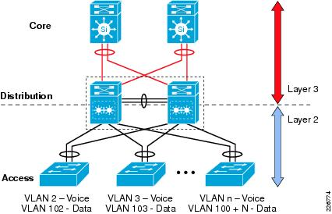
Identify elements of the model that map to IT-related content:
- Network design
- Cisco three-layer hierarchical model
- Access layer
- Distribution layer
- Core layer

