Imagine This (Instructor Version)

**Instructor Note**: Red font color or Gray highlights indicate text that appears in the instructor copy only.

1. Objective

Explain the operation of link aggregation in a switched LAN environment.

Instructor Notes: This activity is introductory in nature and designed to help students envision how switches can be physically connected to use EtherChannel.

Students can work individually or in very small groups to research the EtherChannel concept and present their findings briefly to the class.

1. Scenario

It is the end of the work day. In your small- to medium-sized business, you are trying to explain to the network engineers about EtherChannel and how it looks when it is physically set up. The network engineers have difficulties envisioning how two switches could possibly be connected via several links that collectively act as one channel or connection. Your company is definitely considering implementing an EtherChannel network.

Therefore, you end the meeting with an assignment for the engineers. To prepare for the next day’s meeting, they are to perform some research and bring to the meeting one graphic representation of an EtherChannel network connection. They are tasked with explaining how an EtherChannel network operates to the other engineers.

When researching EtherChannel, a good question to search for is “What does EtherChannel look like?” Prepare a few slides to demonstrate your research that will be presented to the network engineering group. These slides should provide a solid grasp of how EtherChannels are physically created within a network topology. Your goal is to ensure that everyone leaving the next meeting will have a good idea as to why they would consider moving to a network topology using EtherChannel as an option.

1. Required Resources

* Internet connectivity for research
* Software program for presentation model
  1. Use the Internet to research graphics depicting EtherChannel.
  2. Prepare a three-slide presentation to share with the class.
     1. The first slide should show a very short, concise definition of a switch-to-switch EtherChannel.
     2. The second slide should show a graphic of how a switch-to-switch EtherChannel physical topology would look if used in a small- to medium-sized business.
     3. The third slide should list three advantages of using EtherChannel.

1. Instructor Activity Example Resource

**Slide 1: Definition**

[EtherChannel](http://www.cisco.com/en/US/tech/tk389/tk213/tsd_technology_support_protocol_home.html) - EtherChannel provides incremental trunk speeds between Fast Ethernet, Gigabit Ethernet, and 10 Gigabit Ethernet. EtherChannel combines multiple Fast Ethernet up to 800 Mbps, Gigabit Ethernet up to 8 Gbps, and 10 Gigabit Ethernet up to 80 Gbps.

**Slide 2: EtherChannel Physical Graphic Example**

EtherChannel Physical Image

[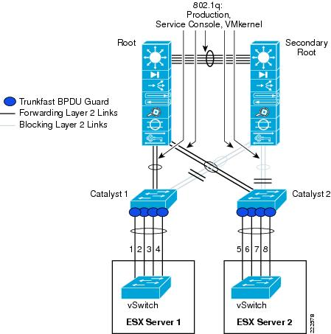](https://www.google.com/search?q=etherchannel&client=firefox-a&hs=Vr5&rls=org.mozilla:en-US:official&source=lnms&tbm=isch&sa=X&ei=IAbkUeLfKNOo4AP42oHwBw&ved=0CAkQ_AUoAQ&biw=1920&bih=920#facrc=_&imgdii=63eOUfibH4uDNM%3A%3BgIiqyimdjZKPTM%3B63eOUfibH4uDNM%3A&imgrc=63eOUfibH4uDNM%3A%3Bf9XB_7YjzmzHZM%3Bhttp%253A%252F%252Fcdn.ttgtmedia.com%252FITKE%252Fuploads%252Fblogs.dir%252F58%252Ffiles%252F2008%252F12%252Fetherchannel3.jpg%3Bhttp%253A%252F%252Fitknowledgeexchange.techtarget.com%252Fnetwork-technologies%252Ftag%252Fetherchannel%252F%3B913%3B449)

**Slide 3: Advantages to using EtherChannel (these will vary per student group):**

* + - Flexible choice of bundling physical connections
    - Scalable bandwidth with resiliency and load sharing across bundled switch links
    - Can also be used to connect router interfaces and servers

1. Identify elements of the model that map to IT-related content:

* EtherChannel
* Physical depiction of EtherChannel
* Load balancing
* Scalable bandwidth
* Trunking