Lab – Configuring a Wireless Router and Client (Instructor Version)

**Instructor Note**: Red font color or Gray highlights indicate text that appears in the instructor copy only.

1. Topology

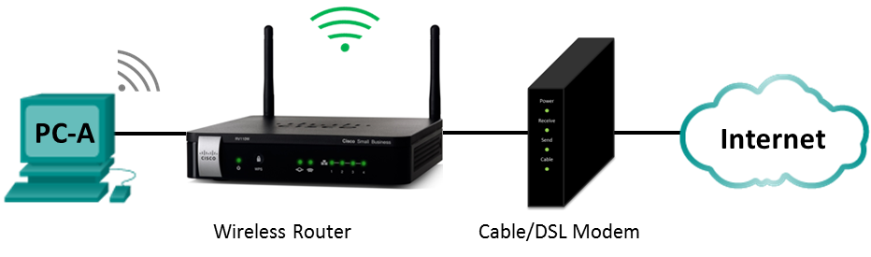

1. Wireless Router Settings

|  |  |
| --- | --- |
| Network Name (SSID) | CCNA-Net |
| Network Passphrase | cisco-net |
| Router Password | cisco123 |

1. Objectives

Part 1: Configure Basic Settings on a Wireless Router

Part 2: Connect a Wireless Client

1. Background / Scenario

It is common to have access to the Internet from anywhere in the home or office today. Wireless connectivity is what makes that possible. Users have embraced the flexibility that wireless routers provide for accessing the network and the Internet.

In this lab, you will configure a wireless router, which includes applying WPA2 security settings and activating DHCP services. You will review some added features available on these routers, such as USB storage, parental controls, and time restrictions. You will also configure a wireless PC client.

1. Required Resources

* 1 Wireless Router
* 1 Cable or DSL modem (Optional - needed for Internet service and provided by ISP)
* 1 PC with a Wireless NIC (Windows 7, Vista, or XP)
* Ethernet cables as shown in the topology

1. Configure Basic Settings on a Wireless Router

One way to configure basic settings on a wireless router is to run the setup CD that came with the router. If you are using the setup CD, you can usually follow the directions provides on the setup CD. If the Setup CD is unavailable, download the setup program from the wireless router manufacturer.

If you choose to manually setup the wireless router, the following direction can be used as a guideline to setup the router.

* 1. Cable the network as shown in the topology.
     1. Power up the cable modem or DSL modem.
     2. Connect the Ethernet cable from your cable modem or DSL modem to the Internet port on the wireless router.
     3. Connect a PC to an unused Ethernet port on the wireless router.
     4. Connect power cable to the wireless router. Power up the wireless router. Allow time for the router to boot up.
  2. Configure the wireless settings.
     1. From the web browser on the PC, enter the IP address or website provided by the manufacturerto connect to the wireless router. Most wireless routers use http://192.168.1.1, http://192.168.0.1, or http://192.168.2.1. Enter the default username and password as provided by the manufacturer if necessary to log into the web interface.
     2. For the Internet setup, use DHCP for the Internet IP address unless the ISP provided you with a static IP address.
     3. For the local network, enable the DHCP server and use 192.168.100.1/24 as the internal network. The starting IP address is 192.168.100.100, and this network allows a maximum number of DHCP users to 150.
     4. Renew the IP address on the PC to continue. Enter **192.168.100.1** in the web browser to access the wireless router web interface.
     5. Configure the SSID as **CCNA-Net**.
     6. Configure the wireless security by setting the authentication type to use the **WPA2 Personal** and set the passphrase to **ccna-net**.
     7. Change the administrative password from the default password to **cisco123**.

1. Connect a Wireless Client

In Part 2, you will configure the PC’s wireless NIC to connect to the wireless router.

**Note**: This lab was performed using a PC running the Windows 7 operating system. You should be able to perform the lab with other Windows operating systems listed; however, menu selections and screens may vary.

* 1. Use the Network and Sharing Center.
     1. Open the **Network and Sharing Center** by clicking the Windows **Start** button > **Control Panel** > **View network status and tasks** under Network and Internet heading in the Category View.
     2. In the left pane, click the **Change adapter settings** link.

The **Network Connections** window provides the list of NICs available on this PC. Look for your **Local Area Connection** and **Wireless Network Connection** adapters in this window.

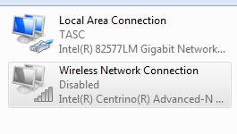

**Note**: VPN adapters and other types of network connections may also be displayed in this window.

* 1. Work with your wireless NIC.
     1. Select and right-click the **Wireless Network Connection** option to display a drop-down list. If your wireless NIC is disabled, you must **Enable** it.

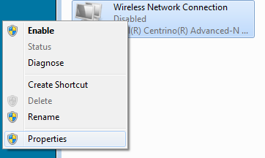

* + 1. Right-click the **Wireless Network Connection**, and then click **Connect/Disconnect**. This displays a list of SSIDs in range of your wireless NIC. Select **CCNA-Net**, and click **Connect**.

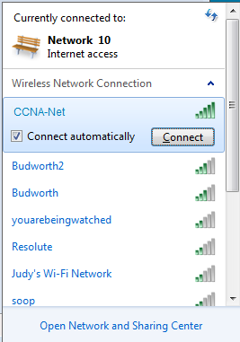

* + 1. When prompted, enter **cisco-net** to supply the network security key, and then click **OK**.

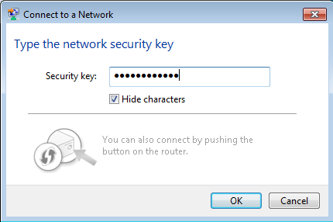

* + 1. The wireless icon should display in your taskbar when you have a wireless connection. Click this icon to display the list of SSIDs in range of your PC.



* + 1. The SSID **CCNA-Net** should now show that you are connected to the CCNA-Net wireless network.

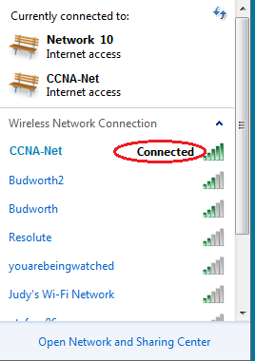

1. Reflection

Why would you not want to use WEP security for your wireless network?

_______________________________________________________________________________________

_______________________________________________________________________________________

_______________________________________________________________________________________

WEP uses RC4 encryption, which can be easily hacked. WPA2 use Advanced Encryption Standard (AES), which is considered the strongest encryption protocol.