Inside and Outside Control (Instructor Version)
Instructor Note: Red font color or Gray highlights indicate text that appears in the instructor copy only.
Objective
Explain how wireless LAN components are deployed in a small- to medium-sized business.
Instructor Notes: This activity can be completed individually, in small groups, or as a class.
Scenario
An assessment has been completed to validate the need for an upgrade to your small- to medium-sized wireless network. Approved for purchase are indoor and outdoor access points and one wireless controller. You must compare equipment models and their specifications before you purchase.
Therefore, you visit the Wireless Compare Products and Services web site and see a features chart for indoor and outdoor wireless access points and controller devices. After reviewing the chart, you note there is some terminology with which you are unfamiliar:
- Federal Information Processing Standard (FIPS)
- MIMO
- Cisco CleanAir Technology
- Cisco FlexConnect
- Band Select
Research the above terms. Prepare your own chart with your company’s most important requirements listed for purchasing the indoor and outdoor wireless access points and wireless controller. This chart will assist in validating your purchase order to your accounting manager and CEO.
Resources
Internet access to the World Wide Web
- Secure Background Knowledge of Wireless Terminology
  - Define unfamiliar wireless terms.
    - FIPS
    - MIMO
    - Cisco CleanAir Technology
    - Cisco FlexConnect
    - Band Select
  - Visit the Wireless Compare Products and Services web site.
    - Compare the devices in each category based on their feature sets.
    - Choose one model from each category: indoor, outdoor, and controller categories for the upgrades for your business.
  - Create a chart for each device chosen in Step 2b to include:
    - The main type of selected device (indoor access point, outdoor access point, or controller).
    - A graphic of each selected device.
    - Five of the most beneficial features that the selected models would provide your business.
  - After research is complete, explain, and justify your choices with another student, class group, or entire class.
Suggested Activity Completion Examples

Wireless device features definitions
FIPS | FIPS is the Federal Information Processing Standard regarding security for wireless devices.
MIMO | Unlike SISO (Single Input, Single Output), MIMO technology uses multiple radio bands and paths to transfer network data through multiple signals. Multiple antennas are used to send multiple spatial streams at the same time allowing for higher data transmission speeds and data delivery payloads.
Cisco CleanAir Technology | CleanAir Technology allows Cisco devices to:  - provide continual, system-wide wireless network discovery without wireless performance impact  - identify source, location and interference of wireless signals  take automatic steps to avoid current and future wireless interference while recording what steps were taken to do so
Cisco FlexConnect | FlexConnect (previously known as Hybrid Remote Edge Access Point or H-REAP) is a wireless solution which enables network administrators to configure and control access points located at remote locations. This is performed by using a local wireless controller through a WAN connection.
Band Select | Band Select is a Cisco-selected frequency range technology based upon the ISM (industrial, scientific, and medical) unlicensed usage. These include:  - 900 MHz  - 2.4 GHz (802.11b, g, and n standards) – better range but lower data rates  - 5 GHz (802.11a, n, and ac standards) – less range but higher data rates

Cisco 2600 Series Indoor Access Point
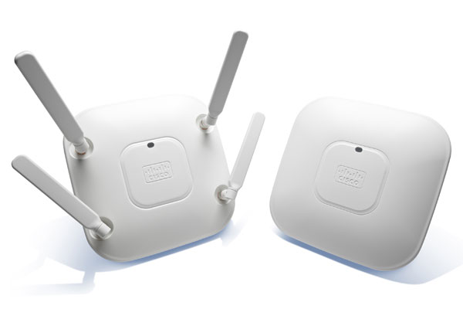
Wi-Fi Standards | 802.11 a, b, g, n  (supports Dual paths/radio rates of 2.4 and 5 GHz)  Data rate capabilities of 450 Mbps
FIPS | In process
CleanAir Technology | Yes
FlexConnect | Yes
Antennas | Internal and external

Cisco 1552I Series Outdoor Access Point
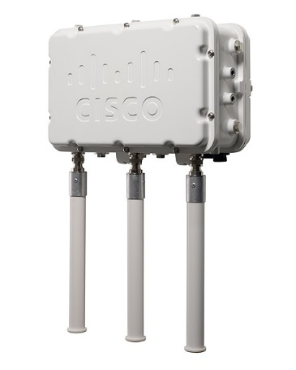
Wi-Fi Standards | 802.11 a, b, g, n  (supports Dual paths/radio rates of 2.4 and 5 GHz)  Data rate capabilities of 300 Mbps downstream with 10/100/1000 Mbps upstream
FIPS | In process
CleanAir Technology | Yes
FlexConnect | Yes
Antennas | Internal

Cisco Wireless Controller Module for ISR G2
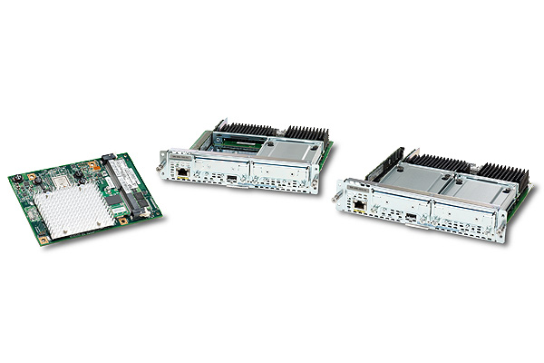
Data Throughput | 500 Mbps
Wireless Guest Services | Yes (up to 500 clients supported by 50 APs)  16 WLANs supported with 16 maximum VLANs allowed
CleanAir Technology | Yes
FlexConnect | Yes
Access Control Lists (ACLs for security) | Yes
Identify elements of the model that map to IT-related content:
- Wireless terminology
- Inside and outside wireless access points
- Wireless controllers
- Wireless device capabilities

