Packet Tracer - Configuring OSPF Advanced Features

1. Topology

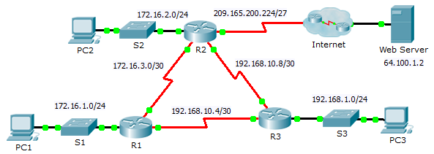

1. Addressing Table

|  |  |  |  |  |
| --- | --- | --- | --- | --- |
| Device | Interface | IPv4 Address | Subnet Mask | Default Gateway |
| R1 | G0/0 | 172.16.1.1 | 255.255.255.0 | N/A |
| S0/0/0 | 172.16.3.1 | 255.255.255.252 | N/A |
| S0/0/1 | 192.168.10.5 | 255.255.255.252 | N/A |
| R2 | G0/0 | 172.16.2.1 | 255.255.255.0 | N/A |
| S0/0/0 | 172.16.3.2 | 255.255.255.252 | N/A |
| S0/0/1 | 192.168.10.9 | 255.255.255.252 | N/A |
| S0/1/0 | 209.165.200.225 | 255.255.255.224 | N/A |
| R3 | G0/0 | 192.168.1.1 | 255.255.255.0 | N/A |
| S0/0/0 | 192.168.10.6 | 255.255.255.252 | N/A |
| S0/0/1 | 192.168.10.10 | 255.255.255.252 | N/A |
| PC1 | NIC | 172.16.1.2 | 255.255.255.0 | 172.16.1.1 |
| PC2 | NIC | 172.16.2.2 | 255.255.255.0 | 172.16.2.1 |
| PC3 | NIC | 192.168.1.2 | 255.255.255.0 | 192.168.1.1 |

1. Objectives

Part 1: Modify OSPF Default Settings

Part 2: Verify Connectivity

1. Scenario

In this activity, OSPF is already configured and all end devices currently have full connectivity. You will modify the default OSPF routing configurations by changing the hello and dead timers and adjusting the bandwidth of a link. Then you will verify that full connectivity is restored for all end devices.

1. Modify OSPF Default Settings
   1. Test connectivity between all end devices.

Before modifying the OSPF settings, verify that all PCs can ping the web server and each other.

* 1. Adjust the hello and dead timers between R1 and R2.
     1. Enter the following commands on **R1**.

R1(config)# **interface s0/0/0**

R1(config-if)# **ip ospf hello-interval 15**

R1(config-if)# **ip ospf dead-interval 60**

* + 1. After a short period of time, the OSPF connection with **R2** will fail. Both sides of the connection need to have the same timers in order for the adjacency to be maintained. Adjust the timers on **R2**.
  1. Adjust the bandwidth setting on R1.
     1. Trace the path between **PC1** and the web server located at 64.100.1.2. Notice that the path from **PC1** to 64.100.1.2 is routed through **R2**. OSPF prefers the lower cost path.
     2. On the **R1** Serial 0/0/0 interface, set the bandwidth to 64 Kb/s. This does not change the actual port speed, only the metric that the OSPF process on **R1** will use to calculate best routes.

R1(config-if)# **bandwidth 64**

* + 1. Trace the path between **PC1** and the web server located at 64.100.1.2. Notice that the path from **PC1** to 64.100.1.2 is redirected through **R3**. OSPF prefers the lower cost path.

1. Verify Connectivity

Verify all PCs can ping the web server and each other.