Packet Tracer - Skills Integration Challenge

1. Topology

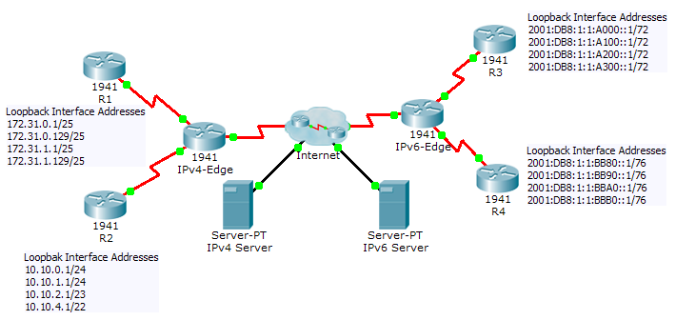

Addressing Table

|  |  |  |  |
| --- | --- | --- | --- |
| Device | Interface | IPv4 Address | Subnet Mask |
| IPv6 Address/Prefix | |
| IPv4-Edge | S0/0/0 | 172.31.6.1 | 255.255.255.252 |
| S0/0/1 | 10.10.8.1 | 255.255.255.252 |
| S0/1/0 | 209.165.200.226 | 255.255.255.224 |
| R1 | S0/0/0 | 172.31.6.2 | 255.255.255.252 |
| Lo8 | 172.31.0.1 | 255.255.255.128 |
| Lo9 | 172.31.0.129 | 255.255.255.128 |
| Lo10 | 172.31.1.1 | 255.255.255.128 |
| Lo11 | 172.31.1.129 | 255.255.255.128 |
| R2 | S0/0/1 | 10.10.8.2 | 255.255.255.252 |
| Lo1 | 10.10.0.1 | 255.255.255.0 |
| Lo2 | 10.10.1.1 | 255.255.255.0 |
| Lo3 | 10.10.2.1 | 255.255.254.0 |
| Lo4 | 10.10.4.1 | 255.255.252.0 |
| IPv6-Edge | S0/0/0 | 2001:DB8:A001:6::1/64 | |
| S0/0/1 | 2001:DB8:A001:7::1/64 | |
| S0/1/0 | 2001:DB8:CAFE:1::2/64 | |
| R3 | S0/0/0 | 2001:DB8:A001:7::2/64 | |
| R4 | S0/0/1 | 2001:DB8:A001:6::2/64 | |

1. Scenario

In this activity, you must implement EIGRP for IPv4 and IPv6 on two separate networks. Your task includes enabling EIGRP, assigning router IDs, changing the hello timers, and limiting EIGRP advertisements.

1. Requirements

EIGRP for IPv4

* Implement EIGRP on IPv4-enabled routers using Autonomous System 1.
* Use a single classful network address to advertise the loopback interfaces.
* Use the wildcard mask to advertise the /30 networks between **R1**, **R2** and **IPv4-Edge**.
* Use the **default** passive interface method and only allow EIGRP updates out the active EIGRP serial interfaces.
* Configure a directly attached default route on **IPv4-Edge** and propagate it in EIGRP updates.
* Configure the serial interfaces between **R1**, **R2** and **IPv4-Edge** to send hellos every 10 seconds.
* **R1** and **R2** should have a default route in the routing table (D*EX).
* Verify **R1** and **R2** can ping the **IPv4 Server**. **IPv4 Server** should also be able to ping every loopback address on **R1** and **R2**.

EIGRP for IPv6

* Implement EIGRP for IPv6 on the IPv6-enabled routers using Autonomous System 1.
* Assign **IPv6-Edge** with the router ID of 1.1.1.1
* Assign **R3** with the router ID of 3.3.3.3
* Assign **R4** with the router ID of 4.4.4.4
* Configure a directly attached default route on **IPv6-Edge** and propagate it in EIGRP updates.
* **R3** and **R4** should show a default external route in the routing table.
* Verify **R3** and **R4** can ping the **IPv6 Server**. **IPv6 Server** should also be able to ping every loopback address on **R3** and **R4**.

1. Suggested Scoring Rubric

**Note**: Packet Tracer does not currently grade EIGRP for IPv6 summary routes. Therefore, part of your grade depends on routing table verification by your instructor.

|  |  |  |
| --- | --- | --- |
| Scored Work | Possible Points | Earned Points |
| IPv6-Edge Routing Table | 10 |  |
| Packet Tracer Score | 90 |  |
| **Total Score** | **100** |  |