ITEC 350
Sample Exam

Name:

- The following figure shows a classification of interconnected processors by scale. Fill in the blacks using one of the terms, LAN, MAN, PAN, WAN, and Internet.

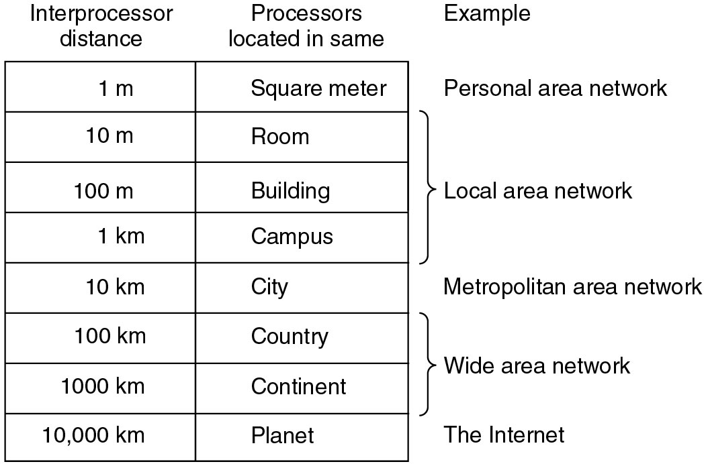
(1)
(2)
(3)
(4)
(5)

What do LAN, MAN, PAN, and WAN stand for, respectively?

(6) LAN

(7) MAN

(8) PAN

(9) WAN

- What is the principal difference between connectionless communication and connection-oriented communication?

- What is the main difference between TCP and UDP?

- Fill in the blanks in the following figure.

OSI 7 layer
(7)
(6)
(5)
(4)
(3)
(2)
(1)

Which of the OSI layers handles each of the following:

(8) Handling a transmission between two nodes which are directly
connected each other.

(9) Determining which route through the subnet to use.

- Which figure represents “Ad Hoc Network”? (a) or (b)?

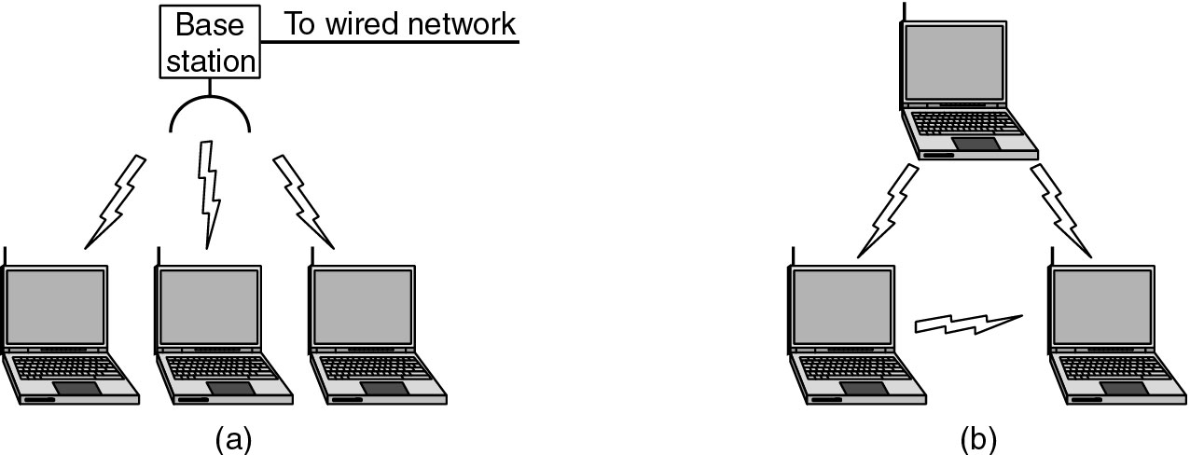

- In network protocol suites, define the following:

- Protocol

- Interface

- Pick five among the following acronyms and write what they stand for.

- POP
- FTP
- UDP
- TCP
- SMTP
- HTTP
- DNS
- ICMP
- PPP
- SATNET
- IRC

- What is the major difference between a packet and a frame?

- Among Quality of Service (QoS) issues, what is the Network “Availability”? Explain it.

- Subnet
(Each answer show the binary representation as well as the dotted decimal representation of IP address)

Radford Corporation has the following class C Internet License:

195.10.1.0

Radford Corp. would like to allow for at least 8 sub-networks using classful subnetting.

(1) How should Radford Corp. divide up the bits in their Class C license to allow for this?

(2) How many devices on each subnet would this allow?

(3) What would their subnet mask be?

(4) What would be the IP address (Subnet ID) of the second subnet?

(5) What would be the IP address of the first machine on the second subnet?

(6) What would be the IP address of the last machine on the second subnet?

(7) What is the broadcast address of the second subnet?

- What is promiscuous mode?

- What can be benefits by using the nonroutable address?

- What is the major role of DNS?

- What is the major role of the reverse lookup using .arpa?

- Parity bits -- Error Detection and Correction

Suppose that we are using two dimensional even parity (i.e., the number of 1’s in the bit stream is an even number). If there is an error while the data is transferred and the received parity bits are as follows, which bit is an error bit? Circle it.

[At the Receiver]
Parity bits
0 | 0 | 0 | 0 | 1
1 | 0 | 1 | 1 | 1
0 | 1 | 1 | 1 | 1
0  Parity bits | 0 | 0 | 1 | 1
1 | 0 | 0 | 1 | 0

- What is the difference between a Router and a Gateway?

- What is the major role of ARP?

