Lab 15

Create an application for a coffee shop ordering system. The GUI should appear as follows:

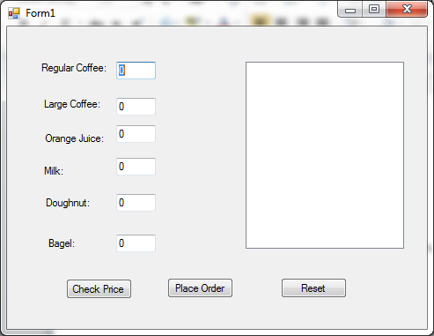

When values are entered and the check price button is clicked a Message Box will display showing the current price as shown.

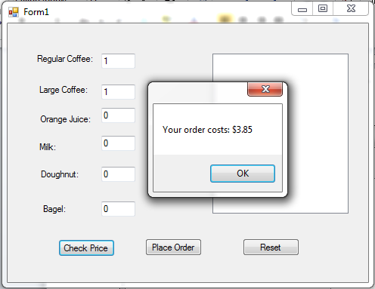

The cost of regular coffee is 1.50, large coffee 2.00, orange juice 1.50, milk 1.25, doughnut 1.75 and bagels 2.25.

There is also a 10% tax that must be included in the calculation of price.

When the place order button is selected the listbox will be populated as shown:

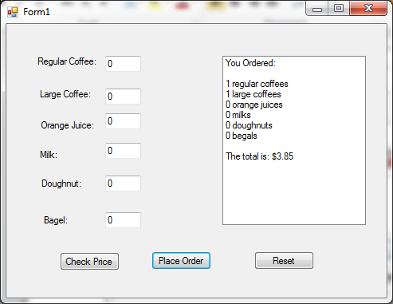

Reset will set all the textboxes to 0.

There are two methods that must be written for this lab. The first is a reset function which will reset all the textboxes to 0. It needs to be called when the reset button is clicked and when the place order button is selected to reset the form for the next order.

There is also a function to determine the price calculation. The price is NOT calculated in the check price or place order button’s click event handlers, they call the appropriate function called price to perform the calculation. The price method needs to return a double and takes in 6 integer parameters (one for each of the textboxes). Be careful of the ordering of the parameters and the arguments you pass to the method…order matters.