JMP Instructions for simple linear regression

Entering data in the table

Each column must only contain data for a single variable. For the purposes of this example, you have decided to measure the length of each ant, and the area of the leaf it is carrying.

Make sure each column is assigned an appropriate “modeling type” (continuous, nominal, or ordinal data) as follows:
In the Columns box, you should see each of your heading names with a symbol (button). Click on the button to get a pop-up menu and change the variable type. Most of the variables you use for analysis should be classified as either continuous (data that you measure in some manner) or nominal (data that you apply a name or category-type to).

Linear regression

1. Analyze menu → Fit Y by X

2. Click on your dependent variable – “leaf area” (which should have a C beside it) - then on “Y, Response”. Click on the independent variable - “ant body length” - (which should also have a C beside it) and then on “X, Factor.” Click OK.

You will see a scatter plot of the data.

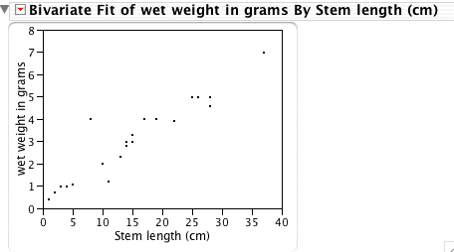

3. Click on the red triangle in the title bar and select “Fit Line.” You will see a red line appear through your data points. That is the line of best fit (slope chosen to minimize the vertical distance between points and the line itself).

A bunch of output will also appear below the graph.

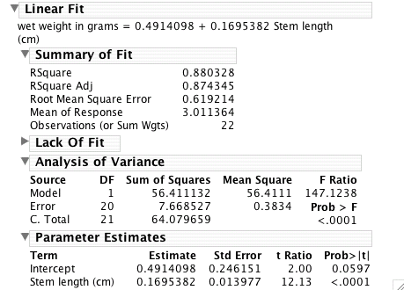

Notice these values:
- Under “linear fit” notice you get the equation for the line of best fit, with a slope and y-intercept.
- Under “summary of fit”, note the “RSquare” , or R^2.
- Under parameter estimates notice you get a p-value for the independent variable

