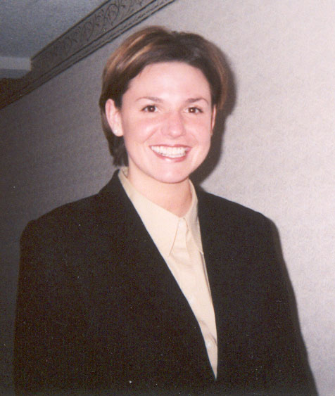
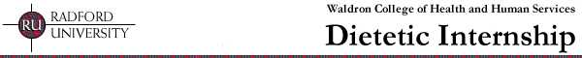

And the winner is…
The recipient of the 2002 Leadership Development Award is Laura P. Jewett, from Radford
University Dietetic Internship. Demonstrating her commitment to educating the public and other health professionals on the positive impact dietitians have in health care, Laura has served as a lobbyist on Legislator's Day for Dietitians in Richmond, VA and has also campaigned on behalf of MNT reimbursement issues while promoting the dietetics profession to state legislators. In addition, she has participated as a project coordinator in the making of an educational video and a series of public service announcements for the "Nutrition Count" project.
Within the University community, she has provided nutrition counseling, health screenings, and coordinated and presented programs in the Weight Management Clinic on campus. The Leadership Development Award provides funds of up to $1,000 to attend the ADA Food and Nutrition Conference & Exhibition (FNCE) or a State Dietetic Association meeting. Established by Susan Finn, PhD, RD, and Judith L. Dodd, MS, RD in 1991, the Leadership Development Fund was created to recognize emerging leaders among current graduates of CP, DI/AP4, and DT programs and encourage their participation in Association activities.

For more information or application procedures, please contact Sherey Zerbian, Manager, ADAF
Grants & Scholarships, at 312/899-4803, or szerbian@eatright.org. Applications may also be downloaded from our web site at www.adaf.org beginning in January 2003.

Commission on Accreditation for Dietetic Education, September 2002 Newsletter.

