**Installing and Running Maple 18**

To install it, first go to the link

<https://ru-portal.portal.radford.edu/rusoftware/Login.aspx>

1. You should see a page that looks like the following, which you should login using your normal RU   
userid and password.

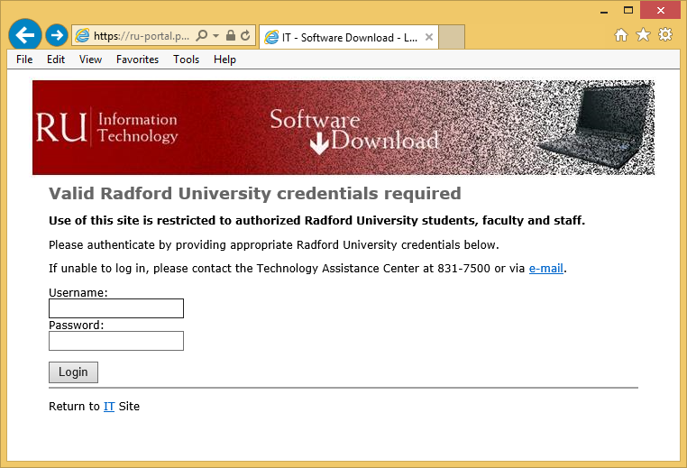

2. Next, select your operating system.

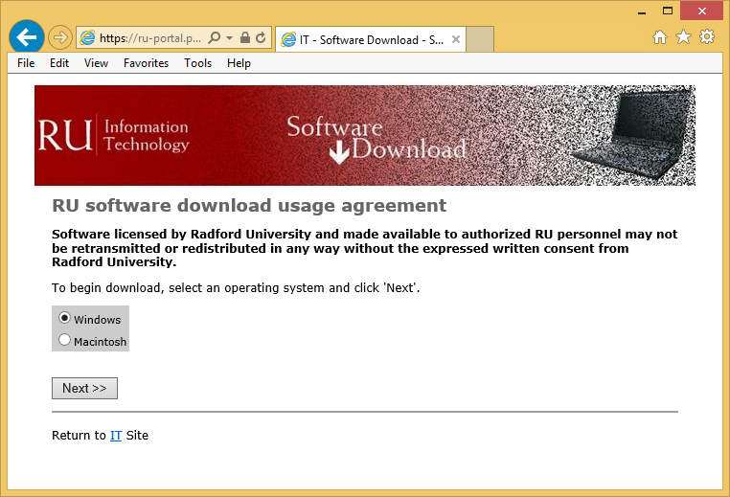

3. Depending on your selection, you should be taken to one of these two pages. Click on the Maple 18 link to download to installer for the program.

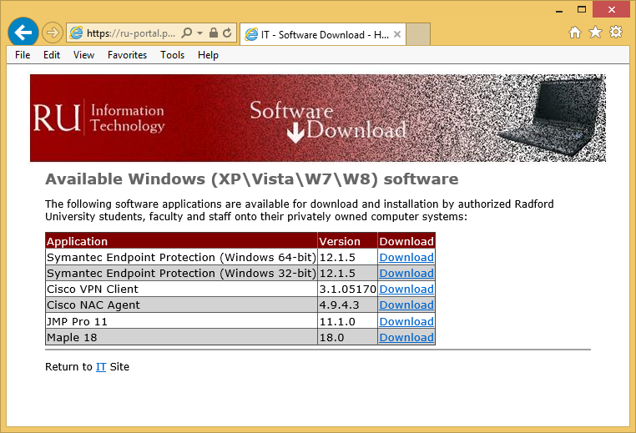 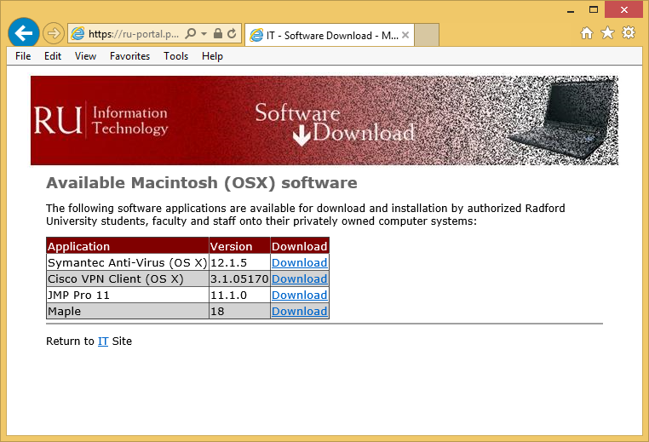

4. After downloading the installation file, run it. You should see a window similar to this. Select **Next.**

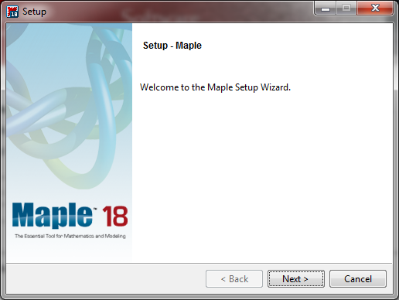

5. After reading the license agreement, choose **I accept the agreement**.  And click **Next**.

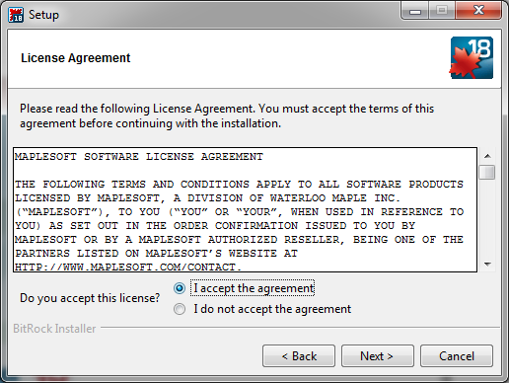

6. On the Installation Directory screen, click **Next**.

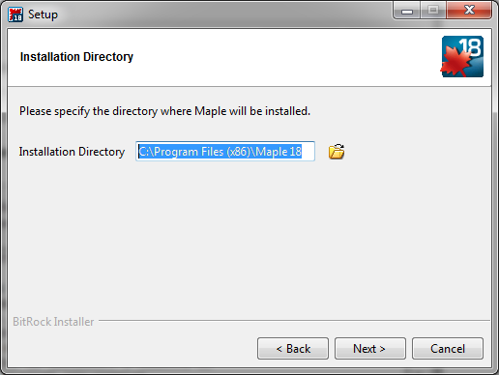

7. On the Install Desktop Shortcut screen, click **Next**.

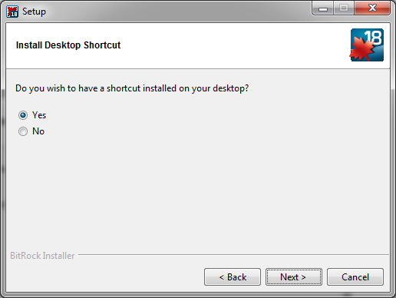

8. On the Install Watcom Compiler screen, check to install the compiler and click **Next**.

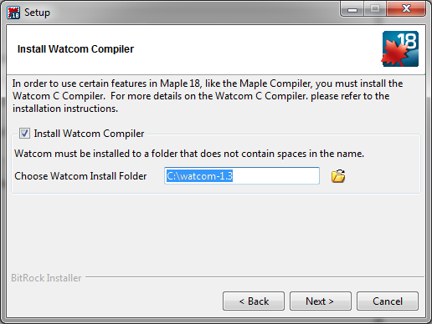

9. On the Choose the Type of License screen, choose **Network Access** and click **Next**.  
  
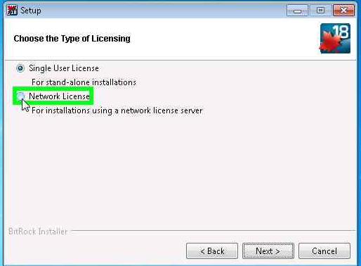 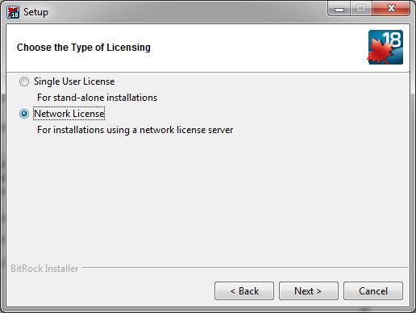

10. On the Single or Redundant Server screen, choose **Single Server** and click **Next**.

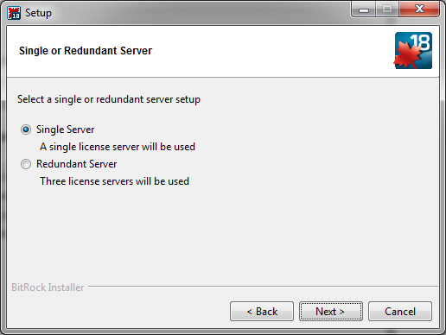

11. On the License Server screen, input "**licenses**" in the License server field and "**27001**" in the Port   
number.  **Note!!! This is very important!**

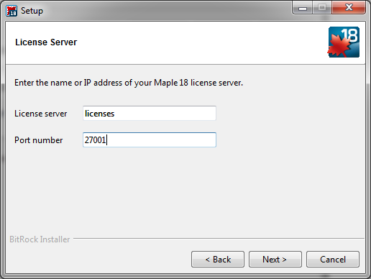

12. On the Check for Updates screen, click **Next**.

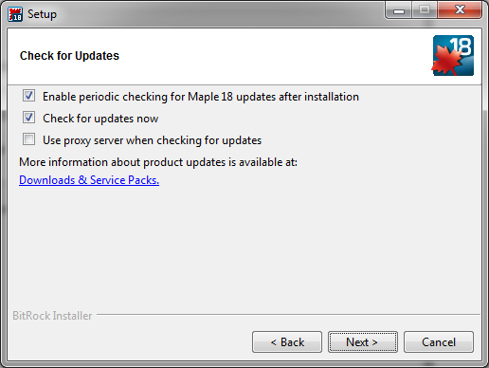

13. On the Pre-Installation Summary screen, click **Next**.

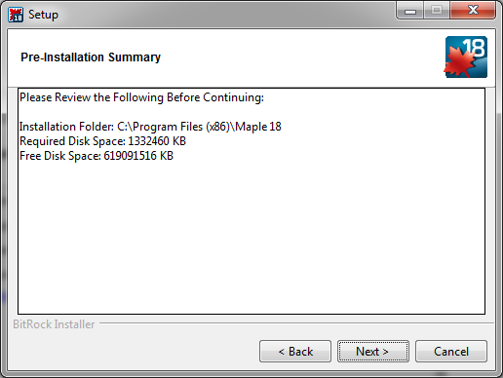

14. When installation occurs, you should see a window that looks like this. Click **Next** when it is finished.

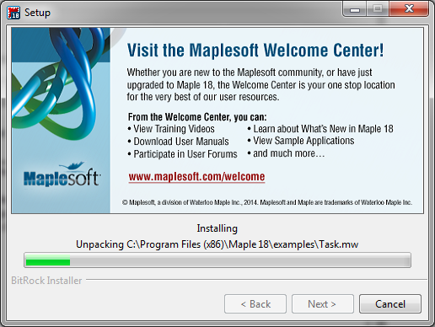

15. On the final screen click **Finish**.

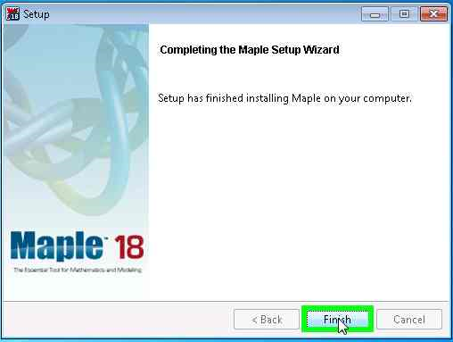

16. Before trying to open Maple, if you are not at the Radford University campus, you must first open and log on to Cisco VPN Client (see Cisco VPN document for instructions).

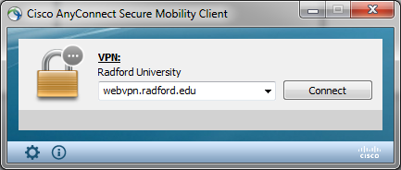

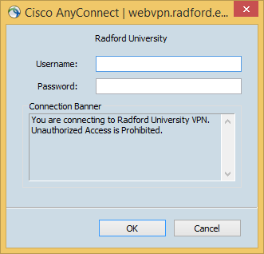 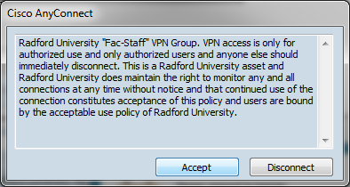

17. Open the Maple 18 software. If you do so successfully, you get a window looking like

