Section 11: Reed-Solomon Codes

HW p. 21 # 1-6 at the end of the notes

In applications that are concerned with information transmission, we want to be assured that the information we transfer is correctly received at its destination. Whether we are dealing with verbal communication or transfer of information electronically by satellite or computer, the assurance that the message is received in its final form without errors is critical in the success of the application.

Error Correcting Codes use mathematical techniques to ensure reliable data of data. If the data is corrupted when it arrives at its destination, a good error correcting code can correct the errors in the message and reproduced the information that was originally sent. In this section, we describe one of the most well known error correcting codes that employ much of the mathematics concerning polynomials that we have studied in previous sections.

Reed-Solomon Codes

Reed-Solomon Codes are named after its developers, Irving Reed and Gustave Solomon (see Figure 1), who developed the code in 1960.

Figure 1: Picture of Irving Reed and Gustave Solomon, inventors of Reed-Solomon Codes.

The code is capable of correcting multiple errors and is good for correcting errors that occur in bursts, known as burst error correction. We describe the mathematics of the code next.
Finite Fields and Reed-Solomon Codes

Reed-Solomon codes are constructed and decoded through the use of finite field arithmetic. The finite field we will use has the form $F=Z_{2}[x]/(p(x))$, where $p(x)$ is an irreducible polynomial of degree n in $Z_{2}[x]$. Besides being irreducible, we would like to choose $p(x)$ to be primitive in $Z_{2}[x]$.

Assuming $p(x)$ is irreducible, let a be a root of $p(x)$. Recall that since $p(x)$ is of degree n, the finite field$F=Z_{2}[x]/(p(x))$ contains $2^{n}$ elements. Recall that the primitive element a can be used to cyclically generate the $2^{n}−1$ non-zero elements of the finite field by computing the powers
$\left\{a,a^{2},a^{3},…,a^{2^{n}−1}=1\right\}$.

and reducing the elements using the polynomial resulting from the fact that $p(a)=0$. We demonstrate the finite field we will use in the demonstrations that follows in the next example.

Example 1: Use the primitive polynomial $p(x)=x^{4}+x+1$ with primitive root a to generate the finite field of $2^{4}=\text{16}$ elements.

Solution:
The following table represents the $2^{4}−1=\text{15}$ non-zero elements.

Power of a | Finite Field Element | Power of a | Finite Field Element
$$a$$ | $$a$$ | $$a^{9}$$ | $$a^{3}+a$$
$$a^{2}$$ | $$a^{2}$$ | $$a^{\text{10}}$$ | $$a^{2}+a+1$$
$$a^{3}$$ | $$a^{3}$$ | $$a^{\text{11}}$$ | $$a^{3}+a^{2}+a$$
$$a^{4}$$ | $$a+1$$ | $$a^{\text{12}}$$ | $$a^{3}+a^{2}+a+1$$
$$a^{5}$$ | $$a^{2}+a$$ | $$a^{\text{13}}$$ | $$a^{3}+a^{2}+1$$
$$a^{6}$$ | $$a^{3}+a^{2}$$ | $$a^{\text{14}}$$ | $$a^{3}+1$$
$$a^{7}$$ | $$a^{3}+a+1$$ | $$a^{\text{15}}$$ | $$1$$
$$a^{8}$$ | $$a^{2}+1$$

Adding the 0 element completes the finite field of 16 elements.
█

Transmitting a Message: Codeword Generation for Reed-Solomon Codes

In error correcting codes, the transmitted message is called a codeword. Reed-Solomon Codes form codewords and transmit information in terms of polynomial coefficients. The codewords are polynomials of degree $2^{n}−1−1=2^{n}−2$ (counting constant coefficients, this gives a total of $2^{n}−1$ polynomial coefficients). Hence, we say that $2^{n}−1$ is the length of the code. The coefficients are elements of the finite field $F=Z_{2}[x]/(p(x))$.

Suppose we want to transmit a message from a source to some destination. When setting up a scheme to transmit a message, we must specify the maximum number of errors that can be corrected in the transmission upon arrival to the message’s destination. Reed-Solomon codes can correct up to a certain number of errors in a transmitted message. Let t be this specified number of errors. Then as long as$2t<2^{n}−1$, where $2^{n}$ is the number of finite field elements, then the scheme is guaranteed to correct t errors.

Codewords in Reed-Solomon codes are created by taking multiples of the polynomial

$g(x)=(x−a)(x−a^{2})(x−a^{3})⋯(x−a^{2t})$,

where a is a root of the primitive polynomial $p(x)$ used to create the finite field $Z_{2}[x]/(p(x))$ and t is the number of errors the code corrects. Here, g(x) is called the generating polynomial. That is, to create a codeword, we take a polynomial m(x) of degree less than $2^{n}−1−2t$ and multiply it by the generating polynomial g(x). This gives the codeword c(x) = m(x)g(x) (note that since $m(x)$ is of degree less than $2^{n}−1−2t$ and $g(x)$ is of degree $2t$, $c(x)$ will be guaranteed to be of degree less than $2^{n}−1−2t+2t=2^{n}−1$. The set of all codewords are given by the set

$$C=\left\{m(x)g(x),m(x)∈F[x],F=Z_{2}[x]/(p(x)),\text{deg}(m(x))<2^{n}−1−2t\right\}$$

Note that since $\text{deg}(m(x))<2^{n}−1−2t$, then counting the constant coefficient, $m(x)$ can have up to $m−2t$ polynomial coefficients, that is,

$m(x)=b_{2^{n}−2t−2}x^{2^{n}−2t−2}+b_{m−2t−3}x^{2^{n}−2t−3}+…+b_{1}x+b_{0},b_{i}∈Z_{2}[x]/(p(x))$.

Since every coefficient is an element of $Z_{2}[x]/(p(x))$, there are a total of
$$(2^{n})^{2^{n}−2t−1}=2^{n2^{n}−2\text{nt}−n}$$

codewords can be formed. We demonstrate how a codeword is created in the next example.
Example 2: Suppose we want to construct a Reed-Solomon code of length 15 that corrects 2 errors. For the polynomial coefficients, we use the finite field for from Example 1 constructed with the primitive polynomial $p(x)=x^{4}+x+1$. Determine, the generating polynomial for this code, the maximum degree of any polynomial $m(x)$ used to construct a codeword, and the codeword resulting from the polynomial $m(x)=a^{\text{10}}x^{9}+a^{3}x^{5}+a^{2}x^{3}$. How many total codewords can be constructed?

Solution:

█
Error Correction in Reed-Solomon Codes

A primary reason codewords are constructed by taking multiples of the generating polynomial is due to fact that it provides an easy way to see if the codeword is received correctly when it reaches its destination. Recall that the generating polynomial has the form
$g(x)=(x−a)(x−a^{2})(x−a^{3})⋯(x−a^{2t})$.

Thus, it can be easily seen that

$g(a^{i})=0\text{ for }i=1,2,…,2t$.

Recall that a codeword $c(x)$ is formed by taking a polynomial $m(x)$ and forming

$c(x)=m(x)g(x)$.

This, we can say that

$c(a^{i})=m(a^{i})g(a^{i})=m(a^{i})(0)=0\text{ for }i=1,2,…,2t$.

This provides a method of checking to see if $c(x)$ is a codeword. If $c(a^{i})≠0$ for any $i=1,2,…,2t$, then $c(x)$ is not a codeword and we must correct the errors that occur in its polynomial coefficients. We describe the method of error correction is not.

Suppose a codeword $c(x)$ is sent and the message $r(x)$ arrives at the messages destination. If $r(x)≠c(x)$, then $r(x)$ is not a codeword and $r(x)$ and $c(x)$ differ at a certain number of polynomials coefficients. Hence, $c(x)=r(x)+e(x)$ or

$r(x)=c(x)+e(x)$.

The polynomial $e(x)$ will contain the positions of the coefficients of where $r(x)$ and $c(x)$ differ. To correct the errors that occur, we must find $e(x)$. Since $r(x)$ is not a codeword, there will be at least one of the terms $a,a^{2},a^{3},…,a^{2t}$ that is not a root of r(x). We assign

$$S_{i}=r(a^{i})=c(a^{i})+e(a^{i})=0+e(a^{i})=e(a^{i})\text{ for }i=1,2,…,2t$$

The values of $r(a^{i})$ evaluated from 1..2t are known as syndromes. If we substitute $a,a^{2},a^{3},…,a^{2t}$ into r(x) and all evaluate to be 0, then r(x) is a codeword and we can stop. If we substitute $a,a^{2},a^{3},…,a^{2t}$ into r(x) and any evaluate to not be 0, then r(x) is not a codeword and we must proceed to the necessary steps to correct it.

To correct $r(x)$ back to $c(x)$, our goal is to find $e(x)$. Let $m=2^{n}−1$ (the number of non-zero finite field elements). We define

$e(x)=\sum_{j=0}^{m−1}{e_{j}x^{j}}$ where $e_{j}∈Z_{2}[x]/(p(x))$.

Then the syndromes are

$S_{i}=r(a^{i})=e(a^{i})=\sum_{j=0}^{m−1}{ea^{\text{ij}}\text{ for }i=1,2,…,2t}$ (1)

Using the $S_{i}'s$ as coefficients, we define the syndrome polynomial $S(z)$ as

$$S(z)=\sum_{i=0}^{2t−1}{S_{i+1}z^{i}=S_{1}+S_{2}z+S_{3}z^{2}+…+S_{2t}z^{2t−1}}$$

Substituting in the $S_{i}'s$ from equation (1) gives

$S(z)=\sum_{i=0}^{2t−1}{S_{i+1}z^{i}=\sum_{i=0}^{2t−1}{\sum_{j=0}^{m−1}{e_{j}a^{(i+1)j}z^{i}=}}}\sum_{j=0}^{m−1}{e_{j}a^{j}\sum_{i=0}^{2t−1}{a^{\text{ij}}z^{i}}}$.

Let

$M=\left\{j≤m−1|e_{j}≠0\right\}$ = {set of positions where errors occur}.

Then

$$S(z)=\sum_{j∈M}{e_{j}a^{j}\sum_{i=0}^{2t−1}{a^{\text{ij}}z^{i}}}$$

or

$S(z)=\sum_{j∈M}{e_{j}a^{j}\sum_{i=0}^{2t−1}{(a^{j}z)^{i}}}$.

Recall the fact that

$$1−y^{k}=(1−y)(1+y+y^{2}+…y^{k−1})$$

Then

$$\sum_{i=0}^{k−1}{y^{i}=}(1+y+y^{2}+…y^{k−1})=\frac{1−y^{k}}{1−y}$$

In the formula $S(z)=\sum_{j∈M}{e_{j}a^{j}\sum_{i=0}^{2t−1}{(a^{j}z)^{i}}}$ if we let $y=a^{j}z$ and $k=2t$ we obtain

$S(z)=\sum_{j∈M}{e_{j}a^{j}\frac{(1−(a^{j}z)^{k})}{1−a^{j}z}}=\sum_{j∈M}{e_{j}a^{j}\frac{(1−a^{j2t}z^{2t})}{1−a^{j}z}}$.

Distributing the $e_{j}a^{j}$ gives

$S(z)=\sum_{j∈M}{\frac{e_{j}a^{j}}{1−a^{j}z} − \sum_{j∈M}{}\frac{e_{j}a^{j(2t+1)}z^{2t}}{1−a^{j}z}}$.

We next multiply numerator and denominator of the previous expression by the term $\begin{aligned}\prod_{i≠j}{}i∈M\end{aligned}$ to get
$$\begin{aligned}\prod_{i≠j}{}i∈M\end{aligned}$$

Simplifying the denominators gives

$\begin{aligned}\prod_{i≠j}{}i∈M\end{aligned}\frac{}{\prod_{i∈M}{(1−a^{i}z)}}$ (2)

We define the polynomials

$V(z)=\prod_{i∈M}{(1−a^{i}z)}$,

$R(z)=\sum_{j∈M}{}\begin{aligned}\prod_{i≠j}{}i∈M\end{aligned}$,

$$U(z)=\sum_{j∈M}{}\begin{aligned}\prod_{i≠j}{}i∈M\end{aligned}$$

Then, substituting into equation 2, we have

$$S(z)=\frac{R(z)}{V(z)}−\frac{U(z)z^{2t}}{V(z)}$$

or

$$S(z)=\frac{R(z)}{V(z)}+\frac{U(z)z^{2t}}{V(z)}$$

Multiplying both sides by $V(z)$ gives

$$V(z)S(z)=R(z)+U(z)z^{2t}$$

or rearranging, we have

$z^{2t}U(z)+S(z)V(z)=R(z)$. (3)

Facts
1. $V(z)$ is called the error locator polynomial, $R(z)$ is the error evaluator polynomial , and $U(z)$ the error co-evaluator polynomial.
2. The polynomials $V(z)$, $U(z)$, and $R(z)$ are found by setting $a=z^{2t}$ and $b=S(z)$ and running the Euclidean Algorithm and recording the results in a Euclidean Algorithm table until $\text{deg}(r_{i})<t$, where t is the number of errors the code corrects.
Then from the relation

$z^{2t}u_{i}+S(z)v_{i}=r_{i}$ where $\text{deg}r_{i}<t$.

We set $U(z)=u_{i}$, $V(z)=v_{i}$, and $R(z)=r_{i}$.
3. $V(z)$ and $R(z)$ are used to correct errors using the roots of $V$. Since
$$V(z)=\prod_{i∈M}{(1−a^{i}z)}$$
Then
$$V^{'}(z)=\sum_{j∈M}{}\begin{aligned}\prod_{i≠j}{}i∈M\end{aligned}$$
Consider
$$\frac{R(z)}{V^{'}(z)}=\frac{\sum_{j∈M}{}\begin{aligned}\prod_{i≠j}{}i∈M\end{aligned}}{\sum_{j∈M}{}\begin{aligned}\prod_{i≠j}{}i∈M\end{aligned}}$$

Consider one factor for $V(z)$, say $(1−a^{k}z)$. The root of this factor is $z=a^{−k}$ since
$(1−a^{k}a^{−k})=1−a^{k+(−k)}=1−a^{0}=1−1=0$.

Note, another way to represent this root uses the fact that for $m=2^{n}−1$ (the number of nonzero elements), that $a^{m}=1$. Hence, we can write to root as $z=a^{m−k}$ since

$(1−a^{k}a^{m−k})=1−a^{k+(m−k)}=1−a^{m}=1−1=0$.

Note that

$$\begin{aligned}\prod_{i≠j}{}i∈M\end{aligned} (\text{Note that }j=k\text{ gives the only non-zero term in the sum}) =e_{k}$$
Thus, $e_{k}=\frac{R(a^{−k})}{V^{'}(a^{−k})}$. Note that $a^{−k}=a^{m−k}$ is a root of $V(z)$.

4. $\text{deg}(V(z))=\text{ \# errors that are corrected}\text{.}$
Example 3: Let $p(x)=x^{4}+x+1$ be a primitive polynomial in $Z_{2}[x]$ with primitive element a used to construct the finite field $Z_{2}[x]/p(x)$from Example 1 that is used to construct a Reed-Solomon code of length 15 that corrects 2 errors. Suppose the codeword

$$c(x)=a^{\text{10}}x^{\text{13}}+a^{8}x^{\text{12}}+ax^{\text{11}}+a^{\text{13}}x^{\text{10}}+a^{\text{11}}x^{9}+ax^{8}+a^{\text{11}}x^{7}+a^{\text{13}}x^{6}+a^{3}x^{5}+a^{5}x^{4}+a^{\text{12}}x^{3}$$

is sent but

$$r(x)=a^{\text{10}}x^{\text{13}}+a^{8}x^{\text{12}}+a^{\text{14}}x^{\text{11}}+a^{2}x^{\text{10}}+a^{\text{11}}x^{9}+ax^{8}+a^{\text{11}}x^{7}+a^{\text{13}}x^{6}+a^{3}x^{5}+a^{5}x^{4}+a^{\text{12}}x^{3}$$

is received. Correct the errors in $r(x)$.

Solution:

█
Binary Reed-Solomon Codes and Burst-Error Correction

In computer data transfer, information is normally stored using binary numbers made up of 0’s and 1’s. We now describe how Reed-Solomon Codes transfer information in terms of binary numbers.

Suppose we set up a Reed-Solomon code with a primitive polynomial $p(x)$ of degree $n$ that generates a finite field of $2^{n}$ elements. If $a$ is a primitive is primitive element, then each $a^{i}∈Z_{2}[x]/(p(x))$ has a binary representation. We describe this representation in the next example.

Example 4: Recall in Example 1 we used the primitive polynomial $p(x)=x^{4}+x+1$ with primitive root a to generate the finite field of $2^{4}=\text{16}$ elements. The 16 elements are given by this table:

Power of a | Polynomial | Power of a | Polynomial
$$a$$ | $$a$$ | $$a^{9}$$ | $$a^{3}+a$$
$$a^{2}$$ | $$a^{2}$$ | $$a^{\text{10}}$$ | $$a^{2}+a+1$$
$$a^{3}$$ | $$a^{3}$$ | $$a^{\text{11}}$$ | $$a^{3}+a^{2}+a$$
$$a^{4}$$ | $$a+1$$ | $$a^{\text{12}}$$ | $$a^{3}+a^{2}+a+1$$
$$a^{5}$$ | $$a^{2}+a$$ | $$a^{\text{13}}$$ | $$a^{3}+a^{2}+1$$
$$a^{6}$$ | $$a^{3}+a^{2}$$ | $$a^{\text{14}}$$ | $$a^{3}+1$$
$$a^{7}$$ | $$a^{3}+a+1$$ | $$a^{\text{15}}$$ | $$1$$
$$a^{8}$$ | $$a^{2}+1$$ | 0 | 0

Note that the degree of each polynomial finite field element is less than 4, which is the degree of $p(x)$. The binary representation of an element is obtained by listing the powers of a in increasing order and listing the coefficients of the polynomial, giving a binary representation of length 4. For example, to find the binary representation of $a^{\text{13}}$, we list its polynomial terms increasing order, which gives $1+a^{2}+a^{3}=1+0a+1a+1a^{3}$. Reading off the coefficients gives the binary representation 1011. To find the binary representation of $a^{5}$, we write its polynomial form as $a+a^{2}=0(1)+1a+1a^{2}+0a^{3}$ and get the binary representation as 0110. A summary of the binary representation is given by the following table.

Power of a | Polynomial | Binary |  |  |  | Power of a | Polynomial | Binary
$a$ | $a$ | 0100 |  |  |  | $$a^{9}$$ | $$a+a^{3}$$ | 0101
$$a^{2}$$ | $$a^{2}$$ | 0010 |  |  |  | $$a^{\text{10}}$$ | $$1+a+a^{2}$$ | 1110
$$a^{3}$$ | $$a^{3}$$ | 0001 |  |  |  | $$a^{\text{11}}$$ | $$a+a^{2}+a^{3}$$ | 0111
$$a^{4}$$ | $$1+a$$ | 1100 |  |  |  | $$a^{\text{12}}$$ | $$1+a+a^{2}+a^{3}$$ | 1111
$$a^{5}$$ | $$a+a^{2}$$ | 0110 |  |  |  | $$a^{\text{13}}$$ | $$1+a^{2}+a^{3}$$ | 1011
$$a^{6}$$ | $$a^{2}+a^{3}$$ | 0011 |  |  |  | $$a^{\text{14}}$$ | $$1+a^{3}$$ | 1001
$$a^{7}$$ | $$1+a+a^{3}$$ | 1101 |  |  |  | $$a^{\text{15}}$$ | $$1$$ | 1000
$$a^{8}$$ | $$1+a^{2}$$ | 1010 |  |  |  | 0 | 0 | 0000

█

For a finite field of $2^{n}$ elements, recall that a codeword $c(x)$ can be up to degree $2^{n}−2$, which gives $2^{n}−1$ coefficients. To write a codeword $c(x)$ in binary form, we perform the following steps.

Steps for Converting a Codeword to Binary Form
1. Write the codeword $c(x)$ with increasing powers of x, starting with the constant term (the $x^{0}$ term) up to the $x^{2^{n}−2}$ term, listing coefficients of 0 in front of powers of x that do not occur.
2. Convert each coefficient of $c(x)$ to binary form. Each coefficient of $c(x)$ will produce a block of n binary digits.

We illustrate this process in the following example.

Example 5: Consider the codeword we formed in Example 2 given by

$c(x)=a^{\text{10}}x^{\text{13}}+a^{8}x^{\text{12}}+ax^{\text{11}}+a^{\text{13}}x^{\text{10}}+a^{\text{11}}x^{9}+ax^{8}+a^{\text{11}}x^{7}+a^{\text{13}}x^{6}+a^{3}x^{5}+a^{5}x^{4}+a^{\text{12}}x^{3}$.

Convert this codeword to binary form.

Solution: Recall that the primitive polynomial $p(x)=x^{4}+x+1$ use to generate this field is of degree $n=4$. Hence, any codeword has $2^{n}−1=2^{4}−1=\text{15}$ polynomial coefficients starting with the constant coefficient up to the coefficient of $x^{2^{n}−2}=x^{2^{4}−2}=x^{\text{14}}$. We start by writing $c(x)$ in terms of increasing powers of x. This gives

$$c(x)=a^{\text{12}}x^{3}+a^{5}x^{4}+a^{3}x^{5}+a^{\text{13}}x^{6}+a^{\text{11}}x^{7}+ax^{8}+a^{\text{11}}x^{9}+a^{\text{13}}x^{\text{10}}+ax^{\text{11}}+a^{8}x^{\text{12}}+a^{\text{10}}x^{\text{13}}$$

Note the constant coefficient and the coefficients of $x$, $x^{2}$ and $x^{\text{14}}$ are missing. We include those terms by writing coefficients of zero in front of them. Hence, the codeword is

$$\begin{aligned}c(x)=0+0x+0x^{2}+a^{\text{12}}x^{3}+a^{5}x^{4}+a^{3}x^{5}+a^{\text{13}}x^{6}+a^{\text{11}}x^{7}+ax^{8}+a^{\text{11}}x^{9}+a^{\text{13}}x^{\text{10}}+ax^{\text{11}} \\ +a^{8}x^{\text{12}}+a^{\text{10}}x^{\text{13}}+0x^{\text{14}}\end{aligned}$$

We next use the table at the end of Example 4 to convert each power of $a$ to its polynomial representation. This gives

$$\begin{aligned}c(x)=0+0x+0x^{2}+(1+a+a^{2}+a^{3})x^{3}+(a+a^{2})x^{4}+a^{3}x^{5}+(1+a^{2}+a^{3})x^{6}+(a+a^{2}+a^{3})x^{7} \\ +ax^{8}+(a+a^{2}+a^{3})x^{9}+(1+a^{2}+a^{3})x^{\text{10}}+ax^{\text{11}}+(1+a^{2})x^{\text{12}}+(1+a+a^{2})x^{\text{13}}+0x^{\text{14}}\end{aligned}$$
Using the binary conversion table to convert each coefficient to a binary block of 4 digits, we obtain the following binary representation of length $n(2^{n}−1)=4(2^{4}−1)=4(\text{15})=\text{60}$ binary digits that are used to represent the codeword $c(x)$.

0000 0000 0000 1111 0110 0001 1011 0111 0100 0111 1011 0100 1010 1110 0000

█

In general, a code of length $2^{n}−1$ is transformed in binary to a code of length $n(2^{n}−1)$.
How does this correspond in correcting errors? To demonstrate how, suppose we have a $t=2$ error correcting Reed-Solomon code with $n=4$. Then t = 2 corresponds to 2 polynomial coefficient errors can be corrected between a received polynomial $r(x)$ and codeword $c(x)$. Consider the following picture:

$$−−−−|−−−−|−−−−|−−−−|−−−−|−−−−$$

Here, 2 polynomial coefficient errors will be guaranteed to correct a maximum of 4 + 1 = 5
binary errors. It is possible it may correct $2⋅4=8$ binary errors.

Fact: For a Reed-Solomon Code of length $2^{n}−1$guaranteed to correct $t$ errors, the code will be guaranteed to correct a maximum of $n(t−1)+1$ errors. It possible can correct up to $\text{nt}$errors.
For example, in Example 3, we corrected the polynomial

$$r(x)=a^{\text{10}}x^{\text{13}}+a^{8}x^{\text{12}}+a^{\text{14}}x^{\text{11}}+a^{2}x^{\text{10}}+a^{\text{11}}x^{9}+ax^{8}+a^{\text{11}}x^{7}+a^{\text{13}}x^{6}+a^{3}x^{5}+a^{5}x^{4}+a^{\text{12}}x^{3}$$
to the codeword

$$c(x)=a^{\text{10}}x^{\text{13}}+a^{8}x^{\text{12}}+ax^{\text{11}}+a^{\text{13}}x^{\text{10}}+a^{\text{11}}x^{9}+ax^{8}+a^{\text{11}}x^{7}+a^{\text{13}}x^{6}+a^{3}x^{5}+a^{5}x^{4}+a^{\text{12}}x^{3}$$

by correcting the two errors in polynomial coefficients of the terms $x^{\text{10}}$ and $x^{9}$.

Comparing the binary representation of $r(x)$ and $c(x)$,

$r(x):$ 0000 0000 0000 1111 0110 0001 1011 0111 0100 0111 0100 1001 1010 1110 0000

$c(x):$ 0000 0000 0000 1111 0110 0001 1011 0111 0100 0111 1011 0100 1010 1110 0000

we can see that 7 binary errors have been corrected ( minimum of 5 and a maximum of 8 could have been corrected).

As can be seen when comparing $c(x)$ and $r(x)$ above, Reed-Solomon codes are ideal for correcting error bursts. When a binary codeword is transmitted, the received vector is said to contain an error burst if it contains several bit errors very close together. In data transmitted through space, error bursts are frequently caused by very brief periods of intense solar energy. It was for this reason that a Reed-Solomon code was used in the Voyager 2 satellite that transmitted photographs of several of the planets in our solar system back to Earth. We will briefly discuss the use of a Reed-Solomon code in the Voyager 2 satellite below. But there are a variety of other reasons why errors in binary codewords often occur naturally in bursts, such as power surges in cable and telephone wires, various types of interference, and scratches on compact discs and DVDs. As a result, Reed-Solomon codes have a rich assortment of applications, and are claimed to be the most frequently used digital error correcting codes in the world. They are used extensively in the encoding of music on compact discs, have played an integral role in the development of high-speed supercomputers, and will be an important tool in the future for dealing with complex communication and information transfer systems.

Reed-Solomon Codes and the Voyager Satellite Missions

In August and September 1977, NASA launched the Voyager 1 and Voyager 2 satellites from Cape Canaveral, Florida. Upon reaching their initial destinations of Jupiter and Saturn, the Voyager satellites provided NASA with the most detailed analyses and images of these planets and their moons that had ever been observed. After leaving Jupiter and Saturn, Voyager 2 continued farther into the outer reaches of our solar system, and successfully transmitted back to Earth data and images from Uranus and Neptune. Without the use of a Reed-Solomon code in transmitting these images, the extreme success achieved by Voyager 2 would have been very unlikely.

Photographs transmitted back to Earth from outer space are usually digitized into binary strings and sent over a space channel. Voyager 2 digitized its full-color images into binary strings of length 15,360,000 positions. Using an uncompressed spacecraft telecommunication system, these bits were transmitted one by one back to Earth, where the images were then reconstructed. This uncompressed system was the most reliable one available when Voyager 2 was launched, and was satisfactory for transmitting images back to Earth from Jupiter and Saturn. However, when Voyager 2 arrived at Uranus in January 1986, it was about twice as far from Earth as it had been when it was at Saturn. Since the transmission of bits back to Earth had already been stretched to a very slow rate from Saturn (around 44,800 bits per second), a new transmission method was necessary in order for NASA to be able to receive a large number of images from Uranus.

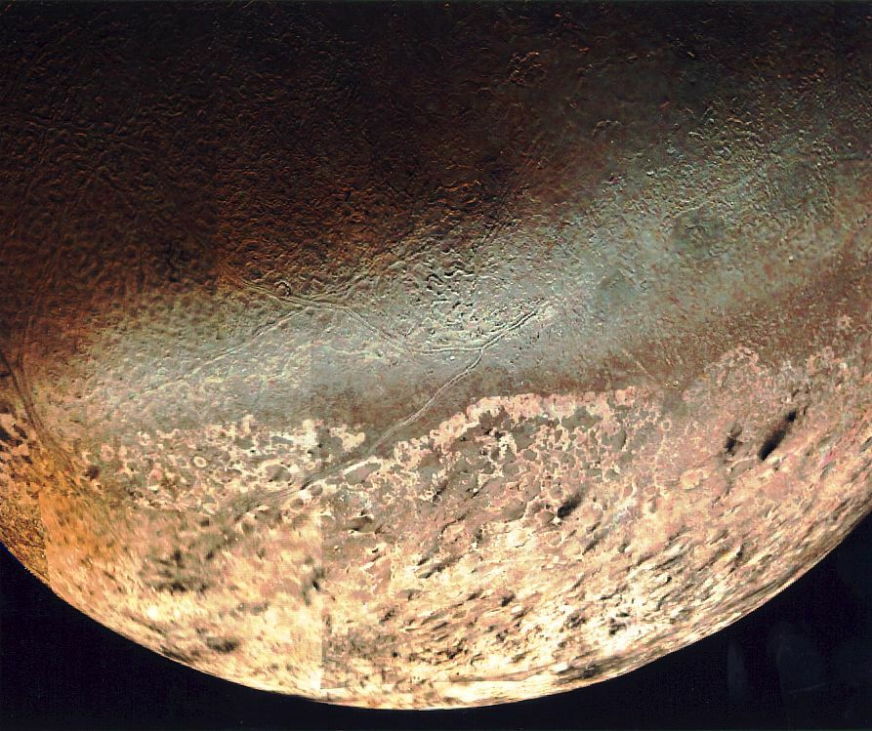
Picture of Neptune and one of its moons Triton taken by the Voyager 2 satellite

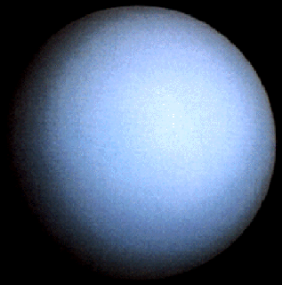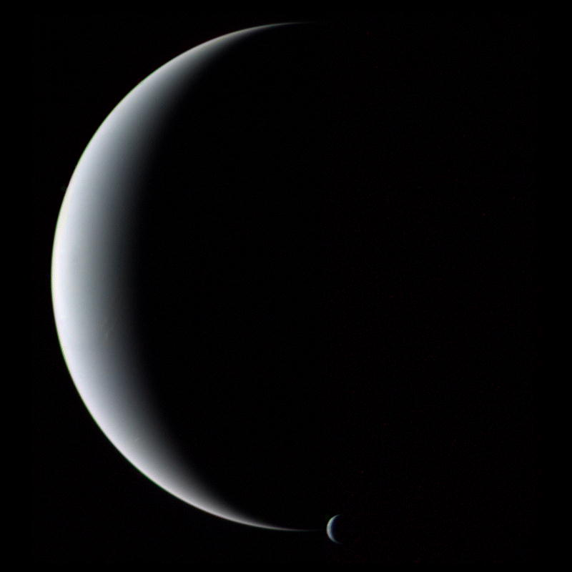
Picture of Uranus and the crescent of Neptune and Triton by the Voyager 2 satellite

The problem of image transmission from Uranus was solved through the work of Robert Rice at California Institute of Technology's Jet Propulsion Laboratory. Rice developed an algorithm that implemented a compressed spacecraft telecommunication system which reduced by a factor of 2.5 the amount of data needed to transmit a single image from Uranus without causing any loss in image quality. However, there was a problem with Rice's algorithm. During the long transmissions through space, compressed binary strings experienced errors much more frequently than uncompressed strings, and Rice's algorithm was very sensitive to bit errors. In fact, if a received compressed binary string from Uranus contained even only a single bit error, the entire resulting image would be completely ruined. After considerable study, it was discovered that the bit errors that occurred during the long transmissions through space usually occurred in bursts. To account for these error bursts, a new system was designed in Voyager 2 for converting images into binary strings that utilized a Reed-Solomon code. These binary strings were then compressed and transmitted back to Earth, uncompressed using Rice's algorithm, and corrected using the Reed-Solomon error correction method. This process was remarkably successful.

Exercises

1. Construct a polynomial codeword with the largest possible degree using the Reed-Solomon code of length 15 that will correct 2 errors given in Example 2, and then convert this polynomial codeword into a binary vector.

2. Convert the binary vector 0000 0000 0000 0000 0000 0010 1110 1011 0110 1101 0000 0000 0000 0000 0000 into the polynomial codeword given by the Reed-Solomon code of length 15 that will correct 2 errors given in Example 2, and then verify that this polynomial really is a codeword in the code.

3. Let C be the two-error correcting Reed-Solomon code that results from the primitive polynomial $p(x)=x^{3}+x+1$ in$Z_{2}[x]$.
a. Construct the finite field used for this code.
b. Construct and simplify the generator polynomial for C.
c. Construct two of the polynomial codewords in C and then convert each of these polynomial codewords into binary vectors.
d. How many codewords does this code contain?
e. Provided that only one error burst occurs during transmission of the binary equivalent of a polynomial codeword in C , what is the maximum error burst length that we would be guaranteed to be able to correct? In a best case scenario, how many errors can the code correct?

4. Correct the following received polynomials in the Reed-Solomon code C in
Exercise 3.
a. $r(x)=a^{5}x^{6}+a^{5}x^{5}+a^{6}x^{4}+{\text{ax}}^{2}+a^{6}x+a^{5}$
b. $r(x)={\text{ax}}^{5}+a^{4}x^{4}+a^{6}x^{3}+a^{3}x^{2}+a^{5}x+a^{4}$
c. $r(x)=a^{4}x^{6}+a^{3}x^{5}+x^{4}+a^{4}x^{3}+a^{2}x^{2}+a^{2}x+a^{3}$

5. Correct the following received polynomials in the Reed-Solomon code described in Examples 2 and 3.
a. $r(x)=a^{6}x^{\text{14}}+a^{4}x^{\text{13}}+{\text{ax}}^{\text{12}}+a^{9}x^{\text{11}}+a^{\text{14}}x^{\text{10}}+a^{\text{10}}x^{5}+a^{8}x^{4}+{\text{ax}}^{3}+a^{\text{13}}x^{2}+a^{5}x$
b. $r(x)=a^{9}x^{\text{13}}+a^{7}x^{\text{12}}+x^{\text{11}}+a^{\text{10}}x^{\text{10}}+x^{9}+a^{9}x^{8}+a^{6}x^{7}+a^{\text{13}}x^{6}+a^{\text{14}}x^{4}$
$+a^{\text{12}}x^{3}+a^{5}x^{2}+a^{2}x+a^{9}$
c. $r(x)=a^{\text{13}}x^{\text{13}}+a^{\text{11}}x^{\text{12}}+a^{4}x^{\text{11}}+{\text{ax}}^{\text{10}}+a^{8}x^{9}+a^{\text{13}}x^{7}+a^{4}x^{5}+{\text{ax}}^{4}+a^{8}x^{3}$

6. Correct the following received polynomials in the three-error correcting Reed-Solomon code that results from the primitive polynomial $p(x)=x^{4}+x^{3}+1$ in$Z_{2}[x]$.
a. $r(x)=a^{7}x^{\text{12}}+a^{2}x^{\text{11}}+a^{8}x^{\text{10}}+a^{8}x^{9}+a^{8}x^{8}+{\text{ax}}^{7}+a^{\text{10}}x^{6}+a^{6}x^{5}+a^{4}x^{4}+a^{7}x^{3}$
$+{\text{ax}}^{2}+a^{6}x+a$
b. $r(x)=a^{5}x^{\text{14}}+a^{\text{14}}x^{\text{13}}+a^{3}x^{\text{12}}+a^{4}x^{\text{11}}+a^{\text{14}}x^{\text{10}}+a^{4}x^{9}+a^{\text{11}}x^{8}+a^{7}x^{7}+a^{\text{11}}x^{6}$
$+a^{9}x^{5}+a^{\text{14}}x^{4}+a^{7}x^{3}+a^{\text{10}}x+a^{5}$
c. $r(x)=a^{8}x^{\text{14}}+a^{\text{12}}x^{\text{13}}+a^{3}x^{\text{12}}+a^{8}x^{\text{11}}+a^{\text{12}}x^{\text{10}}+a^{3}x^{9}+a^{9}x^{8}+a^{5}x^{7}+a^{\text{13}}x^{6}+a^{4}x^{5}$
$+a^{4}x^{4}+a^{8}x^{3}+a^{\text{12}}x^{2}+a^{\text{11}}x+a^{\text{13}}$
d. $r(x)=x^{6}+a^{\text{12}}x^{5}+x^{4}+a^{2}x^{3}+a^{7}x^{2}+a^{\text{11}}x$

