Math 126 Written HW Set 2

This homework set is due Tuesday, July 1st. Show work when possible. Answers magically appearing with no work receive no credit.

1. From Larson Textbook
a. p. 45 # 22
b. p. 59 # 5, 19, 22, 28, 41

2. Consider the following graph of the function $f(x)$:

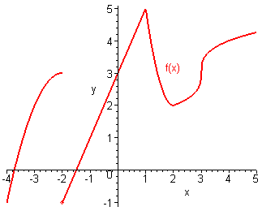

a. Determine the following:

(i). $\underset{x→−2^{−}}{\text{lim}}f(x)=$ (iii).$\underset{x→−2}{\text{lim}}f(x)=$
(ii). $\underset{x→−2^{+}}{\text{lim}}f(x)=$ (iv). $\underset{x→1}{\text{lim}}f(x)=$

b. State the x value)s where the function not continuous?

