Math 126 Written HW Set 3

This homework set is due Monday, July 7th. Show work when possible. Answers magically appearing with no work receive no credit.

1. On these problems, use the limit definition of the derivative (not the basic derivative
formulas) given by $f^{'}(x)=\underset{h→0}{\text{lim}}\frac{f(x+h)−f(x)}{h}$ to differentiate the functions.
a. $f(x)=3x−4$
b. $f(x)=x^{2}−6x$

2. Consider the following graph of the function $f(x)$:

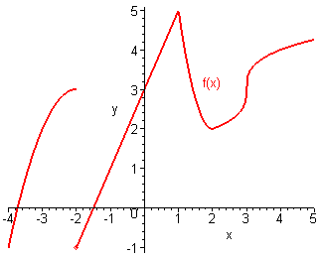

State the x value)s where the function is not differentiable. Explain your reasoning.

3. From Larson Textbook p. 103 # 17, 36, 47. On these, just use the basic derivative formulas to get the derivatives (you don’t have to use the definition of the derivative like in problem 1).

