Math 151 Written HW Set 2

This homework set is due Wednesday, October 9th. Show work when possible. Answers magically appearing with no work receive no credit.

1. From Larson Textbook p. 66 # 23, 30, 31. Note: For these problems, pick a single
value of x where the function is possibly not continuous and try to prove whether it is continuous or not using the definition of continuity, that is show

A function f is continuous at x = a if
i). $f(a)$ exists
ii). $\underset{x→a}{\text{lim}}f(x)$ exists
iii). $\underset{x→a}{\text{lim}}f(x)=f(a)$

2. p. 75 # 25, 29 (for # 29 make sure your calculator is in radian mode)

3. Consider the following graph of the function $f(x)$:

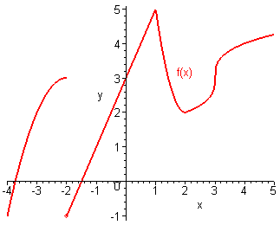

- State the x value)s where the function not continuous?
- For the points where the function is not continuous, is the function continuous from the left? From the right?
- Which of the discontinuities are removeable?

