Math 151 Written HW Set 3

This homework set is due Monday, October 8th. Show work when possible. Answers magically appearing with no work receive no credit.

1. From Larson Textbook p. 88 # 12, 15, 17, 21

On these problems, use the limit definition of the derivative (not the basic derivative
formulas) given by $f^{'}(x)=\underset{h→0}{\text{lim}}\frac{f(x+h)−f(x)}{h}$ to differentiate the functions.

2. Consider the following graph of the function $f(x)$:

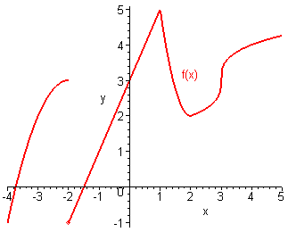

a. State the x value)s where the function not continuous?
b. State the x value)s where the function is not differentiable. Explain your reasoning.

