Section 7.2: Direction Fields and Euler’s Methods

Practice HW from Stewart Textbook (not to hand in)
p. 511 # 1-13, 19-23 odd

For a given differential equation, we want to look at ways to find its solution. In this chapter, we will examine 3 techniques for determining the behavior for the solution. These techniques will involve looking at the solutions graphically, numerically, and analytically.

Examining Solutions Graphically – Direction Fields

Recall from Calculus I that for a function $y(x)$, $y^{'}=\frac{\text{dy}}{\text{dx}}$ gives the slope of the tangent line at a particular point (x, y) on the graph of y(x). Suppose we consider a first order differential equations of the form

$y^{'}=f(x,y)$.

For a solution y of this differential equation, $y^{'}$ evaluated at the point $(x_{1},y_{1})$ represents the slope of the tangent line to the graph of y(x) at this point.
$$x_{1}$$
$$y_{1}$$
Even though we do not know the formula for the solution y(x), having the differential equation $y^{'}=f(x,y)$ gives a convenient way for calculating the tangent line slopes at various points. If we obtain these slopes for many points, we can get a good general idea of how the solution is behaving.
Direction Fields (sometimes called slope fields) involves a method for determining the behavior of various solutions on the x-y plane by calculating the tangent line slopes at various points.

Example 1: Sketch the direction field for the differential equation $y^{'}=x^{2}−y$. Use the result to sketch the graph of the solution with initial condition $y(0)=1$.

Solution: In this problem, we plot points for the four quadrant regions and the x and y axis (we will fill in the first quadrant chart in class).

2nd Quadrant
x | y | $$y^{'}=x^{2}−y$$
-3 | 1 | 8
-2 | 1 | 3
-1 | 1 | 0
-3 | 2 | 7
-2 | 2 | 2
-1 | 2 | -1
-3 | 3 | 6
-2 | 3 | 1
-1 | 3 | -2
1st Quadrant
x | y | $$y^{'}=x^{2}−y$$
1 | 1
2 | 1
3 | 1
1 | 2
2 | 2
3 | 2
1 | 3
2 | 3
3 | 3

3rd Quadrant
x | y | $$y^{'}=x^{2}−y$$
-3 | -1 | 10
-2 | -1 | 5
-1 | -1 | 2
-3 | -2 | 11
-2 | -2 | 6
-1 | -2 | 3
-3 | -3 | 12
-2 | -3 | 7
-1 | -3 | 4
4th Quadrant
x | y | $$y^{'}=x^{2}−y$$
1 | -1 | 2
2 | -1 | 5
3 | -1 | 10
1 | -2 | 3
2 | -2 | 6
3 | -2 | 11
1 | -3 | 4
2 | -3 | 7
3 | -3 | 12

x-axis
x | y | $$y^{'}=x^{2}−y$$
-3 | 0 | 9
-2 | 0 | 4
-1 | 0 | 1
0 | 0 | 0
1 | 0 | 1
2 | 0 | 4
3 | 0 | 9
y-axis
x | y | $$y^{'}=x^{2}−y$$
0 | -3 | 3
0 | -2 | 2
0 | -1 | 1
0 | 0 | 0
0 | 1 | -1
0 | 2 | -2
0 | 3 | 3

We can sketch the slopes on the following graph (will do in class):
y

x

█
Obviously, as can be seen by the last example, sketching direction fields by hand can be a very tedious task. However, Maple can sketch a direction field quickly. For the differential equation $y^{'}=x^{2}−y$ given in Example 1, the following commands in Maple can be used to sketch the direction field:

> with(DEtools): with(plots):
Warning, the name changecoords has been redefined
> de := diff(y(x),x)=x^2-y(x);
> dfieldplot(de, y(x),x=-10..10,y=-30..30, color = black, arrows = MEDIUM, color = blue);

Notes
1. The direction fields for differential equations of the form $y^{'}=f(x)$, where the right
is strictly a function of x have the same slope fields for points with the same x coordinate.
x
y
$$x_{1}$$

$$x_{2}$$

Slope Fields
are same at each x coord

Example: Plot of $y^{'}=t^{2}+\text{cos}(t)$

2. The direction fields for differential equations of the form $y^{'}=f(y)$, where the right
is strictly a function of y have the same slope fields for points with the same y coordinate. A differential equation is strictly a function of the dependent variable y is known as an autonomous equation.
x
y

$$y_{2}$$

Slope Fields
are same at each y coord

$$y_{1}$$

Example: Plot of $y^{'}=(2−y)$

3. A constant solution of the form y = K of an autonomous where the direction field
slopes are zero, that is, where $y^{'}=0$ and the solution y neither increases or decreases, is known as an equilibrium solution.

Example: $y^{'}=(2−y)$ the equilibrium solution is y = 2.
Example 2: Given the direction field plot of the differential equation $y^{'}=y(1−{y^{2}}/9)$.

- Sketch the graphs of solutions that satisfy the given initial conditions:
i. $y(0)=1$ iii. $y(0)=−2$
ii. $y(0)=3$
b. Find all equilibrium solutions.

Solution:

█
Finding Solutions Numerically – Euler’s Method

A common way to examine the solution of a differential equations is to approximate it numerically. One of the more simpler methods for doing this involves Euler’s method.

Consider the initial value problem

$y^{'}=F(x,y), y(x_{0})=y_{0}$.

over the interval $x_{0}=a≤x≤b$. Suppose we want to find an approximation to the solution y(x) given by the following graph:

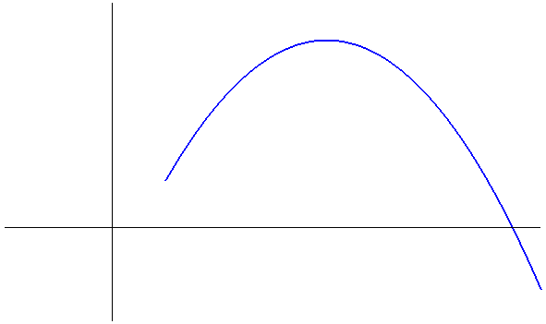
y(x)

Starting at the point $(x_{0},y_{0})$specified by the initial condition $y(x_{0})=y_{0}$, we want to approximate to solution at equally spaced points beyond $x_{0}$ on the x axis. Let h (known as the step size) be the space between the points on the x-axis. Then $x_{1}=x_{0}+h$, $x_{2}=x_{1}+h$, $x_{3}=x_{2}+h$, etc. Consider the tangent line at the point $(x_{0},y_{0})$ that passes through the point $(x_{1},y_{1})$. Since the derivative is used to calculate the slope of the tangent line, it can be seen that

$$\begin{matrix}\text{Slope of the tangent line} \\ \text{to }y(x)\text{ at }(x_{0},y_{0})\end{matrix}=y^{'}|_{(x_{0},y_{0})}=F(x_{0},y_{0})$$

Hence,

$$\begin{aligned}\begin{matrix}\text{Slope through} \\ (x_{0},y_{0})\text{ and }(x_{1},y_{1})\end{matrix} =\text{ Slope at tangent line at }(x_{0},y_{0}) \\ \frac{y_{1}−y_{0}}{x_{1}−x_{0}} = F(x_{0},y_{0}) \\ y_{1}−y_{0} = (x_{1}−x_{0})F(x_{0},y_{0}) \\ y_{1}−y_{0} = h F(x_{0},y_{0}) \\ y_{1} = y_{0}+h F(x_{0},y_{0})\end{aligned}$$

Now, consider the line through the points $(x_{1},y_{1})$ and $(x_{2},y_{2})$.

$$\begin{aligned}\begin{matrix}\text{Slope through} \\ (x_{1},y_{1})\text{ and }(x_{2},y_{2})\end{matrix} ≈\text{ Slope at tangent line at }(x_{1},y_{1})=F(x_{1},y_{1}) \\ \frac{y_{2}−y_{1}}{x_{2}−x_{1}} = F(x_{1},y_{1}) \\ y_{2} = y_{1}+h F(x_{1},y_{1})\end{aligned}$$

In general,

$$y_{n}=y_{n−1}+h F(x_{n−1},y_{n−1})$$

Summarizing,

Euler’s Method

Given the initial value problem

$$y^{'}=F(x,y), y(x_{0})=y_{0}$$

we calculate $(x_{n},y_{n})$ from $(x_{n−1},y_{n−1})$ by computing

$$x=x_{n−1}+h$$

$$y_{n}=y_{n−1}+h F(x_{n−1},y_{n−1})$$

where h is the step size between endpoints on the x-axis.
Example 3: Use Euler’s Method with step size of 0.5 to estimate y(2), where y(x) is the solution to the initial value problem $y^{'}=2x−3y,y(0)=4$. Sketch the graph of the iterates used in finding the estimate.

Solution:

█
Notes
1. Using techniques that can studied in a differential equations course, it can be shown that the exact solution to the initial value problem $y^{'}=2x−3y,y(0)=4$ given in Example 3 is
$$y(x)=\frac{\text{38}}{9}e^{−3x}+\frac{2}{3}x−\frac{2}{9}$$

The approximation to y(2) (what y is when x = 2) was $y_{4}=1\text{.}\text{375}$. The exact value is $y(2)=\frac{\text{38}}{9}e^{−3(2)}+\frac{2}{3}(2)−\frac{2}{9}=\frac{\text{38}}{9}e^{−6}+\frac{4}{3}−\frac{2}{9}≈1\text{.}\text{1215769}\text{.}$ Thus the error between the approximation and the exact value is

$|y(2)−y_{4}|=|1\text{.}\text{1215769}−1\text{.}\text{375}|≈|−0\text{.}\text{253423}|=0\text{.}\text{253423}$.

2. By decreasing the step size h, the accuracy of the approximation in most cases will be better, with a tradeoff in more work needed to achieve the approximations. For example, the chart below shows the approximations generated when the step size for Example 3 is cut in half to h = 0.25.

$$\begin{aligned}x_{n}=x_{n−1}+h \\ =x_{n−1}+0\text{.}\text{25}\end{aligned}$$ | $$\begin{aligned}y_{n}=y_{n−1}+h F(x_{n−1},y_{n−1}) \\ =y_{n−1}+0\text{.}\text{25}(2x_{n−1}−3y_{n−1})\end{aligned}$$ | Exact Value  $$y(x)=\frac{\text{38}}{9}e^{−3x}+\frac{2}{3}x−\frac{2}{9}$$
$$x_{0}=0$$ | $$y_{0}=4$$ | $$y(0)=\frac{\text{38}}{9}e^{0}+\frac{2}{3}(0)−\frac{2}{9}=\frac{\text{36}}{9}=4$$
$$\begin{aligned}x_{1}=x_{0}+h \\ =0+0\text{.}\text{25} \\ =0\text{.}\text{25}\end{aligned}$$ | $$\begin{aligned}y_{1}=y_{0}+0\text{.}\text{25}(2x_{0}−3y_{0}) \\ =4+0\text{.}\text{25}(2(0)−3(4)) \\ =\text{ 4}+0\text{.}\text{25}(\text{0-12})=4+(\text{-3})=1\end{aligned}$$ | $$\begin{aligned}y(0\text{.}\text{25})=\frac{\text{38}}{9}e^{−3(0\text{.}\text{25})}+\frac{2}{3}(−0\text{.}\text{25})−\frac{2}{9} \\ ≈1\text{.}\text{938881000;}\end{aligned}$$
$x_{2}=$0.5 | $y_{2}=$0.375 | $$y(0\text{.}5)≈1\text{.}\text{053216232}$$
$$x_{3}=0\text{.}\text{75}$$ | $y_{3}=$0.34375 | $$y(0\text{.}\text{75})≈0\text{.}\text{7227967261}$$
$$x_{4}=1$$ | $y_{4}=$0.4609375 | $$y(1)≈0\text{.}\text{6546565109}$$
$$x_{5}=1\text{.}\text{25}$$ | $y_{5}=$0.6152343750 | $$y(1\text{.}\text{25})≈0\text{.}\text{7104082603}$$
$$x_{6}=1\text{.}5$$ | $y_{6}=$0.7788085938 | $$y(1\text{.}5)≈0\text{.}\text{8246824299}$$
$$x_{7}=1\text{.}\text{75}$$ | $y_{7}=$0.9447021484 | $$y(1\text{.}\text{75})≈0\text{.}\text{9666006336}$$
$$x_{8}=2$$ | $y_{8}=$1.111175537 | $$y(2)≈1\text{.}\text{1215769542}$$

Here, the approximation to $y(2)≈1\text{.}\text{1215769542}$ is $y_{8}=1\text{.}\text{111175537}$ and the error between the approximation and the exact value is

$|y(2)−y_{8}|≈|1\text{.}\text{1215769}−1\text{.}\text{1111755}|≈|0\text{.}\text{010401}|=0\text{.}\text{010401}$.

The following represents a graph of the curves produced by Euler’s method for various values of h and the exact solution y(x).

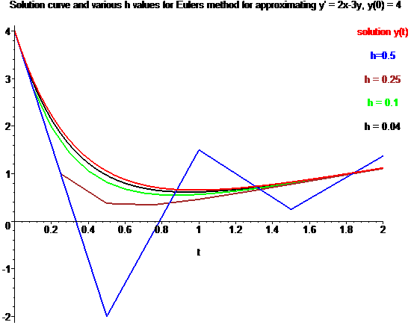

3. There are other numerical methods that can achieve better accuracy with less work
than Euler’s method. However, the underlying approach used in many of these
methods stem from Euler’s approach.

