Section 7.5: The Logistic Equation

Practice HW from Stewart Textbook (not to hand in)
p. 542 # 1-13 odd

The basic exponential growth model we studied in Section 7.4 is good for modeling populations that have unlimited resources over relatively short spans of time. However, most environments have a limit on the amount of population it can support. We present a better way of modeling these types of populations. In general,

1. For small populations, the rate of growth is proportional to its size (exhibits the basic
exponential growth model.
2. If the population is too large to be supported, the population decreases and the rate of
growth is negative.

Let

t = the time a population grows
P or P(t) = the population after time t.
k = relative growth rate coefficient
K = carrying capacity, the amount that when exceeded will result in the population
decreasing.

Notes
1. Note that if P is small, $\frac{\text{dP}}{\text{dt}}≈\text{kP}$ (the population will be assumed to assume basic exponential growth)

2. If P > K, $\frac{\text{dP}}{\text{dt}}<0$ (population will decrease back towards the carrying capacity).

To construct the model, we say

$\frac{\text{dP}}{\text{dt}}=\text{kP}underbracealignl\underset{\text{growth}\text{Part}}{\underbrace{\begin{aligned}\text{exp}\text{onential}\end{aligned}}}⋅(\text{something to make }\frac{\text{dP}}{\text{dt}}<0)$.

To make $\frac{\text{dP}}{\text{dt}}<0$, let $\text{something}=1−\frac{P}{K}$. Note that if $P>K, \frac{P}{K}>1,\text{ and }1−\frac{P}{K}<0$.

Using this, we have the logistic population model.

$$\frac{\text{dP}}{\text{dt}}=\text{kP}\left(1−\frac{P}{K}\right)$$
This differential equation can be solved using separation of variables, where partial fractions are used in the integration process (see pp. 538-539 of Stewart textbook). Doing this gives the solution

$P(t)=\frac{K}{1+{\text{Ae}}^{−\text{kt}}}\text{ , }A=\frac{K−P_{0}}{P_{0}}$,

where $P_{0}$ = the initial population at time t = 0, that is $P(0)=P_{0}$. Summarizing, we have the following.

Logistic Population Growth Model

The initial value problem for logistic population growth,

$\frac{\text{dP}}{\text{dt}}=\text{kP}\left(1−\frac{P}{K}\right), P(0)=P_{0}$,

has solution
$P(t)=\frac{K}{1+{\text{Ae}}^{−\text{kt}}}\text{ where }A=\frac{K−P_{0}}{P_{0}}$.

Here,

t = the time the population grows
P or P(t) = the population after time t.
k = relative growth rate coefficient
K = carrying capacity, the amount that when exceeded will result in the population
decreasing.
$P_{0}$ = initial population, or the population we start with at time t = 0, that is, $P(0)=P_{0}$.

Notes
1. Solutions that can be useful in analyzing the behavior of population models are the
equilibrium solutions, which are constant solutions of the form P = K where $\frac{\text{dP}}{\text{dt}}=0$.
For the logistic population model, $\frac{\text{dP}}{\text{dt}}=\text{kP}\left(1−\frac{P}{K}\right)=0$ when P = 0 and P = K.
2. Sometimes the logistic population model can be varied slightly to take into account
other factors such as population harvesting and extinction factors (Exercises 11 and
13). In these cases, as symbolic manipulator such as Maple can be useful in analyzing
the model predictions.

t
$$P_{0}$$
Example 1: Suppose a species of fish in a lake is modeled by a logistic population model with relative growth rate of k = 0.3 per year and carrying capacity of K = 10000.
a. Write the differential equation describing the logistic population model for this
problem.
b. Determine the equilibrium solutions for this model.
c. Use Maple to sketch the direction field for this model. Draw solutions for several
initial conditions.
d. If 2500 fish are initially introduced into the lake, solve and find the analytic solution
P(t) that models the number of fish in the lake after t years. Use it to estimate the number of fish in the lake after 5 years. Graph the solution and the direction field on the same graph.
e. Continuing part d, estimate the time it will take for there to be 8000 fish in the lake.

Solution:
Part a.)

Part b.)

Part c.) The following Maple commands can be used to plot the direction field.

> with(DEtools): with(plots):
> de := diff(P(t),t)=0.3*P(t)*(1 - P(t)/10000);
> dfieldplot(de, P(t), t = 0..50, P = 0..12000, color = blue, arrows = MEDIUM, dirgrid = [30,30], title = "The Logistic Model dP/dt = 0.3*P*(1-P/10000)");

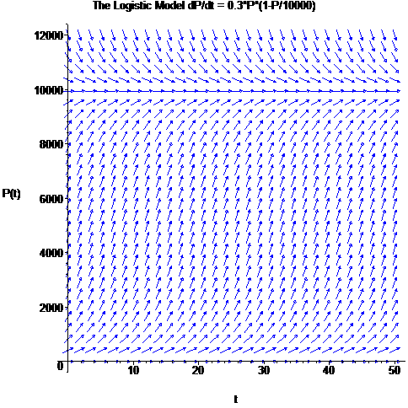

Part d.)

Part e.)

█
Modifications of the Logistic Model

The logistic population model can be altered to consider other population factors. Two methods of doing this can be described as follows:

1. Populations that are subject to “harvesting”. Sometimes a population can be taken
away or harvested at a constant rate. If the parameter c represents to rate per time
period of the population harvested, then the logistic model becomes

$$\frac{\text{dP}}{\text{dt}}=\text{kP}\left(1−\frac{P}{K}\right)−c$$

2. Suppose that when the population falls below a minimum population m, the
population becomes extinct. Then this population can be modeled by the differential
equation

$$\frac{\text{dP}}{\text{dt}}=\text{kP}\left(1−\frac{P}{K}\right)\left(1−\frac{m}{P}\right)$$

Maple can be useful in helping to analyze models of these types. We consider the harvesting problem in the following example.

Example 2: Suppose a species of fish in a lake is modeled by a logistic population model with relative growth rate of k = 0.3 per year and carrying capacity of K = 10000. In addition, suppose 400 fish are harvested from the lake each year.
a. Write the differential equation describing the population model for this problem.
b. Use Maple to determine the equilibrium solutions for this model.
c. Use Maple to sketch the direction field for this model. Draw solutions for several
initial conditions.
d. If 2500 fish are initially introduced into the lake, solve and find the analytic solution
P(t) that models the number of fish in the lake after t years. Use it to estimate the number of fish in the lake after 5 years.
e. Continuing part d, estimate the time it will take for there to be 8000 fish in the lake.

Solution: Part a). We use the harvesting model equation

$$\frac{\text{dP}}{\text{dt}}=\text{kP}\left(1−\frac{P}{K}\right)−c$$

Substituting the relative growth rate coefficient of k = 0.3, carrying capacity K = 10000, amount to be harvested c = 400 into this differential equation, we obtain the model

$$\frac{\text{dP}}{\text{dt}}=0\text{.}3P\left(1−\frac{P}{\text{10000}}\right)−\text{400}$$

Part b.) The equilibrium solutions occur for population values where $\frac{\text{dP}}{\text{dt}}=0$. The following Maple commands will find these values:

> de := diff(P(t),t)=0.3*P(t)*(1 - P(t)/10000) - 400;

> solve(rhs(de) = 0, P(t));

Thus, the equilibrium solutions occur when there are approximately P = 1584 fish and
P = 8416 fish.

(Continued on next page)

Part c.) The following Maple commands can be used to plot the direction field (we will plot the solutions in class).

> with(DEtools): with(plots):
> de := diff(P(t),t)=0.3*P(t)*(1 - P(t)/10000) - 400;
> dfieldplot(de, P(t), t = 0..50, P = 0..12000, color = blue, arrows = MEDIUM, dirgrid = [30,30], title = "The Logistic Model dP/dt = 0.3*P*(1-P/10000) - 400");

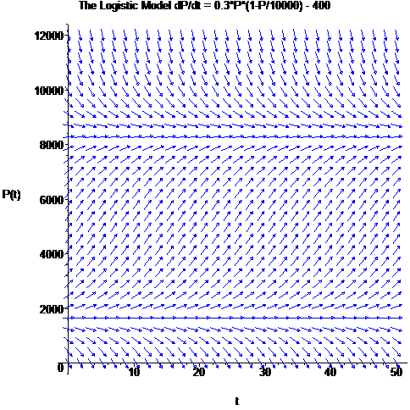

(Continued on next page)

Part d. ) The following Maple commands will find the analytic solution and find the approximate number of fish in the lake after 5 years.

> de := diff(P(t),t)=0.3*P(t)*(1 - P(t)/10000) - 400;
> sol := dsolve({de, P(0) = 2500}, P(t));
> evalf(subs(t = 5, sol));
The next sequence of commands demonstrate how to plot the direction field and solution on the same graph.

> with(DEtools): with(plots):
> p1 := dfieldplot(de, P(t), t = 0..50, P = 0..12000, color = blue, arrows = MEDIUM, dirgrid = [35,35], title = "The Logistic Model dP/dt = 0.3*P*(1-P/10000) - 400"):
> p2 := plot(rhs(sol), t = 0..50, color = red, thickness = 2):
> display([p1, p2]);

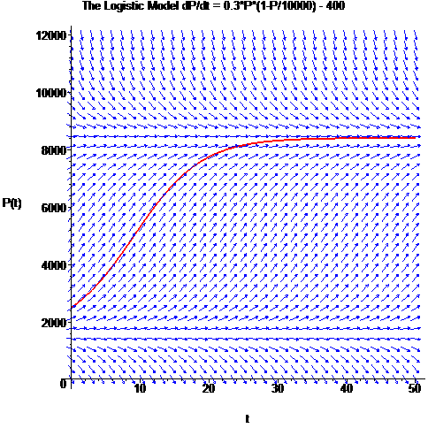

Part e). Taking the solution stored in the variable sol given above in part d, the next command demonstrates how to find the time the population will be 8000.

> sol;
> solve(rhs(sol) = 8000, t);
> evalf(%);
Thus, it takes approximately t = 22.5 years for the population to reach 8000.

█

