Section 8.9: Applications of Taylor Polynomials

Practice HW from Stewart Textbook (not to hand in)
p. 628 # 1-21 odd

Taylor Polynomials

In this section, we use Taylor polynomials to approximate a given function $f(x)$ near a point x = a.

Definition: The $n^{\text{th}}$ Taylor polynomial $T_{n}(x)$ at a function $f(x)$ at x = a is given by

$$T_{n(}(x)=f(a)+f^{'}(a)\frac{f^{'}(a)}{1\text{ !}}(x−a)\frac{f^{''}(a)}{2\text{ !}}(x−a)^{2}+\frac{f^{'''}(a)}{3\text{ !}}(x−a)^{3}+…+\frac{f^{n}(a)}{n\text{ !}}(x−a)^{n}$$

where ${T_{n}(a)=f(a),\text{ \{}T}_{n}^{'}(a)=f^{'}(a),\text{ \{}T{}_{n}^{''}(a)=f^{''}(a), …, T_{n}^{n}(a)=f^{n}(a)$.

Example 1: Find the Taylor (Maclaurin) polynomial for$f(x)=e^{x}$ at a = 0 and n = 2 and use it to approximate $e^{0\text{.}\text{01}}$.

Solution:

█
Note: In general, the higher the degree of the Taylor polynomial and the closer we are to the point x = a that the Taylor polynomial is centered at, the better the approximation

Example 2: Find the Taylor (Maclaurin) polynomial for$f(x)=e^{x}$ at a = 0 and n = 4 and use it to approximate $e^{0\text{.}\text{01}}$.

Solution:

█
The following table illustrates the accuracy of the Taylor polynomials $T_{2}(x)=1+x+\frac{1}{2}x^{2}$
and $T_{4}(x)=1+x+\frac{1}{2}x^{2}+\frac{1}{6}x^{3}+\frac{1}{\text{24}}x$ to $f(x)=e^{x}$ near x = 0.

x | -8 | -1 | -0.1 | -0.01 | 0 | 0.01 | 0.1 | 1 | 5
$$f(x)=e^{x}$$ | 0.0003 | 0.367879 | .904837 | 0.9900498 | 1 | 1.01005016 | 1.1051709 | 2.71882818 | 148.413
$$T_{2}(x)$$ | 25 | 0.5 | 0.905 | 0.99005 | 1 | 1.01005 | 1.105 | 2.5 | 18.5
$$T_{4}(x)$$ | 110.3 | 0.375 | 0.904837 | 0.9900498 | 1 | 1.01005016 | 1.1051708 | 2.7083333 | 65.375

As can be seen, the closer the value of x is nearer to zero, the better the approximation the
Taylor polynomials provided for the function. This is further illustrated by the following graphs:

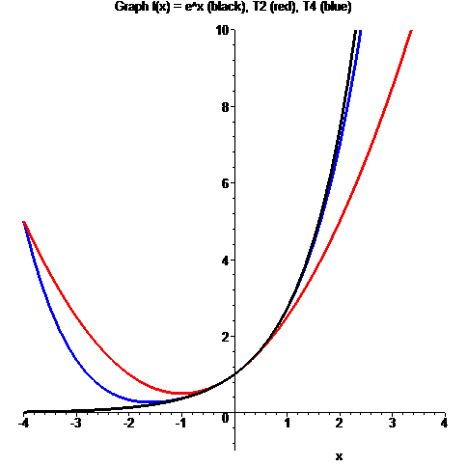

Note: The following Maple commands can be used to find the 2nd and 4th degree Taylor polynomials for $f(x)=e^{x}$ near x = 0.

> with(Student[Calculus1]):
> TaylorApproximation(exp(x), x = 0, order = 2);
> TaylorApproximation(exp(x), x = 0, order = 4);

Example 3: Find the Taylor polynomial $T_{n}(x)$ for the function $f(x)=\sqrt{3+x^{2}}$ at a = 1 for n = 3.

Solution:

█
Error of Approximation

Can be used to determine how close a Taylor polynomial $T_{n}(x)$ is to $f(x)$.

We define the function $R_{n}(x)$, which represents the error between $f(x)$ and $T_{n}(x)$, as follows:

$$R_{n}(x)=f(x)−T_{n}(x)$$

Estimation of Error – Taylor’s Inequality

If $\left|f^{n+1}(x)\right|≤M$ for $|x−a|≤d$ ($−d+a≤x≤d+a$), then

$|R_{n}(x)|≤\frac{M}{(n+1)\text{ !}}|x−a|^{n+1}$ for $|x−a|≤d$

Note: It is many times useful to use Maple to help determine the error of approximation.

Example 4: For $f(x)=\text{ln}(1+2x)$, use Maple to
a. Approximate f by a Taylor polynomial of degree n = 3 centered at a = 1.
b. Use Taylor’s inequality to estimate the accuracy of the approximation $f(x)≈T_{n}(x)$ f
for $0\text{.}5≤x≤1\text{.}5$.

Solution (Part a): The following commands will compute and store the 3rd degree Taylor polynomial centered at x = a = 1.

> with(Student[Calculus1]):
> T3 := TaylorApproximation(ln(1+2*x), x = 1, order = 3);
Thus,
$$T_{3}(x)=\text{ln}(3)−\frac{\text{80}}{\text{81}}+\frac{\text{38}}{\text{27}}x−\frac{\text{14}}{\text{27}}x^{2}+\frac{8}{\text{81}}x^{3}$$

Solution (Part b): It is important to note that the inequality $|x−1|≤0\text{.}5$ by definition says that $−0\text{.}5≤x−1≤0\text{.}5$. Adding 1 to all sides of the inequality gives $0\text{.}5≤x≤1\text{.}5$, which is the given interval. The Taylor inequality estimate says that if

$\left|f^{n+1}(x)\right|≤M$, then$|R_{n}(x)|≤\frac{M}{(n+1)\text{ !}}|x−a|^{n+1}$ for $|x−a|≤d$

For this problem, n = 3, a = 1, and d = 0.5. Thus, the equality becomes

$|R_{3}(x)|≤\frac{M}{4\text{ !}}|x−1|^{4}$ for $|x−1|≤0\text{.}5$

This inequality is guaranteed to be true if $\left|f^{n+1}(x)\right|≤M$, or $\left|f^{4}(x)\right|≤M$ for $0\text{.}5≤x≤1\text{.}5$. Our goal is to find an upper bound for $\left|f^{4}(x)\right|$ on the interval $0\text{.}5≤x≤1\text{.}5$, that is, a value for which $\left|f^{4}(x)\right|$ is guaranteed to be smaller than for the entire interval. We can use a graph of $\left|f^{4}(x)\right|$ to find M. The following Maple commands can be used.
> f := ln(1+2*x);
> f4 := abs(diff(f, x$4));
> plot(f4, x = 0.5..1.5, view = [-1..2, -1..10]);

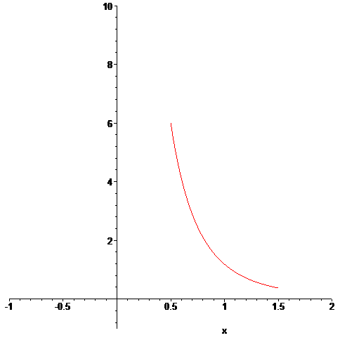

As, the graph shows, the fourth order derivative $\left|f^{4}(x)\right|$ has a maximum of 6 on the interval $0\text{.}5≤x≤1\text{.}5$ and this maximum occurs at $x=0\text{.}5\text{.}$ Thus, M = 6 and $\left|f^{4}(x)\right|≤6$ when $x=0\text{.}5\text{.}$ Hence,

$$|R_{3}(x)|≤\frac{M}{4\text{ !}}|x−1|^{4}=\frac{6}{\text{24}}|0\text{.}5−1|^{4}=\frac{1}{4}|−0\text{.}5|^{4}=(0\text{.}\text{25})(0\text{.}5)^{4}=(0\text{.}\text{25})(0\text{.}\text{0625})=0\text{.}\text{015625}$$
Thus, this says for any value of x in the interval $0\text{.}5≤x≤1\text{.}5$, the function $f(x)=\text{ln}(1+2x)$
and the Taylor polynomial $T_{3}(x)=\text{ln}(3)−\frac{\text{80}}{\text{81}}+\frac{\text{38}}{\text{27}}x−\frac{\text{14}}{\text{27}}x^{2}+\frac{8}{\text{81}}x^{3}$ will never differ more than 0.015625
█

