Section 9.1: Three Dimensional Coordinate Systems

Practice HW from Stewart Textbook (not to hand in)
p. 641 # 1, 2, 3, 7, 10, 11, 13, 14, 15b, 16

3-D Coordinate Axes

In this chapter, we want to consider the 3 dimensional coordinate axes.

z

y

x

Points are located using ordered triples (x, y, z).

Example 1: Plot the points (1, 1, 1), (2, 5, 0), (-2, 3, 4), (1, 1, -4), and (2, -5, 3).

Solution:
x
y
z

█

Note: The 3-D coordinate axes divides the coordinate system into 3 distinct planes – the x-y
plane z = 0, the y-z plane x = 0, and the x-z plane y = 0. (see next page)
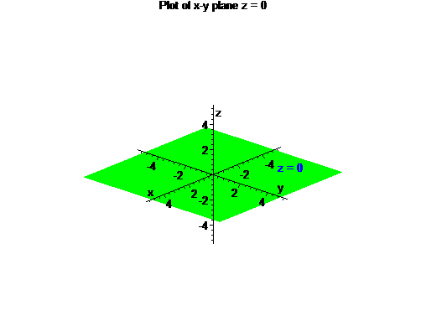

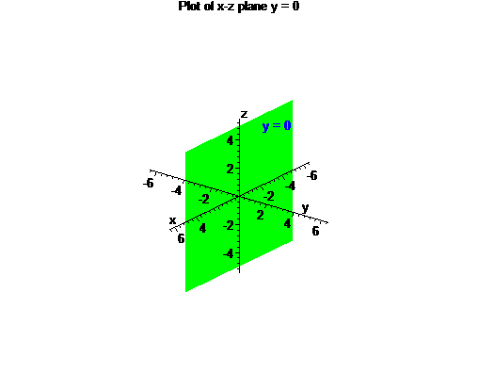

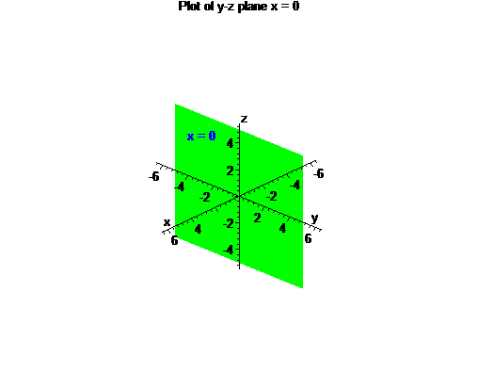

Suppose we are now given the two points $P=(x_{1},y_{1},z_{1})$ and $Q=(x_{2},y_{2},z_{2})$ in 3D space.
x
y
z
$$Q=(x_{2},y_{2},z_{2})$$

$$P=(x_{1},y_{1},z_{1})$$

Then

$$\begin{matrix}\text{Distance between the points} \\ (x_{1},y_{1},z_{1})\text{ and }(x_{2},y_{2},z_{2})\end{matrix}=d=\sqrt{(x_{2}−x_{1})^{2}+(y_{2}−y_{1})^{2}+(z_{2}−z_{1})^{2}}$$

$$\begin{matrix}\text{Midpoint between the points} \\ (x_{1},y_{1},z_{1})\text{ and }(x_{2},y_{2},z_{2})\end{matrix}=M=\left(\frac{x_{1}+x_{2}}{2},\frac{y_{1}+y_{2}}{2},\frac{z_{1}+z_{2}}{2}\right)$$

Example 1: Find the distance and midpoint between the points (2, 1, 4) and (6, 5, 2).

Solution:

█

Recall: An isosceles triangle is a triangle where the lengths of two of its sides are equal. A right triangle is a triangle with a 90 degree angle where the sum of squares of the shorter sides equals the square of the hypotenuse.

$$a^{2}+b^{2}=c^{2}$$

x
x
Icosceles Triangle
Right Triangle
a
b
c
Example 2: Find the lengths of the sides of the triangle PQR if P = (1, -3, -2),
Q = (5, -1, 2) and R = (-1, 1, 2). Deterrmine if the resulting triangle is an isosceles or a right triangle.

Solution: We will use the distance formula to find the length of the triangles sides PQ,
QR, and RP. We obtain the following results:

Length of side PQ = $\sqrt{(5−1)^{2}+(−1−−3)^{2}+(2−−2)^{2}}=\sqrt{4^{2}+2^{2}+4^{2}}=\sqrt{\text{36}}=6\text{.}$

Length of side QR = $\sqrt{(−1−5)^{2}+(1−−1)^{2}+(2−2)^{2}}=\sqrt{(−6)^{2}+2^{2}+0^{2}}=\sqrt{\text{40}}=\sqrt{4⋅\text{10}}=2\sqrt{\text{10}}$

Length of side RP = $\sqrt{(1−−1)^{2}+(−3−1)^{2}+(−2−2)^{2}}=\sqrt{2^{2}+(−4)^{2}+(−4)^{2}}=\sqrt{\text{36}}=6$.

Since sides PQ and RP are equal, the triangle is isosceles. It is not a right triangle since the sum of squares of the shorter sides PQ and RP does not equal the square of the longest side QR. That is,

$(\text{PQ})^{2}+(\text{QR})^{2}=6^{2}+6^{2}=\text{36}+\text{36}=\text{72}≠(2⋅\sqrt{\text{10}})^{2}=4⋅\text{10}=\text{40}=(\text{QR})^{2}$.

The following picture graphs the isosceles triangle in 3D space.

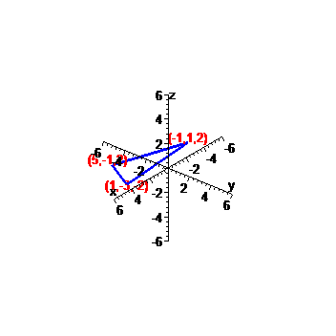

█
Standard Equation of a Sphere

x
y
z


Standard Equation of a Sphere

The standard equation of a sphere with radius r and center $(x_{0},y_{0},z_{0})$ is given by

$$(x−x_{0})^{2}+(y−y_{0})^{2}+(z−z_{0})^{2}=r^{2}$$

In particular, if the center of the sphere is at the origin, that is, if $(x_{0},y_{0},z_{0})=(0,0,0)$, then the equation becomes

$$x^{2}+y^{2}+z^{2}=r^{2}$$

Fact: When the standard equation of a sphere is expanded and simplify, we obtain the general equation of a sphere

Standard Equation of a Sphere

$${\text{Ax}}^{2}+{\text{Ay}}^{2}+{\text{Az}}^{2}+\text{Bx}+\text{Cy}+\text{Dz}+E=0$$

Example 3: Find the standard and general equation of a sphere that passes through the point (2, 1, 4) and has center (4, 3, 3)

Solution:

█
Note: To convert the general form of the sphere equation to standard form, we must complete the square.

Example 4: Find the center and radius of the sphere

$$4x^{2}+4y^{2}+4z^{2}−4x−\text{32}y+8z+\text{33}=0$$

Solution:

█

