Section 9.6: Functions and Surfaces

Practice HW from Stewart Textbook (not to hand in)
p. 683 # 9-13, 19, 20, 23, 24, 25
Handout Sheet 1-6, 7-27 odd

Functions of More Than One Variable

So far most of our experience has been working with functions of one variables.
Some examples are: $f(x)=x^{2}$, $g(x)=\text{ln}x$, $h(x)=e^{x}$. In this section, we want to examine functions and variables of multivariate equations and functions, like $z=f(x,y)=−3x−6y+6$ or $z=f(x,y)=\text{cos}y$. We want to look at techniques for obtaining rough sketches of these types of graphs in 3D space.

Cylinders

A cylinder is formed by taking a curve in 3D space along with lines which intersect the curve projected in the direction of the coordinate axis not included in the equation. You can recognize this by seeing that one of the coordinate axis variables that are missing.

Example 1: Make a rough sketch of the equation $x^{2}+y^{2}=\text{16}$.

Solution:
z

y

█
x
Example 2: Make a rough sketch of the equation $f(x,y)=\text{cos}y$.

Solution:

z

y

x

█

Graphing Planes

Recall that the equation of a plane is given by $\text{ax}+\text{by}+\text{cz}=d$ (note that the variables x, y, To make a rough sketch of a plane in 3D space, it is easiest to find the points of intersection with the coordinate axes.
Example 3: Make a rough sketch of the equation $f(x,y)=4$.

Solution:

z

y

x

█

Example 4: Make a rough sketch of the equation $x+2y=4$.

Solution:

x
y
z

█

Example 5: Make a rough sketch of the equation $z=f(x,y)=−3x−6y+6$.

Solution:

z

y

x

█

Quadric Surfaces

Quadric surfaces are the 3D analog of the conic sections in 2D.

Conic Sections is 2D

Parabolas

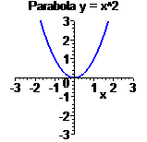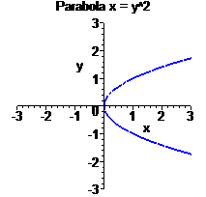

Ellispe

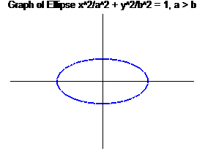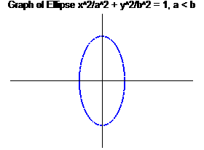

Hyperbola

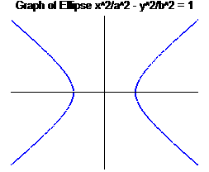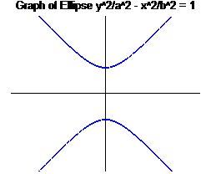

Types of Quadric Surfaces (summary on p.682 text)

Ellispsoid

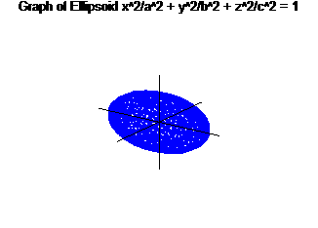
Hyperboloid (One Sheet)

Note: The axis the graph is projected along is the variable with the negative coefficient.

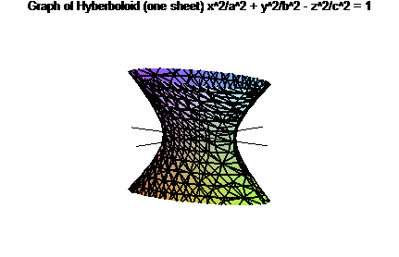
Hyperboloid (Two Sheets)

Note: The axis the graph is projected along is the variable with the positive coefficient.

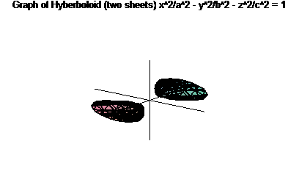

Elliptic Cone

Axis of projection is the variable with the negative coefficient

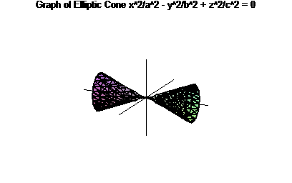

Elliptic Paraboloid

Axis of projection is the variable term raised to the 1st power.

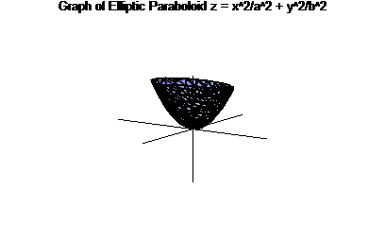

Hyperbolic Paraboloid

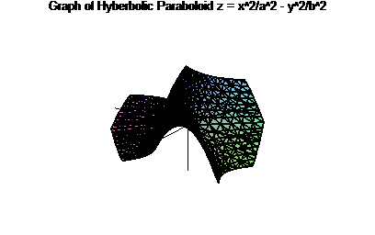

Note: To sketch a 3D quadric surface, sometimes it can be useful to set each variable equal to 0 and sketch the corresponding 2D curve. This is known as a trace.
Example 6: Identify and make a rough sketch of the quadric surface $x^{2}−\frac{y^{2}}{4}−z^{2}=1$.

Solution:

z

y

x

█

Example 6: Identify and make a rough sketch of the quadric surface $\text{16}x^{2}+9y^{2}+9z^{2}=\text{144}$.

Solution:

z

y

x

█

Example 6: Identify and make a rough sketch of the quadric surface $y=4x^{2}+z^{2}$.

Solution:

z

y

x

█

