Section 11.1: Functions of Several Variables

Practice HW from Larson Textbook (not to hand in)
p. 661 # 5-11 odd, 21-27 odd, 31-37 odd, 49-53 odd, 73, 81

Functions of More Than One Variable

So far most of our experience has been working with functions of one variables.
Some examples are: $f(x)=x^{2}$, $g(x)=\text{ln}x$, $h(x)=e^{x}$. In this section, we want to examine functions and variables of multivariate equations and functions, like $z=f(x,y)=x^{2}+4\text{xy}$ or $g(x,y,z)=\frac{{\text{xe}}^{y}}{z^{2}}$.

Example 1: Given $f(x,y)=x^{2}+4\text{xy}$, find $f(−1,2)$.

Solution:

█

Example 2: Given $g(x,y,z)=\frac{{\text{xe}}^{y}}{z^{2}}$, find $g(−2,0,3)$.

Solution:

█
Function of Two Variables – Domain and Range

A function of two variables associates with each ordered pair (x, y) a unique (one and only one) number z = f (x, y).

Informally, the domain of a function of two variables is the set of ordered pairs (x, y) where the function f (x, y) is defined. The range is the set of z values output by f (x, y).

Graphing a Function of Two Variables

Graphically, a function of two variables gives a 3-D surface. It can be useful in some cases to recognize the quadric surface and cylinder graphs studied in Section 9.6 when graphing functions of two variables.

Example 3: Describe the domain and range of $f(x,y)=\sqrt{4−x^{2}−4y^{2}}$. Make a rough sketch of the resulting surface.
.
Solution:

█
Level Curves and Contour Maps

Level Curves gives a way of representing the behavior of a 3D surface using 2D curves in a projection like fashion. Formally, the level curves of a function f of two variables are the curves with equations f (x, y) = k, where k is a constant in the range of f.

All the level curves sketch together form a contour map for a function.

Example 4: Sketch a contour map of the function $f(x,y)=x^{2}+y^{2}$ and show the relationship to the 3D surface it represents.

Solution:

█
Note: A surface $z=f(x,y)$ is steep when the level curves are close together. It is somewhat flatter when they are further apart (see Figure 5 and 6 on p. 742).

Example 5: Use the following contour map to estimate f (2, 1) and f (0, 1).

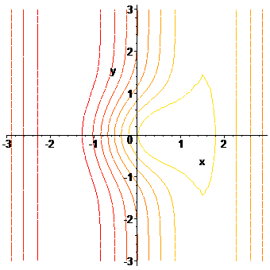
20
50
90
80
40
30
40
60

Solution:

█

