Section 12.3: Change of Variables: Polar Coordinates

Practice HW from Larson Textbook (not to hand in)
p. 750 # 5-15 odd, 19, 20, 23, 25

Polar Coordinates

Up to now , we have represented graphs as a collection of points (x, y) in the rectangular coordinate. For example, the following represents the graph of the circle $x^{2}+y^{2}=4$ in rectangular coordinates.

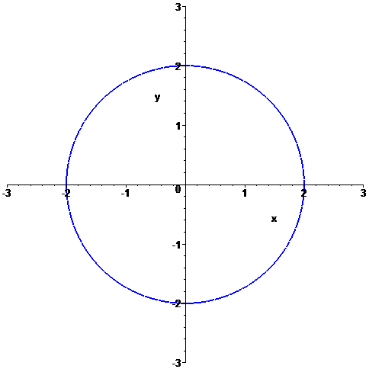

Equations like this can be expressed in polar coordinates.

In polar coordinates, each coordinate is of the form $(r,θ)$

$$(r,θ)$$

r

$θ$ = angle of rotation

Polar Axis (usually x-axis)
Pole (usually origin)

In polar coordinates, for the circle $x^{2}+y^{2}=4$, the points on the circle have a different representation.

Conversion of Rectangular and Polar Coordinates

Consider the following diagram:

y

$$(x,y)=(r,θ)$$

x

We say $\text{cos}θ=\frac{\text{adjacent}}{\text{hypotenuse}}=\frac{x}{r}$, $\text{sin}θ=\frac{\text{opposite}}{\text{hypotenuse}}=\frac{y}{r}$, and $\text{tan}θ=\frac{\text{opposite}}{\text{adjacent}}=\frac{y}{x}$.

Using these equations and the Pythagorean Theorem, we have the following conversion equations.

Conversion Formulas

To convert from polar form $(r,θ)$ to rectangular form (x, y) and vise versa, we use the following conversion equations.

From polar to rectangular form: $x=r\text{cos}θ$ and $y=r\text{sin}θ$.

From rectangular to polar form: $r^{2}=x^{2}+y^{2}$ and $\text{tan}θ=\frac{y}{x}$.

Sine and Cosine of Basic Angle Values

$θ$ Degrees | $θ$ Radians | $$\text{cos}θ$$ | $$\text{sin}θ$$ | $$\text{tan}θ=\frac{\text{sin}θ}{\text{cos}θ}$$
0 | 0 | $$\text{cos}0=1$$ | $$\text{sin}0=0$$ | 0
30 | $$\frac{π}{6}$$ | $$\frac{\sqrt{3}}{2}$$ | $$\frac{1}{2}$$ | $$\frac{\sqrt{3}}{2}$$
45 | $$\frac{π}{4}$$ | $$\frac{\sqrt{2}}{2}$$ | $$\frac{\sqrt{2}}{2}$$ | 1
60 | $$\frac{π}{3}$$ | $$\frac{1}{2}$$ | $$\frac{\sqrt{3}}{2}$$ | $$\sqrt{3}$$
90 | $$\frac{π}{2}$$ | 0 | 1 | undefined
180 | $π$ | -1 | 0 | 0
270 | $$\frac{3π}{2}$$ | 0 | -1 | undefined
360 | $$2π$$ | 1 | 0 | 0

Signs of Basic Trig Functions in Respective Quadrants

Quadrant | $$\text{cos}θ$$ | $$\text{sin}θ$$ | $$\text{tan}θ=\frac{\text{sin}θ}{\text{cos}θ}$$
I | + | + | +
II | - | + | -
III | - | - | +
IV | + | - | -
Example 1: Find the corresponding rectangular coordinates for the point $(1,\frac{5π}{4})$.

Solution:

█
Example 2: Find the polar coordinates for the point (0, -5).

Solution:

█
Evaluating Double Integrals Using Polar Coordinates

Changing a double integral from rectangular to polar coordinates can sometimes result in an integral that is easier to evaluate.

Suppose we have a region R on the x-y plane satisfying the polar conditions

$0≤g_{1}(θ)≤r≤g_{2}(θ)$ and $θ_{1}≤θ≤θ_{2}$.

x
y
$$g_{2}(θ)$$

$$g_{1}(θ)$$

$$θ_{1}$$
$$θ_{2}$$

Then if the function of two variables z = f (x, y) is defined over R, we say that

$$\begin{matrix}\text{Volume under} \\ z=f(x,y)≥0\text{ over R}\end{matrix}=\iint_{R}{f(x,y)\text{dA}=\int{\int{f(r\text{cos}θ,r\text{sin}θ)r\text{dr}dθ}}}$$

Example 3: Evaluate the double integral $\int_{0}^{\frac{π}{2}}{ \int_{0}^{1−\text{cos}θ}{ \text{sin}θ \text{dr} dθ}}$

Solution:

█

Example 4: Evaluate the double integral by changing to polar coordinates.
$$\int_{0}^{2}{ \int_{y}^{\sqrt{8−y^{2}}}{ \sqrt{x^{2}+y^{2}} \text{dx} \text{dy}}}$$

Solution:

█

Example 5: Use polar coordinates to evaluate $\iint_{R}{(x+y)\text{dA}}$ where R is the region that lies in the first quadrant between the circles $x^{2}+y^{2}=1$ and $x^{2}+y^{2}=4$.

Solution:

█
Example 6: Find the volume under the surface $z=e^{−x^{2}−y^{2}}$ and above the disk $x^{2}+y^{2}≤4$.
Solution: 



