Section 9.7/12.7: Triple Integrals in Cylindrical and Spherical Coordinates

Practice HW from Larson Textbook (not to hand in)
Section 9.7: p. 606 # 1-35 odd
Section 12.7: p. 780 # 1-4 , Supplemental Exercises at end of notes # 1-8

Cylindrical Coordinates

Cylindrical coordinates extend polar coordinates to 3D space. In the cylindrical coordinate system, a point P in 3D space is represented by the ordered triple $(r,θ,z)$. Here, r represents the distance from the origin to the projection of the point P onto the x-y plane, $θ$ is the angle in radians from the x axis to the projection of the point on the x-y plane, and z is the distance from the x-y plane to the point P.
z

$$P(r,θ,z)$$

y
r

$$θ$$

x

As a review, the next page gives a review of the sine, cosine, and tangent functions at basic angle values and the sign of each in their respective quadrants.
Sine and Cosine of Basic Angle Values

$θ$ Degrees | $θ$ Radians | $$\text{cos}θ$$ | $$\text{sin}θ$$ | $$\text{tan}θ=\frac{\text{sin}θ}{\text{cos}θ}$$
0 | 0 | $$\text{cos}0=1$$ | $$\text{sin}0=0$$ | 0
30 | $$\frac{π}{6}$$ | $$\frac{\sqrt{3}}{2}$$ | $$\frac{1}{2}$$ | $$\frac{\sqrt{3}}{2}$$
45 | $$\frac{π}{4}$$ | $$\frac{\sqrt{2}}{2}$$ | $$\frac{\sqrt{2}}{2}$$ | 1
60 | $$\frac{π}{3}$$ | $$\frac{1}{2}$$ | $$\frac{\sqrt{3}}{2}$$ | $$\sqrt{3}$$
90 | $$\frac{π}{2}$$ | 0 | 1 | undefined
180 | $π$ | -1 | 0 | 0
270 | $$\frac{3π}{2}$$ | 0 | -1 | undefined
360 | $$2π$$ | 1 | 0 | 0

Signs of Basic Trig Functions in Respective Quadrants

Quadrant | $$\text{cos}θ$$ | $$\text{sin}θ$$ | $$\text{tan}θ=\frac{\text{sin}θ}{\text{cos}θ}$$
I | + | + | +
II | - | + | -
III | - | - | +
IV | + | - | -

The following represent the conversion equations from cylindrical to rectangular coordinates and vice versa.

Conversion Formulas

To convert from cylindrical coordinates $(r,θ,z)$ to rectangular form (x, y, z) and vise versa, we use the following conversion equations.

From cylindrical to rectangular form: $x=r\text{cos}θ$, $y=r\text{sin}θ$, z = z.

From rectangular to cylindrical form: $r^{2}=x^{2}+y^{2}$ , $\text{tan}θ=\frac{y}{x}$, and z = z
Example 1: Convert the points $(\sqrt{2},\sqrt{2},3)$ and $(−3,\sqrt{3},−1)$ from rectangular to cylindrical coordinates.

Solution:

█
Example 2: Convert the point $(3,−\frac{π}{4},1)$from cylindrical to rectangular coordinates.

Solution:

█

Graphing in Cylindrical Coordinates

Cylindrical coordinates are good for graphing surfaces of revolution where the z axis is the axis of symmetry. One method for graphing a cylindrical equation is to convert the equation and graph the resulting 3D surface.

Example 3: Identify and make a rough sketch of the equation $z=r^{2}$.

Solution:

x
y
z

█

Example 4: Identify and make a rough sketch of the equation $θ=\frac{π}{4}$.

Solution:

x
y
z

█
Spherical Coordinates

Spherical coordinates represents points from a spherical “global” perspective. They are good for graphing surfaces in space that have a point or center of symmetry.

Points in spherical coordinates are represented by the ordered triple

$$(ρ,θ,φ)$$

where $ρ$ is the distance from the point to the origin O, $θ$, where is the angle in radians from the x axis to the projection of the point on the x-y plane (same as cylindrical coordinates), and $φ$ is the angle between the positive z axis and the line segment $\overset{→}{\text{OP}}$ joining the origin and the point P$(ρ,θ,φ)$. Note $0≤φ≤π$.

$$θ$$
z

$$P(ρ,θ,φ)$$
$$φ$$

$$ρ$$

y

x

Conversion Formulas

To convert from spherical coordinates $(ρ,θ,φ)$ to rectangular form (x, y, z) and vise versa, we use the following conversion equations.

From spherical to rectangular form: $x=ρ\text{sin}φ \text{cos}θ$, $y=ρ\text{sin}φ \text{sin}θ$, $z=ρ\text{cos}φ$
From rectangular to spherical form: $ρ^{2}=x^{2}+y^{2}+z^{2}$ , $\text{tan}θ=\frac{y}{x}$, and
$φ=\text{arccos}(\frac{z}{\sqrt{x^{2}+y^{2}+z^{2}}})=\text{arccos}(\frac{z}{ρ})$

Example 5: Convert the points (1, 1, 1) and $(−3,−\sqrt{3},2\sqrt{2})$ from rectangular to spherical coordinates.

Solution:

█
Example 6: Convert the point $(9,\frac{π}{4},π)$ from rectangular to spherical coordinates.

Solution:

█

Example 7: Convert the equation $ρ=2\text{sec}φ$ to rectangular coordinates.

Solution:

█
Example 8: Convert the equation $φ=\frac{π}{3}$ to rectangular coordinates.

Solution: For this problem, we use the equation $φ=\text{arccos}(\frac{z}{\sqrt{x^{2}+y^{2}+z^{2}}})$. If we take the cosine of both sides of the this equation, this is equivalent to the equation

$$\text{cos}φ=\frac{z}{\sqrt{x^{2}+y^{2}+z^{2}}}$$
Setting $φ=\frac{π}{3}$ gives
$\text{cos}\frac{π}{3}=\frac{z}{\sqrt{x^{2}+y^{2}+z^{2}}}$.

Since $\text{cos}\frac{π}{3}=\frac{1}{2}$, this gives

$$\frac{1}{2}=\frac{z}{\sqrt{x^{2}+y^{2}+z^{2}}}$$

or

$$\sqrt{x^{2}+y^{2}+z^{2}}=2z$$

Hence, $\sqrt{x^{2}+y^{2}+z^{2}}=2z$ is the equation in rectangular coordinates. Doing some algebra will help us see what type of graph this gives.

Squaring both sides gives

$\begin{aligned}x^{2}+y^{2}+z^{2}=(2z)^{2} \\ x^{2}+y^{2}+z^{2}=4z^{2} \\ x^{2}+y^{2}−3z^{2}=0\end{aligned}$
The graph of $x^{2}+y^{2}−3z^{2}=0$ is a cone shape half whose two parts be found by graphing the two equations $±\sqrt{x^{2}+y^{2}+z^{2}}=2z$. The graph of the top part, $\sqrt{x^{2}+y^{2}+z^{2}}=2z$, is displayed as follows on the next page.

(continued on next page)
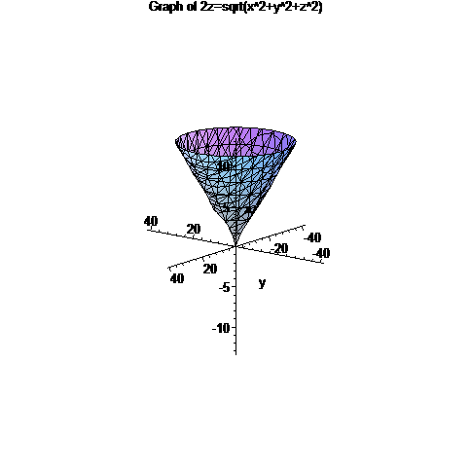
█

Example 9: Convert the equation $x^{2}+y^{2}=z$ to cylindrical coordinates and spherical coordinates.

Solution: For cylindrical coordinates, we know that $r^{2}=x^{2}+y^{2}$. Hence, we have $r^{2}=z$ or
$$r=±\sqrt{z}$$

For spherical coordinates, we let $x=ρ\text{sin}φ \text{cos}θ$, $y=ρ\text{sin}φ \text{sin}θ$, and $z=ρ\text{cos}φ$
to obtain

$$(ρ\text{sin}φ \text{cos}θ)^{2}+(ρ\text{sin}φ \text{sin}θ)^{2}=ρ\text{cos}φ$$

We solve for $ρ$ using the following steps:

$$\begin{aligned}ρ^{2}{\text{sin}}^{2}φ {\text{cos}}^{2}θ+ρ^{2}{\text{sin}}^{2}φ {\text{sin}}^{2}θ=ρ\text{cos}φ (\text{Square terms}) \\ ρ^{2}{\text{sin}}^{2}φ({\text{cos}}^{2}θ+{\text{sin}}^{2}θ)=ρ\text{cos}φ (\text{Factor }ρ^{2}{\text{sin}}^{2}φ) \\ ρ^{2}{\text{sin}}^{2}φ (1)−ρ\text{cos}φ=0 (\text{Use identity }{\text{cos}}^{2}θ+{\text{sin}}^{2}θ=1) \\ ρ(ρ{\text{sin}}^{2}φ−\text{cos}φ)=0 (\text{Factor }ρ) \\ ρ=0,ρ{\text{sin}}^{2}φ−\text{cos}φ=0 (\text{Set each factor equal to zero and solve}) \\ ρ=0,ρ=\frac{\text{cos}φ}{{\text{sin}}^{2}φ}\end{aligned}$$
█
Triple Integrals in Cylindrical Coordinates

Suppose we are given a continuous function of three variables $f(r,θ,z)$ expressed over a solid region E in 3D where we use the cylindrical coordinate system.

x
z

$$z=h_{2}(r,θ)$$

E
y
$$r=g_{2}(θ)$$
$$θ_{1}$$
$$z=h_{1}(r,θ)$$
$$θ_{2}$$

$$r=g_{1}(θ)$$

Then

$$\iiint_{E}{f(r,θ,z)\text{dV}}=\int_{θ=θ_{1}}^{θ=θ_{2}}{ \int_{r=g_{1}(θ)}^{r=g_{2}(θ)}{ \int_{z=h_{1}(r,θ)}^{z=h_{2}(r,θ)}{ f(r,θ,z) r \text{dz} \text{dr} dθ}}}$$

$\text{Volume of E}=\iiint_{E}{\text{dV}}=\int_{θ=θ_{1}}^{θ=θ_{2}}{ \int_{r=g_{1}(θ)}^{r=g_{2}(θ)}{ \int_{z=h_{1}(r,θ)}^{z=h_{2}(r,θ)}{ r \text{dz} \text{dr} dθ}}}$

Example 10: Use cylindrical coordinates to evaluate $\iiint_{E}{(x^{3}+{\text{xy}}^{2})\text{dV}}$, where E is the solid in the first octant that lies beneath the paraboloid $z=1−x^{2}−y^{2}$.

Solution:

█

Example 11: Use cylindrical coordinates to find the volume of the solid that lies both within the cylinder $x^{2}+y^{2}=4$ and the sphere $x^{2}+y^{2}+z^{2}=9$.

Solution: Using Maple, we can produce the following graph that represents this solid:
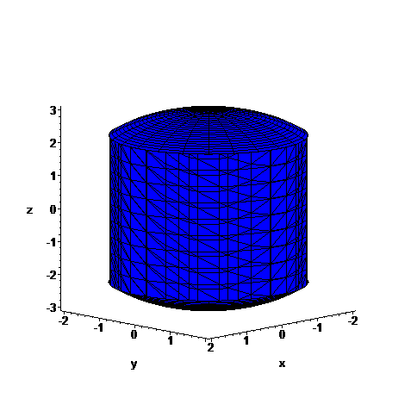
In this graph, the shaft of the solid is represented by the cylinder equation $x^{2}+y^{2}=4$. It is capped on the top and bottom by the sphere $x^{2}+y^{2}+z^{2}=9$. Solving for z, the upper and bottom portions of the sphere can be represented by the equations $z=±\sqrt{9−x^{2}−y^{2}}$.
Thus, z ranges from $z=−\sqrt{9−x^{2}−y^{2}}$ to $z=\sqrt{9−x^{2}−y^{2}}$. Since $x^{2}+y^{2}=r^{2}$ in cylindrical coordinates, these limits become $z=−\sqrt{9−r^{2}}$ to $z=\sqrt{9−r^{2}}$.When this surface is projected onto the x-y plane, it is represented by the circle $x^{2}+y^{2}=4$. The graph is

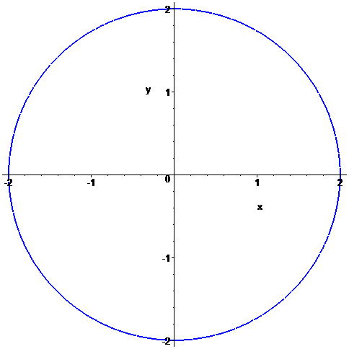
(Continued on next page)
This is a circle of radius 2. Thus, in cylindrical coordinates, this circle can be represented from r = 0 to r = 2 and from $θ=0$ to $θ=2π$. Thus, the volume can be represented by the following integral:
$$\text{Volume}=\iiint_{E}{\text{dV}}=\int_{θ=θ_{1}}^{θ=θ_{2}}{ \int_{r=g_{1}(θ)}^{r=g_{2}(θ)}{ \int_{z=h_{1}(r,θ)}^{z=h_{2}(r,θ)}{ r\text{dz} \text{dr} dθ}}}=\int_{θ=0}^{θ=2π}{ \int_{r=0}^{r=2}{ \int_{z=−\sqrt{9−r^{2}}}^{z=\sqrt{9−r^{2}}}{ r \text{dz} \text{dr} dθ}}}$$

We evaluate this integral as follows:
$\begin{aligned}\int_{θ=0}^{θ=2π}{ \int_{r=0}^{r=2}{ \int_{z=−\sqrt{9−r^{2}}}^{z=\sqrt{9−r^{2}}}{ r \text{dz} \text{dr} dθ}}}=\int_{θ=0}^{θ=2π}{{ \int_{r=0}^{r=2}{\text{rz}|}}_{z=−\sqrt{9−r^{2}}}^{z=\sqrt{9−r^{2}}}} \text{dr} dθ \\ =\int_{θ=0}^{θ=2π}{ \int_{r=0}^{r=2}{\text{ r}(}}\sqrt{9−r^{2}})−r(−\sqrt{9−r^{2}})\text{dr} dθ \\ =\int_{θ=0}^{θ=2π}{ \int_{r=0}^{r=2}{2r}}\sqrt{9−r^{2}}\text{dr} dθ \\ =\int_{θ=0}^{θ=2π}{{−\frac{2}{3}(9−r^{2})^{{}^{\frac{3}{2}}}|}_{r=0}^{r=2}} dθ (\text{Use u-du sub let }\text{u }=\text{ 9-}r^{2}) \\ =\int_{θ=0}^{θ=2π}{[−\frac{2}{3}(9−2^{2})^{{}^{\frac{3}{2}}}}−−\frac{2}{3}(9−0^{2})^{{}^{\frac{3}{2}}}]dθ \\ =\int_{θ=0}^{θ=2π}{[−\frac{2}{3}(5)^{{}^{\frac{3}{2}}}}+\frac{2}{3}(9)^{{}^{\frac{3}{2}}}]dθ \\ =\int_{θ=0}^{θ=2π}{[\text{18}−\frac{\text{10}}{3}\sqrt{5}}]dθ (\text{Note }(9)^{{}^{\frac{3}{2}}}\text{27 and }(5)^{{}^{\frac{3}{2}}}=5\sqrt{5}) \\ =[\text{18}−\frac{\text{10}}{3}\sqrt{5}]θ|_{θ=0}^{θ=2π} \\ =(\text{18}−\frac{\text{10}}{3}\sqrt{5})2π−0 \\ =\text{36}π−\frac{\text{20}π}{3}\sqrt{5}\end{aligned}$

Thus, the volume is $\text{36}π−\frac{\text{20}π}{3}\sqrt{5}$.

█

Triple Integrals in Spherical Coordinates

Suppose we have a continuous function $f(ρ,φ,θ)$ defined on a bounded solid region E.

x
y
$$θ$$
$$ρ$$
$$P(ρ,θ,φ)$$
z
$$φ$$

Then

$$\iiint_{E}{f(ρ,φ,θ)\text{dV}}=\int_{θ=θ_{1}}^{θ=θ_{2}}{ \int_{φ=φ_{1}}^{φ=φ_{2}}{ \int_{ρ=h_{1}(φ,θ)}^{ρ=h_{2}(φ,θ)}{ f(ρ,φ,θ) ρ^{2}\text{sin}φ dρ dφ dθ}}}$$

$\text{Volume of E}=\iiint_{E}{\text{dV}}=\int_{θ=θ_{1}}^{θ=θ_{2}}{ \int_{φ=φ_{1}}^{φ=φ_{2}}{ \int_{ρ=h_{1}(φ,θ)}^{ρ=h_{2}(φ,θ)}{ ρ^{2}\text{sin}φ dρ dφ dθ}}}$

Example 12: Use spherical coordinates to evaluate $\iiint_{Q}{e^{\sqrt{x^{2}+y^{2}+z^{2}}}\text{dV}}$, where Q is enclosed by the sphere $x^{2}+y^{2}+z^{2}=9$ in the first octant.

Solution:

█
Example 13: Convert $\int_{−2}^{2}{ \int_{0}^{\sqrt{\text{16}−x^{2}}}{ \int_{0}^{\sqrt{\text{16}−x^{2}−y^{2}}}{ \sqrt{x^{2}+y^{2}} \text{dz} \text{dy} \text{dx}}}}$from rectangular to spherical coordinates and evaluate.

Solution: Using the identities $x=ρ\text{sin}φ\text{cos}θ$ and $y=ρ\text{sin}φ\text{sin}θ$, the integrand becomes

$$\begin{aligned}\sqrt{x^{2}+y^{2}}=\sqrt{ρ^{2}{\text{sin}}^{2}φ{\text{cos}}^{2}θ+ρ^{2}{\text{sin}}^{2}φ{\text{sin}}^{2}θ} \\ =\sqrt{ρ^{2}{\text{sin}}^{2}φ({\text{cos}}^{2}θ+{\text{sin}}^{2}θ)} \\ =\sqrt{ρ^{2}{\text{sin}}^{2}φ(1)}=ρ\text{sin}φ\end{aligned}$$

The limits with respect to z range from z = 0 to $z=\sqrt{\text{16}−x^{2}−y^{2}}$. Note that $z=\sqrt{\text{16}−x^{2}−y^{2}}$ is a hemisphere and is the upper half of the sphere $x^{2}+y^{2}+z^{2}=\text{16}$.
The limits with respect to y range from y = 0 to $y=\sqrt{\text{16}−x^{2}}$, which is the semicircle located on the positive part of the y axis on the x-y plane of the circle $x^{2}+y^{2}=\text{16}$ as x ranges from $x=−4$ to $x=4$. Hence, the region described by these limits is given by
the following graph

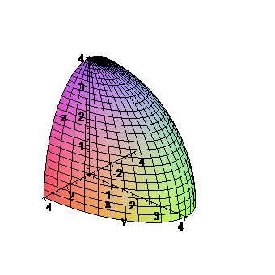
Thus, we can see that $ρ$ ranges from $ρ=0$ to $ρ=4$, $φ$ ranges from $φ=0$ to $φ=\frac{π}{2}$ and $θ$ ranges from $θ=0$ to $θ=π$. Using these results, the integral can be evaluated in polar coordinates as follows:

(continued on next page)

$\begin{aligned}\int_{−4}^{4}{ \int_{0}^{\sqrt{\text{16}−x^{2}}}{ \int_{0}^{\sqrt{\text{16}−x^{2}−y^{2}}}{ \sqrt{x^{2}+y^{2}} \text{dz} \text{dy} \text{dx}}}} \\ =\int_{θ=0}^{θ=π}{ \int_{φ=0}^{φ=\frac{π}{2}}{ \int_{ρ=0}^{ρ=4}{ ρ\text{ sin}φ(ρ^{2}\text{sin}φ)dρ dφ dθ}}} \\ \int_{θ=0}^{θ=π}{ \int_{φ=0}^{φ=\frac{π}{2}}{ \int_{ρ=0}^{ρ=4}{ ρ^{3}{\text{sin}}^{2}φdρ dφ dθ}}} \\ \int_{θ=0}^{θ=π}{ \int_{φ=0}^{φ=\frac{π}{2}}{ \frac{ρ^{4}}{4}{\text{sin}}^{2}φ|_{ρ=0}^{ρ=4}dφ dθ}} (\text{Integrate with respect to }ρ) \\ \int_{θ=0}^{θ=π}{ \int_{φ=0}^{φ=\frac{π}{2}}{ [\frac{4^{4}}{4}{\text{sin}}^{2}φ−0]dφ dθ}}=\int_{θ=0}^{θ=π}{ \int_{φ=0}^{φ=\frac{π}{2}}{\text{ 64 }{\text{sin}}^{2}φdφ dθ}} (\text{Sub in limits and simplify}) \\ \int_{θ=0}^{θ=π}{ \int_{φ=0}^{φ=\frac{π}{2}}{\text{ 64}\left[\frac{1−\text{cos}2φ}{2}\right] dφ dθ}} (\text{Use trig identity }{\text{sin}}^{2}u=\frac{1−\text{cos}2u}{2}) \\ \int_{θ=0}^{θ=π}{ \int_{φ=0}^{φ=\frac{π}{2}}{\text{ 32}(1−\text{cos}2φ)dφ dθ}} =\int_{θ=0}^{θ=π}{ \int_{φ=0}^{φ=\frac{π}{2}}{ (\text{32}−\text{32}\text{cos}2φ)dφ dθ}} (\text{Simplify and dist 32}) \\ \int_{θ=0}^{θ=π}{{(\text{32}φ−\text{32}(\frac{1}{2})\text{sin}2φ)|}_{φ=0}^{φ=\frac{π}{2}}} (\text{Integrate with respect to }ϕ\text{, use u-du sub for cos2}φ) \\ \int_{θ=0}^{θ=π}{{(\text{32}φ−\text{16}\text{sin}2φ)|}_{φ=0}^{φ=\frac{π}{2}}}dθ=\int_{θ=0}^{θ=π}{[\text{32 }\left(\frac{π}{2}\right)−\text{16}\text{sin}2(\frac{π}{2})}]−(\text{32}(0)−\text{16}\text{sin}0)dθ \\ \int_{θ=0}^{θ=π}{(\text{16}π−\text{16}\text{sin}π}−0)dθ=\int_{θ=0}^{θ=π}{(\text{16}π−\text{16}(0)})dθ \\ \int_{θ=0}^{θ=π}{\text{ 16}π}dθ=\text{16}\text{πθ}|_{θ=0}^{θ=π} (\text{Integrate with respect to }θ) \\ \text{16}π(π)−0=\text{16}π^{2}\end{aligned}$ █
Supplemental Exercises

1. Use cylindrical coordinates to evaluate $\iiint_{Q}{\sqrt{x^{2}+y^{2}}\text{dV}}$, where Q is the region that lies inside the cylinder $x^{2}+y^{2}=\text{16}$ and between the planes $z=−5$ and $z=4$. (Answer $\text{384}π$)

2. Use cylindrical coordinates to evaluate $\iiint_{Q}{e^{z}\text{dV}}$, where Q is the region enclosed by the paraboloid $z=1+x^{2}+y^{2}$ , cylinder $x^{2}+y^{2}=5$, and the x-y plane. (Answer $π(e^{6}−e−5)$)

3. Find the volume of the region Q bounded by the paraboloids $z=x^{2}+y^{2}$ and $z=\text{36}−3x^{2}−3y^{2}$. (Answer $\text{162}π$)

4. Use spherical coordinates to evaluate $\iiint_{Q}{(x^{2}+y^{2}+z^{2})\text{dV}}$, where Q is the unit ball $x^{2}+y^{2}+z^{2}≤1$ . (Answer $\frac{4π}{5}$)

5. Use spherical coordinates to evaluate $\iiint_{Q}{z\text{dV}}$, where Q lies between the spheres $x^{2}+y^{2}+z^{2}=1$ and $x^{2}+y^{2}+z^{2}=4$ in the first octant. (Answer $\frac{\text{15}π}{\text{16}}$)

6. Use spherical coordinates to evaluate $\iiint_{Q}{x^{2}\text{dV}}$, where Q is bounded by the xy-plane and the hemispheres $z=\sqrt{9−x^{2}−y^{2}}$ and $z=\sqrt{\text{16}−x^{2}−y^{2}}$. (Answer $\frac{\text{1562}π}{\text{15}}$)

7. Evaluate the integral $\int_{−2}^{2}{ \int_{−\sqrt{4−y^{2}}}^{\sqrt{4−y^{2}}}{ \int_{\sqrt{x^{2}+y^{2}}}^{2}{ \text{xz} \text{dz} \text{dx} \text{dy}}}}$ by changing to cylindrical coordinates. (Answer 0)
8. Evaluate the integral $\int_{0}^{1}{ \int_{0}^{\sqrt{1−x^{2}}}{ \int_{\sqrt{x^{2}+y^{2}}}^{\sqrt{2−x^{2}−y^{2}}}{ \text{xy} \text{dz} \text{dy} \text{dx}}}}$ by changing to cylindrical coordinates. (Answer $(4\sqrt{2}−5)/{\text{15}}$)

