Section 13.3: The Fundamental Theorem of Line Integrals

Practice HW from Larson Textbook (not to hand in)
p. 820 # 7, 8, 13, 19, 20, 29

The Fundamental Theorem of Line Integrals

Consider the consider the vector field $F(x,y)=2\text{xy}\text{ i}+(x^{2}−y)\text{ j}$ and suppose we evaluate $\int_{C}{F⋅\text{dr}}$over the two paths
$C_{1}:r(t)=2\text{cos}t\text{ i}+2\text{sin}t\text{ j}, 0≤t≤\frac{π}{2}$ and $C_{2}:r(t)=(2−2t)\text{ i}+2t\text{ j},0≤t≤1$.
The paths can be seen in the following diagram:

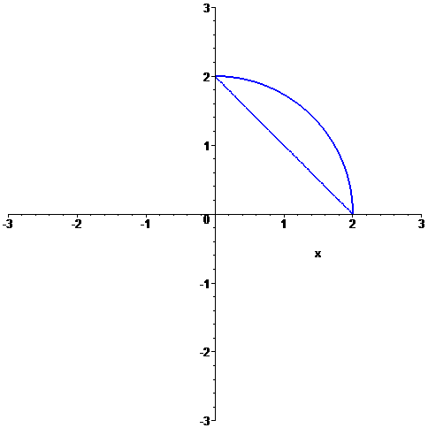
$$C_{1}$$
$$C_{2}$$

For the path $C_{1}:r(t)=2\text{cos}t\text{ i}+2\text{sin}t\text{ j}, 0≤t≤\frac{π}{2}$, we saw from Example 5 in the Section 11.2 notes that $\int_{C_{1}}{F⋅\text{dr}}=−2$

For the path $C_{2}:r(t)=(2−2t)\text{ i}+2t\text{ j}$, we have $x(t)=2−2t,y(t)=2t$. Thus,

$\begin{aligned}F(x(t),y(t))=F(2−2t,2t) \\ =2(2−2t)(2t)\text{ i}+((2−2t)^{2}−2t)\text{ j} \\ =(8t−8t^{2})\text{ i}+(4−4t−4t+4t^{2}−2t)\text{ j} \\ =(8t−8t^{2})\text{ i}+(4−\text{10}t+4t^{2})\text{ j}\end{aligned}$.

Since $r^{'}(t)=−2\text{ i}+2\text{ j}$, we have

$$\begin{aligned}\int_{C_{2}}{F⋅\text{dr}}=\int_{t=0}^{t=1}{F(x(t),y(t))⋅r^{'}(t)\text{dt}} \\ =\int_{t=0}^{t=1}{8t−8t^{2},4−\text{10}t+4t^{2}><−2,2>\text{dt}} \\ =\int_{t=0}^{t=1}{[(8t−8t^{2})(−2)+(4−\text{10}t+4t^{2})(2)]\text{dt}} \\ =\int_{t=0}^{t=1}{(−\text{16}t+\text{16}t^{2}+8−\text{20}t+8t^{2})\text{dt}} \\ =\int_{t=0}^{t=1}{(\text{24}t^{2}−\text{36}t+8)\text{dt}} \\ =(8t^{3}−\text{18}t^{2}+8t)|_{t=0}^{t=1} \\ =(8(1)^{3}−\text{18}(1)^{2}+8(1))−0 \\ =−2\end{aligned}$$

Note that for the paths $C_{1}$ and $C_{2}$, the initial point and ending points are the same. That is each graph starts at the point (2, 0) (t = 0 for both $C_{1}$ and $C_{2}$) and both end at the point (0, 2) ($t=\frac{π}{2}$ for $C_{1}$ and t = 1 for $C_{2}$). The line integrals for both of these paths are

$$\int_{C_{1}}{F⋅\text{dr}}=−2=\int_{C_{2}}{F⋅\text{dr}}$$

For conservative vector fields, this common values for the line integrals is not a coincidence.

Fact: The value of $\int_{C}{F⋅\text{dr}}$ is independent of path if and only if the vector field F is conservative.
If we know the function f where $∇f(x,y)=F$, there is a much easier way to evaluate to line integral of a conservative vector field F, which we state next.

Fundamental Theorem of Line Integrals

Given a path $r(t)=x(t)\text{ i}+y(t)\text{ j}, a≤t≤b$, with initial point $(x(a),y(a))$and terminal point $(x(b),y(b))$. Then if F is a conservative vector field with function f where $∇f(x,y)=F$, then

$$\int_{C}{F⋅\text{dr}}=f(x(b),y(b))−f(x(a),x(a))$$

The function has a natural extension of functions of 3 variables.

Example 4: Use to fundamental theorem of line integrals to evaluate $\int_{C}{F⋅\text{dr}}$ for $F(x,y)=2\text{xy}\text{ i}+(x^{2}−y)\text{ j}$ over the path C from the point (2, 0) to (0, 2).

Solution:

█
Example 5: Evaluate $\int_{C}{F⋅\text{dr}}$ for $F(x,y,z)=x^{2}\text{ i}+y^{2}\text{ j}+z^{2}\text{ k}$ over the path $C:r(t)=\text{sin}t\text{ i}+\text{cos}t\text{ j}+t^{2}\text{ k}, 0≤t≤\frac{π}{2}$.

Solution:

█

Note: If a curve C given by r(t) is closed, that is, r(a) = r(b) for $a≤t≤b$where the path has the same initial and terminal points, then $\int_{C}{F⋅\text{dr}}=0$ if F is conservative.

